Environmental, Social and Governance continued

We value inclusion and diversity
Nufarm values diversity. It fuels innovative thinking and decision making and to continue to grow and solve for the sustainability challenges of the future, we need diverse perspectives and experiences and an inclusive work environment where everyone can bring their whole self to work.
This year we implemented the first phase of our 2022-2025 inclusion and diversity strategy. Increasing gender diversity is an important element of our strategy so we are working to improve gender representation and focusing on attracting, recruiting and promoting female talent.
Last year we set a target of no less than 35 per cent of either gender in our workforce by 2025. This year we increased female representation from 26 per cent in FY21 to 27 per cent. Female representation is also improving at the board and leadership levels. We also set a new target of 40:40:20 in our senior leadership team by 2030: 40 per cent who identify as female, 40 per cent who identify as male and 20 per cent who identify as female, male, or other.
To solidify our commitment to gender diversity and equality, we adopted UN SDG 5 Gender Equality, adding our voice to the global cry to empower all women and girls and achieve gender equality.
More information on our approach to inclusion and diversity and our 2022–2025 inclusion and diversity strategy is in our FY22 corporate governance statement.

We ensure the health, safety, and wellbeing of our people
We believe that if we can operate our business safely,
we have a greater chance of helping our customer GROW A BETTER TOMORROW®.
We operate licenced major hazard facilities and manage the associated risks through rigorous process safety management systems. We also have a mobile sales and agronomy team that participates in regular driver safety programs to keep them safe out on the roads.
This year we completed corporate health and safety audits of five of our 11 crop protection manufacturing sites, assessing them against Nufarm’s best practice corporate health and safety standard. While our sites demonstrated some improvement, further opportunities were identified, along with some good practice solutions that we are sharing across sites.
FY22 brought with it ongoing COVID-19 disruptions and worker shortages but we are pleased to report no deterioration in our lost time injury frequency rate (LTIFR) (0.81 in FY22 compared with 0.90 in FY21). Unfortunately, our serious injury frequency rate (SIFR) increased this year (3.07 in FY22 compared with 2.69 in FY21) due to strains, sprains, cuts and injuries of that nature. We are striving towards our zero-injury goal and turning this trend around is a priority for us. We continue to emphasise workforce training. We are also recruiting additional health and safety professionals to further embed our safety-first culture and practices across the business.
We are conscious of the additional pressure on the mental health and wellbeing of our people, including as a result of COVID-19. This year we held many mental health and wellbeing events across all our regions, empowering our people to care for themselves and those around them. The focus increased during our mental health week in October 2021. The feedback from our people was so positive that we have expanded the program, establishing a ‘wellness month’ in early FY23.
We have also introduced a global wellness platform in partnership with Lifeworks, the world’s largest employee assistance provider, to support our people and their families worldwide.
The journey towards zero injuries is not a straight line, but we have never lost sight of this goal and will continue to strive for it to make sure everyone goes home safely every day.

For more information on our sustainability approach, targets and performance, see our 2022 Sustainability Report which will be available in early 2023

Nufarm's SIFR and LTIFR – rolling 12 month averages (per million hours worked)

4.5


4.0
3.5
3.0
2.5
2.0
1.5
1.0
0.5
0.0
Jan-16 Mar-16 May-16 Jul-16 Sep-16 Nov-16 Jan-17 Mar-17 May-17 Jul-17 Sep-17 Nov-17 Jan-18 Mar-18 May-18 Jul-18 Sep-18 Nov-18 Jan-19 Mar-19 May-19 Jul-19 Sep-19 Nov-19 Jan-20 Mar-20 May-20 Jul-20 Sep-20 Nov-20 Jan-21 Mar-21 May-21 Jul-21 Sep-21 Nov-21 Jan-22 Mar-22 May-22 Jul-22 Sep-22

Nufarm Group LTIFR Rolling 12 months Nufarm Group SIFR Rolling 12 months

16 Nufarm Limited | Annual Report 2022

Definitions
Consistency of definitions—across data sources within a country, across countries, and over time— is essential for the effective use of migration- and forced displacement–related data. However, there are wide variations, including in high-income countries with solid statistical systems. For example, the Norwegian authorities and the United Nations High Commissioner for Refugees (UNHCR) noted sig- nificant discrepancies between the numbers of refugees in Norway reported for the end of 2013—18,734 by Eurostat; 46,033 by UNHCR; and 132,203 by Statistics Norway—reflecting differences in definitions, time frames, and statistical methods.2 Similarly, the definition of migrant in national censuses varies across countries. It can be based on place of birth, citizenship, time of arrival, or even ethnicity or race (figure S2.1). Countries, government agencies within the same country, and researchers collect data using any one of these definitions, making comparisons and analyses difficult.

Figure S2.1 Many population censuses do not collect basic and consistent data on migration
35
33
30
30
24
22
10

30

25
Number of censuses

20

15

10

5

0
Africa Asia Europe North America Oceania South America
Total countries in database
Country of birth and citizenship
Country of birth and citizenship, and year of arrival
Source: Juran and Snow 2018. Based on data for 149 countries from United Nations Department of Economic and Social Affairs (UN DESA).
Note: The number of censuses refers to censuses in the 2010 round whose questionnaires include two or three core questions on country of birth, citizenship, and year of arrival.

Data sources
Multiple sources of data can inform policy making, each with its strengths and limitations. Each set of instruments is insufficient to fully address the data challenges related to migration. However, each can help provide evidence on specific aspects of cross-border movement. Effective policy making requires using multiple data sources across geographic, disciplinary, and institutional boundaries. Various data sources can complement one another so that, over time, a comprehensive picture emerges:

62 | WORLD DEVELOPMENT REPORT 2023

World Oil Supply

OECD
OECD liquids production in 2021 is forecast to increase by 0.21 mb/d y-o-y to average 29.32 mb/d, revised up by 0.02 mb/d m-o-m owing to an upward revision of 0.04 mb/d in the production forecast for OECD Americas, which is now projected to grow by
0.30 mb/d to average 25.0 mb/d. OECD Europe is forecast to decline by 0.09 mb/d, with an average supply of 3.81 mb/d. The supply forecast in OECD Asia Pacific is also forecast to decline by 0.01 mb/d y-o-y to average 0.51 mb/d.
For 2022, oil production in the OECD is forecast to increase by 1.30 mb/d y-o-y to average 30.62 mb/d, unchanged compared to a month earlier, despite upward revisions in OECD Americas by 105 tb/d, which are offset by a downward adjustment in the supply forecast of OECD Europe. Based on these revisions, OECD Americas is forecast to grow by

Graph 5 - 5: OECD quarterly liquids supply, y-o-y changes
mb/d
4
-2.70

1.33 1.08 1.09 1.67 1.10 1.17 1.25

2

0

-2

-4
1Q21
2Q21
3Q21
4Q21*
1Q22*
2Q22*
3Q22*
4Q22*

Note: * 4Q21-4Q22 = Forecast. Source: OPEC.

1.14 mb/d to average 26.14 mb/d. Oil production in OECD Europe and OECD Asia Pacific is anticipated to grow respectively by 0.13 mb/d and 0.03 mb/d y-o-y to average 3.94 mb/d and 0.54 mb/d.

OECD Americas
US

US liquids production in August 2021 was down by
0.13 mb/d m-o-m to average 17.87 mb/d, higher by
0.78 mb/d compared with August 2020.
Crude oil production decreased in August 2021 by
185 tb/d m-o-m to average 11.14 mb/d, up by
0.58 mb/d y-o-y. Regarding crude and condensate production breakdown by region (PADDs), production decreased on the US Gulf Coast (USGC) by 257 tb/d to average 7.86 mb/d, while it increased in the other four PADDs in August.
NGLs production was up by 113 tb/d to a record high at average 5.57 mb/d in August. Meanwhile, production of non-conventional liquids (mainly ethanol) in July decreased by 12 tb/d m-o-m to average 1.22 mb/d, according to the Department of Energy (DOE). It is estimated that output continued declining to 1.17 mb/d in August.
Looking at states, production in the Gulf of Mexico (GoM), declined by 312 tb/d m-o-m to average
1.54 mb/d. Part of this monthly decline in the GoM was offset by higher output in new Mexico, North Dakota, Alaska, and Texas.
In the US Midwest, production in North Dakota increased by 29 tb/d to average 1.09 mb/d, but still is lower by 65 tb/d y-o-y. Production in Alaska recovered by 29 tb/d m-o-m to average 0.41 mb/d amid easing of maintenance. Oil output in Oklahoma and Colorado showed a minor increase m-o-m, and finally production in New Mexico and Texas rose m-o-m by 50 tb/d to average 1.35 mb/d and 18 tb/d to average
Graph 5 - 6: US monthly liquids output by key component

mb/d
20
18
16
14
12
10
8
Aug 20
Sep 20
Oct 20
Nov 20
Dec 20
Jan 21
Feb 21
Mar 21
Apr 21
May 21
Jun 21
Jul 21
Aug 21

Crude NGLs Others Total
Source: OPEC.

Table 5 - 3: US crude oil production by selected state and region, tb/d
State | Change  Jul 21 Aug 21 Aug 21/Jul 21
Oklahoma 379 380 |  | 1
Colorado 390 391 |  | 1
Alaska 380 409 |  | 29
North Dakota 1,060 1,089 |  | 29
New Mexico 1,296 1,346 |  | 50
Gulf of Mexico (GoM) 1,847 1,535 |  | -312
Texas 4,816 4,834 |  | 18
Total | 11,326 11,141 | -185
Sources: EIA and OPEC.

OPEC Monthly Oil Market Report – November 2021 39

The global food system and what we eat is not only relevant as far as environmental
sustainability is concerned, but also in terms of health sustainability. For example, overweight and obesity are significant health issues driven not only by how much we eat, but also by the type of foods we consume. The share of adults globally who are overweight or obese has more than doubled since 1975 and now stands at over 40% based on estimates from the World Health Organisation (WHO). The health implications of this are very significant. In our earlier report on the global food system, we highlighted work from the Global Burden of Disease Study in 2019, which showed that around 35 million years of
life were lost in 2019 due to metabolic risks,
largely from a combination of eating too much, eating the wrong food and not exercising enough (Figure 3). We also estimated that the cost of overweight and obesity to the global economy was around USD 5 trillion.

Changing what we eat can make a big difference

The need to change what we eat, how much we eat and how we produce it becomes clear when taking potential future scenarios into account.
In our report on the global food system, we showed that food-related emissions could

Figure 1: Food-related GHG emissions by source globally
Non-food 74%
Food 26%

Land use for livestock, 16%
Land use for human food, 8%
Crops for human food, 21%
Crops for animal feed, 6%
Livestock & fish farms, 30%

Wild catch fish, 1%
Food processing 4%
Transport 6%
Packaging, 5%
Retail, 3%

Source: Poore and Nemecek (2018), Credit Suisse Sustainable Consumer Survey

increase by close to 45% in the next 30 years if

historical patterns around food consumption and growth in spending power across the emerging world continue (Figure 4). Clearly, such a “no- change” development would be at odds with the overall desire to reach a net-zero world by 2050. In “The ROE of a Tree,” we calculated that a change in dietary habits would provide significant potential to reduce carbon emissions. This could be achieved in two ways:
- First, a shift in consumption from an animal protein-based diet to one that is more heavily weighted toward plant-based products would be less emission-intense.
- Second, such a shift would free up land that could be used for reforestation and increase natural carbon sequestration (Figure 5).
Overall, our calculations in “The ROE of a Tree” suggested that more than 80% of current anthropogenic emissions could be captured through reforestation if diets were to shift and smart agricultural solutions were adopted.
Changing what we eat can therefore make a big difference.

Figure 2: Contribution of greenhouse gases by food type in average diet

Fruits 2% Other 4%
Grain products 2%
Vegetables 3%
Eggs 3%
Fish and seafood 6%

Beverages 6%

Dairy 18%

Source: Center for Sustainable Systems at the University of Michigan, USA

Meat 56%

24

Making Data Meaningful Part 2: A guide to presenting statistics

4.4 Selecting the appropriate type of chart
Knowing what type of charts to use with what type of information is crucial. Some charts are more appropriate than others, depending on the nature of the data. In this section, we provide guidelines for the most common types of charts: bar charts and population pyramids, line charts, pie charts and scatter plots.

Bar charts

A bar chart is the simplest type of chart to draw and read. It is used to compare frequencies or values for different categories or groups.

GOOD EXAMPLE of a bar chart

Germany Finland Latvia Estonia Slovenia
Lithuania
Netherlands
Georgia Cyprus Croatia Israel Spain
Luxembourg
Italy United Kingdom
Ukraine
Female ambassadors in 2006

0 5 10 15 20 25 30 35 40
Percent of total number of ambassadors

So urce: UNECE Statistical Database

The bars can be either vertically or horizontally oriented. In the horizontal orientation, the text is easier to read, as in the example above. It is also easier to compare the different values when the bars are ordered by size from smallest to largest, rather than displayed arbitrarily.

The bars should be much wider than the gaps between them. The gaps should not exceed 40% of the bar width.

A stacked bar chart can be used to show and compare segments of totals. Caution should be exercised when using this type of chart. It can be difficult to analyze and compare, if there are too many items in each stack or if many items are fairly close in size.

19

Directors' Remuneration Report

Relative importance of spend on pay
The chart below shows the relative spend on pay compared with dividends paid to Unilever shareholders and underlying earnings. Underlying earnings represent the underlying profit attributable to Unilever shareholders and provides a good reference point to compare spend on pay. The chart below shows the percentage of movement in underlying earnings, dividends and total staff costs versus the previous year.

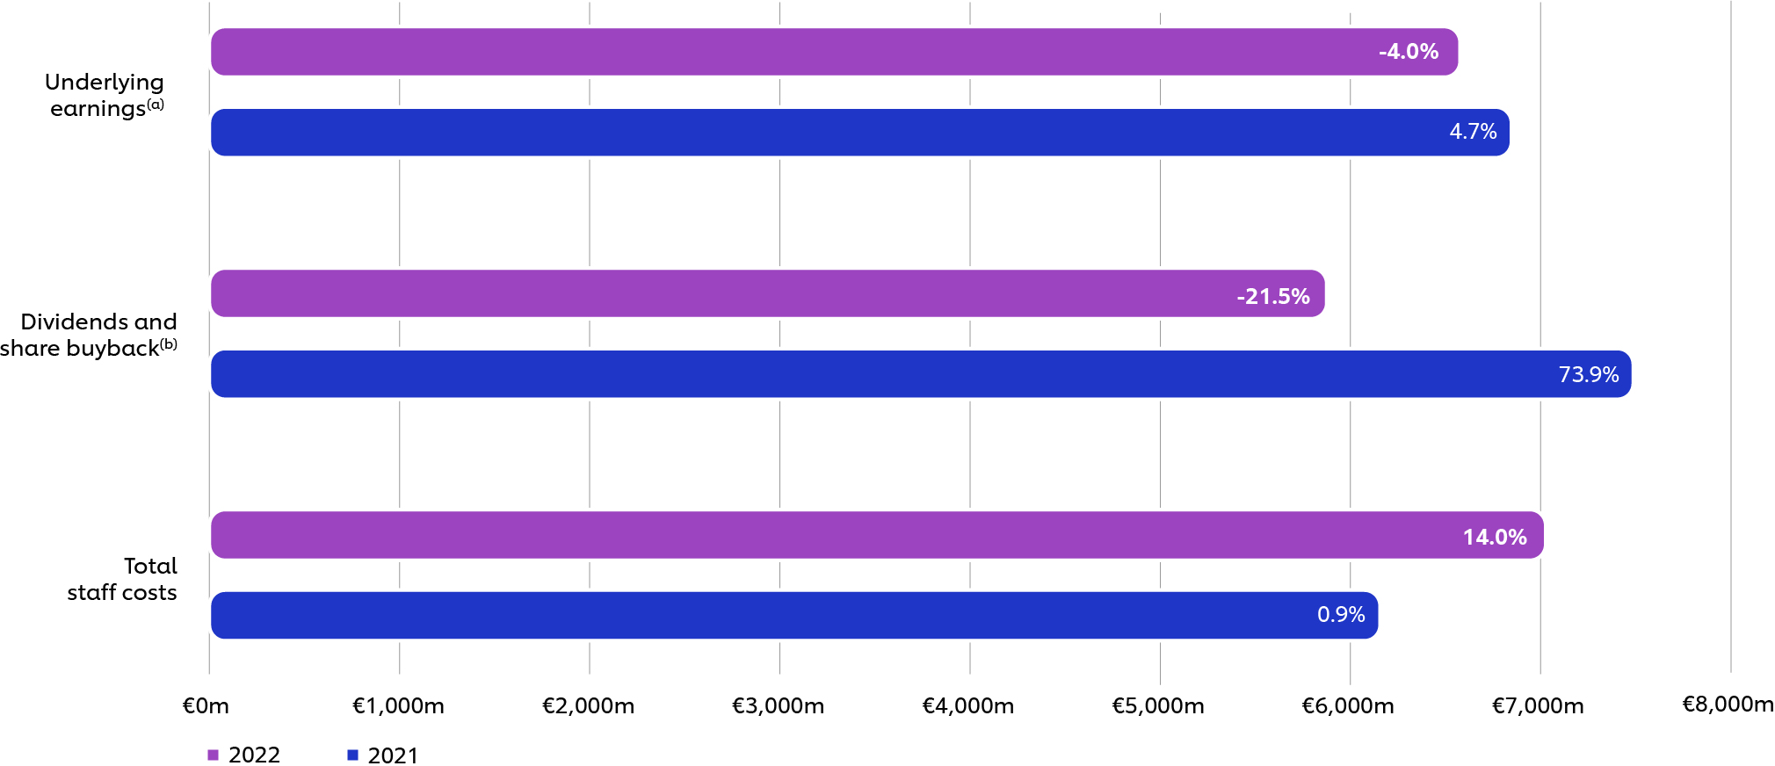

- In calculating underlying profit attributable to shareholders, net profit attributable to shareholders is adjusted to eliminate the post-tax impact of non-underlying items in operating profit and any other significant unusual terms within net profit but not operating profit (see note 7 on page 171 for details).
- Includes share buyback of €1,509m in 2022 and €3,018m in 2021.

CEO single figure ten-year history
The table below shows the ten-year history of the CEO single figure of total remuneration:
2013 2014 2015 2016 2017 2018 2019 2020 2021 2022
CEO single figure of total remuneration (€‘000) | 7,740 | 9,561 | 10,296 | 8,370 | 11,661 | 11,726 | 4,894 | 3,447 | 4,890 | 5,395
Annual bonus award rates against maximum opportunity | 78% | 66% | 92% | 92% | 100% | 51% | 55% | 32% | 54% | 89%
GSIP performance shares vesting rates against maximum opportunity | 64% | 61% | 49% | 35% | 74% | 66% | 60% | n/a | n/a | n/a
MCIP matching shares vesting rates against maximum opportunity | n/a | 81% | 65% | 47% | 99% | 88% | n/a | 42% | 44% | 35%

Ten-year historical Total Shareholder Return (TSR) performance
The graph below includes growth in the value of a hypothetical £100 investment over ten years’ FTSE 100 comparison based on 30-trading-day average values.
The table below shows Unilever’s performance against the FTSE 100 Index, which is the most relevant index in the UK where we have our principal listing. Unilever is a constituent of this index.

130 Unilever Annual Report and Accounts 2022 | Governance

Chart 2.2 Coal Supply

5.0
Q1 Q2 Q3 Q4 Q1 Q2 Q3 Q4 Q1 Q2 Q3 Q4 Q1 Q2 Q3
2018
2019
2020
2021
Imports Surface mining
Deep mined
4.5
4.0
Million tonnes
3.5
3.0
2.5
2.0
1.5
1.0
0.5
0.0

Domestic coal production has fallen steadily because of coal mine closures and a pattern of generally reduced demand over time, particularly for generation. Recent production was also affected by both restrictions from Covid-19 and localised flooding. With reduced production, imports filled the gap in demand, rising from 1.1 million tonnes in the third quarter of 2020 to 1.3 million tonnes in the third quarter of 2021. Set against historic imports however, current volumes are low: imports peaked at 13.3 million tonnes in the second quarter of 2013.

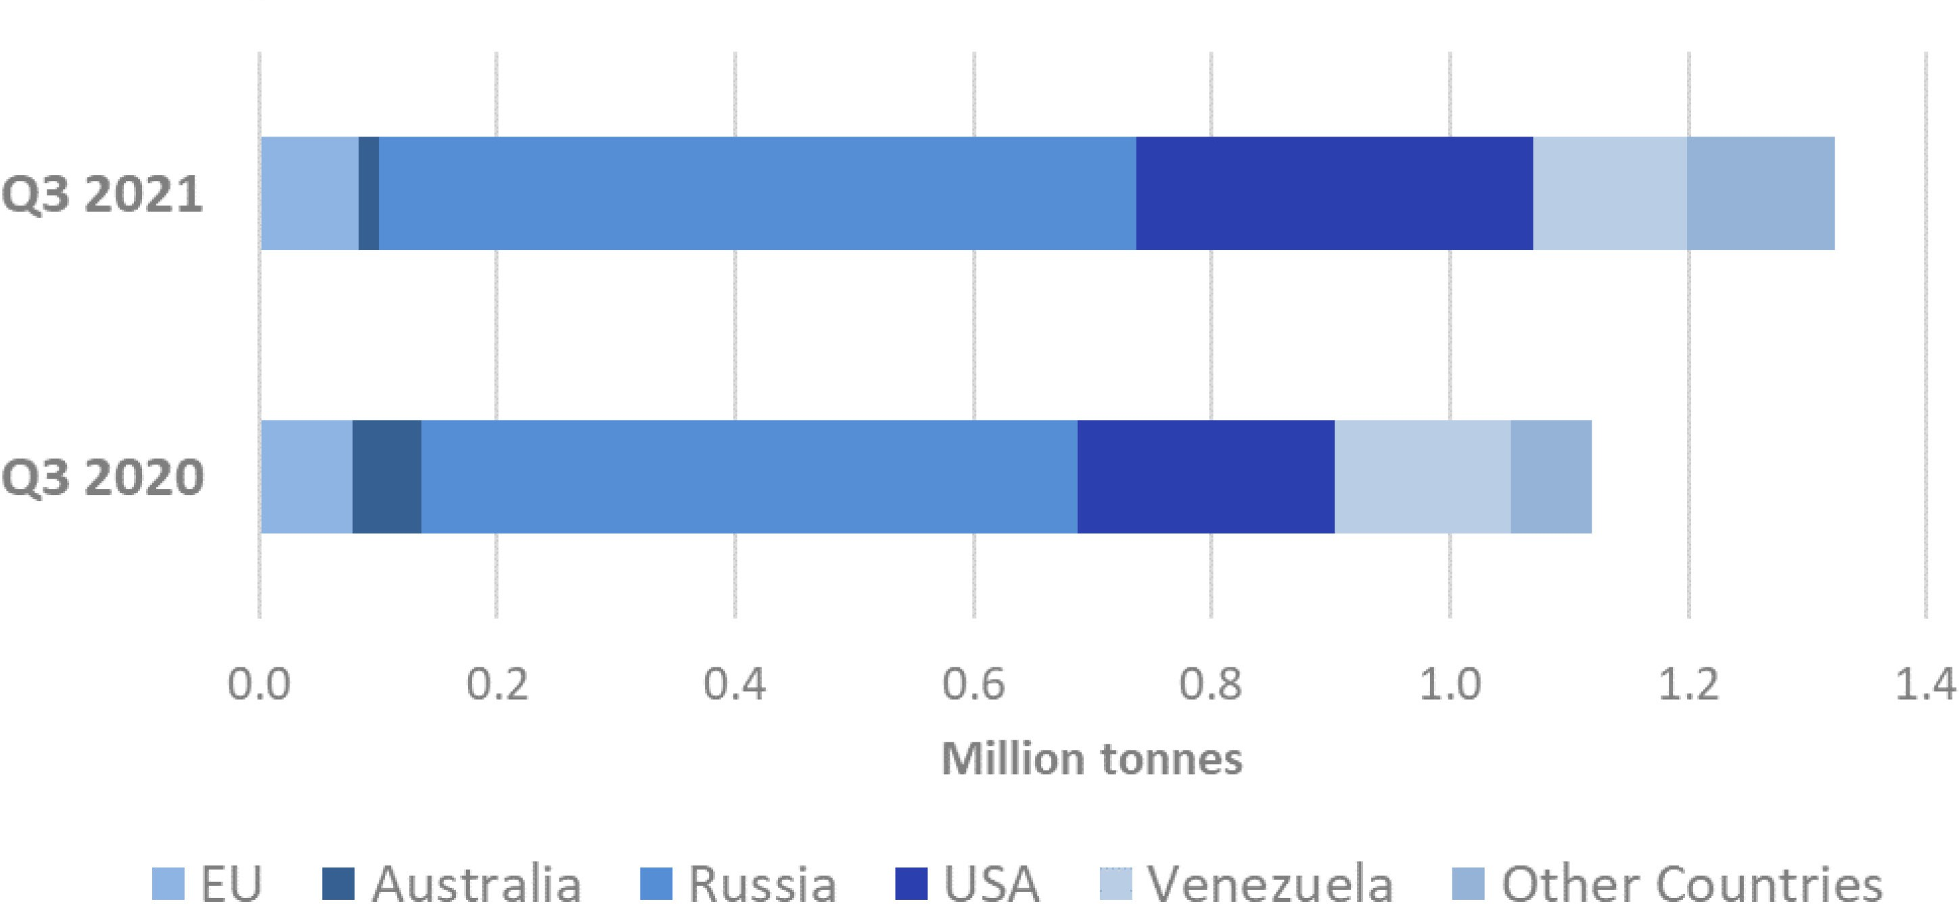
Chart 2.3 Coal Imports

In Quarter 3 2021 Russia (48 per cent), the USA (25 per cent) and Venezuela (10 per cent) accounted for 83 per cent of total coal imports.

5

Three Tactics That Engage Consumers on Climate Consumers / Contents

One of the important next steps for business leadership to take on climate change, especially in the wake of COP26, is to think through how to engage their customers on climate. Climate action costs money, so pioneers risk being disadvantaged — unless they can learn how to create value from their climate leadership. Unlocking this value is not just a commercial business opportunity; it is a vital enabler of climate action at scale.

For companies serving corporate customers, the routes to commercial value are relatively clear. Corporate customers are pursuing their own climate transition efforts, creating opportunities to help them through differentiated products that decarbonize their supply chain, through joint problem-solving efforts that deepen the customer relationship, or through playing new roles as value migrates along the chain.

Companies serving consumers have found the challenge much harder. The opportunity looks attractive: Research consistently shows that as individuals, we care a lot about climate change, and we say that we are happy to pay more for sustainable options. Yet many companies have stories of climate-friendly products and services they have launched, that have had next to no take-up. And consumers remain mostly unaware, and unengaged, with the climate efforts companies are making.

This is not a failure of individuals; this is a failure of companies to figure out how climate
leadership translates into value.

Exhibit 1: Stated willingness to pay
A substantial majority of people across countries say they are willing to pay for sustainability

Total UK
28 |  |  |  | 27 |  |  |  |  |  | 23 |  |  |  |  |  |  | 12 |  |  |  |  | 6 |  |  | 2
36 |  |  |  |  |  |  | 29 |  |  |  |  |  | 20 |  |  |  |  |  |  | 8 |  |  | 5 |  | 2
 |  |  |  |  |  |  |  |  |  |  |  |  |  |  |  |  |  |  |  |  |  |  |  |  | 2
36 |  |  |  |  |  |  | 27 |  |  |  |  | 19 |  |  |  |  |  |  | 10 |  |  |  | 5 |  | 2
12 |  | 22 |  |  |  | 33 |  |  |  |  |  |  |  | 21 |  |  |  |  |  |  |  | 9 |  |  | 2
20 |  |  | 30 |  |  |  |  |  | 26 |  |  |  |  |  |  | 11 |  |  |  |  | 7 |  |  | 3

US

China Brazil

0% 10%
20%
30%
40% 50% 60% 70%
80% 90%
100%

N/A, I am not willing to pay a premium 0-5% 6-10% 11-15% 16-20% 21-25% >25%

“Are you willing to pay a premium for sustainable products and services? If yes, how much?” Source: Oliver Wyman Forum 2021. N = 3,500.

© Oliver Wyman 50

