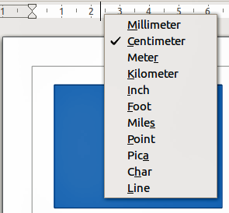
Figure 1: Ruler units

Status bar
The Status bar is located at the bottom of the screen in all LibreOffice components; it includes several Draw-specific fields. For details on the contents and use of these fields, see Chapter 1 Introducing LibreOffice in this guide and in the Draw Guide Chapter 1 Introducing Draw.
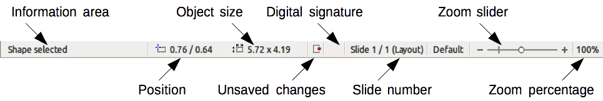
Figure 2: Draw status bar
Note | The sizes are given in the current measurement unit and are not to be confused with the ruler units. The measurement unit on the Status bar is defined in Tools > Options > LibreOffice Draw > General, where you can also change the scale of the page.

Toolbars
To display or hide the various Draw toolbars, go to View > Toolbars on the main menu bar. On the menu that appears, select which toolbars you want to display. For more about working with toolbars, see Chapter 1 Introducing LibreOffice in this guide.
The tools available in the Draw toolbars are explained in the following sections. The appearance of the toolbar icons may vary depending on your operating system and the selection of icon size and style in Tools > Options > LibreOffice > View.

Standard toolbar
The Standard toolbar is the same for all LibreOffice components and is not described in detail in this chapter.
Figure 3: Standard toolbar

Drawing toolbar
The Drawing toolbar is the most important toolbar in Draw. It contains all the necessary functions for drawing various geometric and freehand shapes and for organizing them on the page.
Figure 4: Drawing toolbar

Line and Filling toolbar
The Line and Filling toolbar lets you modify the main properties of a drawing object. The icons and pull-down lists vary, according to the type of object selected. For example, to change the style of a line, click on the up and down arrows for Line Style and select the required style.
Figure 5: Line and Filling toolbar

Text Formatting toolbar
If the selected object is text, the Line and Filling toolbar changes to the Text Formatting toolbar, which is similar to the Formatting toolbar in Writer. For more information, see Chapter 4 Getting Started with Writer in this guide.
Figure 6: Text Formatting toolbar

Options toolbar
Use the Options toolbar to activate or deactivate various drawing aids. The Options toolbar is not one of the toolbars displayed by default. To display the Options toolbar, select View > Toolbars > Options.
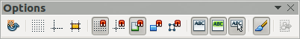
Figure 7: Options toolbar
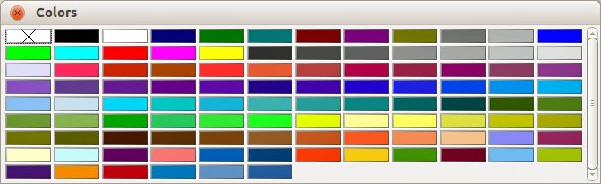
Figure 8: Colors dialog

Choosing and defining colors
To display the Colors dialog (Figure 8), select View > Toolbars > Color Bar to display the current color palette. This dialog lets you rapidly choose the color of the various objects (lines, areas, and 3D effects). The first box in the panel corresponds to none (no color).
You can access several specialized color palettes in Draw, as well as change individual colors to your own taste. This is done using the Area dialog by selecting Format > Area on the main menu bar or clicking the Area icon on the Line and Filling toolbar, then selecting the Colors tab (Figure 9).
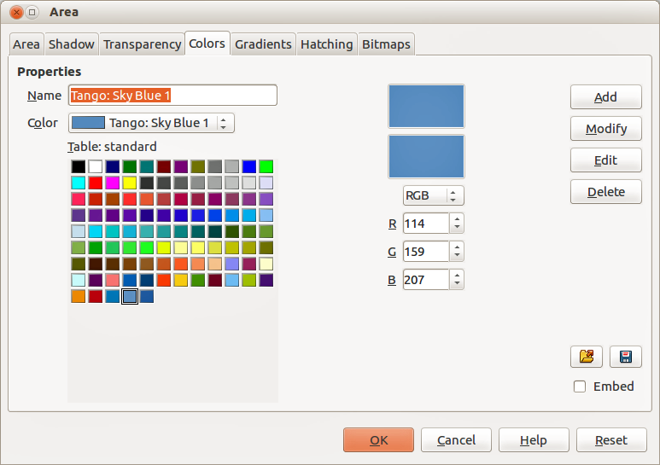
Figure 9: Area dialog – Colors page
To load another palette, click on the Load Color List icon . The file selector dialog asks you to choose one of the standard LibreOffice palettes (files with the file extension *.soc). For example, web.soc is a color palette that is adapted to creating drawings for placing in web pages. These colors will display correctly on workstations with screens capable of at least 256 colors.
The color selection box also lets you individually change any color by modifying the numerical values in the fields provided to the right of the color palette. You can use the color schemes known as CMYK (Cyan, Magenta, Yellow, Black) or RGB (Red, Green, Blue).
Click on the Edit button to open the Color dialog, where you can set individual colors. See “Color options” in Chapter 2 Setting Up LibreOffice in this guide.
For a more detailed description of color palettes and their options, see the Draw Guide Chapter 10 Advanced Draw Techniques.

Drawing basic shapes
Draw provides a wide range of shapes, located in palettes accessed from the Drawing toolbar (Figure 4) and a full list of these various tools is shown in Figure 10. The icons or buttons that are already installed on the Drawing toolbar are highlighted in Figure 10.
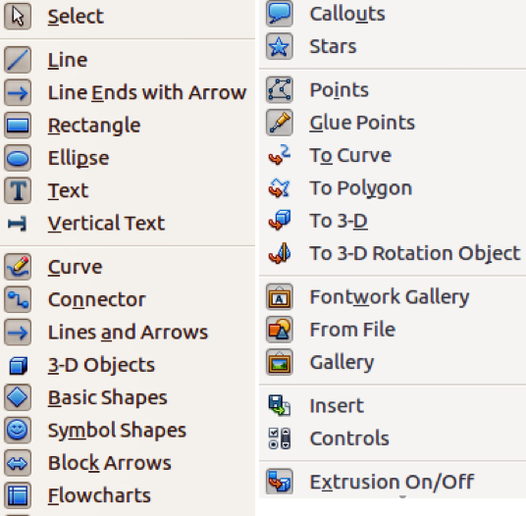
Figure 10: Tools available for Drawing toolbar
This section describes only a few of the basic shapes, including text, which are treated as objects in Draw. See the Draw Guide for a complete description of the shapes available.
Please note that some of the icons on the Drawing toolbar will change according to the shape that has been selected from the choice available. Icons with tool palettes available are indicated by a small triangle to the right of the icon.
Note | When you draw a basic shape or select one for editing, the Info field at the left side in the status bar changes to reflect the present action: for example Line created, Text frame xxyy selected, and so on.

Drawing a straight line
Click on the Line icon and place the cursor at the point where you want to start the line (Error: Reference source not found). Drag the mouse while keeping the mouse button pressed. Release the mouse button at the point where you want to end the line. A selection handle appears at each end of the line, showing that this object is the currently selected object. The selection handle at the starting point of the line is slightly larger than the other selection handle.
Keep the Shift key pressed while you draw a line to restrict the drawing angle of the line to a multiple of 45 degrees (0, 45, 90, 135, and so on).
Note | This is the default behavior of the Shift key. However, if the option When creating or moving objects in the Snap position section of Tools > Options > LibreOffice Draw > Grid has been selected, the action of the Shift key is the opposite. Lines will automatically be drawn at a multiple of 45 degrees unless the Shift key is pressed.

