ECOC 2024: An industry’s urgency to push and explore
by Tatiana Berdinskikh, Vladimir Kozlov, and Roy Rubenstein
October 8th, 2024

Summary
Call it the AI effect. The impression at this year’s European Conference on Optical Communications (ECOC) is of an industry pushing technologies with all options on the table.

Whether it is electrical signals or optical, copper or optical interconnect, chips or PICs, this is an industry eager to enable new speed hikes – 1,600 gigabit per second (Gb/s) modules were evident at the show while 1.6 terabit coherent is starting.
There were also developments for 224Gb/s and 448Gb/s electrical and optical lanes, while a new form factor supporting 12.8 terabit, 25.6 terabit and more is being mooted. There was also a first example of coherent optics – albeit ‘lite’ - inside the data center. And talk of more parallelism continued, whether it is multi-core fiber or multi-carrier coherent optics.
What is driving the sense of urgency? The demands for higher-speed interconnect to help scale up and scale out AI systems. The onus on the optical industry is to keep strict hold of power consumption. Computational silicon is making huge demands on power such that the optics must do all it can not to further burden the power consumption. Arista’s Andy Bechtolsheim’s ECOC plenary session talk address this (discussed below).
This is an exciting time for optics. The hyperscalers with their AI needs are driving industry innovation. These developments will serve the industry whatever happens overall with AI in the coming years.
This year marked the 50th anniversary of ECOC with the event taking place in Frankfurt from September 22-26. The first European conference, held in London in 1975, focused on optical fiber communications. The inaugural ECOC attracted 74 conference papers totaling 224 pages. Fifty years on, the conference proceedings have grown to 2,000 pages and the event attracted over 1,800 participants.
Below is LightCounting’s coverage of key announcements at the show. We do not claim this is a comprehensive list of all the important technology announcements made at ECOC.

ECOC Plenary session
The plenary session’s keynotes ranged from materials (silicon photonics), photonic integration, data center optical connectivity, to communications service providers’ optical networks.

Talk 1: Andy Bechtolsheim: optics and AI datA centers
Andy Bechtolsheim’s, co-founder and chief architect at Arista Networks, keynote addressed how AI is driving photonic developments in the data center. At the Hot Interconnects event in August, Bechtolsheim discussed how input-output (I/O) requirements will need to scale one hundredfold to meet AI systems’ processing requirements by 2030. At ECOC, Bechtolsheim focused on the progress made in copper and optical interconnect technologies and outlined a technology roadmap and challenges to keep scaling I/O.
Distributed computing needs for AI is growing tenfold each year while accelerator chips’ processing performance is doubling only every two years. Systems must scale up (densely interconnected xPUs) and scale out (linking scale-up units). Bechtolsheim cited a future cluster example with 512 AI accelerators, each having a bandwidth of 25.6 terabits per second (Tb/s). This will require 32, 1.6 terabit (1600G-DR8) pluggables - 16 modules either side of the accelerator chip.
Bechtolsheim is a long-standing fan of pluggables. He stressed their reliability and serviceability merits while highlighting how the alternative packaging schemes - on-board optics and co-packaged optics – have yet to be deployed in volume. However, 1600G-DR8 modules with PAM-4 DSPs consume too much power. Early DSP-based 1600G-DR8 prototypes consume 30W, unacceptable given the power consumption of AI accelerators. Bechtolsheim’s belief is that 1600G linear pluggable optics (LPO) that ditch the DSP and consume around 10W is the approach. With AI clusters with up to 1 million xPU supercomputers being spoken of, a 20W power savings per module is a must, given the huge numbers of optical modules used for such a behemoth system.
Figure 1: Andy Bechtolsheim’s candidate 10m-link technologies for future 512-xPU systems
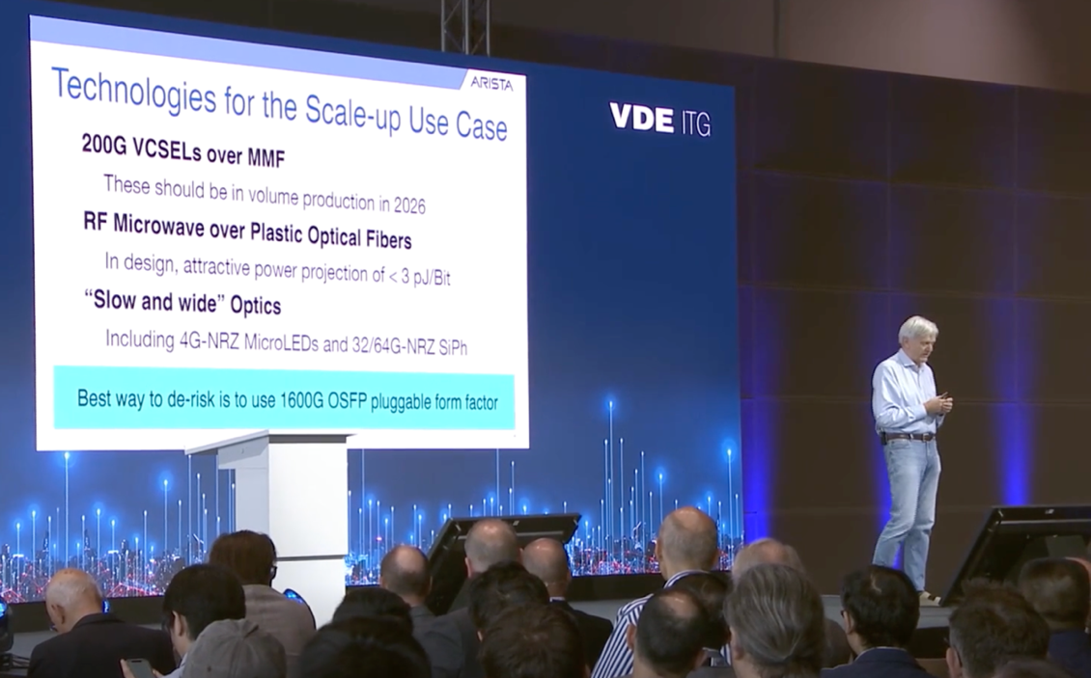
Source: ECOC
Current pluggables using 112G serdes are still growing in volume but the advent of 1600G-DR8 is driving 224G electrical and optical lanes and will then be followed by 448G. Bechtolsheim ended his keynote by looking at candidate technologies for these higher speeds.
The current state-of-the-art scale-up systems is Nvidia’s GB200 NVL72 rack hosting 72 Grace Blackwell GPUs. The rack consumes 120kW and uses copper interconnect. The equivalent interconnect bandwidth, were it implemented in optics, would require 648, 1600G modules. That would add 20kW to the system’s power consumption, the equivalent of 12 extra GB200s, he said.
The next scale-up system will be larger, hosting 128 accelerators, and will triple the bandwidth of the NVL72. This too will be copper based, says Bechtolsheim. But the sweet spot for a scale-up system is 512 superchips and that will require eight cabinets and 10m links. Bechtolsheim listed three candidate approaches: 200G VCSELs, an RF microwave technology sent over plastic optical fiber that would consume under 3pJ/W, and a slow and wide parallel approach based on 4Gb/s per lane MicroLeds or 32/64Gb/s non-return-to-zero (NRZ) signaling (see Figure 1). The slow-and-wide approach promises simpler links and lower picoJoules per bit (pJ/b). An issue with the different proposals is the combinations of signal translations required. Bechtolsheim called for industry standardization work: “To get these new things to market, one has to de-risk optics.”

talk 2: Joyce Poon: How integrated Photonics will impact computing
Lightmatter’s head of photonics architecture, Joyce Poon, gave a 100-year perspective on integrated photonics. She started with a survey of seminal developments, opening with a paper presented in 1971 by Amnon Yariv on a vision for active integrated photonics. Poon added the work of Richard Soref in the 1980s showing the role silicon could play, followed by Intel’s and Luxtera’s pioneering silicon photonics work in the 2000s, and the technology’s progress since including the embrace by foundries.
Poon outlined Lightmatter’s 3D integration co-packed optics technology and its Passage scalable adaptive platform for AI computing. Passage supports various accelerator chips - CPUs, GPUs, FPGAs, high-bandwidth stacked memory (HBM) and neuromorphic devices – with space for 48 full-sized chips. The platform supports topologies such as all-to-all, rings, and a 2D hypertoroid, and can adapt configurations in a millisecond using optical circuit switching (OCS). The Passage architecture also supports single hops anywhere with a latency up to 2ns. Lastly, the platform’s collective bandwidth is hundreds of Tb/s and Passage’s external fiber attach bandwidth capacity is up to 56Tb/s.
Poon believes AI will change human-computer interactions. The path will be from talking to a smartphone to ‘wearables’ to eventually human-brain-machine interfaces. The latter will require silicon photonics operating in visible light (<1um) and she outline research involving opto-genetics whereby neurons can be modified to be controlled by light.
Figure 2: A century’s view of integrated photonics, according to Lightmatter’s Poon.
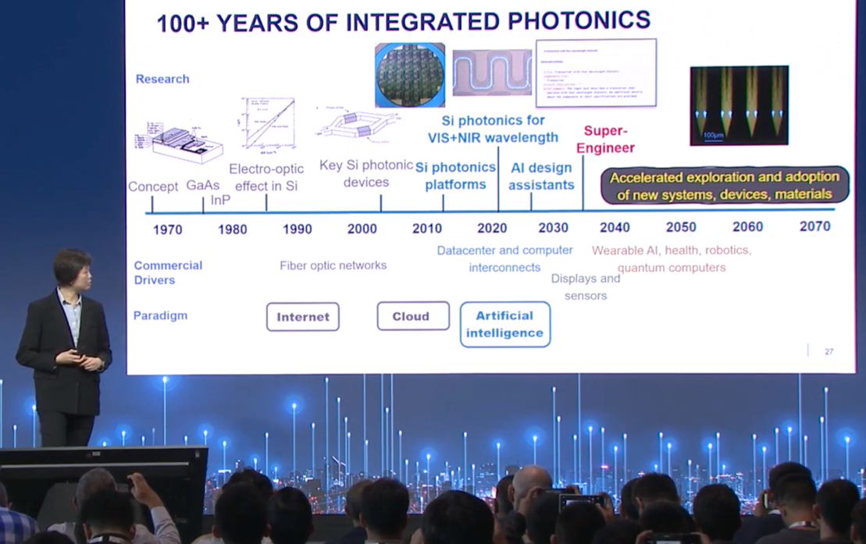
Source: ECOC
Poon concluded by looking out 50 years. AI will help engineers develop photonics designs before it achieves ‘super-engineer’ status. Such systems will develop optimal designs, automatically choosing the best mix of optics, chips and their packaging. What will ECOC then become? A gathering of ex-engineers reminiscing in scenic European locations?

OIF INterops and demonstrations
The OIF’s latest interoperability test involving coherent optical pluggable modules mimicking an optical ring connecting three “data centers” (implemented using hundreds of kilometers of spooled fiber).
Figure 3: The multi-span plug-fest hosted by the OIF showing 400ZR+ and 100ZR
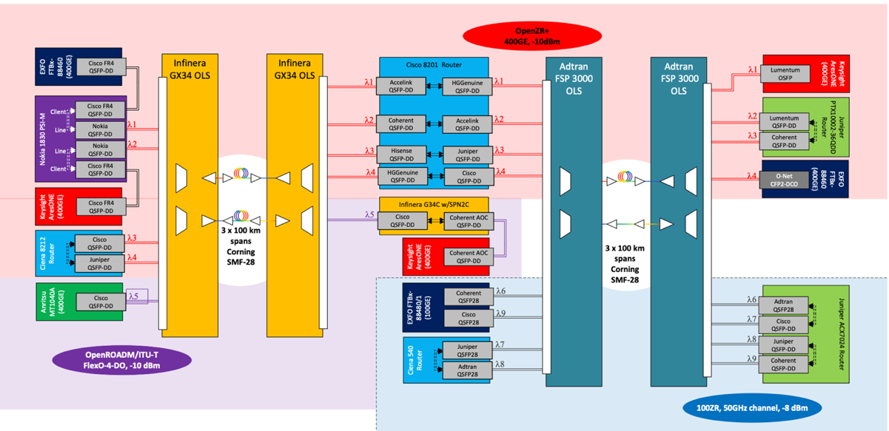
Source: OIF
The interop showcased the widest category of coherent pluggables including 100ZR coherent optics for the first time. Two of the sites were linked using 400ZR (75GHz channels) and 800ZR coherent pluggables (150GHz channels) over a single 100km span. The second data center connected to a third site over a multi-span 300km link using 400ZR+ optics implementing the OpenROADM and OpenZR+ MSA modes. The ring connectivity was completed with the third and first data centers linked by a 250km multi-span link using 400ZR+ OpenZR+ and 100ZR. Four companies – Adtran, Cisco, Coherent, and Juniper - provided QSFP28 100ZR pluggables. The coherent pluggable demonstrations used open line systems from Adtran and Infinera (see Figure 3).
Figure 4: A Synopsys 224Gb/s feeding a Applied Optoelectronics 1600G-DR8 LPO module
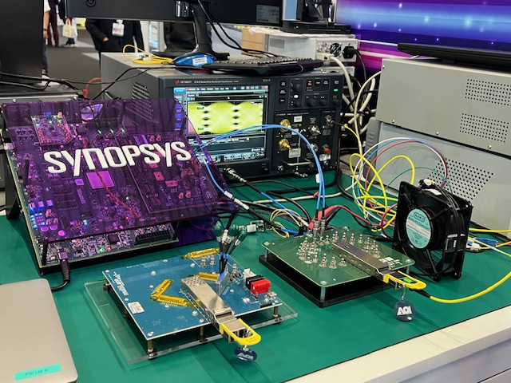
The OIF also showcased several 224Gb/s demonstrations.
One used 224Gb/s serdes over a mid-reach and long-reach copper link by feeding two types of copper cabling: direct-attached copper and active copper cabling (equalization but no retiming and no DSP).
The second demo involved a 224Gb/s serdes feeding a 1600G-DR8 linear pluggable optics (LPO) module over single-mode fiber. This was the first time the OIF has showcased 224Gb/s LPO.
Source: LightCounting

Coherent optics

Ciena’s WaveLogic 6 Extreme and Nano DSPs
Ciena demonstrated a working 1.6Tb/s WaveLogic 6 Extreme coherent modem. Ciena recently announced the first trial using the WaveLogic 6 Extreme which sent a 1.6Tb/s lambda over 470km in a live network. At ECOC, Ciena detailed two more performance metrics sending 1.6Tb/s between two data centers in Australia over 700km links that had different spans and ROADM counts. Ciena now has 23 customers for its WaveLogic 6 Extreme modem.
Ciena also detailed how its 3nm 1.6Tbps WaveLogic 6 Nano DSP will be used inside a data center implementing the OIF’s 800LR mode. Ciena highlights two modes as to what would be the first use of coherent (‘lite’) inside the data center. Figure 5 top uses the 1.6T WaveLogic 6 Nano delivering two 800LR to an OCS. The advantage of the coherent lite is countering optical loss but the design requires two fiber pairs. A bidirectional design (Figure 5 bottom) with a circulator reduces the two 800G signals to be implemented using a single fiber. Up to 6.4Tb/s can be fed into the OCS using eight O-band wavelengths and a multiplexer/demultiplexer, up to 8x the capacity per port. When Google unveiled its OCSes used in its data centers in 2022, it showed 200Gb/s wavelengths and a roadmap to 1.6Tb/s modules by 2024. With this design, a further quadrupling of capacity is possible.
Figure 5: First use of coherent light in the data center using Ciena’s 1.6T WaveLogic 6 Nano DSP
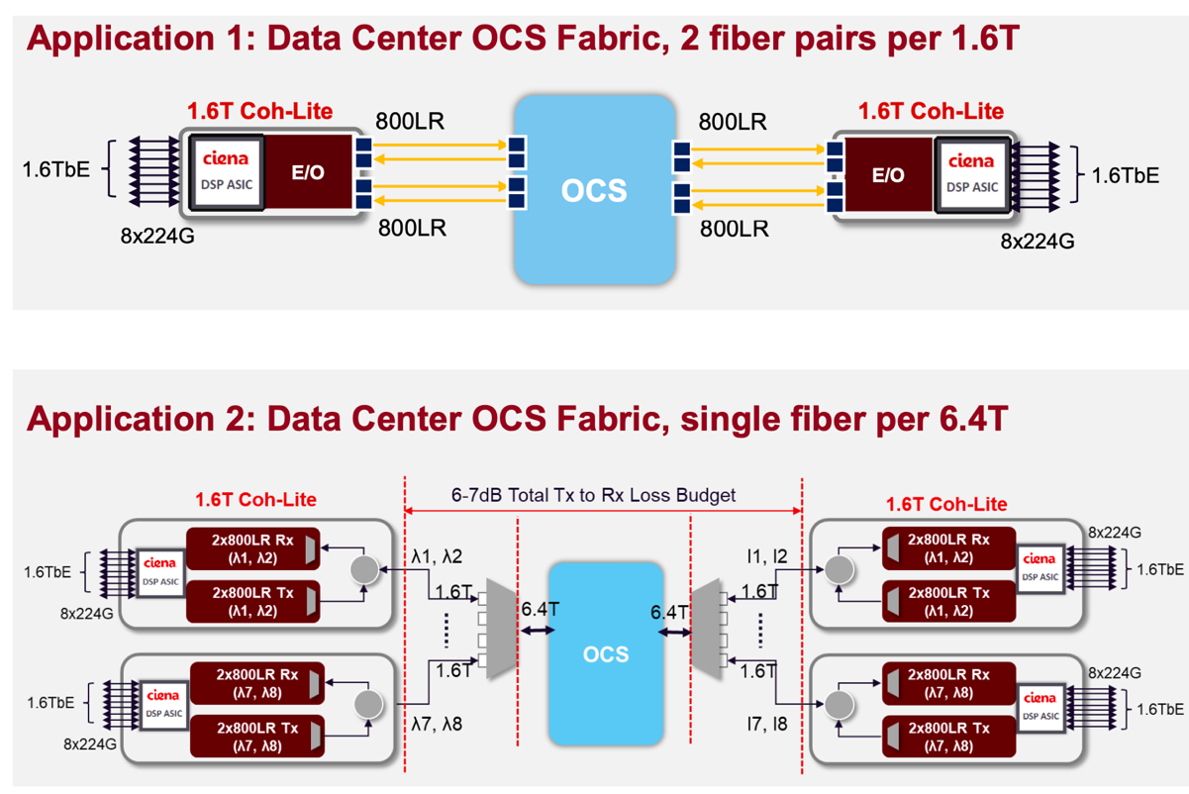
Source: Ciena
Two other coherent lite applications include linking data centers in a campus – a single 1.6Tb/s wavelength between buildings up to 20km apart and a WDM campus implementation for capacity links up to 25.6Tbps. The Nano 6 ASIC will be available before the year end.

Acacia’s 800ZR+ pluggable coherent module using the 4nm Delphi DSP
Acacia demonstrated its 800ZR+ OSFP pluggable module using its Delphi DSP implemented in a 4nm CMOS process. The module supports up to 131GBd and implements interoperable probabilistic constellation shaping. The Acacia module is available in C-band and L-band variants and also supports ultra long-haul reaches at 400Gb/s
Table 1: Comparison of the OIF’s various generations of ZR pluggables and the 1600ZR+

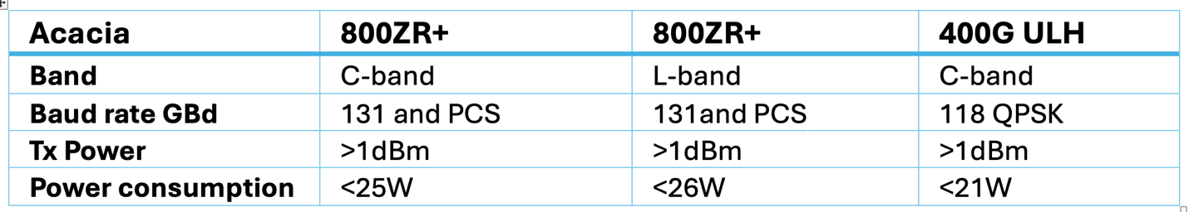
Source: Acacia

800Zr+ interop and an L-band version
Just before ECOC, Coherent, Lumentum, and Marvell detailed an interop between their 800ZR+ modules. Using the oFEC forward error correction scheme and 118 GBd, a distance of 520km was achieved. Using a higher baud rate – 124GBd and probabilistic constellation shaping (PCS) - the 800G transmission distance doubled to 1,040km. Coherent also announced 800ZR/ZR+ transceivers for the L-band at ECOC.

1600ZR/1600ZR+ coherent pluggable interfaces
The OIF’s work on the next generations of coherent pluggables – the 1600ZR and 1600ZR+ - is taking shape. The 1600ZR is the follow-on of the 800ZR module. The 1600ZR will carry 1600 gigabits of data over a 120km span. The module will use a single carrier with a symbol rate of 235GBd while the channel width will be 300GHz. The OIF is considering three schemes for the forward error correction (FEC): oFEC for the highest performance, cFEC, and the least powerful concatenated KP4 BCH scheme. The higher performance choice oFEC is favoured for 1600ZR+. The initial power consumption target for 1600ZR is 26W, but first products will likely consume several Watts more. Extrapolating Acacia’s power consumptions at 400ZR+ and 800ZR+ (see Table 1), 1600ZR+ is likely to be at least 31W.
Table 2: Comparison of the OIF’s various generations of ZR pluggables and the 1600ZR+
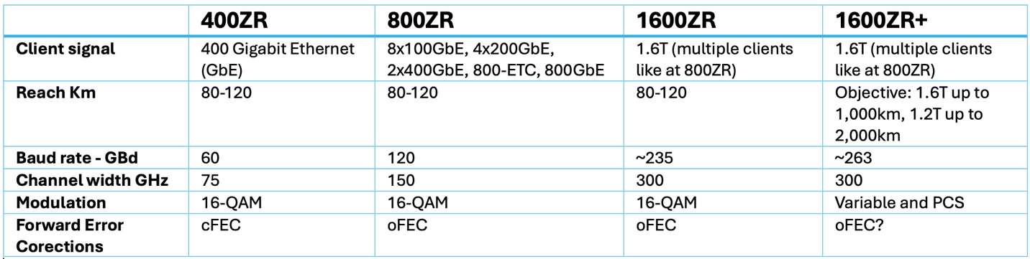
Source: LightCounting
The 1600ZR+ work is the first time the OIF is tackling a longer-reach coherent pluggable specification. The design aims to send 1,600 gigabits of traffic over 1,000km and 1,200 gigabits over 2,000km. The baud rate for 1600ZR+ is expected to be 263GBd. Two 1600ZR+ camps have emerged – one supporting a single carrier approach and the other, including a hyperscaler, wants to use four sub-carriers. The issue is equalization-enhanced phase noise (EEPN) that imposes a tighter constraint on the receive laser. Using sub-carriers, the laser constraints can be relaxed, enabling more suppliers. The single-carrier camp argues that sub-carriers complicate the coherent DSP design. LightCounting talked to several coherent DSP players that said implementing a DSP to support 1600ZR and 1600ZR+, including sub-carriers, is not a design issue. Meanwhile, the chosen probabilistic constellation shaping (PCS) scheme is still to be decided.
The specifications for the 1600ZR are on track to be completed in the first half of 2026, with the 1600ZR+ following in the second half of 2026. The first module products are expected in 2027 and perhaps 2028. This suggests a delay compared to the objective stated when the specification work started but then 1600ZR+ was always likely to take an extra quarter or two compared to previous, technologically simpler OIF ZR projects.

Rump session
This year’s Rump Session looked at whether quantum technologies are research hype or on track to be commercially successful. Quantum technologies promise to solve unique problems. To date, public and private source have invested tens of billions of dollars. Global investments now amount to $42 billion; the most significant investments being made by China at $15 billion, Germany $5.2 billion, the UK $4.3 billion and the US $3.75 billion. The Rump Session addressed whether quantum technologies would deliver on the hopes soon, yield returns on investment, and create what is heralded as the second quantum revolution.
Figure 6: The Rump Session tackling investments and returns from quantum technologies
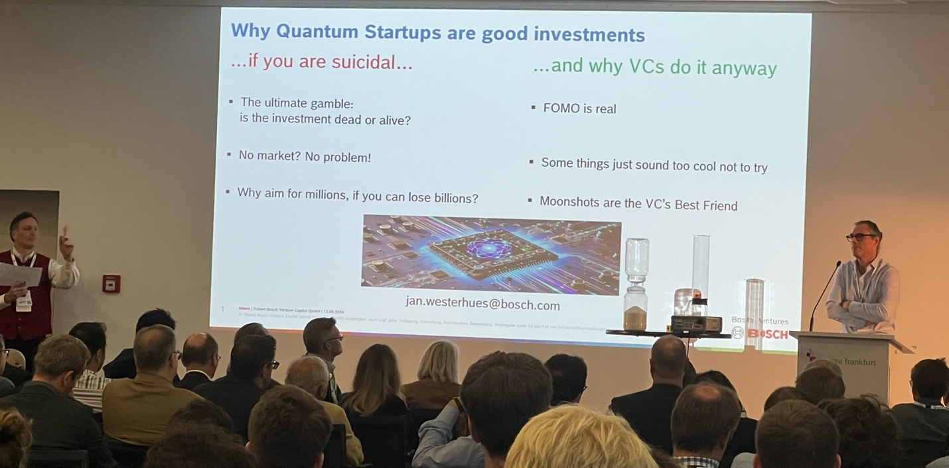
Source: LightCounting
Two topics were discussed: quantum technologies in information security and quantum technologies in advanced computing. Quantum computing was invented in 1980, and quantum key distribution (QKD) was discovered in 1984. Yet, after 40 years, there is no widespread deployment for quantum computing and QKD. There are 367 start-ups in the quantum ecosystem and even Nvidia has a quantum computing team.
A view expressed at the Rump Session is that it is essential to create realistic expectations aligned with investor goals. Practical quantum algorithms are also needed. The audience was skeptical about quantum computing. Only a small percentage of attendees believed in it, according to a quick poll.

448Gb/s interfaces
Figure 7: Keysight’s demonstrations of 448Gb/s interfaces
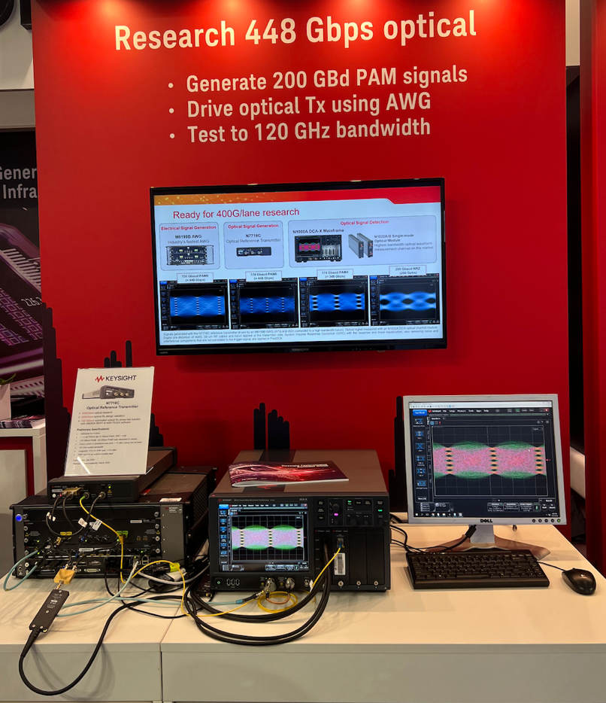
With 224Gb/s electrical and optical lanes for data center interfaces taking shape, attention is turning to the next doubling of speed: 448Gb/s electrical and optical lanes. The appropriate modulation formats for electrical and optical transmission channels is still an area of research but the options being considered are 150GBd PAM-8, 174GBd PAM-6, and 224GBd PAM-4.
At ECOC 2024, Keysight showed 448Gb/s using 150GBd PAM-8 and 174 GBd PAM-6 for the electrical and optical channels. The electrical setup consisted of Keysight’s M8199B arbitrary waveform generator (AWG), Keysight’s N1046A digital communication analyzer and HyperLabs’ HL9409 broadband balun. For the optical setup, the signals were generated using the N7718C reference transmitter driven by an M8199B AWG.
Source: Keysight

Workshops
Intra-Datacenter Connectivity Bottlenecks & trends for AI Clusters
This data center bottleneck workshop attracted over 250 people attendees. The workshop had two sessions: AI cluster architecture challenges and input-output (I/O) solutions for AI clusters.
Meta discussed AI cluster networks and explained how networking challenges grow with cluster size. The 400Gb/s (4x100Gb/s) links today are rapidly moving to 800Gb/s (4x 200Gb/s) links. Meta questioned whether linear pluggable optics is a solution to these network scaling challenges.
Future clusters to support one trillion parameter models will require larger scale-up networks. The Grand Telon rack supports 8 GPUs but what happens when the scale-up domain exceeds a single rack-cabled backplane? Copper cable links cost <$0.010/Gb/s and are more reliable than optical links while consume less power. Meta highlighted that optical innovations are required to make such scale-up domains. Co-packaged optics and integrated optics solutions will need to be investigated to meet such challenges. Meta reported that hardware failures dominate its AI clusters: 71 percent of interruptions are hardware based. Meta has seen its fair share of failures given the firm is an early technology adopter.
Formerica OptoElectronics discussed immersion cooling challenges and solutions. The challenges of immersion cooling include mindset - do you want to put “what” in “where”, material compatibility issues, signal integrity, reliability/ availability/ manufacturability/ safety and warranty. Multiple Open Compute Project (OCP) workstreams are addressing these challenges, including testing, validation, standardization, and certification. Signal integrity is critical for immersion cooling as are sealed optical cables.
Huawei, discussed distributed AI cluster architectures and the role of I/O. The company discussed scaling law vs. Moore’s law and how AI models are outgrowing CMOS process node benefits: computational power demand increased by 3,000x while a single GPU card's computational power increased by 8x only. Therefore, larger-scale DC clusters are needed. Huawei discussed the limitations of super-scale AI factories (> two years to build a new AI factory and powering it) while distributed data centers can use existing smaller data centers, each requiring less power. The future challenges for distributing workloads and their I/O must focus on bandwidth, latency, and reliability.
Broadcom discussed linear and co-packaged optics for AI networks. Power efficiency estimates were provided for 200Gb/s per lane. Co-packaged optics doesn’t suffer from excess electrical insertion loss (<=10dB), provides the highest density, and highest power efficiency of 4-5 pJ/bit.
Broadcom also announced the general availability of its Sian2 200G/lane PAM-4 DSP. Sian2 features 4x200G/ electrical and optical lanes one year on from the Sian DSP that supports 100Gb/s electrical and 200Gb/s optical interfaces. The Sian2 DSP enable fewer lane 1600G pluggable modules (two DSPs used per transceiver) and given 200G/lane interfaces are foundational for AI clusters. At ECOC, Broadcom’s Sian2 DSP inside 1600G optical modules were demonstrated by Innolight and Eoptolink.
Figure 8: The Sian2 halves the electrical lanes needed for 1600G optical transceivers
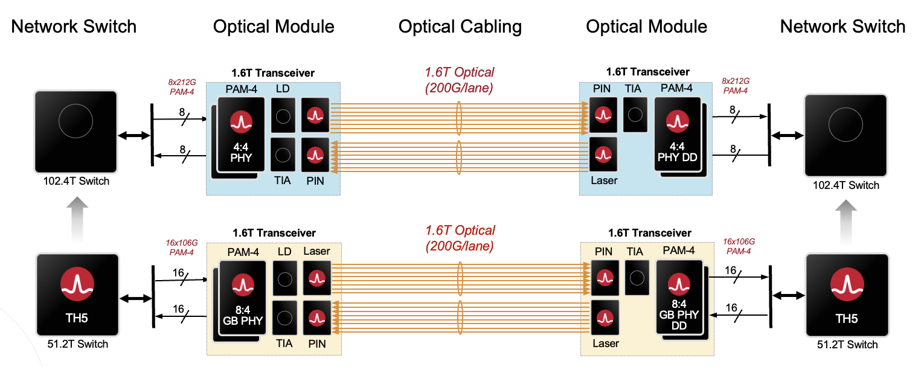
Source: Broadcom
Coherent discussed VCSELs and the prospects of 200G/lane multi-mode links. Coherent highlighted that VCSEL-based co-packaged optics is an excellent alternative for short-reach systems. Here, no external laser modules are required, and no polarization maintaining fiber is needed. Communication and DSP techniques will help make next-generation VCSEL links viable.

Overhyped or the Real Deal: Which Photonics Integration Platform Will Lead the Way?
Another workshop addressed two key issues:
- When will the long-anticipated mass adoption of PICs happen?
- Which integration platform and what functionality are needed?
The workshop also discussed the platform and component availability and noted that while substrate size lowers cost, high volumes are needed.
imec presented its lithium niobate integration/ electronics/ wafer level optical integration platform (OI). Its silicon photonics iSiPP platform supports up to 200G/lane optics. There is also ongoing laser integration work using flip-chip and micro-transfer printing approaches. The discussion address 400G/lane, 250GBd coherent transceivers. imec says it is fundamentally challenging to scale silicon photonics modulators far beyond a 50GHz analogue bandwidth while maintaining reasonable drive voltage and losses. imec is proceeding with micro-transfer printing of thin-film lithium niobate modulators on its 200mmiSiPP200 (N) platform focusing on yield optimization, array printing, and reliability.
Global Foundries says that its GF Fotonix silicon photonics platform offers a suite of advanced photonic devices, including enhanced silicon nitride devices, dense WDM ring filters, 56GbBd photodetectors and modulators. There are also 112GBd versions in development as well as a 127µm-pitch passive V-groove fiber attach. Future directions are focused on connectorized (detachable) broadband fiber attach, novel materials, and 3D integration solutions.
Smart Photonics, a photonic semiconductor pure-play indium phosphide foundry, described how the material is a mature platform that enables complex PIC designs. Indium phosphide enables monolithic integration of all the key functionalities: lasers, amplifiers, and high-speed efficient modulators. It is an enabler for low-cost integrated circuits. The target markets for the platform include C-band coherent pluggables and applications for O-band such as high-speed PON, 400G/800G applications, and the External Laser Small Form Pluggable (ELSFP) for factor. Micro-transfer printing provides the simultaneous transfer of multiple coupons from the InP wafer to the target SiPh wafer, solving heterogeneous integration for high volumes. The EU supply chain for micro-transfer printing is critical in providing such a path to high-volume manufacturing.
Start-up OpenLight provided its perspective with its commercial heterogeneous integration platform. Using heterogenous Integration, the Indium Phosphide (inP) based lasers, EAM, and all other active components are bonded onto the silicon as part of the integrated photonics chip. OpenLight presented 1.6T PIC architecture for two variants: 1600G-DR8 and 1600G 2xFR4. These platforms help achieve efficiency levels better than 3 pJ/bit for datacenters, compared to today’s modules at greater than 5 pJ/bit. The platforms also provide a path to scale to 400G/s channel for 3.2Tb/s and beyond.
Figure 9: OpenLight’s heterogenoous silicon photonics integration platform
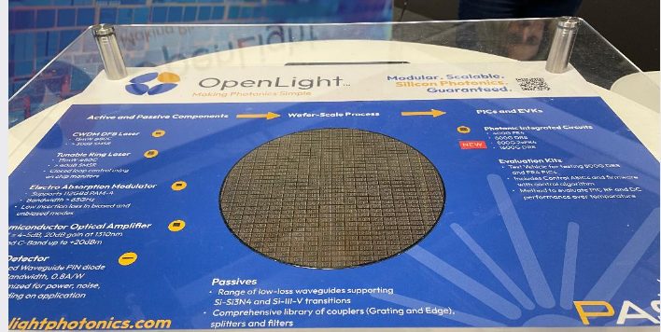
Source: OpenLight
Lumiphase detailed its work on barium titanate-enhanced photonics, which promises to boost silicon photonics with next-generation modulator performance. Barium titanium oxide is an extremely efficient electro-optical “Pockels” crystal and provides the largest electro-optical effect on silicon.
Barium titanate’s merits include high efficiency, high speed, compact footprint, high reliability, and volume-scale integration. Lumiphase says that a 200mm production flow on the silicon photonic platform exists, and the first qualified product on the market is planned for the first half of 2026 for 400G/lambda direct detect and 1.6Tb/s coherent application.
The workshop’s panel discussion asked the audience what the biggest hurdles for using a heterogeneous platform listing such factors as a lack of second sourcing, a perceived lack of yield, price, performance. The largest problem, said the audience, is a lack of yield, photonic performance, and packaging. The audience also listed its priorities: top of the list is performance followed by volumes, manufacturability, and the supply chain.

Massively Parallel Optical Transceivers and Interfaces
Another workshop addressed massively parallel optics was split between short-reach optics and coherent. In the shott reach session, industry veteran and advisor at start-up Quintessent, Chris Cole, called for a new higher density optical form factor. Current pluggable optics have stunted optical innovation for the last decade, he argued. One limitation is the large-sized, limited number of gold-finger interconnects on the edge of the printed circuit board (PCB) that fits inside pluggable module. Another issue is heat dissipation.
Cole is promoting the idea of a new pluggable form factor that will support significantly more electrical and optical channels. He proposed some specifications for what the module could look like: 256 electrical lanes each up to 448Gbps and as many or more optical lanes to support 12Tb/s, 25.6Tb/s and even higher capacities. The module should also support a 100W power consumption. Cole working with other interested parties on the proposed form factor plan to pitch their proposal to the OIF in November. “I’m very optimistic it will be approved,” said Cole.

NewPhotonics and Softbank ink AI RAn deal
NewPhotonics announced at ECOC that it was signed an agreement with Softbank, the Japanese communications service provider, to provide photonics technology to develop solutions for AI-RAN. The AI-RAN initiative, of which Softbank is a founding member, plans to use AI hardware to implement and improve the performance of radio access networks (RANs) while using the AI hardware for new services to grow operators’ revenues.
Figure 10: NewPhotonics provides optics for 1600G optical transceivers including enhanced LPO
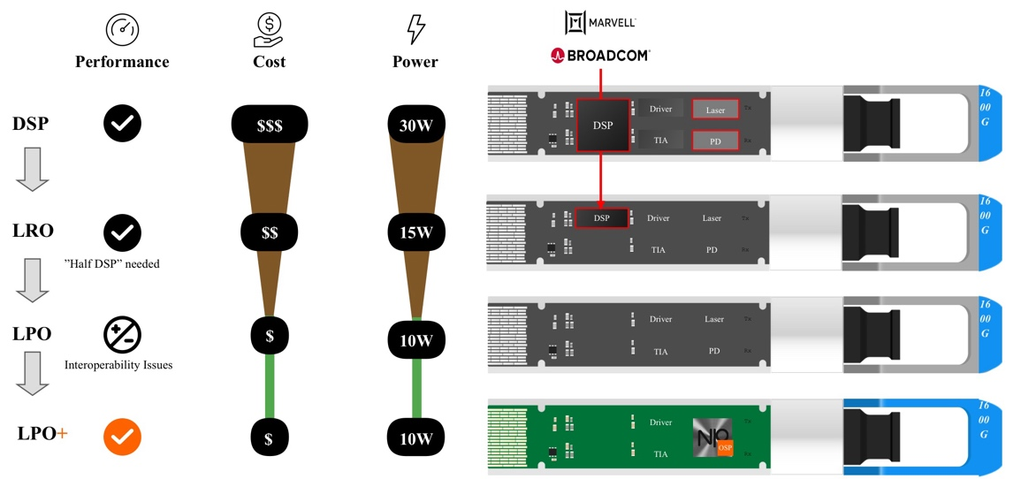
Source: NewPhotonics
Softbank selected NeoPhotonics for its LPO optics and will work with the company to develop co-packaged optics and all-optics switch technology. Softbank needs speed, reach, and low latency optics. NewPhotonics’ optical signal processing-based technology supports 224Gb/s lanes for 1600G DSP- and LPO-based pluggable transceivers. The company has demonstrated a reach of 30km for its optics and has a roadmap to higher channel speeds. NewPhotonics has also developed a scheme whereby the optical receiver communicates with the transmitter in-band so that the optical signal processing can adapt to the link. This, says NewPhotonics, improves link budget performance and addresses the concern of interoperability associated with LPO at 224Gb/s.
Thermal management & Liquid Cooling
An industry trend is towards higher bandwidth and power density of pluggable optical modules. The latest generation of 800 ZR+ QSFP-DD/OSFP modules dissipate between 25-35W while the 1600ZR+ QSFP-DD/OSFP will likely dissipate between 30-35W. Traditional air-cooling systems are not sufficient.
Figure 11: A liquid-cooled 400G OSFP demo
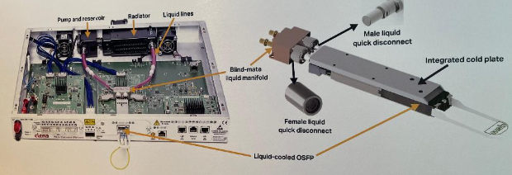
Source: Ciena
Ciena demonstrated hybrid liquid-air cooling. The hybrid system uses liquid cooling for high-power devices, such as ASICs and high-power modules while low-power components are air-cooled at low fan speeds. Compared to air cooling, a hybrid cooling system advantages include a 70% reduction in facility cooling power, an 80% reduction in fan power, and a 15dBA reduction in fan acoustic noise.
Hybrid cooling also provides the ability to achieve higher power density, higher receptacle port density, and higher cooling performance. Liquid cooling of Ciena’s demo was based on Cold Plate technology. The proprietary integrated liquid solution dissipates over 80W instead of 30W using air cooling.
Figure 12: DustPhotonics’ silicon photonics chip in the Eoptolink transceiver module
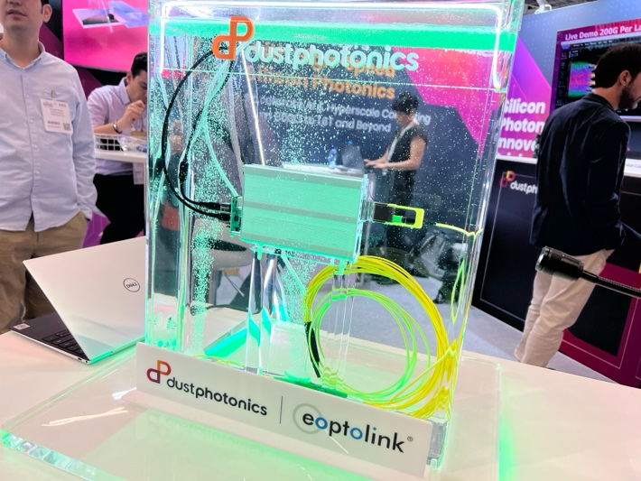
Source: Dustphotonics
Immersion cooling is a promising technology for power management in next-generation data centers. Immersion cooling has challenges, such as materials breaking in the liquid environment or different indexes of refraction of air and liquid, which is important for free space optics. DustPhotonics demonstrated the compatibility of its PIC with immersion cooling earlier this year at OFC 2024. At ECOC, DustPhotonics’ chip was integrated into the Eoptolink transceiver module, showing its silicon photonics products working with immersion cooling at 800G and 1.6T.

ECOC Post-deadline PAPERs
Nokia Bell Labs demonstrated a wavelength division multiplexing (WDM) concept using demultiplexer-free frequency combs at the transmitter and receiver in a four wavelength 200GHz grid WDM system with flexible symbol rates that aimes to avoid the power-hungry wavelength control at the demultiplexers.
Aloe Semiconductor, Chris Doerr’s start-up, the University of Central Florida, NTT Innovative Devices Corporation and Sumitomo Electric Device Innovations presented a dual-polarization direct detect system that multiplexes two polarizations in an EML-based transmitter assembly while demultiplexing in a silicon photonics integrated receiver. A novel polarization recovery algorithm is key to enabling the fast and robust polarization tracking. Eoptolink demonstrated Aloe’s technology delivering 448Gb/s per optical lane.
In another paper, Y. Xiong et al. reported the first field-deployed hollow-core optical fiber cable with a lower loss than solid-core fibers. The 9.4km deployed cable shows an average loss of 0.13/ 0.11dB/km when the two self-splice losses are included/ excluded. See Figure 13.
Figure 13: The first field-deployed HCF cable with a lower loss than solid-core fibre

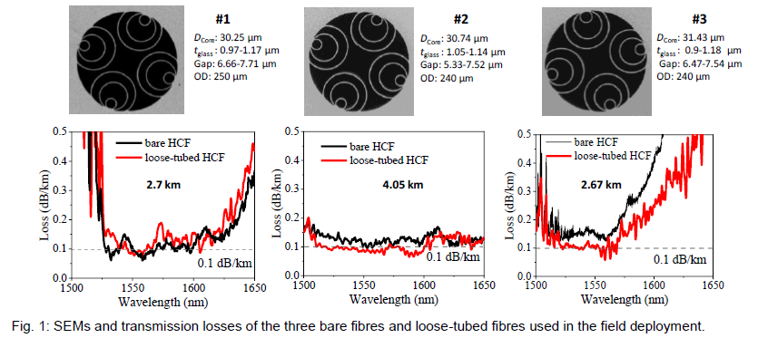
NTT, Sumitomo Electric Industries, and Chiba Institute Technology, Japan, demonstrated 4.65THz WDM/ SDM transmission of 140GBd PS-QAM signals over a field-installed 12-coupled-core fiber cable with standard cladding diameter, achieving a record 0.455Pb/s coupled-core capacity in a field environment. They also demonstrated 0.389Pb/s over 1,000 km transmission of spatial MIMO channels with greater than 12Tb/s/wavelength net bitrate (see Figure 14).
Figure 14: Bitrate for the first demonstration of field-installed 12CCF transmission with >12 Tb/s spatial MIMO channels

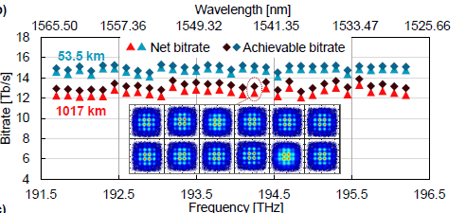
Such results support the feasibility of a future SDM deployments with sub-petabit-class total capacity and 10Tb/s-class channel capacity.

