ECOC 2024: An industry’s urgency to push and explore

October 8th, 2024

Summary
Call it the AI effect. The impression at this year’s European Conference on Optical Communications (ECOC) is of an industry pushing technologies with all options on the table.
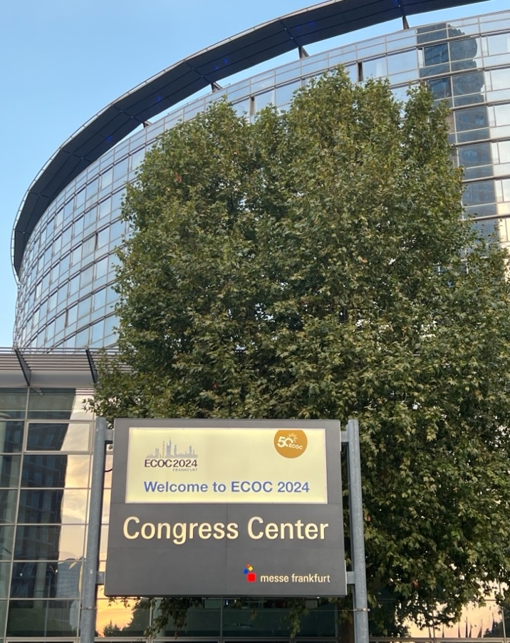
Whether it is electrical signals or optical, copper or optical interconnect, chips or PICs, this is an industry eager to enable new speed hikes – 1,600 gigabit per second (Gb/s) modules were evident at the show while 1.6 terabit coherent transport is starting.
There were also developments for 224Gb/s and 448Gb/s electrical and optical lanes, while a new form factor supporting 12.8 terabit, 25.6 terabit and more is being mooted. There was also a first example of coherent optics – albeit ‘lite’ - inside the data center. And talk of more parallelism continued, whether it is multi-core fiber or multi-carrier coherent optics.
What is driving the sense of urgency? The demands for higher-speed interconnects to help scale up and scale out AI systems. The onus on the optical industry is to keep strict hold of power consumption. Computational silicon is making huge demands on power such that the optics must do all it can not to further burden the power consumption. Arista’s Andy Bechtolsheim’s ECOC plenary session talk address this (discussed below).
This is an exciting time for optics. The hyperscalers with their AI needs are driving industry innovation. These developments will serve the industry whatever happens overall with AI in the coming years.
This year marked the 50th anniversary of ECOC with the event taking place in Frankfurt from September 22-26. The first European conference, held in London in 1975, focused on optical fiber communications. The inaugural ECOC attracted 74 conference papers totaling 224 pages. Fifty years on, the conference proceedings have grown to 2,000 pages and the event attracted over 1,800 participants.
Below is LightCounting’s coverage of key announcements at the show. We do not claim this is a comprehensive list of all the important technology announcements made at ECOC.

