 | Wessex News  November 2023

Hello Group

Car News
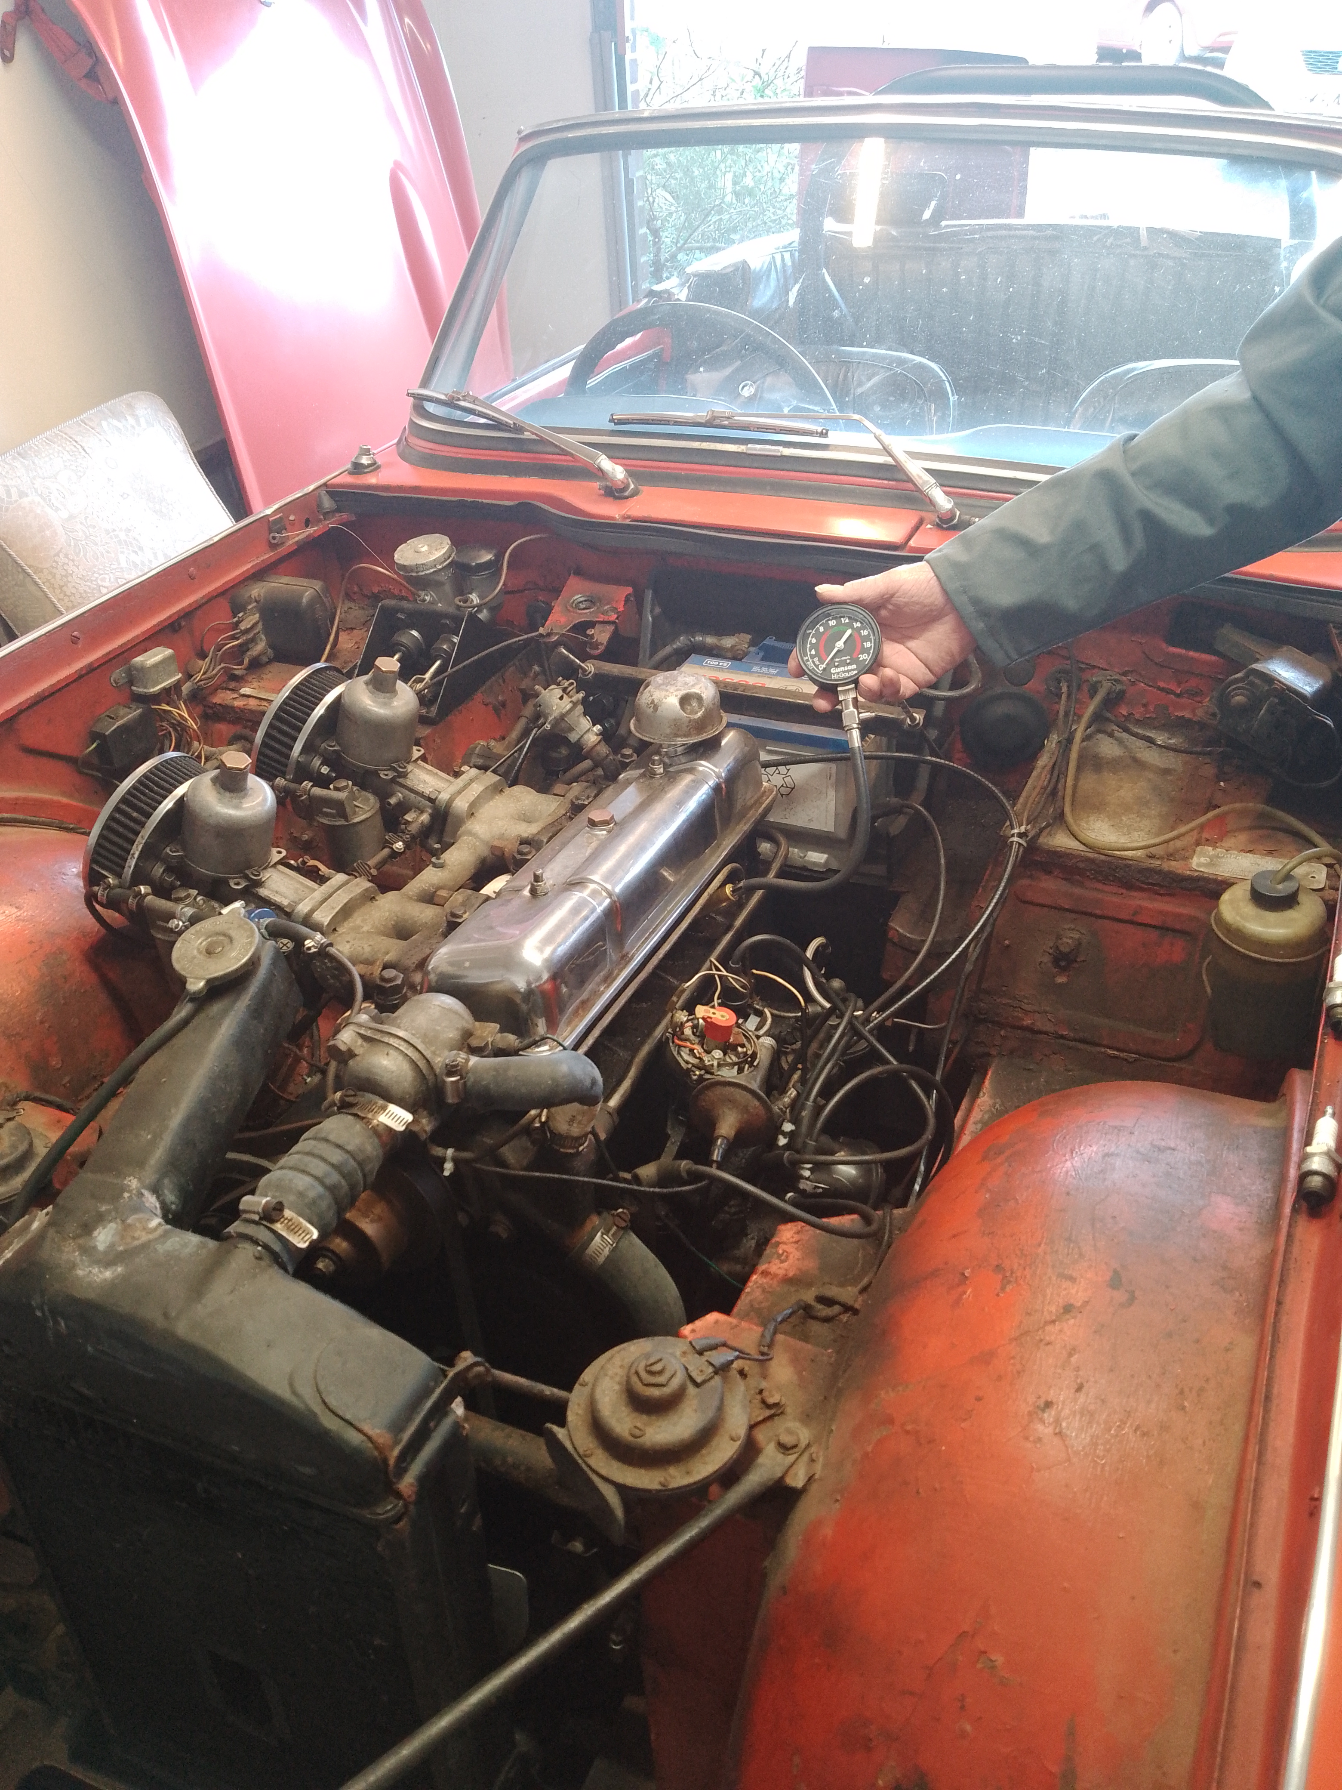
I have been working on disassembling my ‘4, in the hope I can put it back together again later! As you may recall, my poor old car looks like it has been dragged out of the sea, but nonetheless had continued to run pretty well during my 30 years of ownership. However, time has now caught up with it and there are two pressing faults: the rust in the rear wings and failing gearbox layshaft bearings. The plan is to remove the wings for repair, and to extract the engine and gearbox. My thanks to Julian (pictured) for good advice and performing a compression test which noted that one of the cylinders was down. We removed the bonnet and boot, and since then I have removed the rear bumpers, seats, hood frame, trim and rear lights. Some of this was easy, some of this was the predictable struggle. However, this pales into insignificance in trying to remove the rears wings. Access to the wing spire bolts is very limited, but hopefully the purchase of a “swivel end ring spanner” and more dousing in Plus-Gas will see me through. More next issue – Hopefully!

Inter-Club General Knowledge Quiz with MGOC - Thursday 16th November
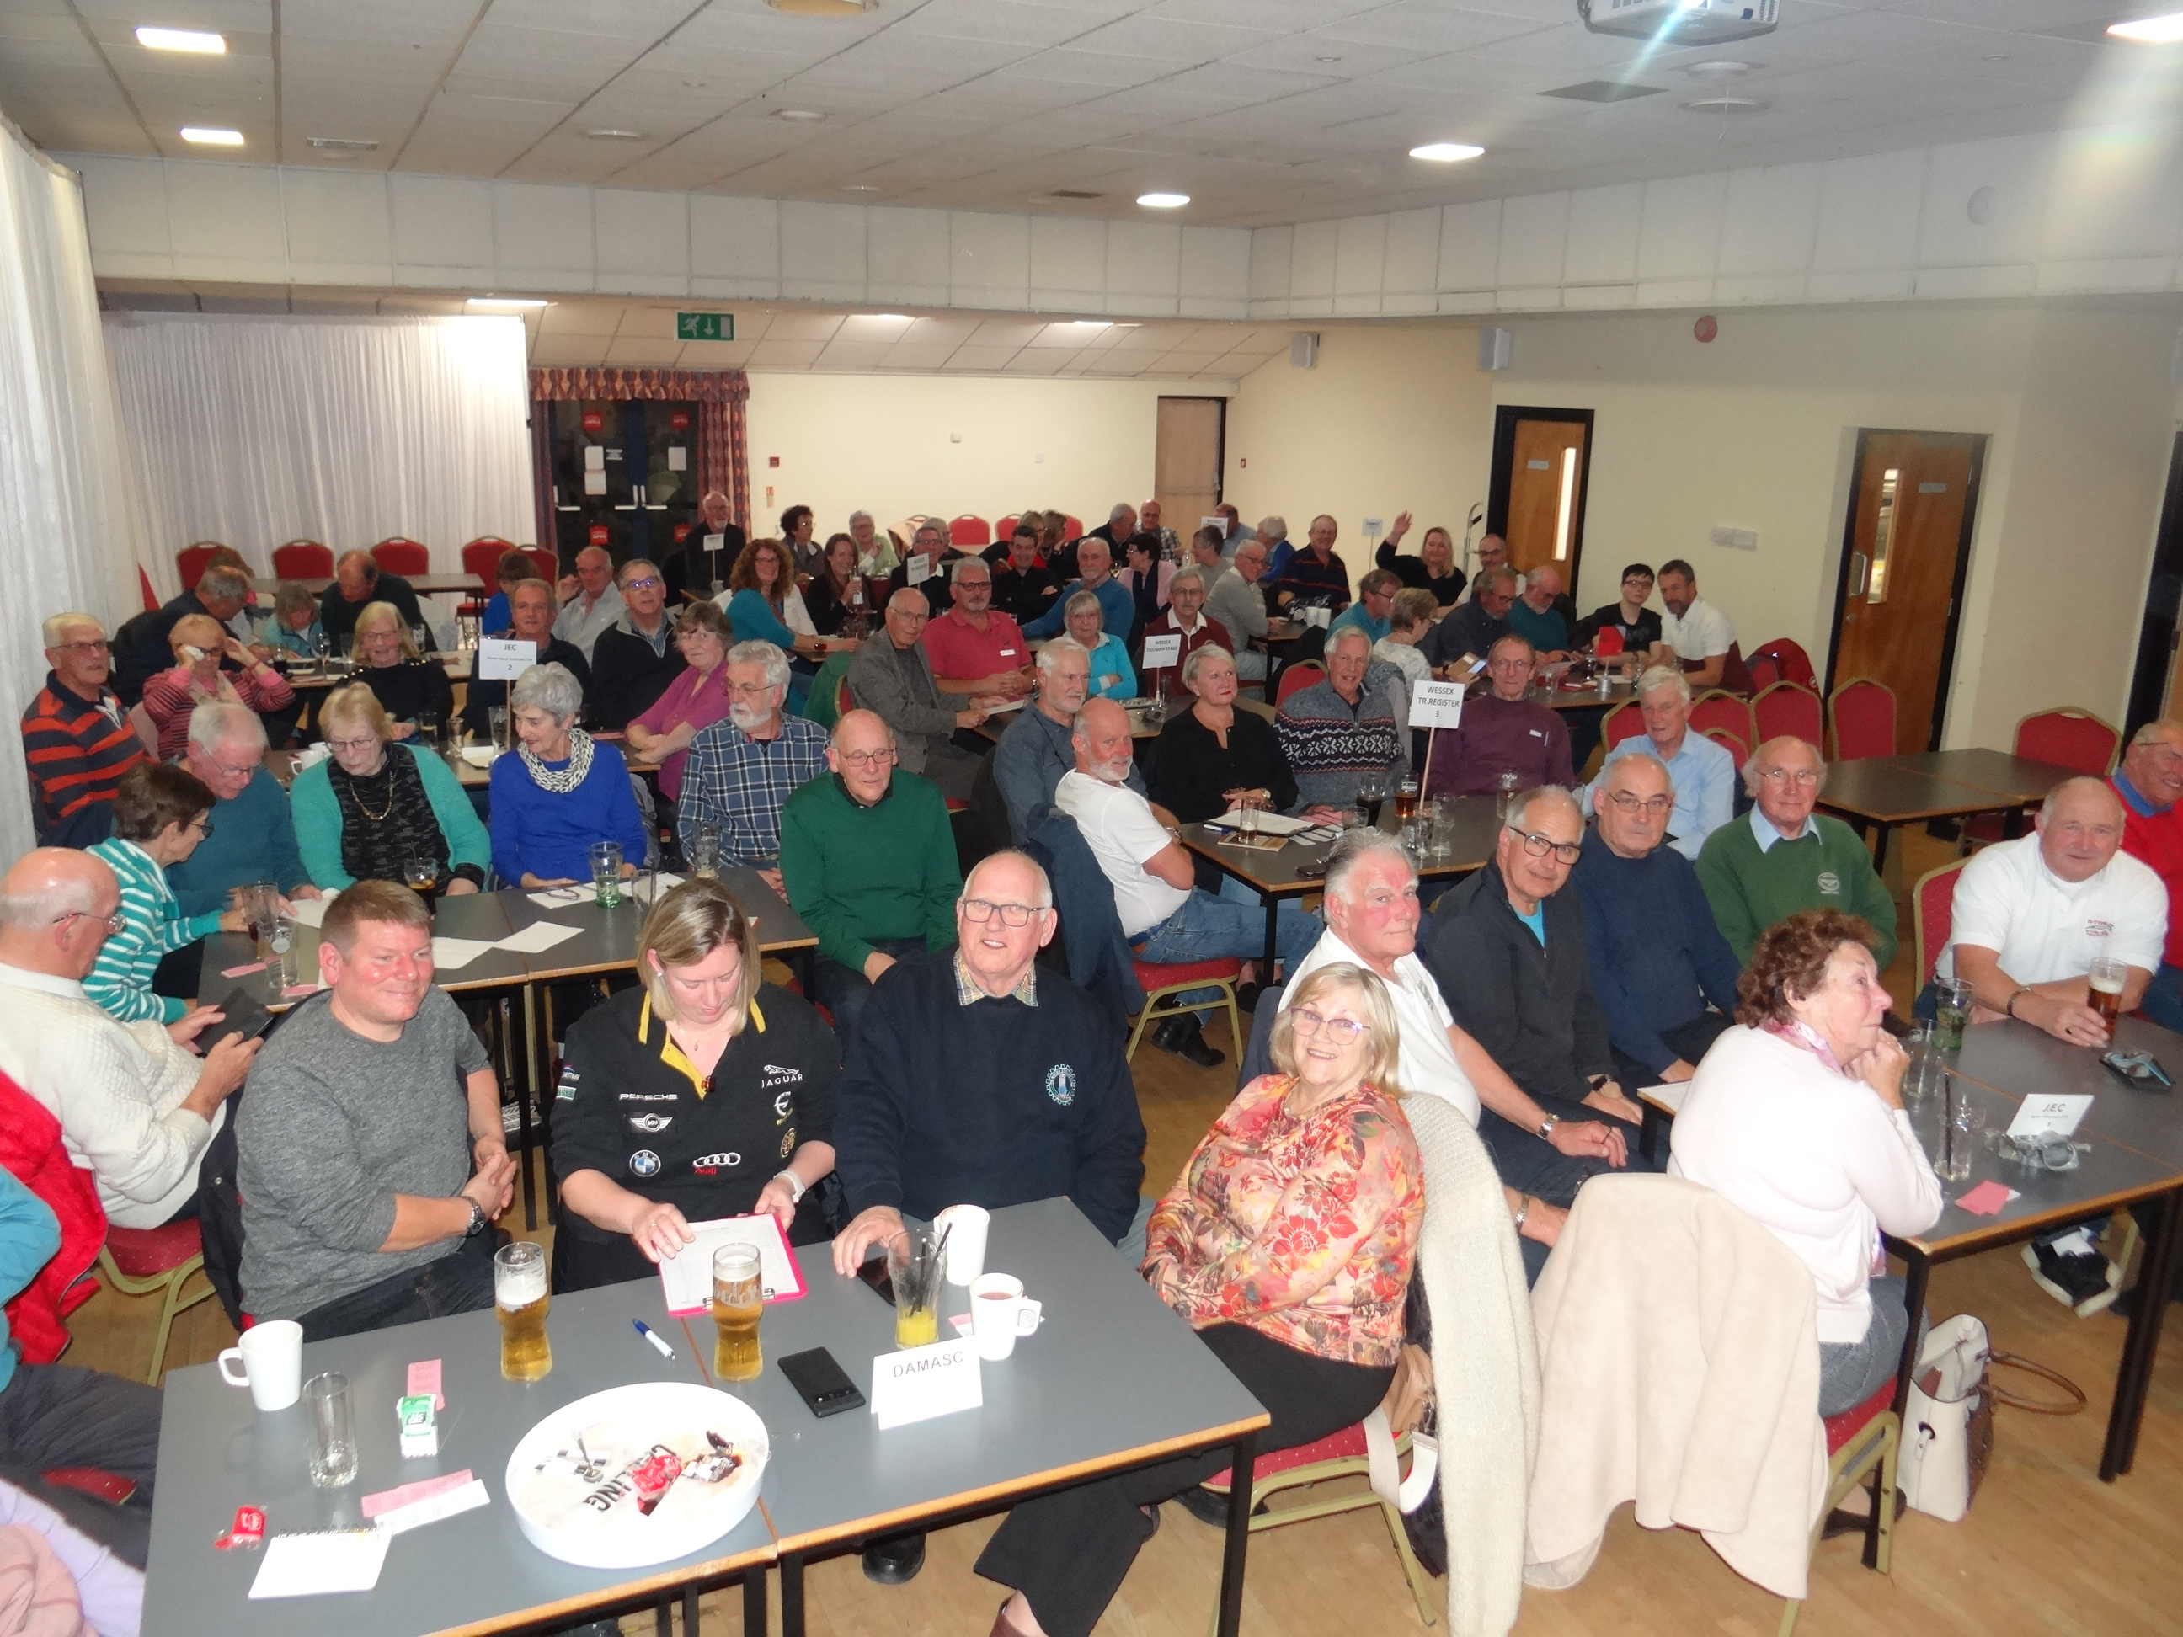
An enjoyable event with a very good turn out but questions very hard! We are on each others mailing lists now and may very well do further events in the future.



WhatsApp

This continues to be well used. As ever, we encourage you to join. Follow this link and Jasper will accept you to the group.

https://chat.whatsapp.com/Crmu6QvABgF2oqO63KkOjp

Classifieds - Please submit any For Sale or Wanted items to the Editor.

Nothing this month.

Future Events
The Christmas Dinner is the December club night, the International is at the end of June in Malvern. Hopefully Neil's January quiz will be easier than the MGOC one!

Diary
November Club Night | 28th November – Noggin and Natter
Christmas Dinner | 9thDecember, The White Buck - Jasper
2024
January Club Night | 23rd January (5 Tuesdays in January) – Quiz
February Club Night | 27th February -Skittles (venue to be finalised)
March Club Run | Seven Stars near Petersfield (tbc)
March Club Night | 26th March – Talk (tbc)
TR International 2024 ! | 28-30th June, Malvern

Why not come and Join us on the Committee? Have you got a run of your own, or know of a destination you would like us to explore? Have you got any interesting TR stories, or photographs you would like to share? Perhaps your story could feature in our next Newsletter, or one of your photos in the next calendar, send them in! Share your technical information and your mechanical know-how. We’re always looking for new people to join the committee to bring new ideas, so why not give it a go — you might enjoy it!

Come and have a chat at Club Night, or drop Neil an e-mail if you’d like to know a little more.

Contact Information
E-mail: wessexgroupleader@gmail.com | (Not manned 24/7!)
Neil Reynolds - Group Leader | 07850-391941
Jasper Small - Membership Secretary | 07802-679178
Keith Boniface | 07923-653044
Richard Nevines - Regalia | 07836 256868
Nigel Jordon – Treasurer
Adrian Jefferies – Editor | adrian.jefferies@rocketmail.com

