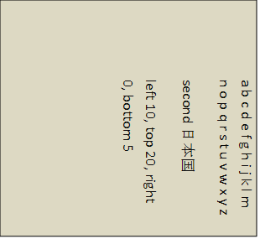
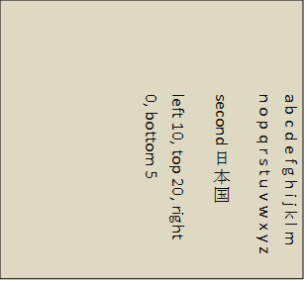
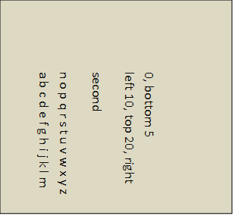
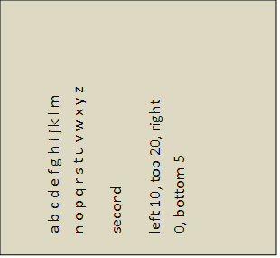
Dummy
a b c d e f g h i j k l m n o p q r s t u v w x y z
second 日本国
left 10, top 20, right 0, bottom 5
a b c d e f g h i j k l m n o p q r s t u v w x y z
second 日本国
left 10, top 20, right 0, bottom 5
a b c d e f g h i j k l m n o p q r s t u v w x y z
second
left 10, top 20, right 0, bottom 5
a b c d e f g h i j k l m n o p q r s t u v w x y z
second
left 10, top 20, right 0, bottom 5

