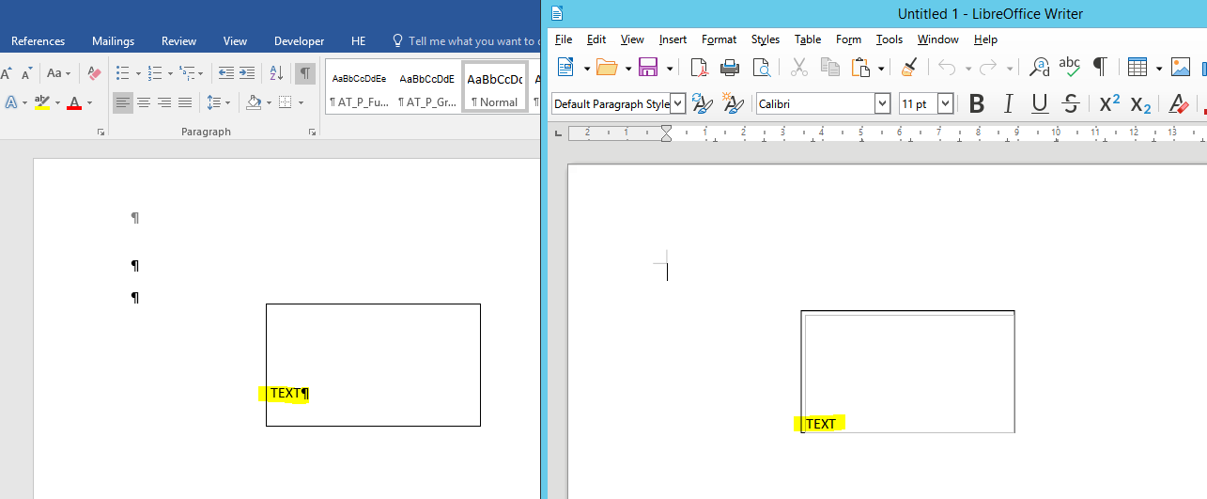

Description:
- Insert a Text Box in a Word document.
- Insert any text into the Word Text Box.
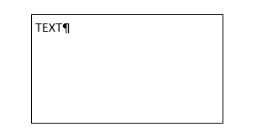
- Change the Spacing After of the paragraph of the text, e.g. Spacing After = 10pt
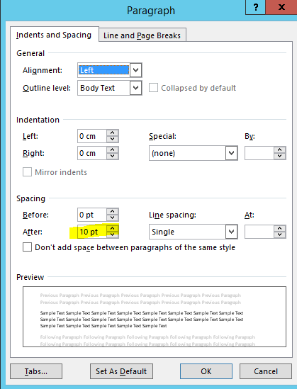
- Change the Vertical alignment of the text box to Bottom
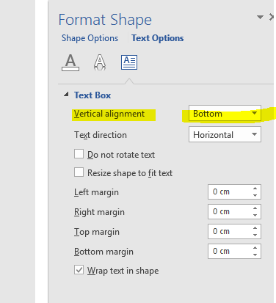
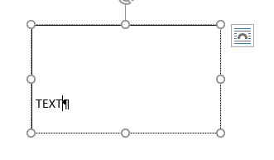
- If you open this document in Libre Office, you can see that the vertical position of the text is different.

REASON: The Spacing After of the paragraph is not considered in Libre Office.

