Original document was created and edited in Microsoft Word with Track Changes enabled, then all changes were saved. After that the document was opened in LibreOffice Writer.
Single item and some text in another items are removed
Word
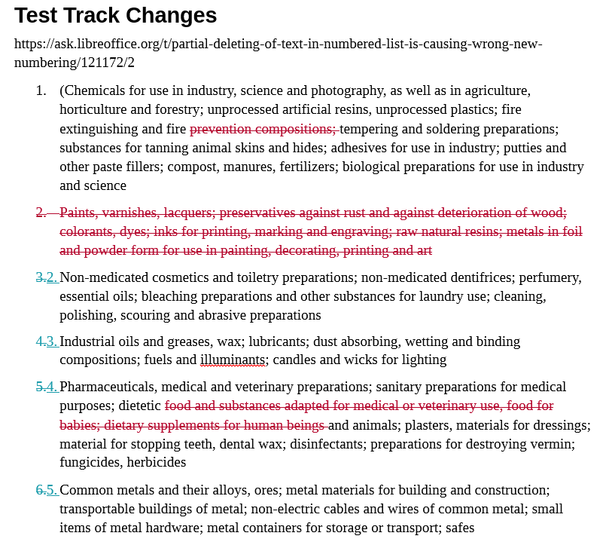

LibreOffice Writer
