Test for 3D borders
All borders are in 3pt. Border color is #FFC000.
Border Box Style 1 = single
Border Box Style 21
left, top: threeDEmboss,
right, bottom:threeDEngrave
Border 3D Style 21
left, top, right, bottom: threeDEmboss
The following style has set w:frame="true" directly in file markup.
Border 3D Style 21 frame ON
left, top, right, bottom:threeDEmboss
right, bottom: w:frame="true"

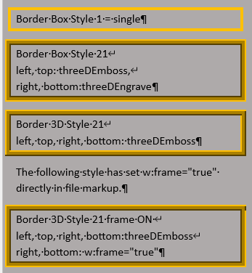
Screenshot Word 365

