Objectifs

Aperçu de z/OS
Aperçu de JES2
Flux des travaux dans JES2 Syntax et conventions
Aperçu de SDSF
Démonstration de SDSF

OS/390 Overview
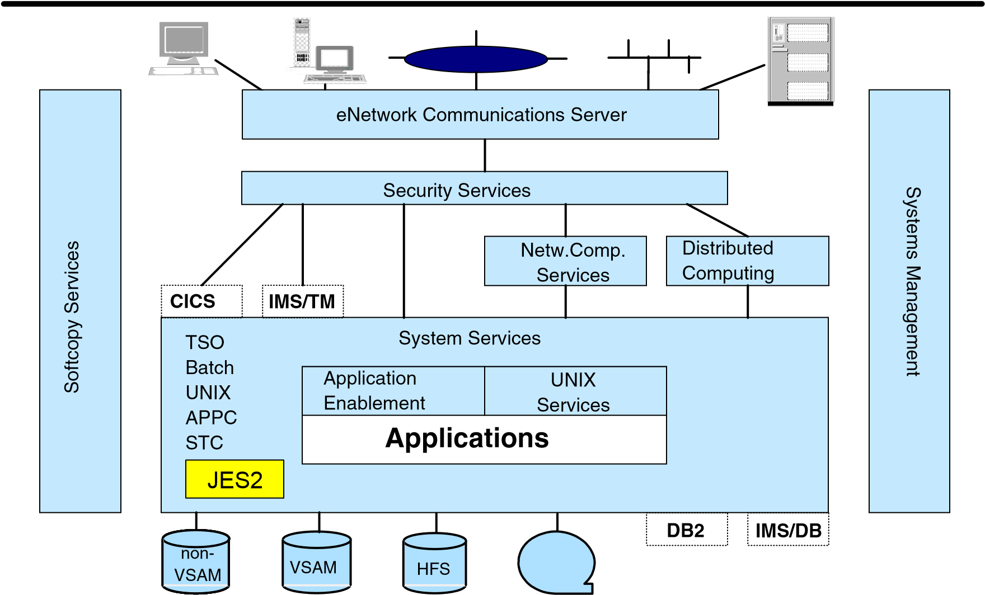
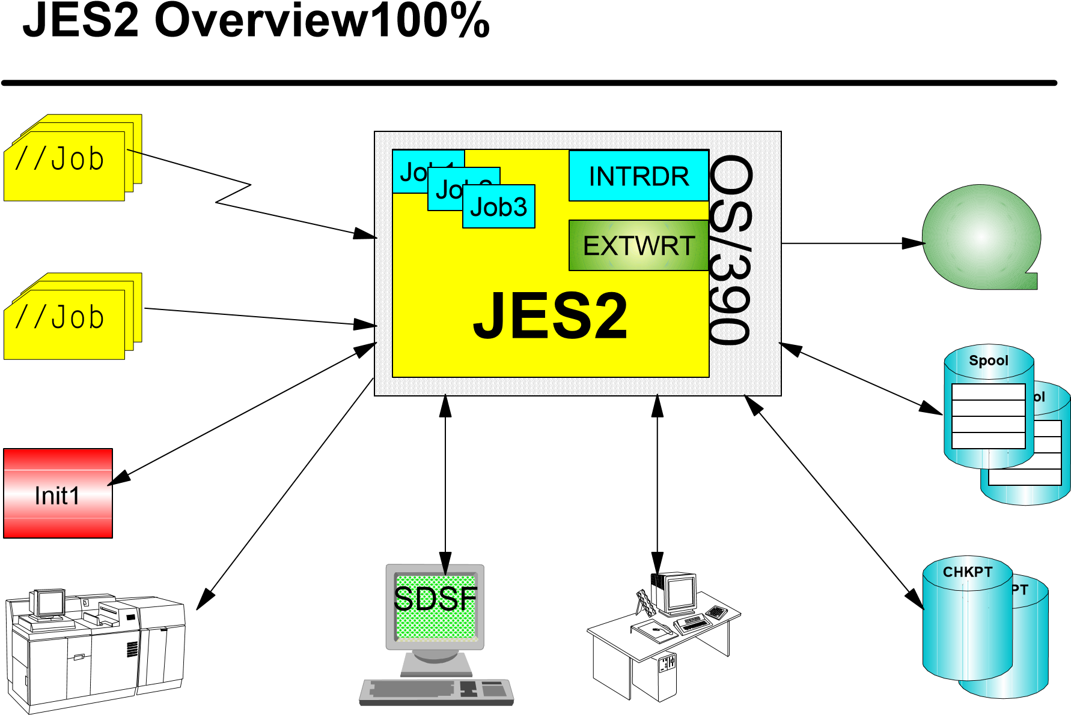

Creation of an Address Space
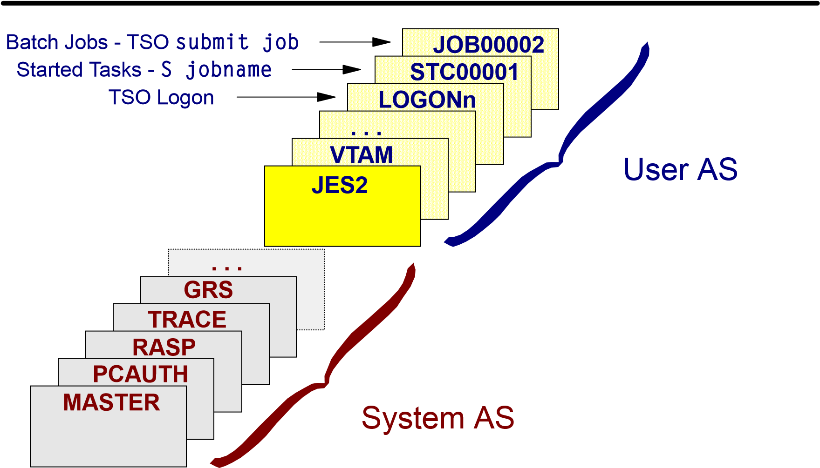

JES2 Job Flow 1 - Input
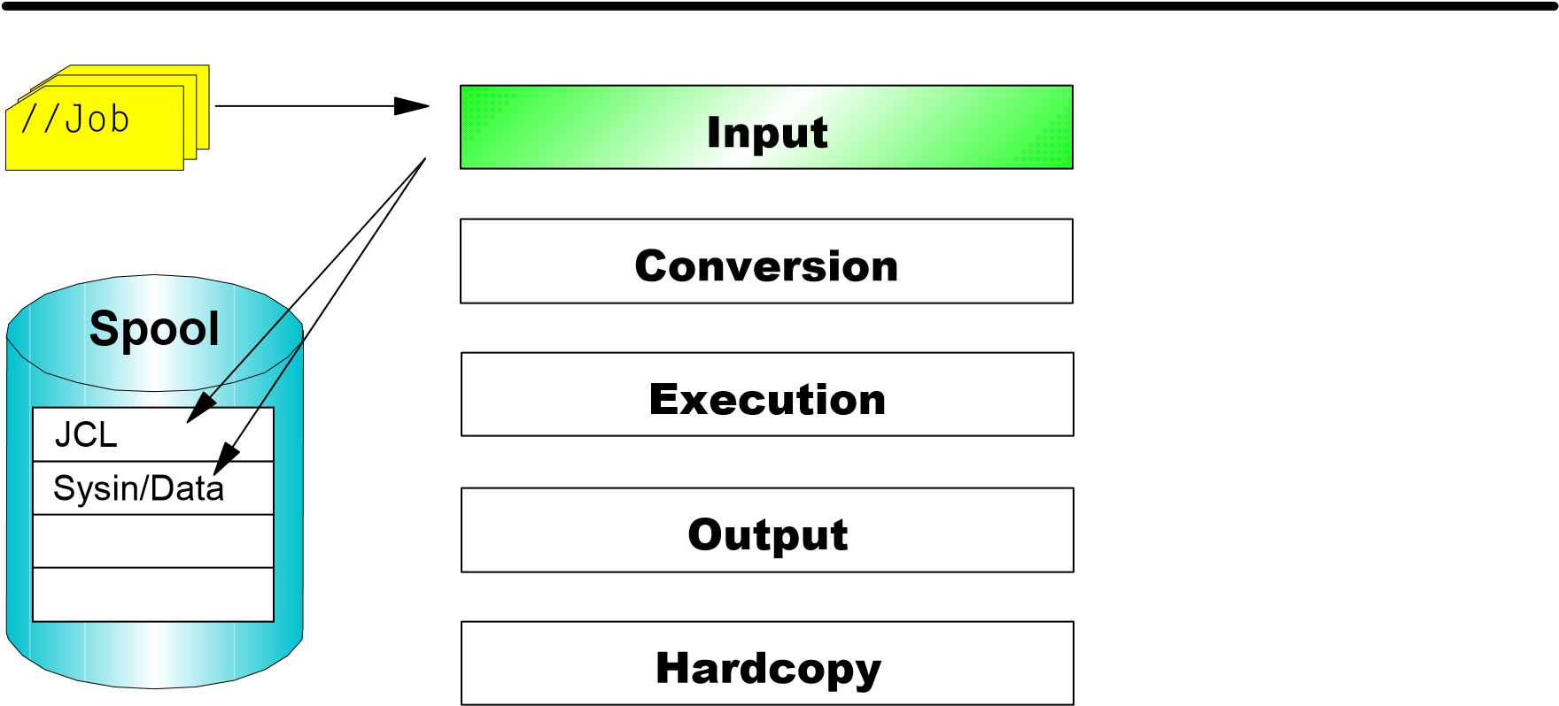

JES2 Job Flow 2 - Conversion
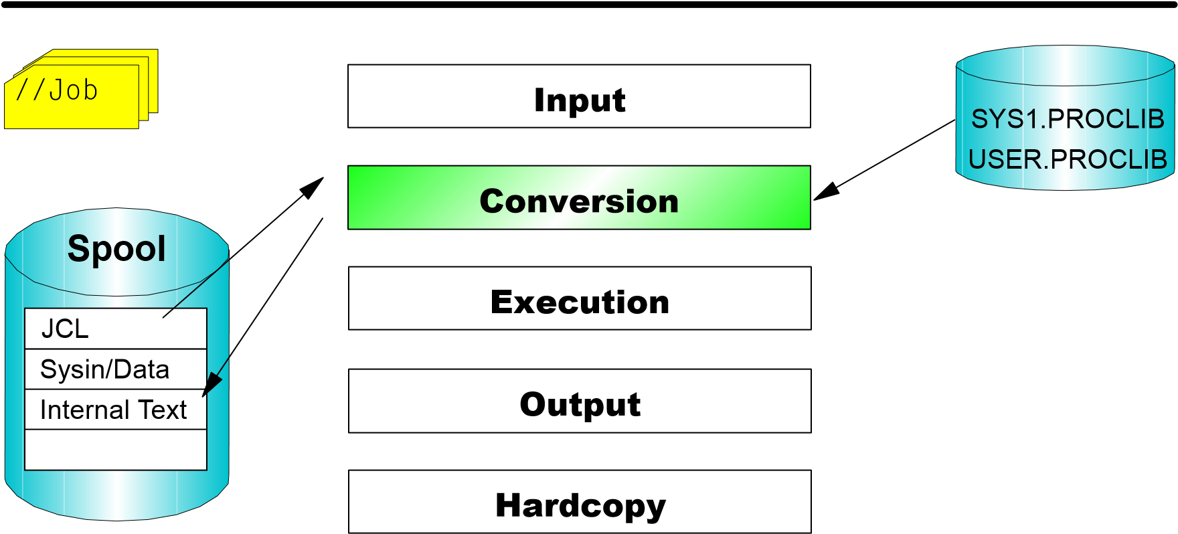

JES2 Job Flow 3 - Execution
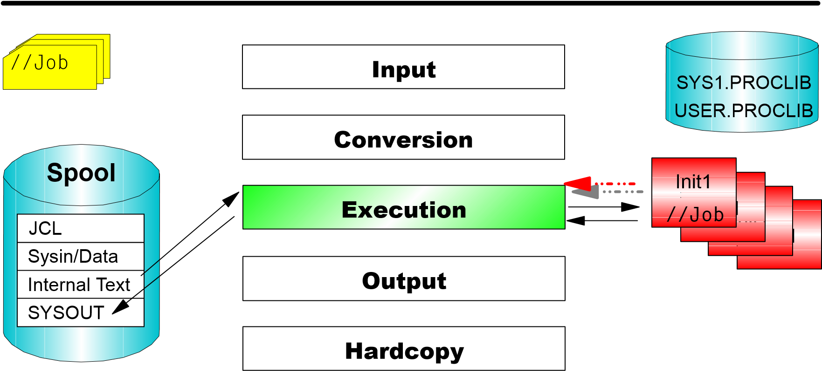

JES2 Job Flow 4 - Output
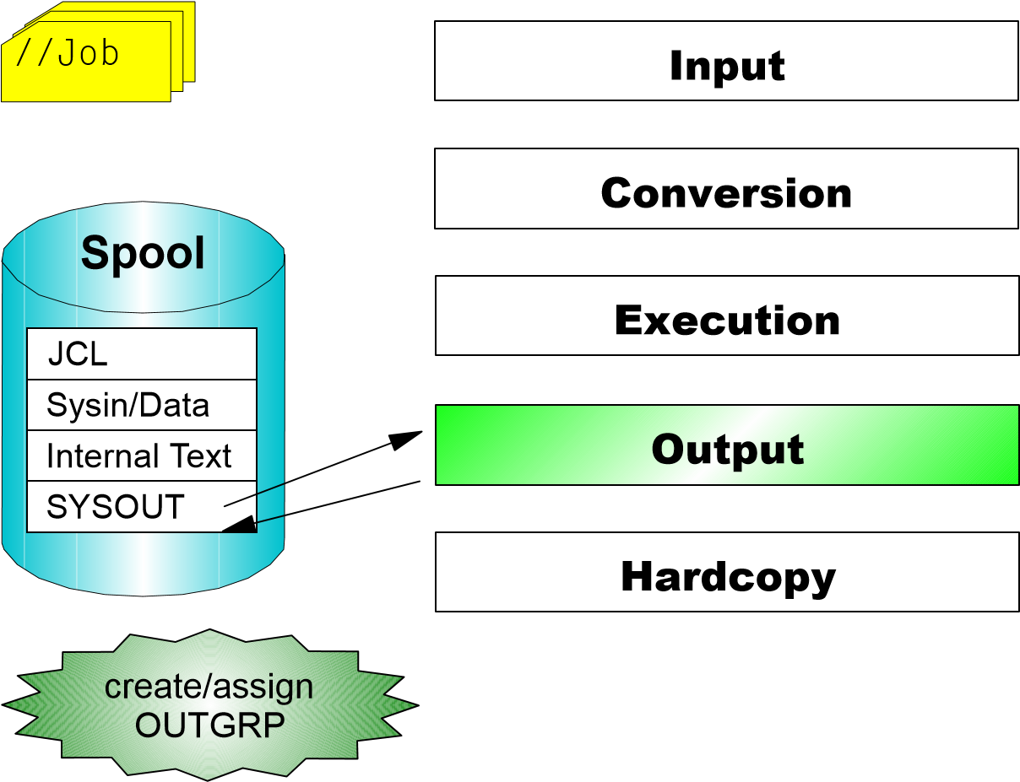
SYS1.PROCLIB
USER.PROCLIB
1
Init
Init
1
Init
1
I
nit
1

JES2 Job Flow 5 - Hardcopy
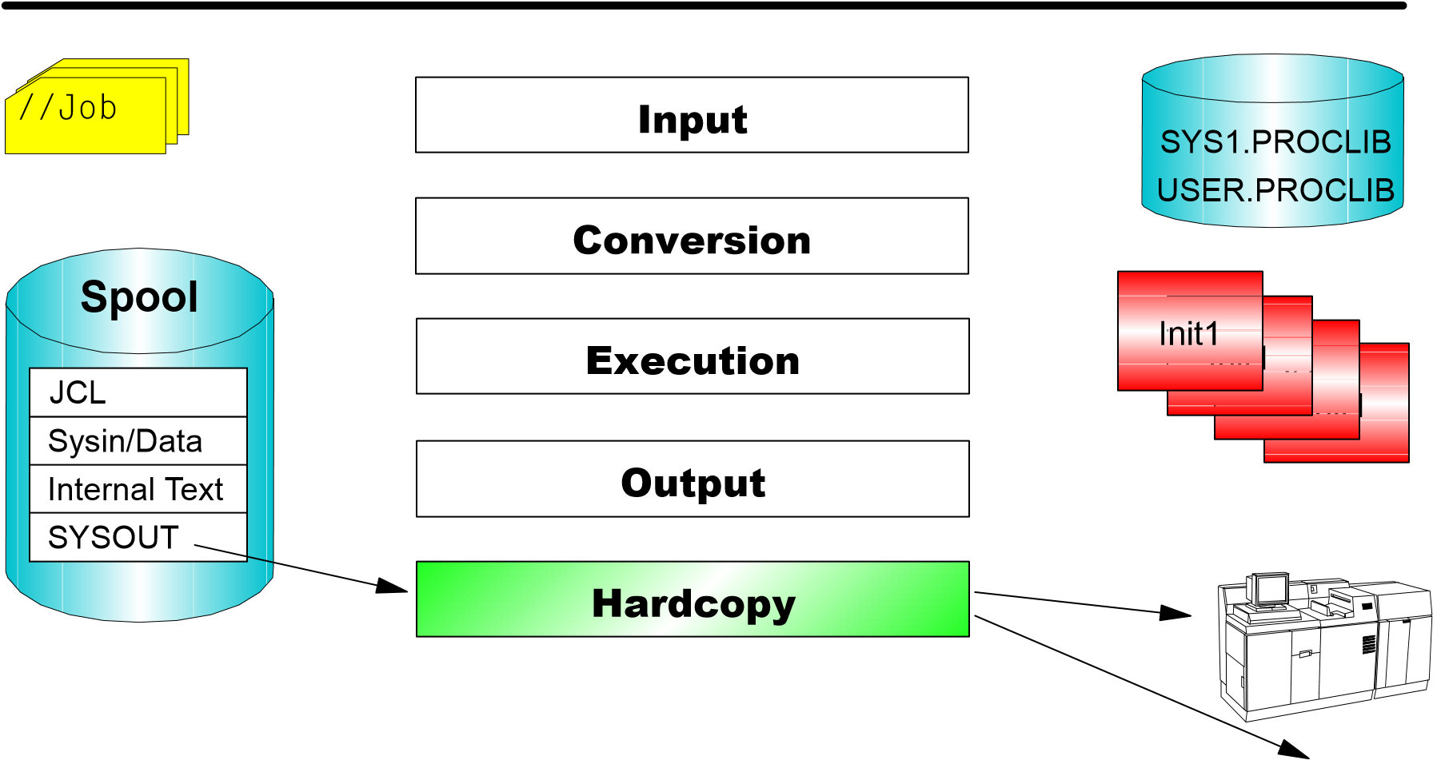

JES2 Job Flow 6 - Purge
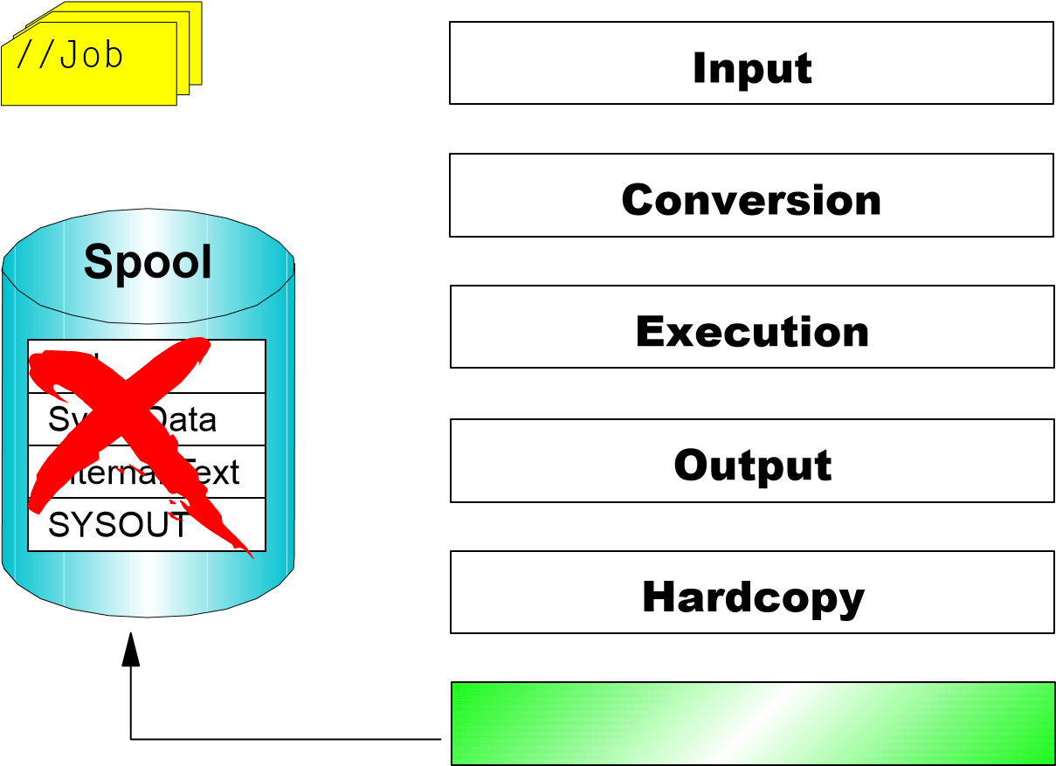
SYS1.PROCLIB
USER.PROCLIB
1
Init
Init
1
Init
1
I
nit
1

JES2 Job Flow - Overview
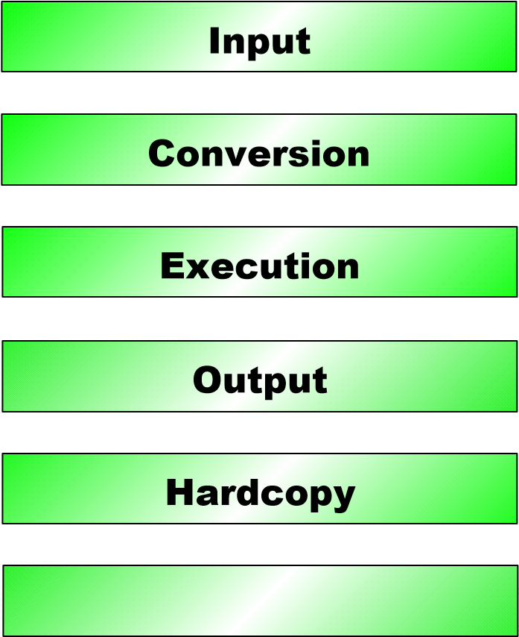
Spool
JCL
SYSOUT
Internal Text
Sysin/Data
SYS1.PROCLIB
USER.PROCLIB
1
Init
1
Init
1
Init
I
nit
1
//Job
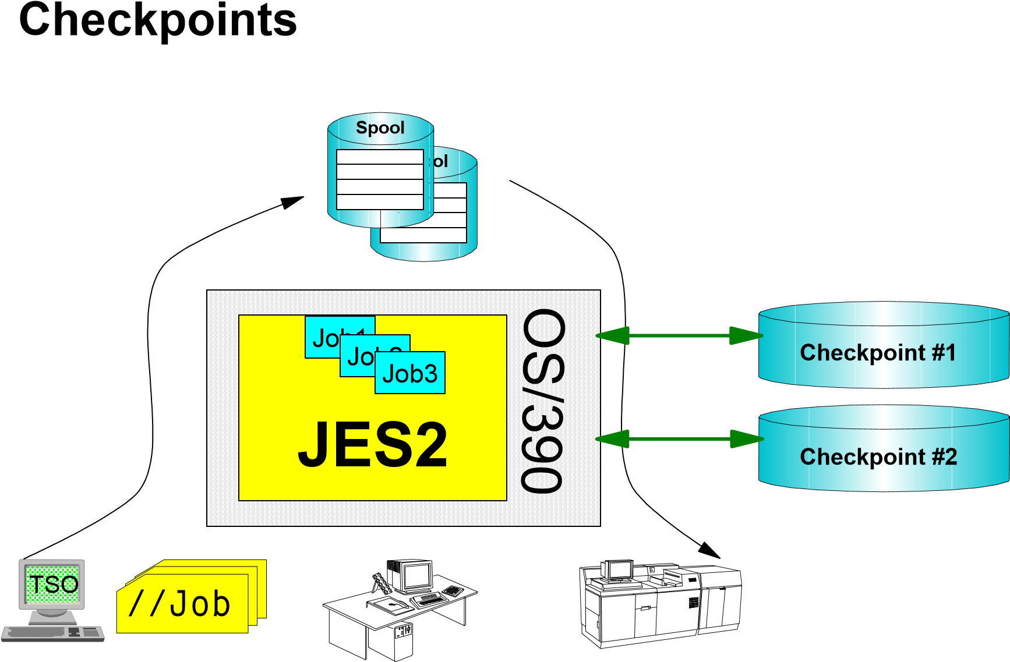

JES2 Internal Reader
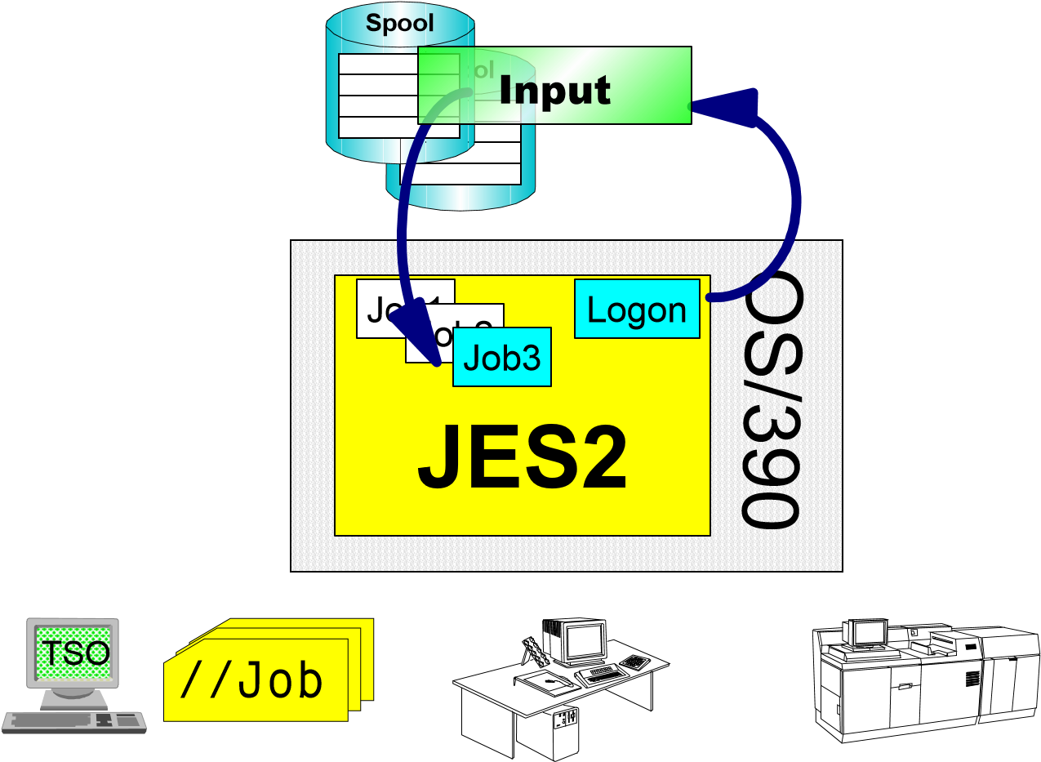
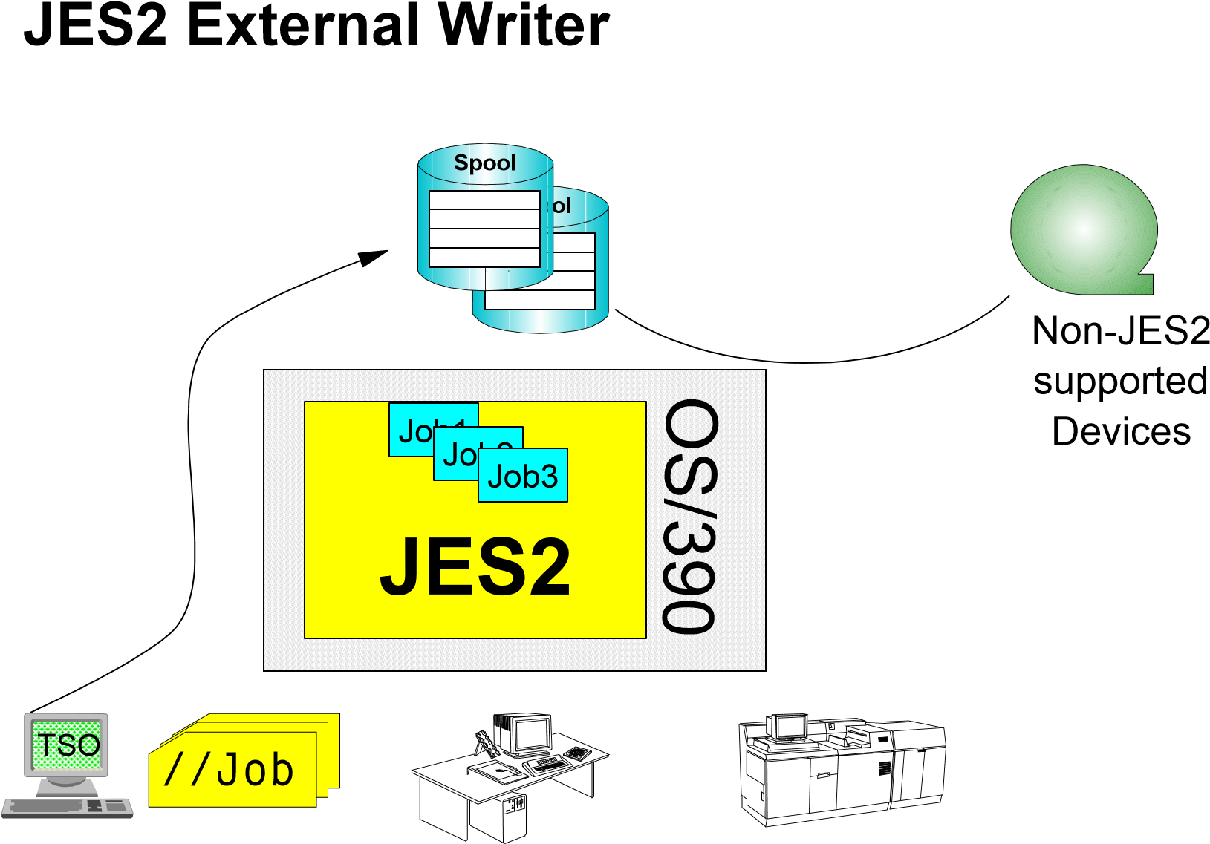

JES2 MAS Complex
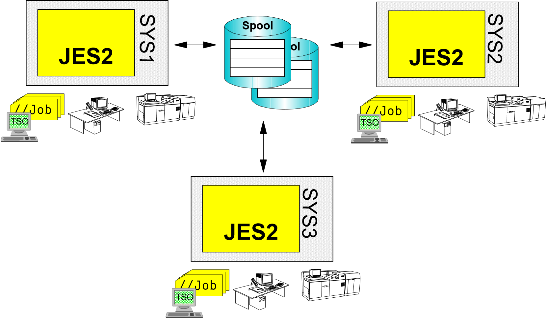
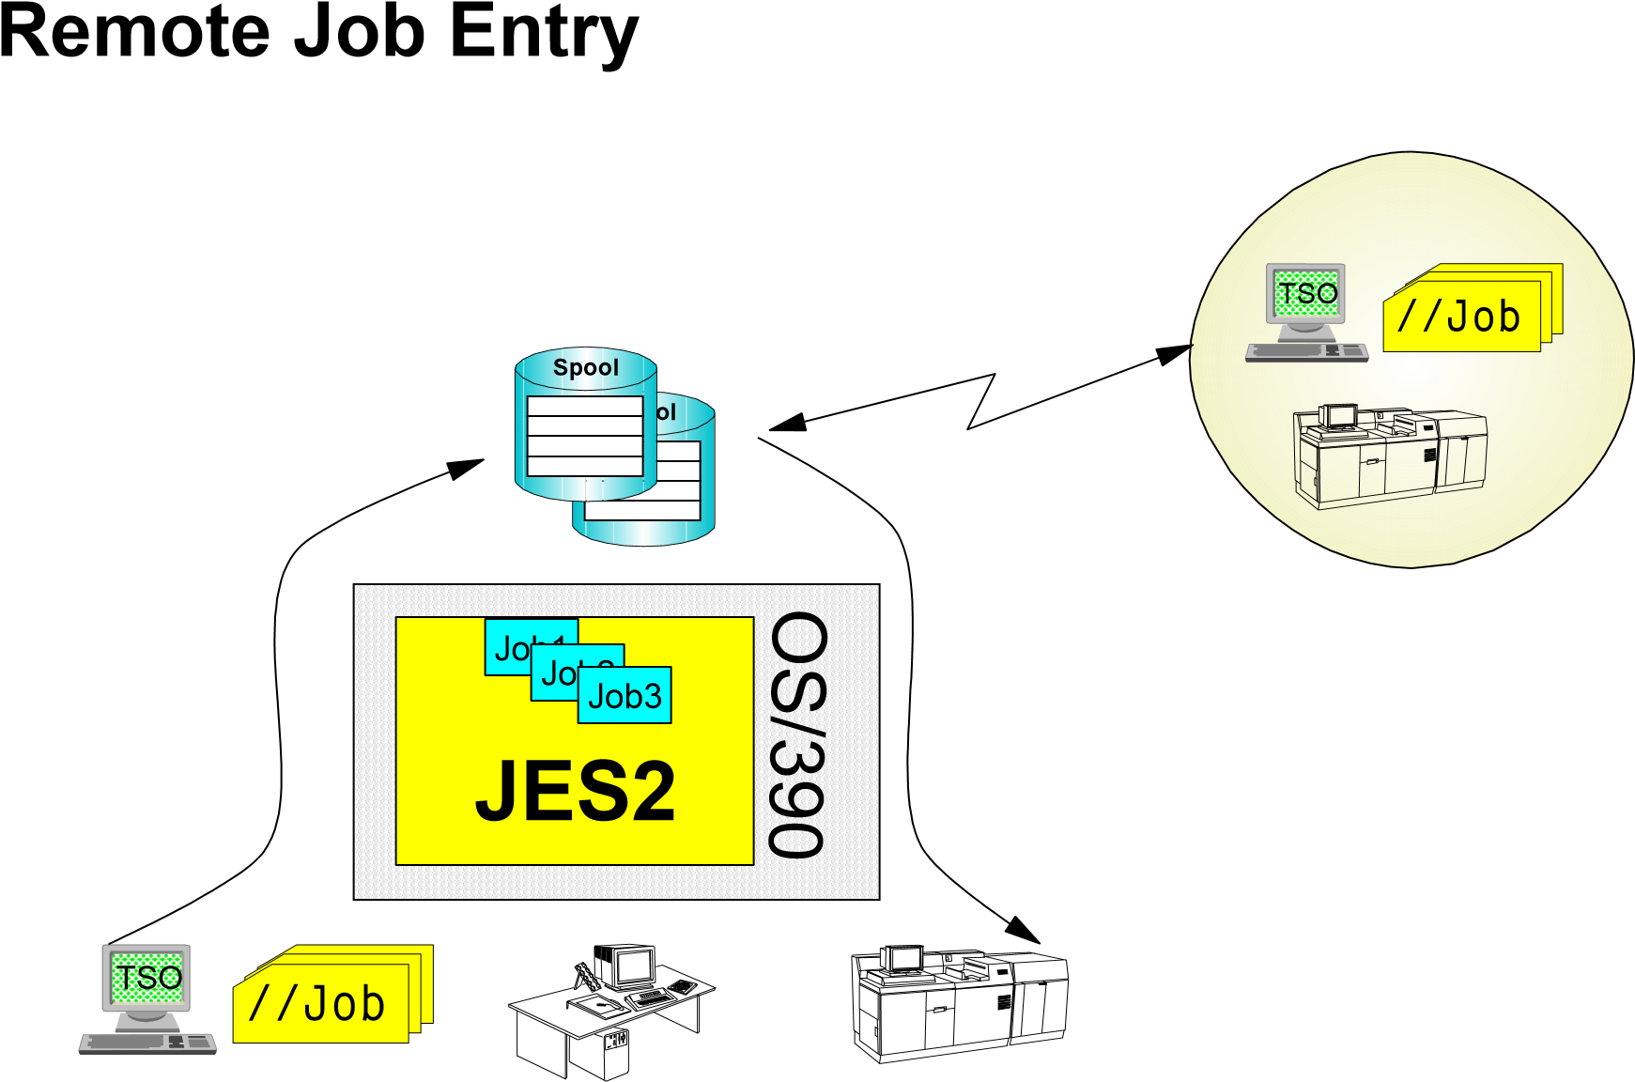

JES2 NJE - Network Job Entry
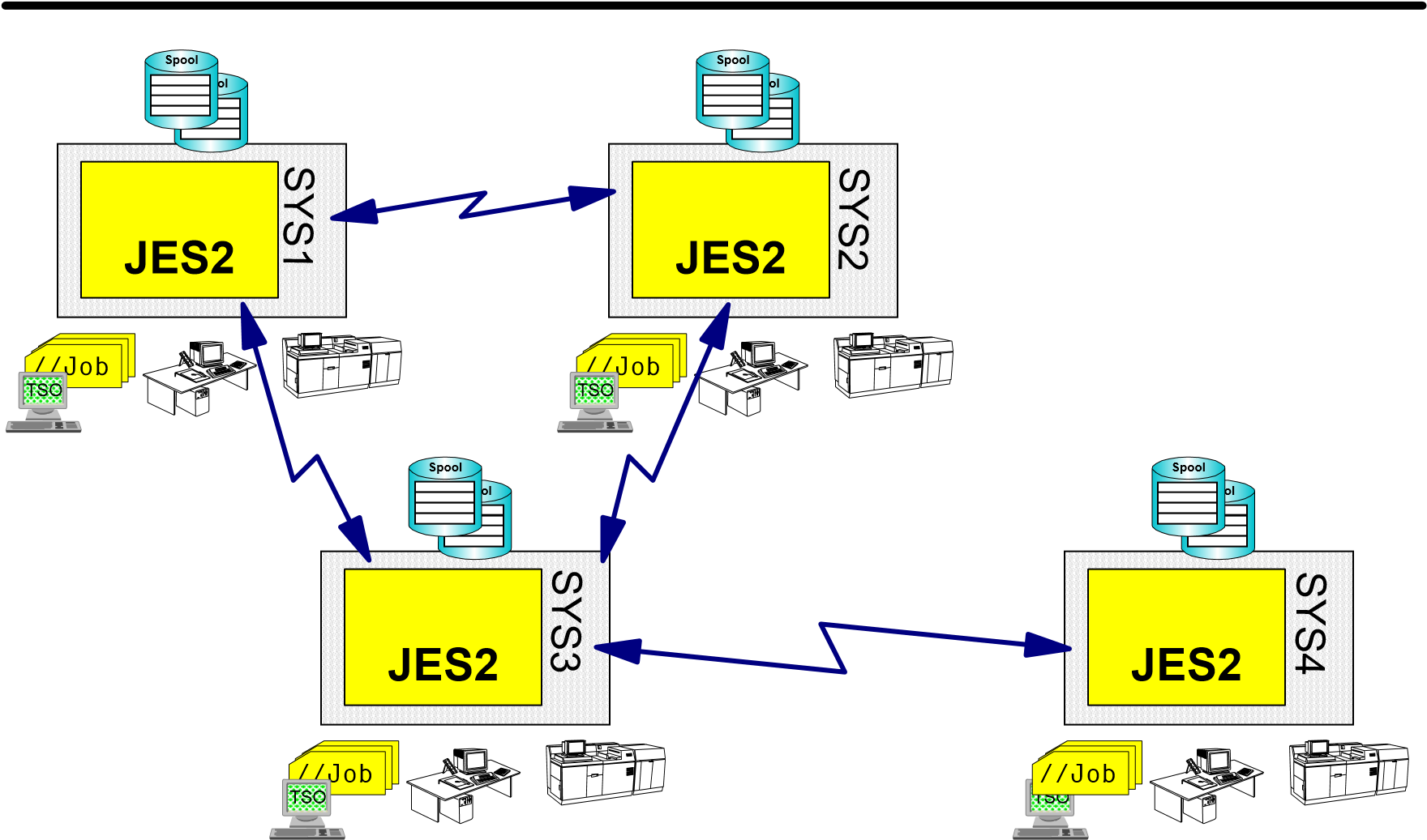

OS/390 Print Server
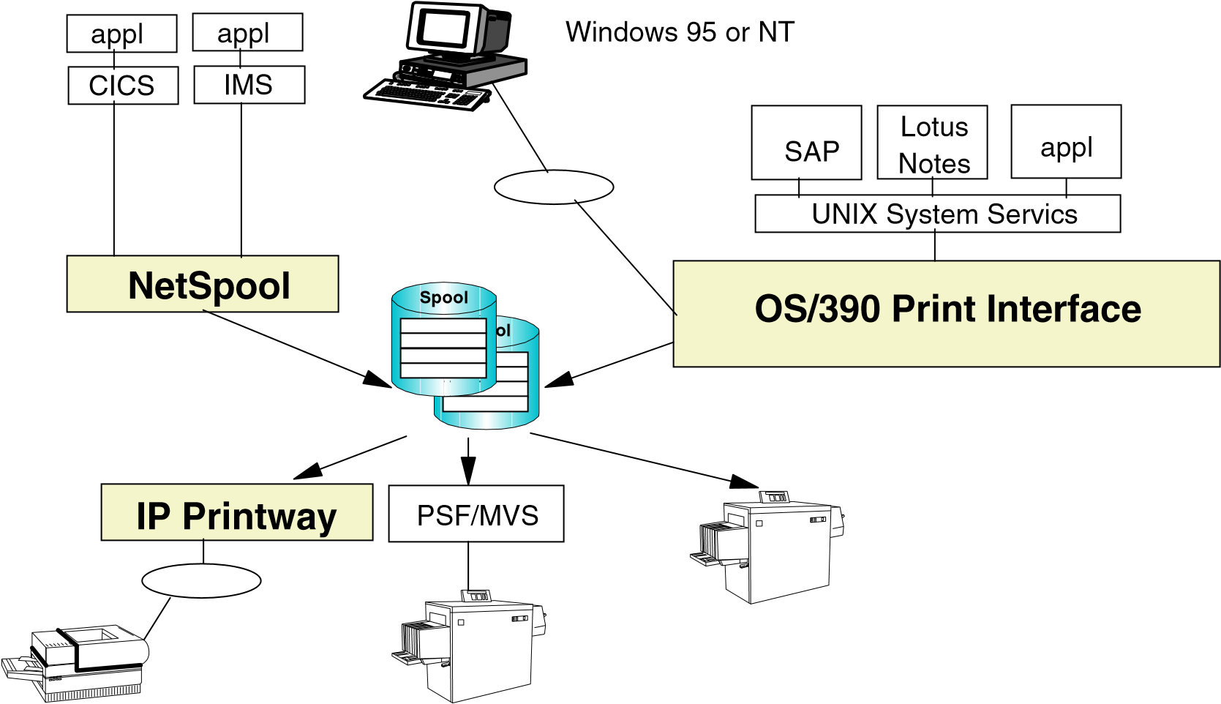

JES2 Messages
10.03.42 JOB00016 $HASP100 TSO1A ON INTRDR
10.03.47 JOB00016 $HASP373 TSO1A STARTED - INIT A - CLASS B - SYS SYS1
10.04.12 JOB00016 $HASP395 TSO1A ENDED
10.05.58 STC00004 $HASP150 SYSLOG OUTGRP=2.1.1 ON PRT1
10.05.58 STC00004 *$HASP150 SYSLOG SETUP - PRT1
10.06.05 $HASP000 OK
10.06.19 $HASP160 PRT1 INACTIVE - CLASS C JOB oder STC (Started Task) Number
Message Text
$HASP = JES2 Message Identifier
### = No. of Message



Replies
Possible Replies
REPLY 01,u
R 01,u
1
,u 1u 1,1
1 1 011 01u
but NOT 11
10.03.42
*01 $HASP
4
26
SPECIFY
OPTIONS - JES2

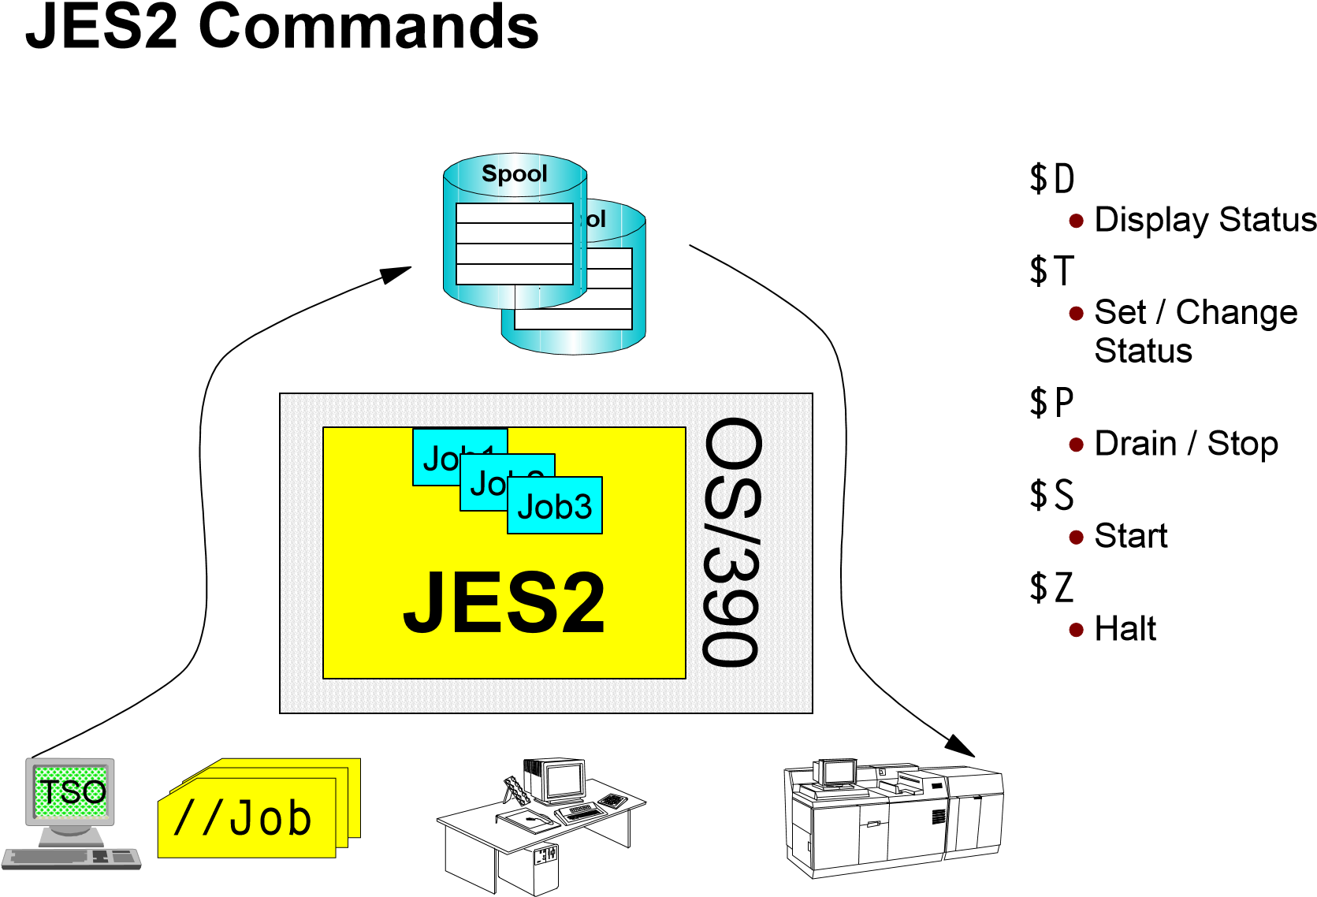

JES2 Execution and Output Class
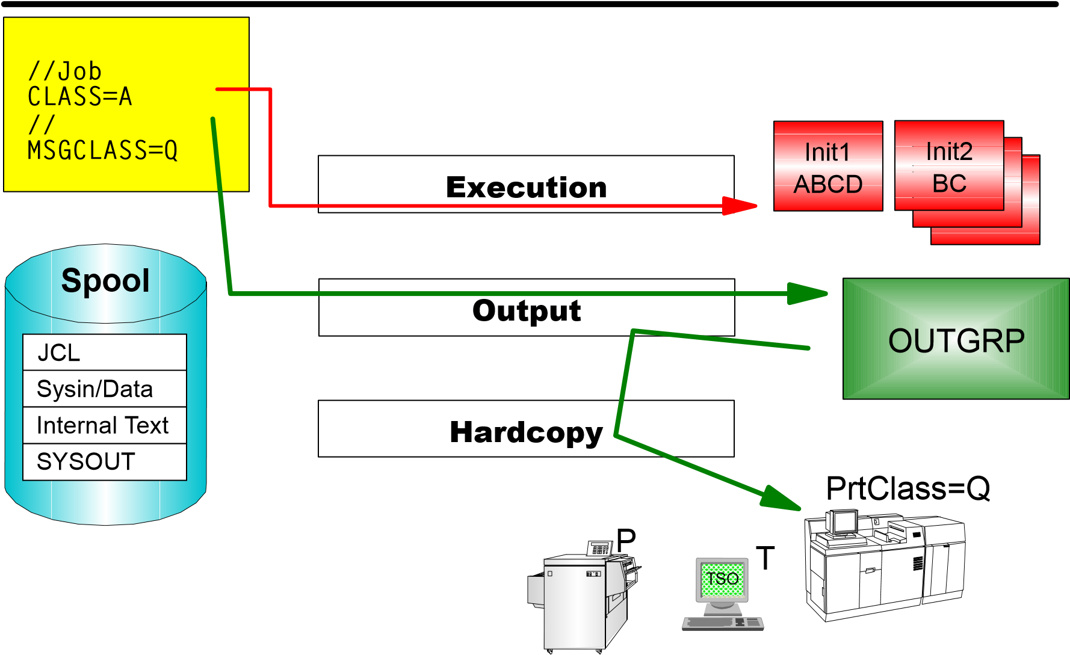

JES2 Bibliography

OS/390 JES2 Commands
OS/390 JES2 System Commands Summary
OS/390 JES2 Messages
OS/390 JES2 Init and Tuning
SDSF Reference Summary
SDSF Guide and Reference
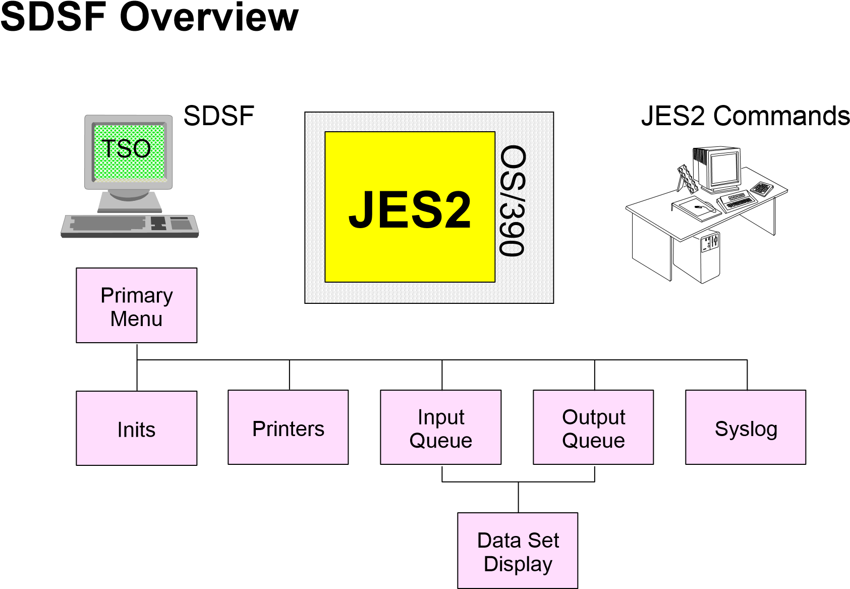

ISPF Primary Option Menu
Menu Utilities Compilers Options Status Help
-----------------------------------------------------------------------------
ISPF Primary Option Menu OS/390 : V2R6M0
Option ===>

- Settings Terminal and user parameters User ID . : TSO0
- View Display source data or listings Time. . . : 12:03
- Edit Create or change source data Terminal. : 3278
- Utilities Perform utility functions Screen. . : 1
- Foreground Interactive language processing Language. : ENGLISH
- Batch Submit job for language processing Appl ID . : ISR
- Command Enter TSO or Workstation commands TSO logon : LOGON
- Dialog Test Perform dialog testing TSO prefix: TSO0
- LM Facility Library administrator functions System ID : SYS1
- IBM Products IBM program development products MVS acct. : ACCTSPST
- SCLM SW Configuration Library Manager Release . : ISPF 4.5
- Workplace ISPF Object/Action Workplace Here you find
O OMVS OpenMVS SDSF!
R RACF/COURSE Racf-Definition for a course
A IBM PRODUCTS Additional IBM Program Products
S SYSPROG System Programmer Workbench

F1=Help F3=Exit F10=Actions F12=Cancel

SDSF Primary Option Menu
Display Filter View Print Options Help
-------------------------------------------------------------------------------
HQX1900------------------ SDSF PRIMARY OPTION MENU --------------------------
COMMAND INPUT ===> SCROLL ===> CSR

LOG - Display the system log
DA - Display active users in the sysplex
I - Display jobs in the JES2 input queue
O - Display jobs in the JES2 output queue
H - Display jobs in the JES2 held output queue
ST - Display status of jobs in the JES2 queues
PR - Display JES2 printers on this system
INIT - Display JES2 initiators on this system
MAS - Display JES2 members in the MAS
LINE - Display JES2 lines on this system
NODE - Display JES2 nodes on this system
SO - Display JES2 spool offload for this system
PUN - Display JES2 punches on this system
RDR - Display JES2 readers on this system
JC - Display job classes in the MAS
SE - Display scheduling environments in the MAS or sysplex
RES - Display WLM resources in the MAS or sysplex
F1=HELP F2=SPLIT F3=END F4=RETURN F5=IFIND F6=BOOK
F7=UP F8=DOWN F9=SWAP F10=LEFT F11=RIGHT F12=RETRIEVE

Résumé
Aperçu de z/OS Aperçu de JES2
Internal Reader
External Writer
Remote Job Entry Network Job Entry
z/OS Print Server
Flux des travaux dans JES2
Syntax et conventions
Aperçu de SDSF
Démonstration de SDSF

Objectifs

Flux z/OS IPL
Procédure de démarrage de JES2
Paramètres de démarrage de JES2
Commandes de terminaison
Arrêt d'un système z/OS JES

OS/390 IPL Flow 1
H/W
IPL
Get Loadparm
Find LOADxx
and IODF
Build UCBs
Device Mapping - Non-DASD pathing
Find NIP console
No NIP console use HMC
Use Couplexx to determine
sysplex mode
Master Catalog
System Parameters
IRIMs
)
Nucleus Initialization Program (NIP
DASD Pathing
Determine state of
sysplex, CFRM policy
CF's, structures, CTCs

OS/390 IPL Flow 2
Master Scheduler Initialization
Send Sysplex and System Name to the HMC
Other CPs brought online (Views Area Green)
Write SYSNAME to Sysplex Couple Data Set
Write SPID value to Couple Data Set if formatted with V5
(provides info for IOS431 message) Establish path groups for online DPS devices
Redrive any outstanding I/O Requests
IOS120I List all DASD Devices that I/O failed to complete
IOS120A CONT or Wait message for each device with contention
Use MCS Consoles

Creation of an Adress Space
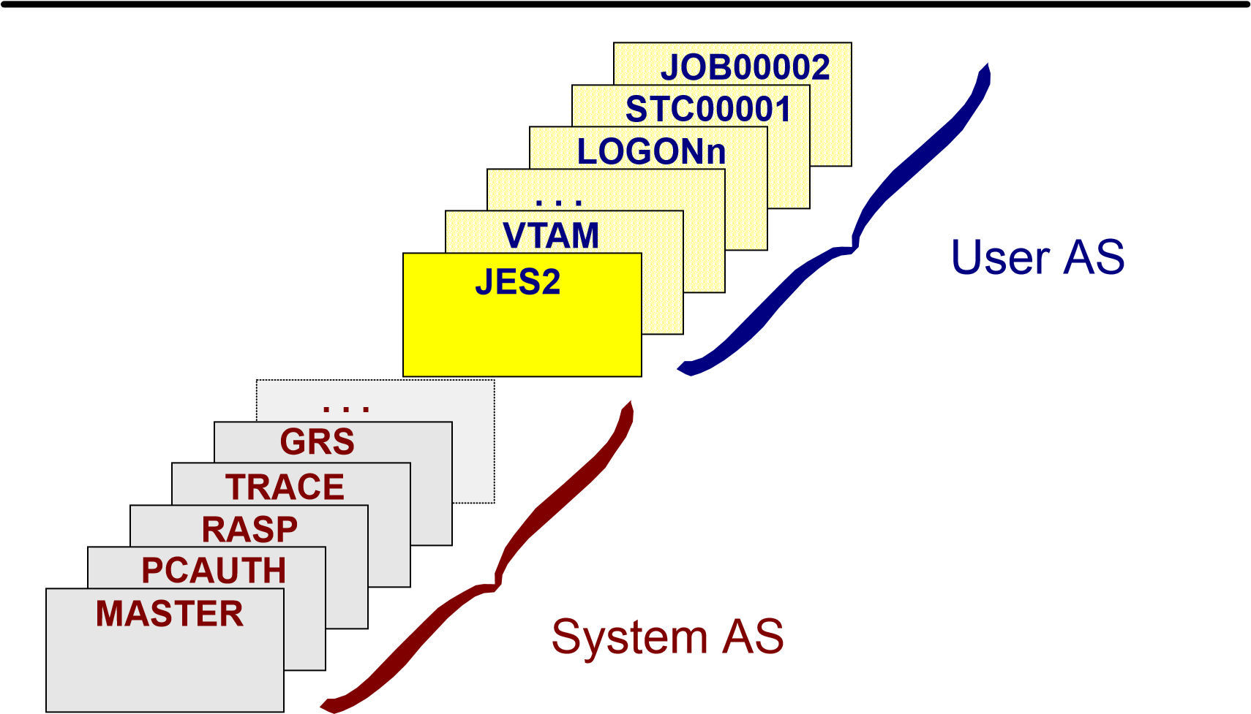

JES2 Start-Up
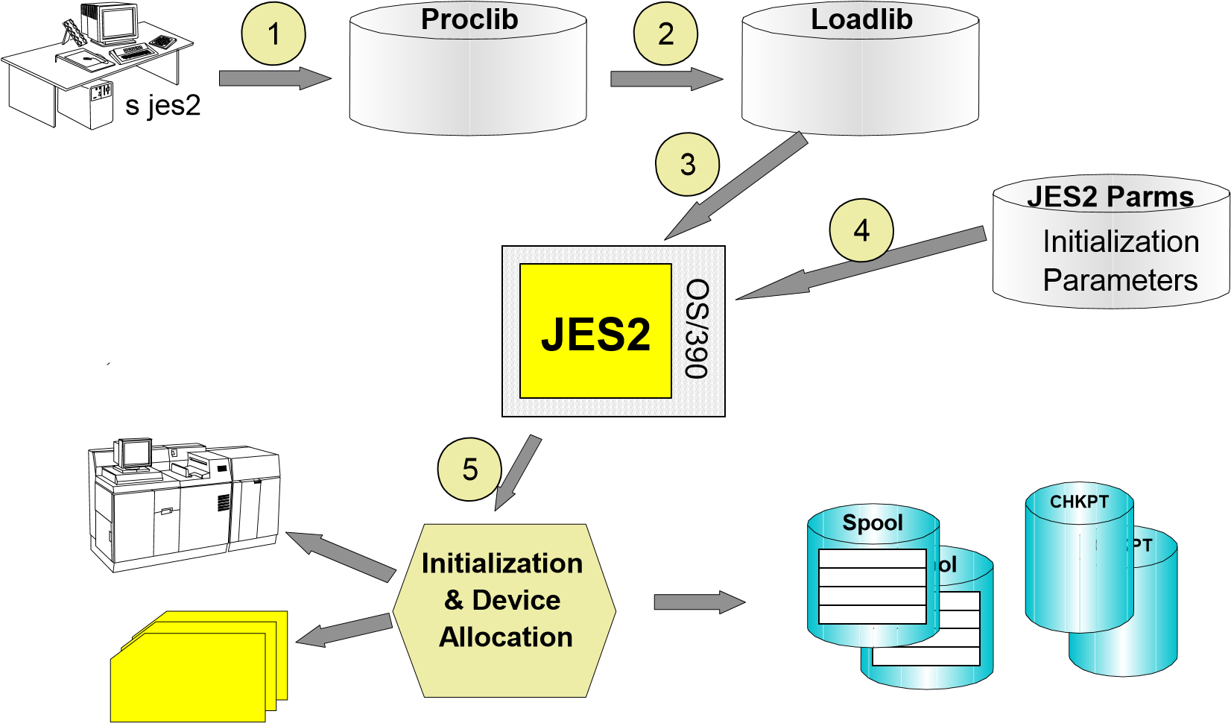

JES2 Start and Options
S JES2
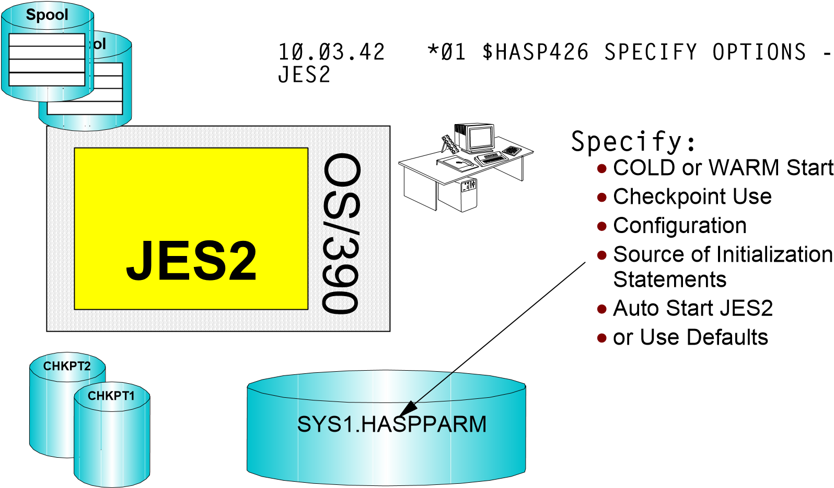


s jes2
IEF677I WARNING MESSAGE(S) FOR JOB JES2 ISSUED
*03
$HASP426 SPECIFY OPTIONS - JES2 OS
2.6.0
03
,nolist,noreq,haspparm=testparm
IEE600I REPLY TO 03 IS;NOLIST,NOREQ,HASPPARM=TESTPARM
$HASP478 INITIAL CHECKPOINT READ FROM CHKPT1..
$HASP493 JES2 ALL-SYSTEMS WARM-START IS IN PROGRESS
$HASP150 SYSLOG OUTGRP=1.1.1 ON PRT1 389 RECORDS
$HASP000 OK
$HASP099 ALL AVAILABLE FUNCTIONS COMPLETE
s jes2,parm=(nolist),member1=testparm
IEF677I WARNING MESSAGE(S) FOR JOB JES2 ISSUED
$HASP478 INITIAL CHECKPOINT READ FROM CHKPT1..
$HASP493 JES2 ALL-SYSTEMS WARM-START IS IN PROGRESS
$HASP400 ENTER REQUESTS
$s
$HASP000 OK
$HASP099 ALL AVAILABLE FUNCTIONS COMPLETE

s jes2,aa0
IEF677I WARNING MESSAGE(S) FOR JOB JES2 ISSUED
*03
$HASP426 SPECIFY OPTIONS - JES2 OS
2.6.0
03
,u
IEE600I REPLY TO 03 IS;U
$HASP478 INITIAL CHECKPOINT READ FROM CHKPT1..
$HASP493 JES2 ALL-SYSTEMS WARM-START IS IN PROGRESS
$HASP400 ENTER REQUESTS
$s
$HASP000 OK
$HASP099 ALL AVAILABLE FUNCTIONS COMPLETE

Start Types

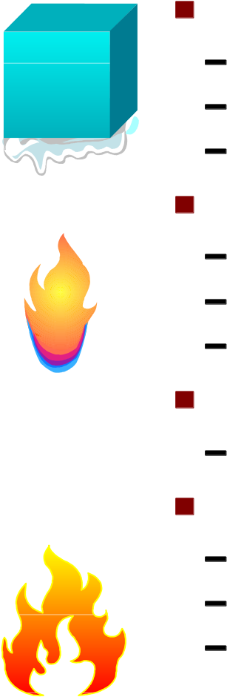
Cold Start
JES2 queues are re-initialized
Spool data set(s) may be re-formatted Only running system in MAS environment

Warm Start
Jobs, SYSIN and SYSOUT on spool survive
Output restartet from last checkpoint
Other MAS processors unaffected

Quick Start Hot Start
Warm start in MAS - not the first member
Restart without OS/390 MVS IPL
Other address spaces continue
Other MAS processors unaffected

Shutdown OS/390
Make sure, that no new work will start at the JES2 resources
$P
Stop all Jobs that are running (in reverse order)
D A,L
P job or Z job or C job
Stop OMVS
D OMVS,A=ALL
shows all active OMVS Processes; Refer to the PID (Process ID) and terminate all running PIDS (except PID = 0 or 1)
F BPXOINIT,TERM=pid
F BPXOINIT,SHUTDOWN=FORKINIT
When the Message "$HASP099 ALL AVAILABLE FUNCTIONS COMPLETE" appears, Stop JES2
$P JES2
Removes an MAS member from sysplex with JES2 ending cleanly
V XCF,sysname,OFFLINE
Member draining?
The Message "$HASP623 MEMBER DRAINING" accours
There are still JES2 resources active (e. g. Printer, Jobs) Make sure that all resources have been drained
$P PRT*
$P I(1-*)
$P LNE*
Make sure, that there is no job or subsystem running
D A,L
except the jobs listed before JES2
Make sure that all OMVS Processes are terminated see foil before

JES2 Termination Commands
Prevent any JES2 function from accepting new work after conclusion of current activity
$P
Stop JES2 Resources
$P RDRn | Stop reader from reading additional jobs
$P PRTn | Stop printer from printing additional jobs
$P INITn | Stop initiator from selecting additional jobs
$P LNEn | Stop communication line from transmitting
 | additional work
Terminate JES2 processing after conclusion of all current activities
$P JES2
$P JES2,QUICK Withdraw cleanly,regardless of any cross-system activity
Abnormal Termination
$P JES2,TERM Interupts current Task and Terminates JES2
$P JES2,ABEND Interupts current Task and Terminates JES2 $P JES2,ABEND,FORCE Interupts current Task and Terminates JES2

Résumé

Flux z/OS IPL
Procédure de démarrage de JES2
Paramètres de démarrage de JES2
Commandes de terminaison
Arrêt d'un système z/OS JES

Objectifs

Input: Reader and Internal Reader
Execution: Initiator and Jobs
Output: Printer and Output
Syslog
SPOOL and Checkpoints
SPOOL Offload

JES2 Job Input Processing

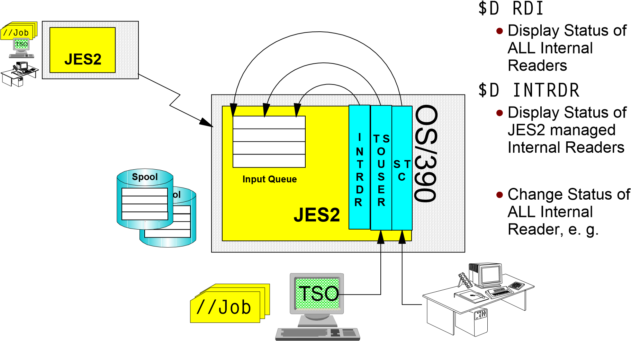
$T INTRDR
CLASS=

JES2 Job Control Language Conversion
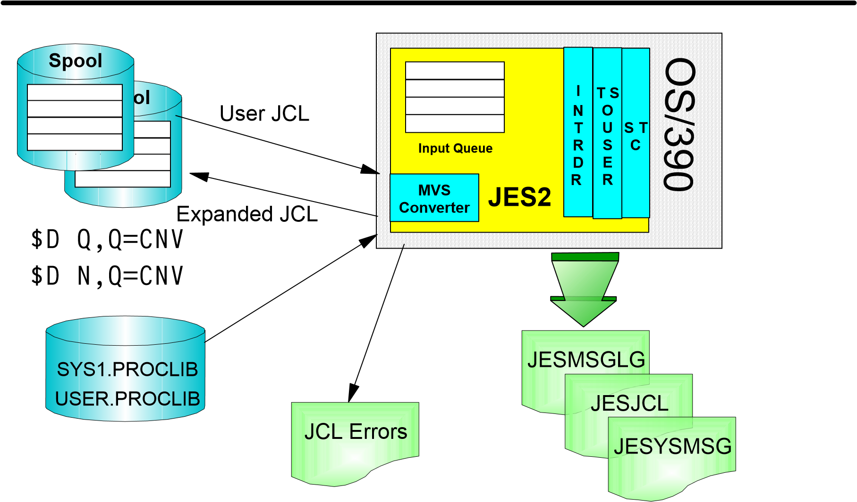

SDSF - Input Queue
Display Filter View Print Options Help
-------------------------------------------------------------------------------
SDSF INPUT QUEUE DISPLAY ALL CLASSES LINE 8-22 (22)
PREFIX=* DEST=(ALL) OWNER=*
NP JOBNAME JOBID OWNER PRTY C POS PRTDEST RMT NODE SAFF
VMRTE JOB00700 TSS0001 6 A 8 LOCAL 1
DISKAL JOB00703 TSS0001 6 A 9 LOCAL 1 S00
JBSPIN JOB00704 TSS0001 6 A 10 LOCAL 1
ASMRMT JOB00705 TSS0001 6 A 11 LOCAL 1
JOB1 JOB00706 TSS0001 6 A 12 LOCAL 1
JOB2 JOB00707 TSS0001 6 A 13 LOCAL 1
JOB3 JOB00708 TSS0001 6 A 14 LOCAL 1
JOB4 JOB00709 TSS0001 6 A 15 LOCAL 1
TSS00017 JOB00694 TSS0001 6 B LOCAL 1
PRT2PRT JOB00699 TSS0001 6 F 1 LOCAL 1
PFICHE JOB00701 TSS0001 6 F 2 LOCAL 1
TSS00013 JOB00690 TSS0001 6 I 1 LOCAL 1
LISTCX JOB00702 TSS0001 6 I 2 LOCAL 1
TSS00016 JOB00693 TSS0001 6 O 1 LOCAL 1
TSS00018 JOB00695 TSS0001 6 * LOCAL 1
COMMAND INPUT ===> SCROLL ===> PAGE
F1=HELP F2=SPLIT F3=END F4=RETURN F5=IFIND F6=BOOK
F7=UP F8=DOWN F9=SWAP F10=LEFT F11=RIGHT F12=RETRIEVE

JES2 Initiator
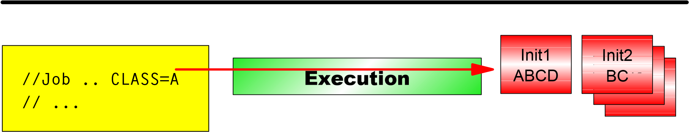
$DI $DI(4)
$DI(7-11)
Display Status of Initiators Status of an Initiator^{starting}activ $TI(4)Change Status, e. g. CLASS=
inactive $SI(4) $SI(7-11) $SI(4-*) drainingStart of Initiators

drained $ZI(4) $ZI(7-11) $ZI(4-*) ^{halted} $PI(4) $PI(7-11) $PI(4-*)
haltingHalt of Initiators
Stop of Initiators

JES2 Job Selection and Execution
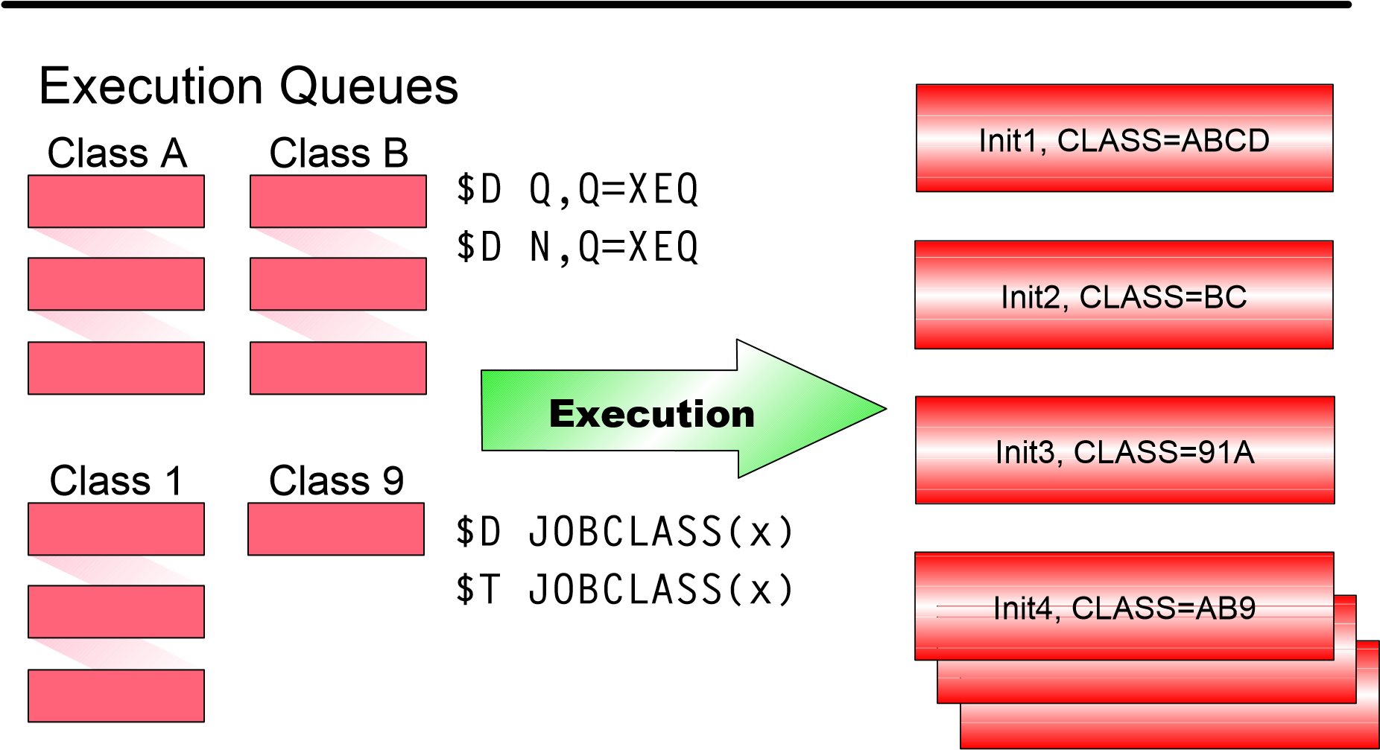

SDSF - Initiators
Display Filter View Print Options Help
-------------------------------------------------------------------------------
SDSF INITIATOR DISPLAY 15 Members processed
COMMAND INPUT ===> SCROLL ===> CSR
NP ID STATUS CLASSES JOBNAME STEPNAME PROCSTEP JOBID C ASID ASIDX
- ACTIVE A TSO0LA S01 JOB00302 A 32 0020
- ACTIVE B TSO0LB S01 JOB00303 B 33 0021
- ACTIVE C TSO0LC S01 JOB00309 C 34 0022
- ACTIVE D TSO0LD S01 JOB00310 D 35 0023
- DRAINED E
- DRAINED F
- DRAINED G
- DRAINED H
- DRAINED I
- DRAINED J
- ACTIVE ABCDEFGH TSO0LBB S01 JOB00304 B 36 0024
- DRAINED IHGFEDCB

F1=HELP F2=SPLIT F3=END F4=RETURN F5=IFIND F6=BOOK
F7=UP F8=DOWN F9=SWAP F10=LEFT F11=RIGHT F12=RETRIEVE

Initiator Overview JES vs. WLM

JES2 Initiators
Select jobs from JES-managed job classes only Started and stopped by operators Active in goal and compatibility modes Consume job numbers
WLM Initiators
Select jobs from WLM-managed job classes only Started and stopped by
WLM based on
Available capacity
Goals
Active in goal mode only Started under MSTR subsystem, so they do not consume job numbers

WLM Managed Job Queuing
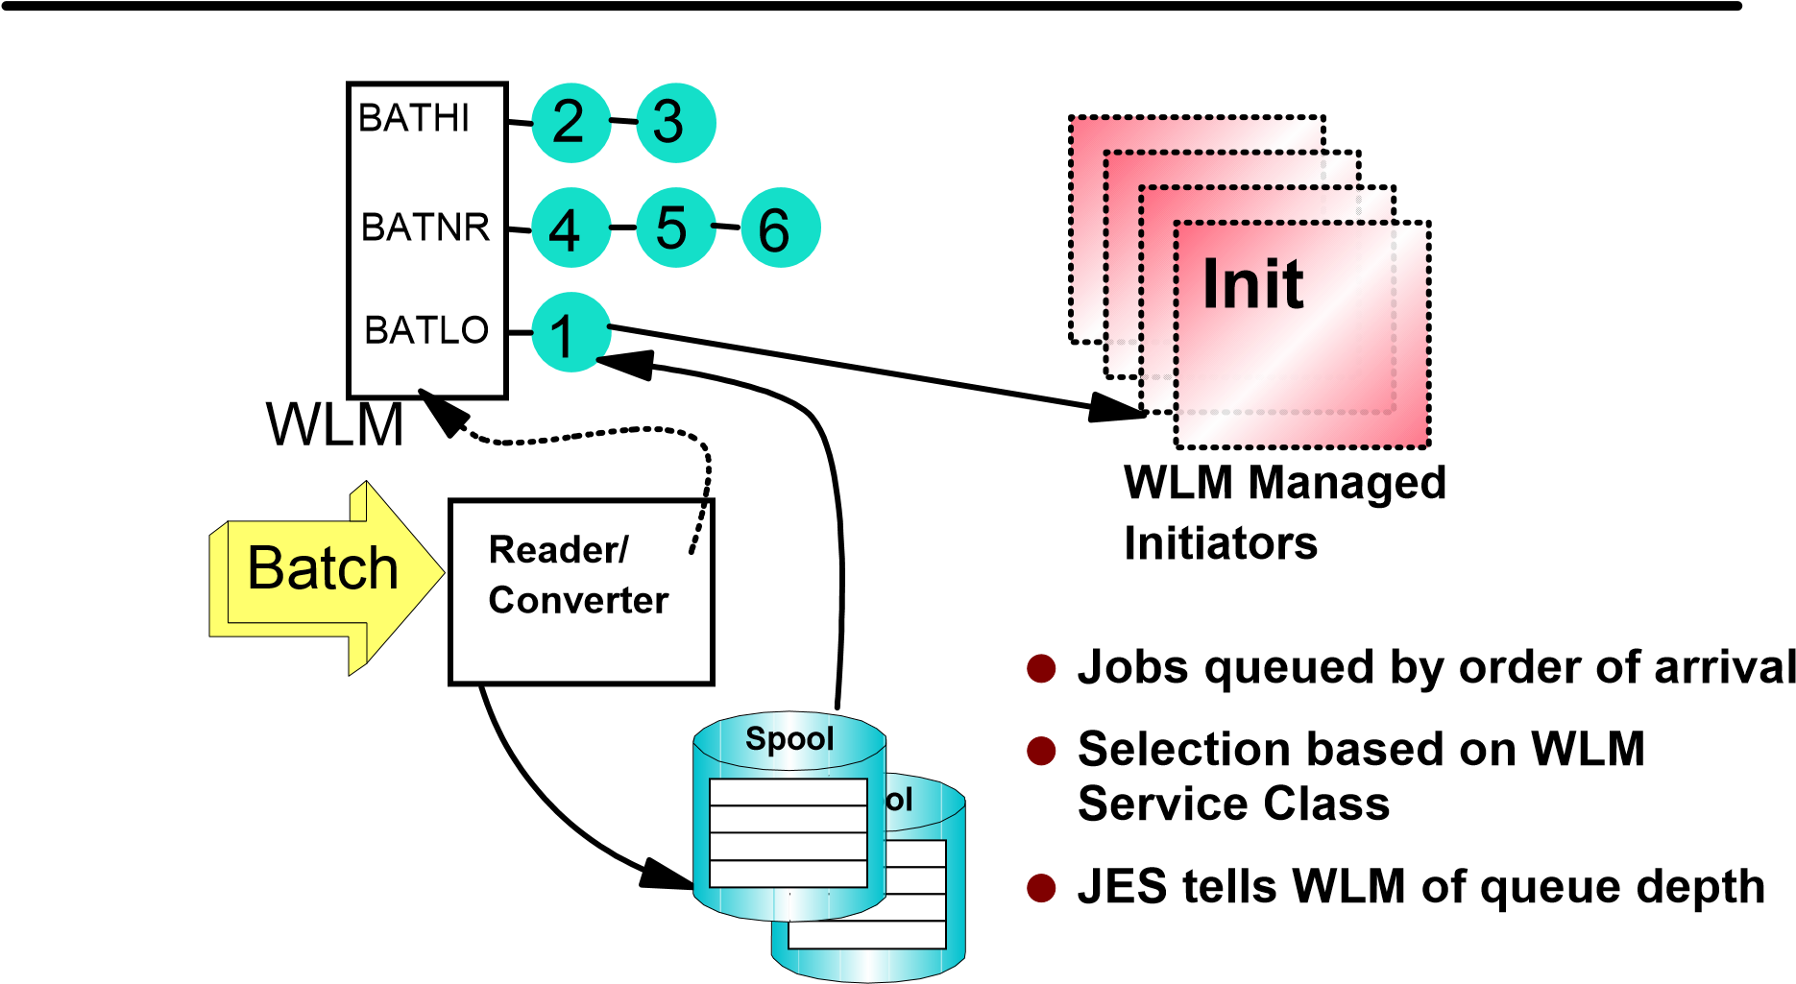

SDSF - Display Active Users
Display Filter View Print Options Help
-------------------------------------------------------------------------------
SDSF DA S00 S00 PAG 0 SIO 0 CPU 21 LINE 16-30 (30)
PREFIX=* DEST=(ALL) OWNER=*
NP JOBNAME STEPNAME PROCSTEP JOBID OWNER C POS DP REAL PAGING SIO
JES2 JES2 IEFPROC NS FD 386 0.00 0.00
SMF SMF IEFPROC NS FF 28 0.00 0.00
LLA LLA LLA NS FD 133 0.00 0.00
VLF VLF VLF NS FD 227 0.00 0.00
RMF RMF IEFPROC STC00628 IBMUSER NS FD 50 0.00 0.00
RMFGAT RMFGAT IEFPROC STC00630 IBMUSER NS FD 184 0.00 0.00
NET NET NET STC00617 IBMUSER NS FD 94 0.00 0.00
SMS SMS IEFPROC NS FD 103 0.00 0.00
RACF RACF RACF STC00625 IBMUSER NS FD 48 0.00 0.00
TNF TNF NS FD 19 0.00 0.00
VMCF VMCF NS FD 24 0.00 0.00
CATALOG CATALOG IEFPROC NS FF 149 0.00 0.00
TSS00016 S1 G JOB00693 TSS0001 A IN C0 176 0.00 0.00
TSO TSO STEP1 STC00629 IBMUSER WM FF 32 0.00 0.00 TSS0001 $TMPROC IBME13A1 TSU00687 TSS0001 IN FE 479 0.00 0.00
COMMAND INPUT ===> SCROLL ===> PAGE F1=HELP F2=SPLIT F3=END F4=RETURN F5=IFIND F6=BOOK
F7=UP F8=DOWN F9=SWAP F10=LEFT F11=RIGHT F12=RETRIEVE

SDSF - Status Display
Display Filter View Print Options Help
-------------------------------------------------------------------------------
SDSF STATUS DISPLAY ALL CLASSES LINE 1-12 (12)
PREFIX=* DEST=(ALL) OWNER=*
NP JOBNAME JOBID OWNER PRTY QUEUE C POS SAFF ASYS STATUS
TSS00018 JOB00695 TSS0001 6 CONVERSION D HOLD
TSS00017 JOB00694 TSS0001 6 EXECUTION B HOLD
TSS00016 JOB00693 TSS0001 6 EXECUTION O 1
TSS0001 TSU00687 TSS0001 15 EXECUTION S00 S00
TSS00012 JOB00661 TSS0001 1 PRINT A 93
Display Filter View Print Options Help
-------------------------------------------------------------------------------
SDSF STATUS DISPLAY ALL CLASSES LINE 1-12 (12)
PREFIX=* DEST=(ALL) OWNER=*
NP JOBNAME TDEST SECLABEL TGNUM TGPCT ORIGNODE EXECNODE DEVICE
TSS00018 CAL 1 0.13 LOCAL LOCAL
TSS00017 CAL 1 0.13 LOCAL LOCAL
TSS00016 CAL 1 0.13 LOCAL LOCAL
TSS0001 CAL 1 0.13 LOCAL LOCAL
TSS00012 STESA.PROG2 1 0.13 LOCAL LOCAL

SDSF - Job Class Display
Display Filter View Print Options Help
------------------------------------------------------------------------------
SDSF JOB CLASS DISPLAY ALL CLASSES LINE 1-24 (32) COMMAND INPUT ===> SCROLL ===> PAGE
PREFIX=* DEST=(ALL) OWNER=*
NP C STATUS MODE WAIT-CNT XEQ-CNT HOLD-CNT ODISP QHOLD HOLD
- NOTHELD WLM
- NOTHELD WLM
- HELD JES 6 (KEEP,KEEP) YES NO
- NOTHELD JES 2 1 2 (KEEP,KEEP) NO NO
- NOTHELD JES (KEEP,KEEP) NO NO
- NOTHELD JES 1 (PURGE,KEEP) NO NO
- NOTHELD JES 7 (KEEP,KEEP) NO YES
- NOTHELD JES (KEEP,KEEP) NO NO
- HELD JES 2 (KEEP,KEEP) YES NO
- NOTHELD JES (PURGE,KEEP) NO NO
- NOTHELD JES 4 1 (KEEP,KEEP) NO NO L NOTHELD WLM
F1=HELP F2=SPLIT F3=END F4=RETURN F5=IFIND F6=BOOK
F7=UP F8=DOWN F9=SWAP F10=LEFT F11=RIGHT F12=RETRIEVE

Controlling Job Execution
Job Commands
CmdCmd Specify jobSpecify job
$D JQ'jobname' | Display
$C J(4711) | Cancel
$P S(0815) | Purge
$H T(0007) | Hold
$A | Release
$E | Restart
$T | Set / Modify
Hold/Release ALL jobs
$H|$A A,ALL
Hold job class
$T JOBCLASS(a),QHELD={Y|N}'


Handling Execution Errors
$HASP308 jobname
ESTIMATED TIME
EXCEED BY 5
MINUTES
$HASP375 jobname ESTIM
ATE EXCEEDED
BY 400

LINES/KBYTES/PAGES
14% SPOOL
CANCEL JOB?
$D ESTIME
$D ESTPAGE
$D ESTLNCT
$T ESTIME,NUM=x

JES2 Output - Printer
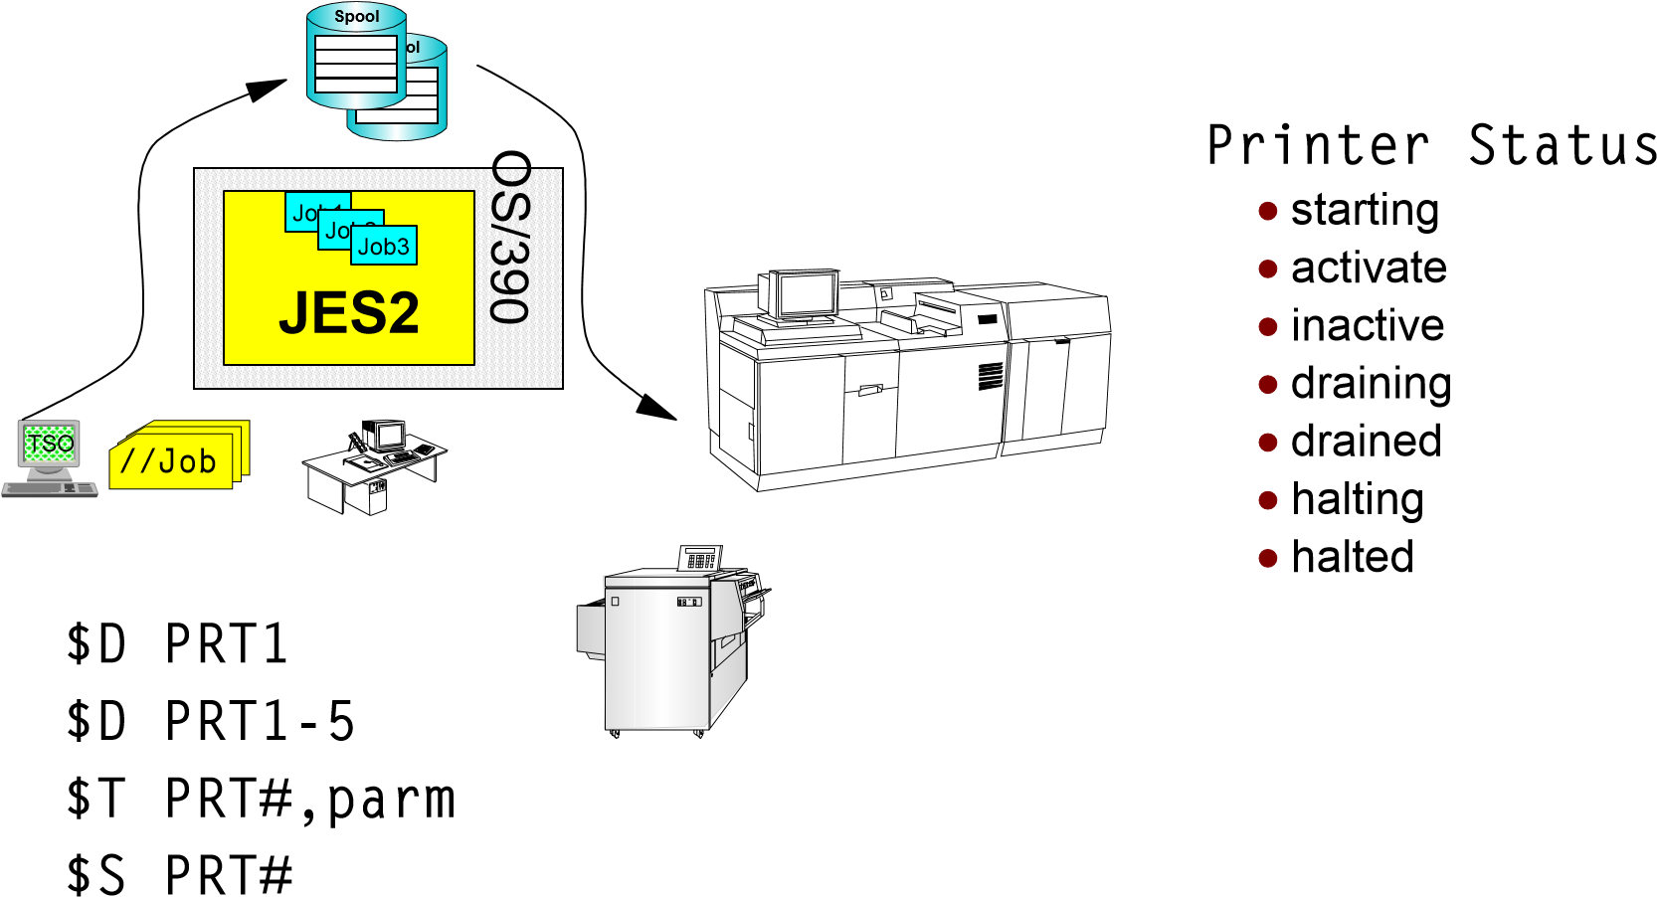
$Z PRT#
$P PRT#

JES2 Output - Printerdefinitions
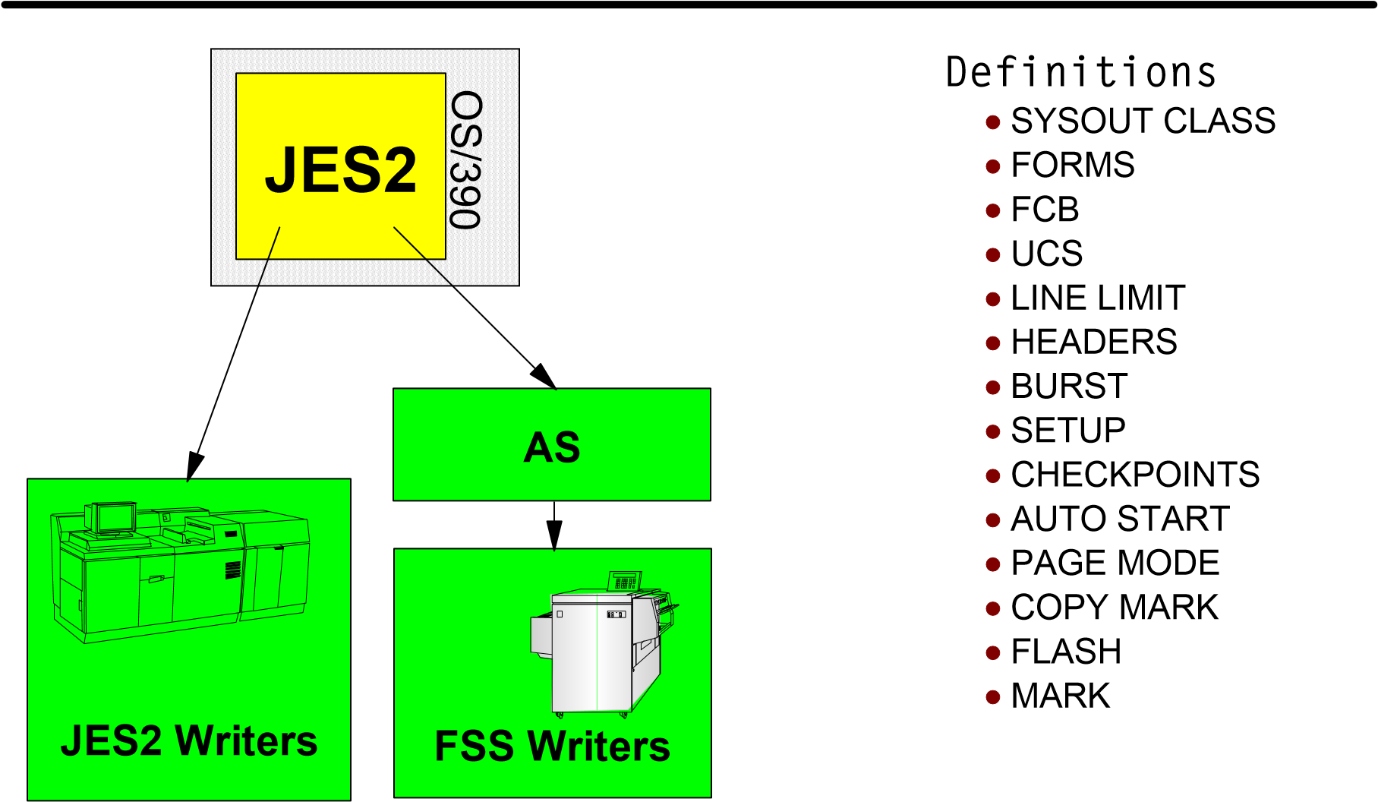

Controlling Active JES2 Printers
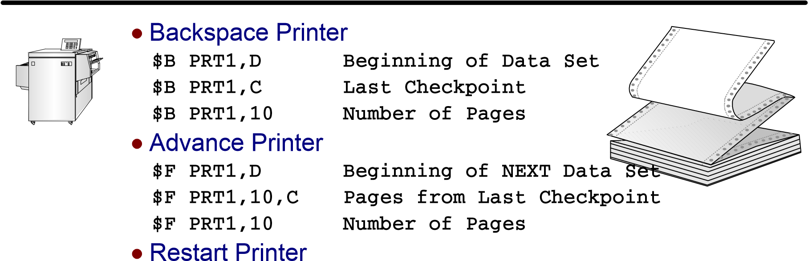
$E PRT1
Requeue Current Output Group, Start Print from Beginning
Repeat Output
$N PRT1 Repeat Printing of Output Group
Interrupt Output
$I PRT1
Start Printing at Checkpoint or one or more pages from interrupt

SDSF - Printer 1/2
Display Filter View Print Options Help
-------------------------------------------------------------------------------
SDSF PRINTER DISPLAY LINE 1-1 (1)
PREFIX=* DEST=(ALL) OWNER=*
NP PRINTER STATUS SFORMS SCLASS JOBNAME JOBID OWNER REC-
PRT1 INACTIVE STANDARD A
Display Filter View Print Options Help
-------------------------------------------------------------------------------
SDSF PRINTER DISPLAY LINE 1-1 (1)
PREFIX=* DEST=(ALL) OWNER=*
NP PRINTER REC-CNT REC-PRT PAGE-CNT PAGE-PRT JP DP C SECLABEL FORMS F
PRT1
Display Filter View Print Options Help
-------------------------------------------------------------------------------
SDSF PRINTER DISPLAY LINE 1-1 (1)
PREFIX=* DEST=(ALL) OWNER=*
NP PRINTER FCB UCS WRITER FLASH DEST BURST SEP SEPDS PRMODE SF
PRT1 YES NO ST

SDSF - Printer 2/2
Display Filter View Print Options Help
-------------------------------------------------------------------------------
SDSF PRINTER DISPLAY LINE 1-1 (1)
PREFIX=* DEST=(ALL) OWNER=*
NP PRINTER SFCB SUCS SWRITER SFLH WORK-SELECTION
PRT1 STD2 PN (Q,R,PRM,LIM,F/UCS,FCB,W)
Display Filter View Print Options Help
-------------------------------------------------------------------------------
SDSF PRINTER DISPLAY LINE 1-1 (1)
PREFIX=* DEST=(ALL) OWNER=*
NP PRINTER MIT PAGE-LIMIT DFCB SETUP COPYMARK PAU K TR SEPCHAR UCSV
PRT1 0-* HALT NO NO DEFAULT NO
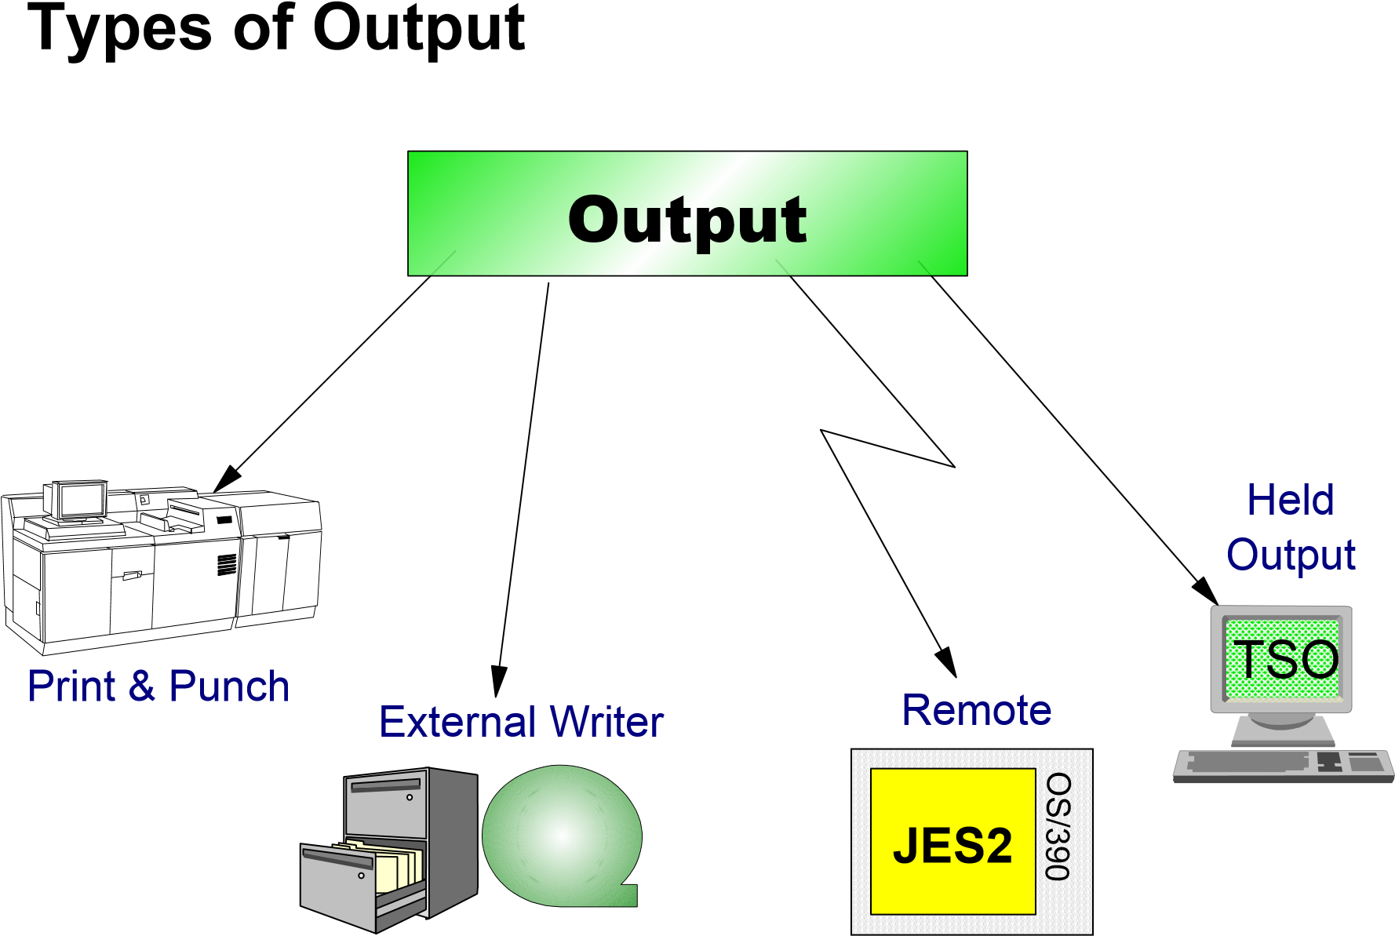

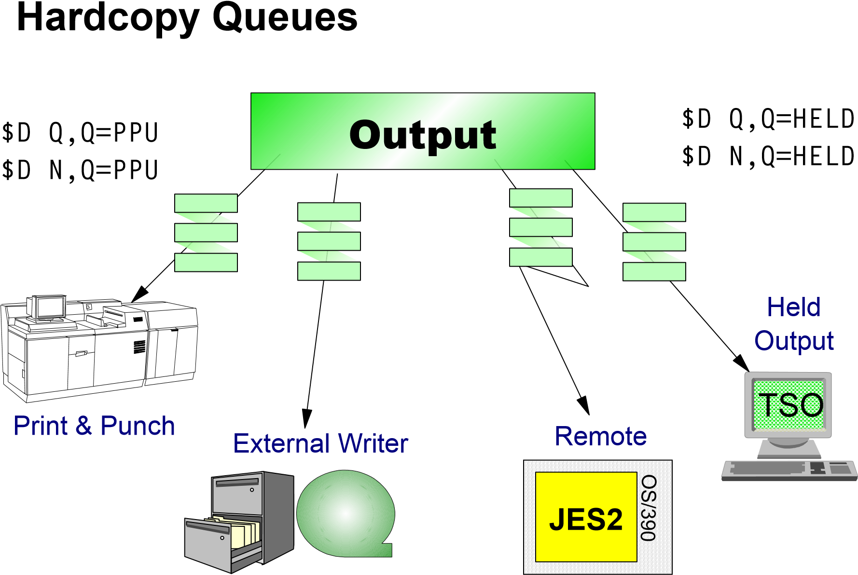

Output Processing
//...
//OUT DD SYSOUT=Q,
// DEST=LOCAL,
// FORMS=4711,
//...
/* OUTPUT ...
/* ROUTE PRINT ...
/* XMIT MVS.TSOUR1
OUTDEF ..
OUTCLASS (Q)
OUTPRTY
JCL Definitions
JCL User Control
JES2 Init
GROUPID
FORMS
CARRIAGE (FCB)"ADDRESS"
FLASH
SETUP REQUIREMENTS
DESTINATION
DATA TYPE
TRAIN (UCS)
...
BURSTER
...
WRITER NAME
...
Job
Output
Element
GROUPID.JOE1.JOE2
$D OUTDEF
$D OUTPRTY
$D
OUTCLASS(x)
Output Commands
$L xx
List Output for jobname
$O JQ'jobname'
Release a HOLD Output
$D O JQ'jobname'
Display Output Groups for jobname

SDSF Output
Display Filter View Print Options Help
-------------------------------------------------------------------------------
SDSF OUTPUT ALL CLASSES ALL FORMS LINES 2,993 LINE 1-15 (24)
PREFIX=* DEST=(ALL) OWNER=*
NP JOBNAME JOBID OWNER PRTY C FORMS DEST TOT-REC
TSS00014 JOB00691 TSS0001 144 A CHECKS LOCAL 54
PRT2PRT JOB00699 TSS0001 144 A STANDARD LOCAL 50
ASMRMT JOB00705 TSS0001 144 A STANDARD R1 103
TSS00011 JOB00688 TSS0001 144 A 2PRT R14 11
TSS00012 JOB00689 TSS0001 144 B STANDARD LOCAL 3
TSS0001B JOB00698 TSS0001 144 B STANDARD LOCAL 3
VMRTE JOB00700 TSS0001 144 B STANDARD ESSMVS1 45
COMMAND INPUT ===> SCROLL ===> PAGE F1=HELP F2=SPLIT F3=END F4=RETURN F5=IFIND F6=BOOK
F7=UP F8=DOWN F9=SWAP F10=LEFT F11=RIGHT F12=RETRIEVE

SDSF - Held Output
Display Filter View Print Options Help
-------------------------------------------------------------------------------
SDSF HELD OUTPUT DISPLAY ALL CLASSES LINES 88 LINE 1-2 (2)
PREFIX=* DEST=(ALL) OWNER=*
NP JOBNAME JOBID OWNER PRTY C ODISP DEST TOT-REC TOT-
TSS0001B JOB00698 TSS0001 144 Q HOLD LOCAL 61
TSS00013 JOB00690 TSS0001 144 Q HOLD LOCAL 27
Display Filter View Print Options Help
-------------------------------------------------------------------------------
SDSF HELD OUTPUT DISPLAY ALL CLASSES LINES 88 LINE 1-2 (2)
PREFIX=* DEST=(ALL) OWNER=*
NP JOBNAME TOT-PAGE FORMS FCB STATUS UCS WTR FLASH BURS
TSS0001B STANDARD **** **** **** NO
TSS00013 STANDARD **** **** **** NO
Display Filter View Print Options Help
-------------------------------------------------------------------------------
SDSF HELD OUTPUT DISPLAY ALL CLASSES LINES 88 LINE 1-2 (2)
PREFIX=* DEST=(ALL) OWNER=*
NP JOBNAME FLASH BURST PRMODE RMT NODE SECLABEL O-GRP-N OGID1 OGID2 JP
TSS0001B **** NO LINE 1 1 1 1 1
TSS00013 **** NO LINE 1 1 1 1 1

Purging TSO Held Output
$O JOBQ,Q=T,DAYS>5,CANCEL
Save SPOOL Space
Purges TSO Held Output (Class=T)
Older than 5 Days
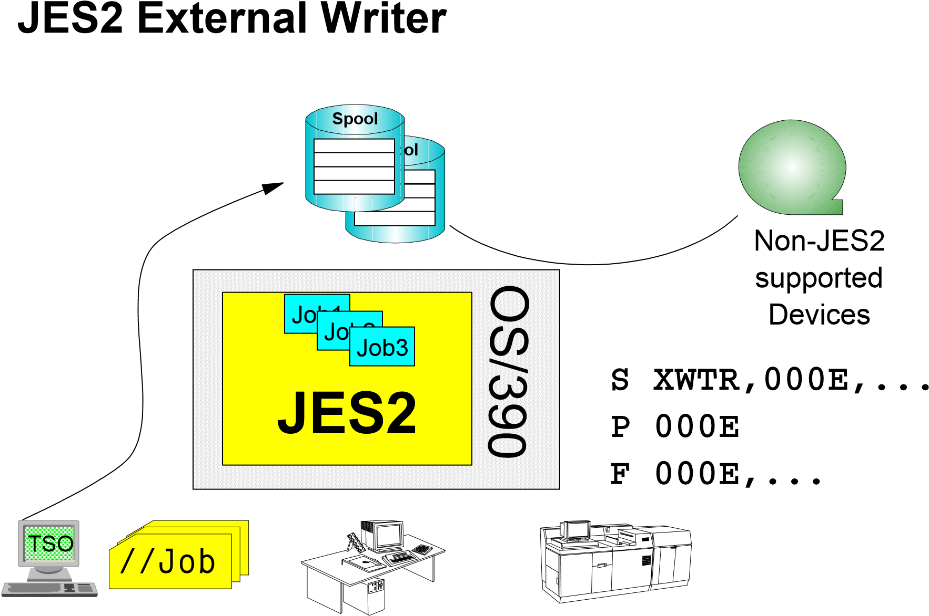

SDSF - Syslog
Display Filter View Print Options Help
-------------------------------------------------------------------------------
SDSF SYSLOG 292.101 SYS1 SYS1 10/18/1999 LINE 0 COLUMNS 51 130
COMMAND INPUT ===> SCROLL ===> CSR
********************************* TOP OF DATA **********************************
0000 IEE042I SYSTEM LOG DATA SET INITIALIZED
0290 CONTROL M,UEXIT=N IEAVN701 - INTERNALLY ISSUED K M
0290 IEA371I SYS1.PARMLIB ON DEVICE 0690 SELECTED FOR IPL PARAMETERS
0290 IEA246I LOAD ID 28 SELECTED
0290 IEA246I NUCLST ID 00 SELECTED
0290 IEA519I IODF DSN = SYS1.IODF00
0290 IEA520I CONFIGURATION ID = SPST . IODF DEVICE NUMBER = 0690
0290 IEA091I NUCLEUS 1 SELECTED
0290 IEA093I MODULE IEANUC01 CONTAINS UNRESOLVED WEAK EXTERNAL REFERENCE
IFFIOM
0290 IEA093I MODULE IEANUC01 CONTAINS UNRESOLVED WEAK EXTERNAL REFERENCE
IEDQATTN
0290 IEA093I MODULE IEANUC01 CONTAINS UNRESOLVED WEAK EXTERNAL REFERENCE
IECTATEN
0290 IEA370I MASTER CATALOG SELECTED IS M.OSES28
0290 IEE252I MEMBER IEASYM00 FOUND IN SYS1.PARMLIB
0290 *IEA247I USING IEASYS28 FOR OS/390 02.06.00 HBB6606
F1=HELP F2=SPLIT F3=END F4=RETURN F5=IFIND F6=BOOK
F7=UP F8=DOWN F9=SWAP F10=LEFT F11=RIGHT F12=RETRIEVE

SDSF - Userlog
Display Filter View Print Options Help
-------------------------------------------------------------------------------
SDSF ULOG CONSOLE TSO0 LINE 0 COLUMNS 21- 100
COMMAND INPUT ===> SCROLL ===> CSR
********************************* TOP OF DATA **********************************
13:11:16.62 ISF031I CONSOLE TSO0 ACTIVATED
13:11:34.69 -D U,,,0690,1
13:11:34.72 IEE457I 13.11.34 UNIT STATUS 178
UNIT TYPE STATUS VOLSER VOLSTATE
0690 3390 S-SPD OSES28 STRG/RSDNT
13:11:43.19 -$SPRT1
13:11:43.20 $HASP627 PRT1 NOT AVAILABLE
13:11:54.49 -$PI(A)
13:11:54.50 $HASP892 INIT(1) STATUS=DRAINED,CLASS=A,NAME=A,ASID=0
13:12:09.81 -S OP10
13:12:25.99 -$CJ93,P
13:12:26.02 JOB00093 $HASP890 JOB(TSO0L1)
$HASP890 JOB(TSO0L1) STATUS=(AWAITING OUTPUT),CLASS=1
$HASP890 PRIORITY=9,SYSAFF=(ANY),HOLD=(NO
$HASP890 PURGE=YES,CANCEL=YES
13:12:26.79 -$CJ315,P
13:12:26.80 JOB00315 $HASP890 JOB(TSO0L1)
F1=HELP F2=SPLIT F3=END F4=RETURN F5=IFIND F6=BOOK
F7=UP F8=DOWN F9=SWAP F10=LEFT F11=RIGHT F12=RETRIEVE

SDSF - Scheduling Environment
Display Filter View Print Options Help
------------------------------------------------------------------------------
SDSF SCHEDULING ENVIRONMENT DISPLAY MAS SYSTEMS
LINE 1-9 (9)
COMMAND INPUT ===> SCROLL ===> PAGE
PREFIX=* DEST=(ALL) OWNER=*
NP SCHEDULING-ENV DESCRIPTION
SYSTEM
BATCH_DFLT Default Batch SC64
BATCH_PROD Production Batch SC63
CICS_DEV Development CICS active SC64
CICS_PROD Production CICS active SC63
NO_CICS_DEV Development CICS inactive SC63
NO_CICS_PROD Production CICS inactive
OVERNIGHT Over Night (1800 - 0700)
PRIMESHIFT Prime Shift (0800 - 1700) SC63,SC64
SANDBOX Test Sysplex: SC63 and SC64 SC63,SC64
F1=HELP F2=SPLIT F3=END F4=RETURN F5=IFIND F6=BOOK
F7=UP F8=DOWN F9=SWAP F10=LEFT F11=RIGHT F12=RETRIEVE

SDSF - Resource Panel
Display Filter View Print Options Help
------------------------------------------------------------------------------
SDSF RESOURCE DISPLAY MAS SYSTEMS LINE 1-11 (11)
COMMAND INPUT ===> SCROLL ===> PAGE
PREFIX=* DEST=(ALL) OWNER=*
NP RESOURCE SC63 SC64
BATCH_DFLT OFF ON
BATCH_PROD ON OFF
CICSD01 OFF ON
CICSD02 OFF ON
CICSD03 OFF ON
CICSP01 ON RESET
CICSP02 ON RESET
OVERNIGHT RESET RESET
PRIMESHIFT ON ON
SC63 ON ON
SC64 ON ON
F1=HELP F2=SPLIT F3=END F4=RETURN F5=IFIND F6=BOOK
F7=UP F8=DOWN F9=SWAP F10=LEFT F11=RIGHT F12=RETRIEVE

SPOOL Management Commands












Display Defintion and Utilization
SPOOL1
SYS1.HASPACE
SPOOL2
SYS1.HASPACE
SPOOL3
SYS1.HASPACE
$D SPOOLDEF
$D SPL(volser)
Start/Add a SPOOL Volume
$S SPL(volser)
Stop/Remove a SPOOL Volume
$P SPL(volser)
Stop a SPOOL Volume an delete all Job Output on it
$P SPL(volser),CANCEL
Display all Jobs >nn% on SPOOL
$D JOBQ,SPOOL=(PERCENT>=nn)

SPOOL Volume States
STATUS | IN USE | ALLOCATABLE | SELECTABLE
STARTING ACTIVE  DRAINING  DRAINED  HALTING  INACTIVE | NO  YES  YES  NO  YES  NO | NO  YES  NO  NO  NO  NO | NO  YES  YES  NO  NO  NO
IN USE Active jobs may be using spool space on volume

ALLOCATION SPOOL space may be allocated on volume

SELECTABLE Jobs that have SPOOL space on the volume may be selected for JES2 processing

Managing JES2 SPOOL Utilization
$HASP050 JES2 TGs 80%
UTILIZATION REACHED
How much SPOOL is allocated?
What Jobs using large amounts of SPOOL?
$HASP375 jobname ESTIMATE EXCEEDED BY ... ?
Are all of the SPOOL Volumes available?
Recovering SPOOL Space
Delete "old" TSO Output Datasets
Offload SPOOL
Add a Spool Volume
Handling SPOOL I/O Errors
$HASP251 TRACK GRO
UP REMOVED FROM ....
$HASP094 I/O
ERROR ON SPOOL
What jobs have data
on the SPOOL Volume
$D N,ALL,V=volser
Halt SPOOL volume
Drain SPOOL volume
Restart SPOOL volumes

Checkpoint Configuration


$D CKPTDEF 
CKPT1
SYS1.HASPCKP1
CKPT2
SYS1.HASPCKP2
OS
/
3
9
0
JES2



Handling Checkpoint I/O Errors
$HASP291 JES2 CKPT1
DATA SET I/O ERROR
Many Error Messages
Operator dialogs -->
JES2 Messages
Switch Checkpoint Dataset

Fonction de déchargement du SPOOL

Convervation des travaux après redémarrage à froid
Extraction de la totalité du SPOOL pendant les périodes de pointe
Migration vers une autre version de JES2 Conversion en un autre type DASD pour le SPOOL
Sauvegarde des connexions réseau
Archivage des travaux et des datasets
SYSOUT
Sauvegarde des datasets du SPOOL

Offloading Jobs / SYSOUT to Device 1




OFF1.JT
SYS1.HASPACE
OFFLOAD(1)
DSN=dataset1
, ...
OFFLOAD(2)
DSN=dataset2
, ...
OFFLOAD1
OFFLOAD2
Spool
OFF2.JT
OFF1.ST
OFF2.ST

OFF1.JR

OFF2.JR OFFLOAD8

OFFLOAD(8)
OFF1.SR DSN=dataset8, ...
OFF2.SR

Offload Example Commands

$T OFF1.JT,CLASS=...,CREATOR=
$T OFF1.JT,WS=(-CL)
$T OFF1.ST,JOB=.......,CREATOR=,MOD=
$T OFF1.ST,WS=(-Q)
$T OFFLOAD(1),DSN=...,UNIT=....
$S OFFLOAD1,TYPE=TRANSMIT
INITIALIZATION STATEMENTS
OFF(1).JT | CLASS=...,DISP=DELETE,START=YES, VOLUME=volid,WS=(/),...
OFF(1).ST | DISP=DELETE,START=YES,QUEUE=..., VOLUME=volid,WS=(/),...
OFFLOAD(1) | DSN=...,LABEL=SL,PROTECT=NO,  UNIT=...

Reloading Jobs / SYSOUT from Device 1

OFF1.JT
OFF2.JT
OFF1.ST
OFF2.ST
OFF1.JR
OFF2.JR
OFF1.SR
OFF2.SR
OFFLOAD(1)
DSN=dataset1
, ...
OFFLOAD(2)
DSN=dataset2
, ...
OFFLOAD(8)
DSN=dataset8
, ...
OFFLOAD1
OFFLOAD2
OFFLOAD8

SYS1.HASPACE
Spool

Reload Example Commands

$T OFF1.JR,WS=(-CL),CLASS=...,RANGE...,CREATOR=
$T OFF1.SR,WS=(-Q),JOB...,FORMS=...,CREATOR=,MOD= $T OFFLOAD(1),DSN=...,UNIT...
$S OFFLOAD1,TYPE=RECEIVE
INITIALIZATION STATEMENTS
OFF(1).JR | CLASS=...,START=YES,RANGE...,  WS=(/),...
OFF(1).SR | START=YES,QUEUE=...,  WS=(/),...
OFFLOAD(1) | DSN=...,LABEL=SL,PROTECT=NO,  UNIT=...

Résumé

Input: Reader and Internal Reader
Execution: Initiator and Jobs
Output: Printer and Output
Syslog
SPOOL and Checkpoints
SPOOL Offload

Objectifs

JES2 et WLM (Work Load Manager)
JES2 dans un sysplex z/OS Print Server
NJE, RJE et SNA
Améliorations apportées à JES2

JES2 WLM Batch Support
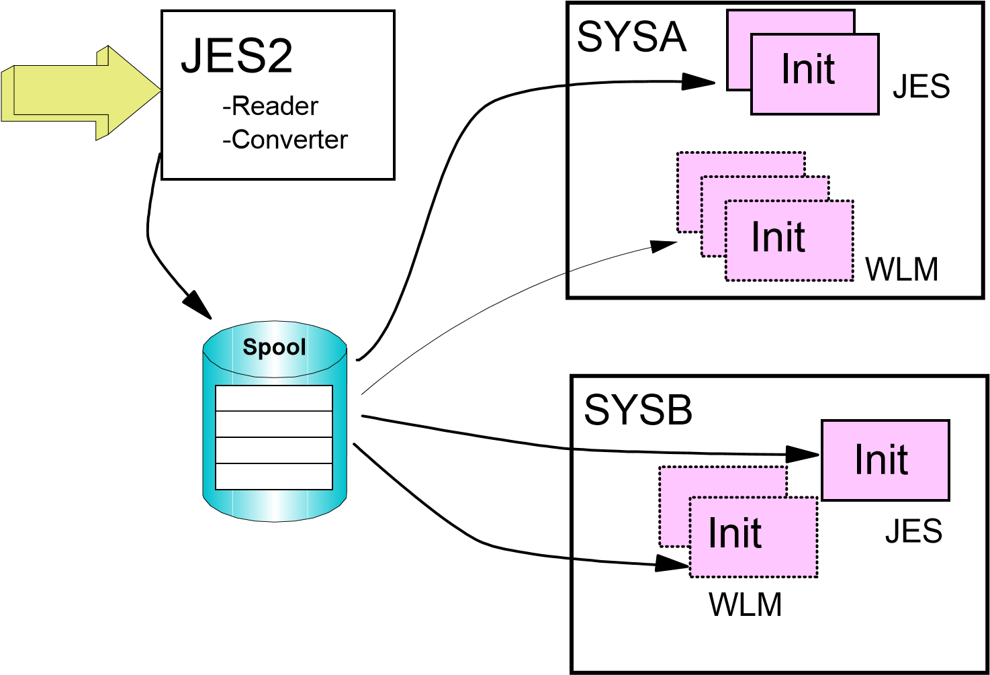

Initiator Overview JES vs. WLM

JES2 Initiators
Select jobs from JES-managed job classes only
Started and stopped by operators Active in goal and compatibility modes Consume job numbers

WLM Initiators
Select jobs from
WLM-managed job classes only
Started and stopped by WLM based on
Available capacity
Goals
Active in goal mode only Started under MSTR subsystem, so they do not consume job numbers

Batch Job Flow
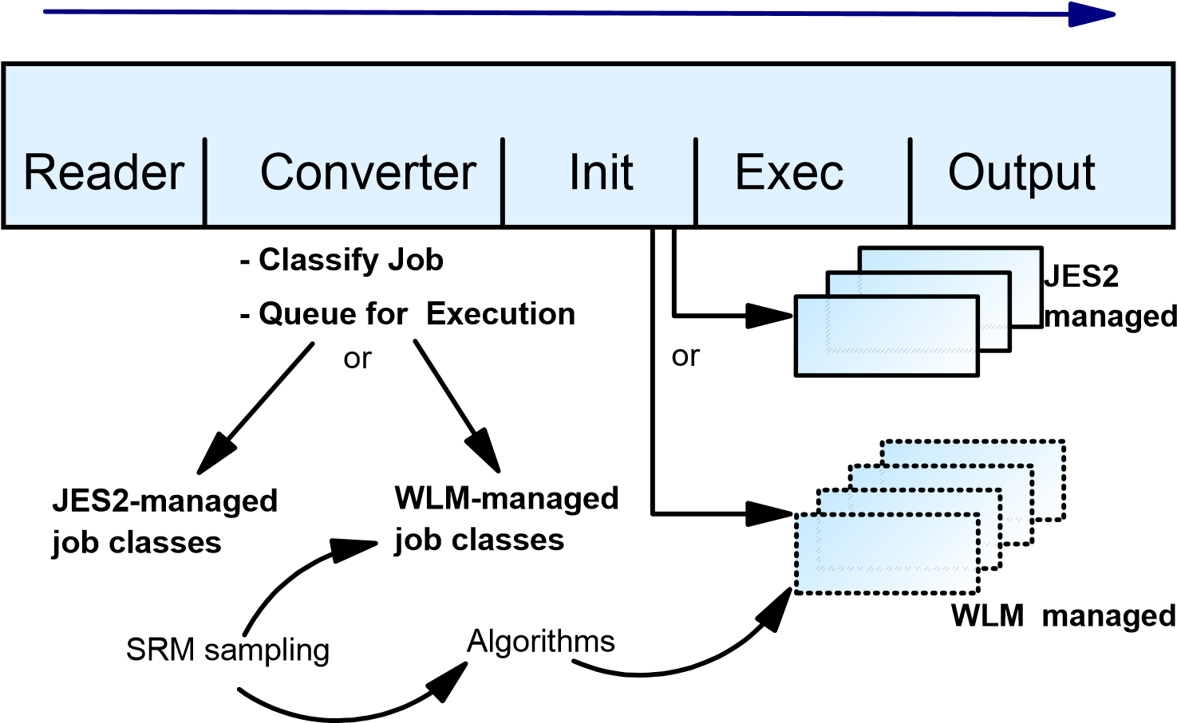

WLM Managed Job Queuing
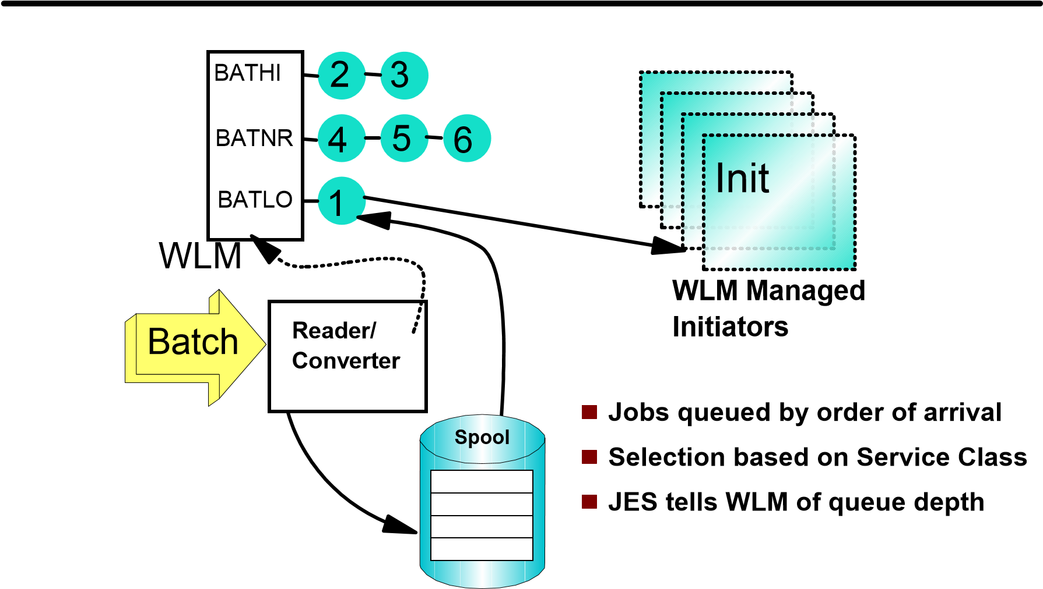

Pre-Execution Job Delays
Reader | Job  ^{Conv}delay | Init | Exec | Output
Operational Delays job class held spool held
TYPRUN=HOLDjob queue held
JES Scheduling Delays
Response time in OS/390 V2 duplicate jobname
(^{TYPRUN=JCLHOLD}no conversion)job class execution limits
Resource Delays
resource affinity scheduling
Execution Delays
waiting for an initiator

Controlling Job Initiation
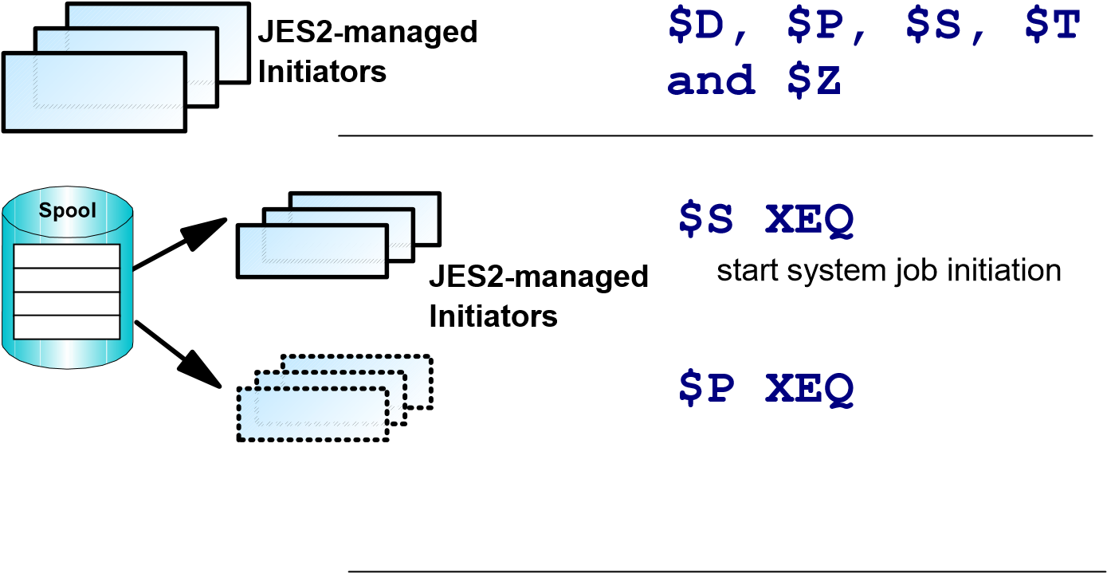
WLM-managed stop system job initiation
Initiators
WLM-managed start job immediately
job a
$SJ
Spool
job a
Initiator started
WLM selects system

Sysplex Overview
Sysplex
CFRM
1
12
2
3
4
5
6
7
8
9
10
11
X
C
F
/
X
E
S
X
C
F
/
X
E
S
SYSA
SYSB
Sysplex Timer
Coupling Facility
Couple Data Sets

JES2 in a Sysplex
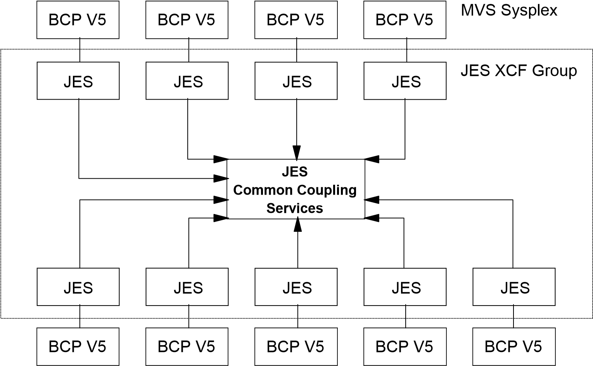

JES2 Checkpoint in a Sysplex
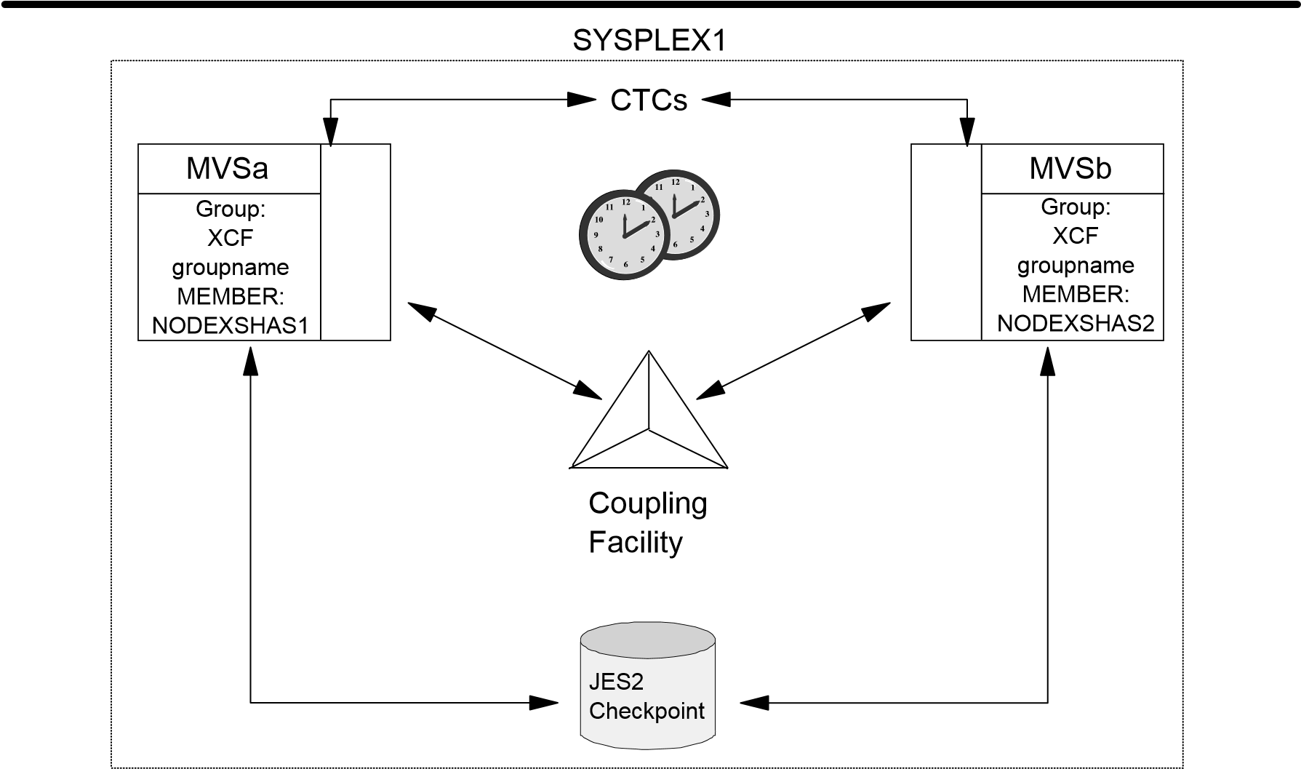

Benefits from Use of the CF

Common Time
High-Speed Messaging Service
Monitor System and Adress Space Events and Status
Performance Improvement in accessing the Checkpoint
Less Contention
Recovery Dialog Improvements

OS/390 Print Server
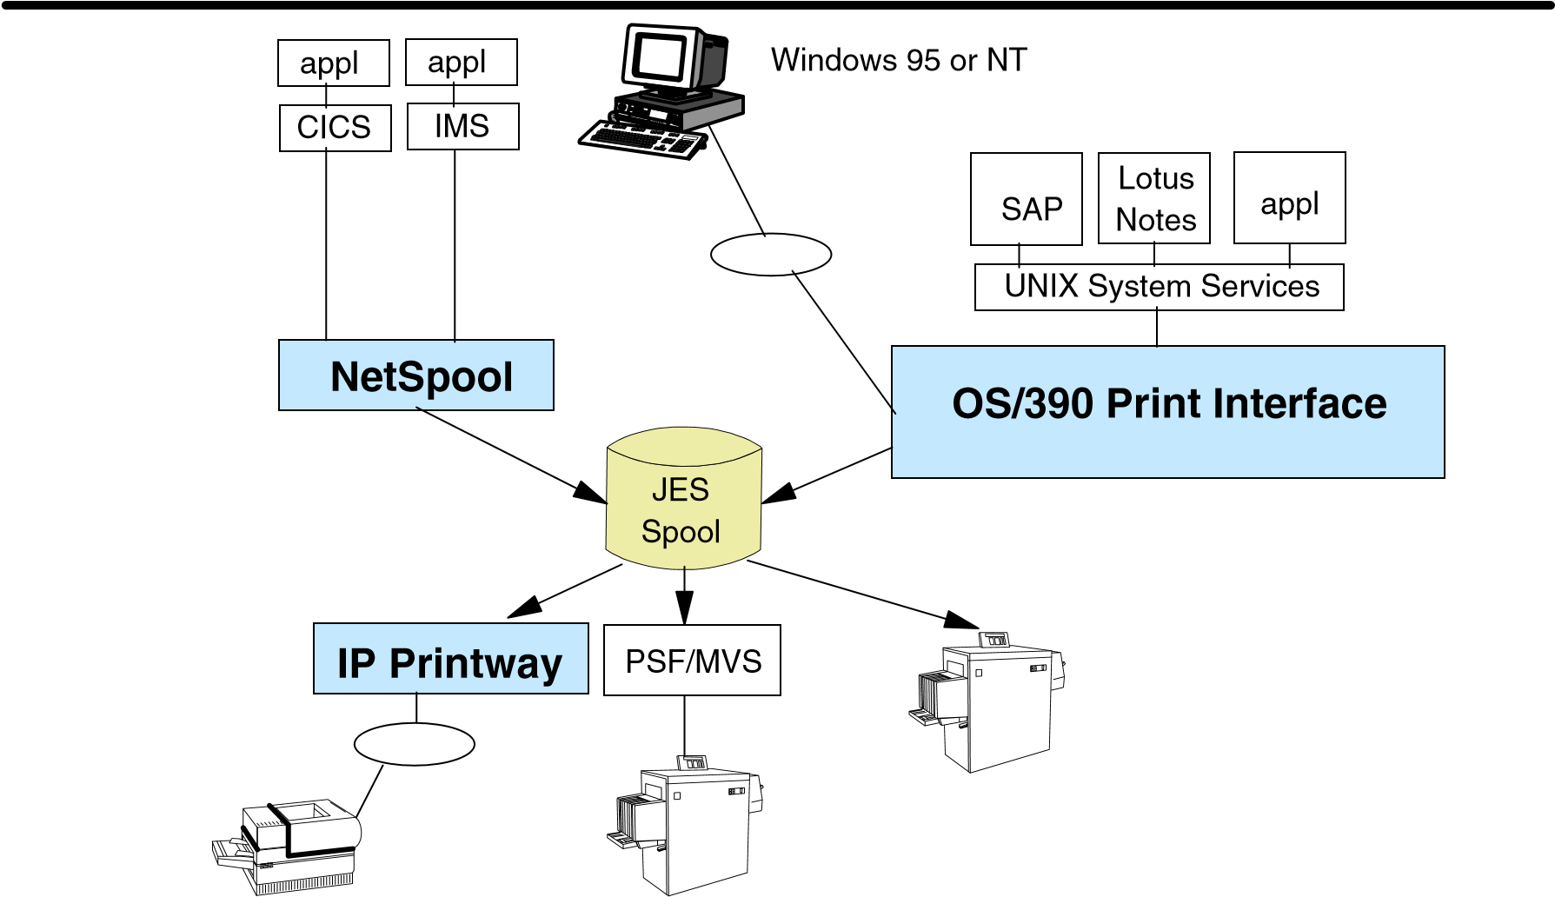

OS/390 Print Interface
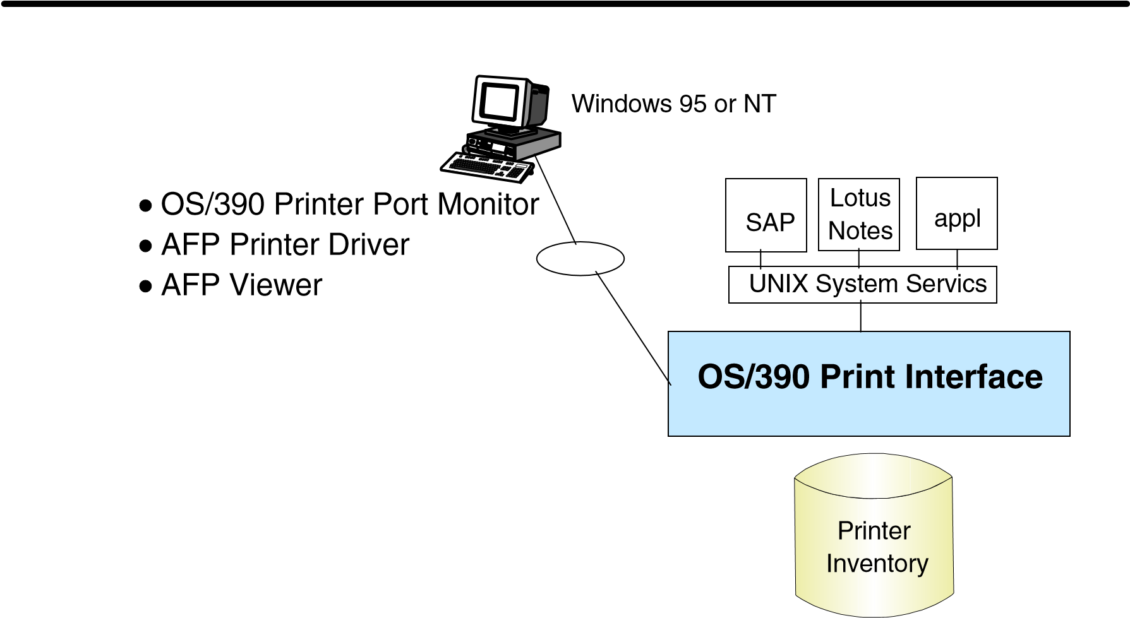

Printing Documents from UNIX Applications
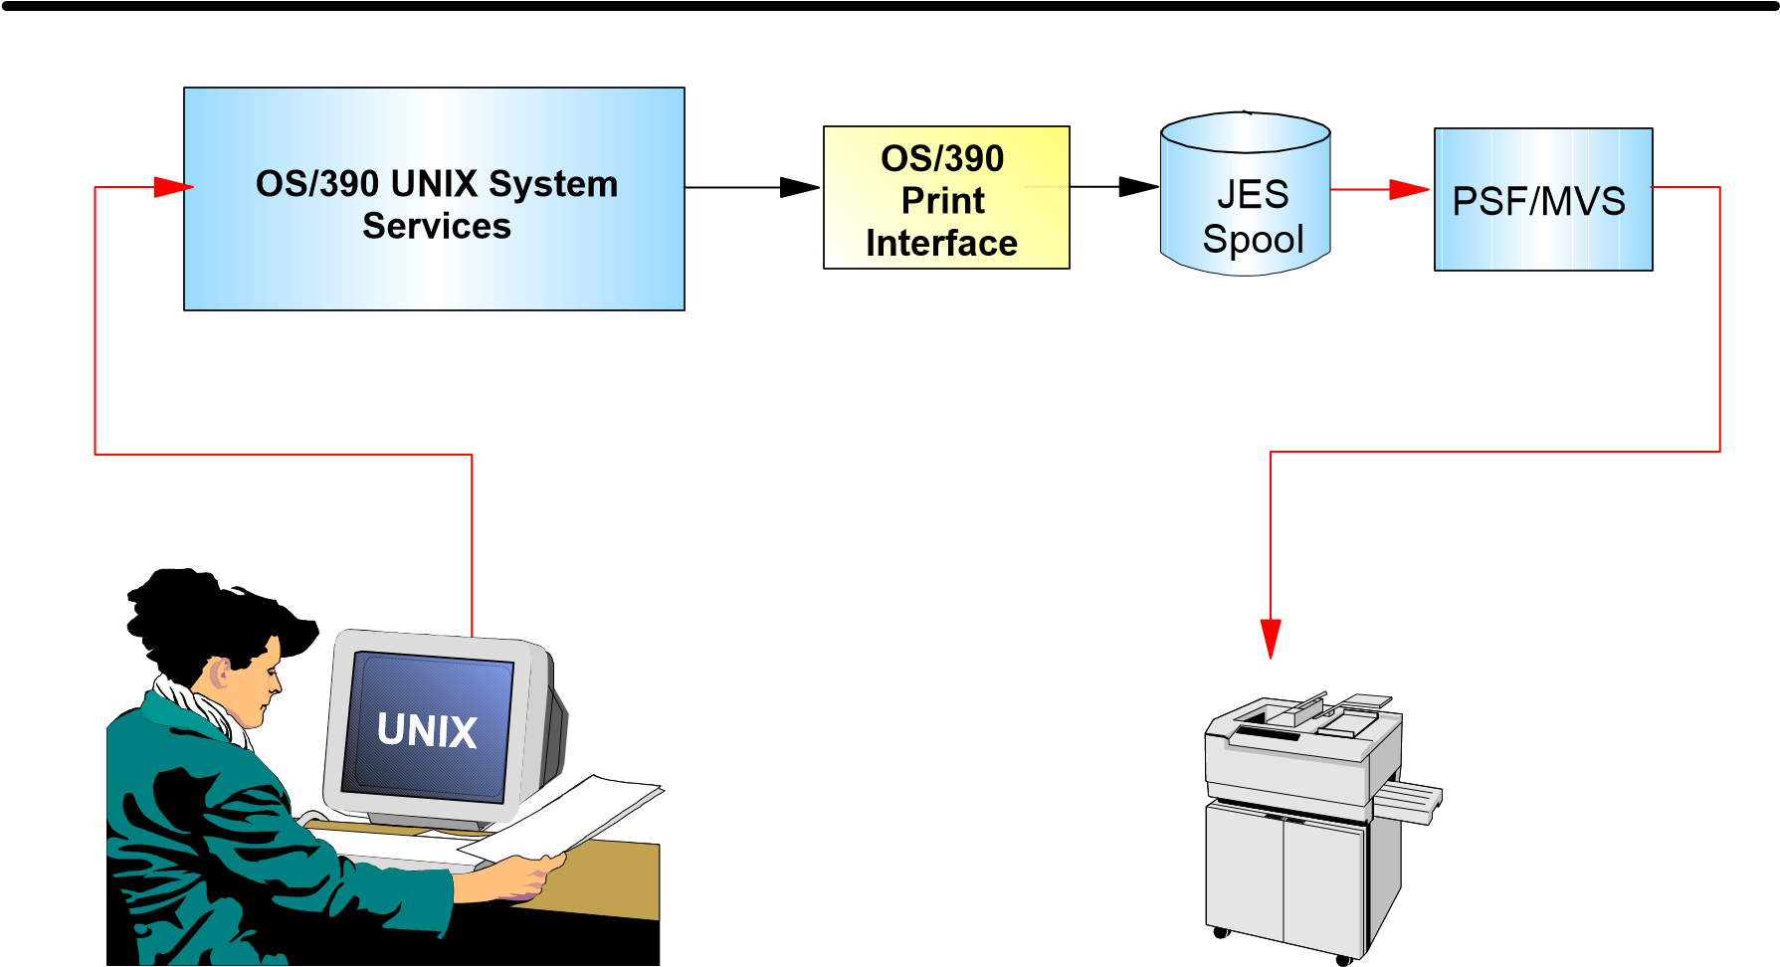

Printing Documents from Windows
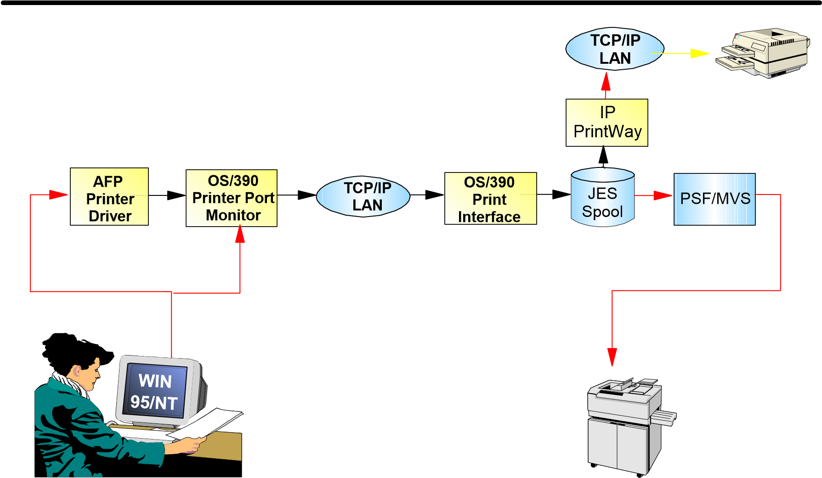

Viewing/Printing Documents from Web
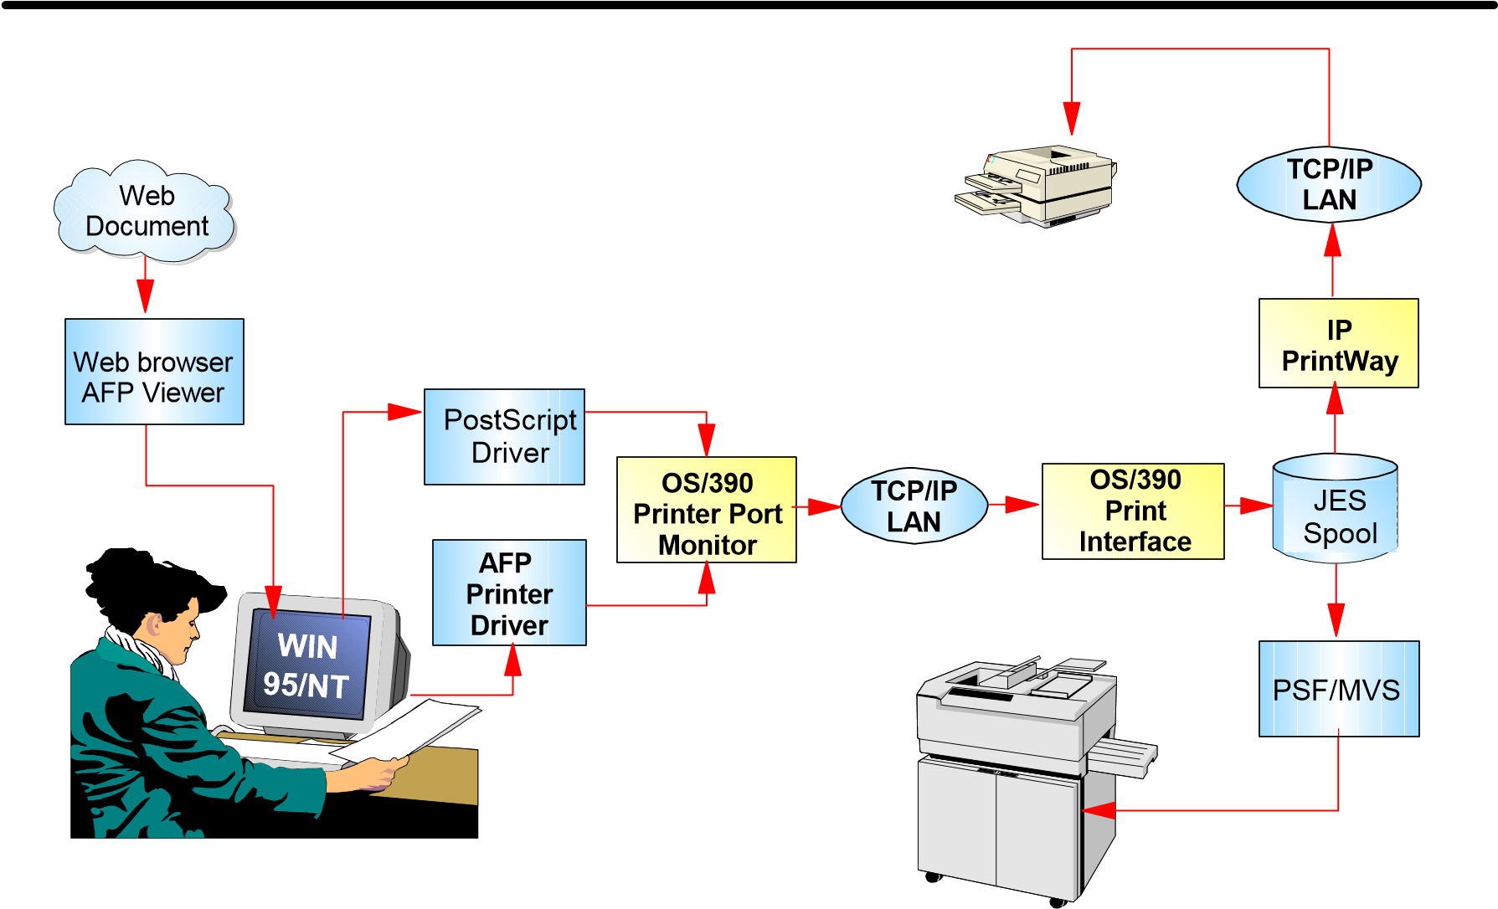

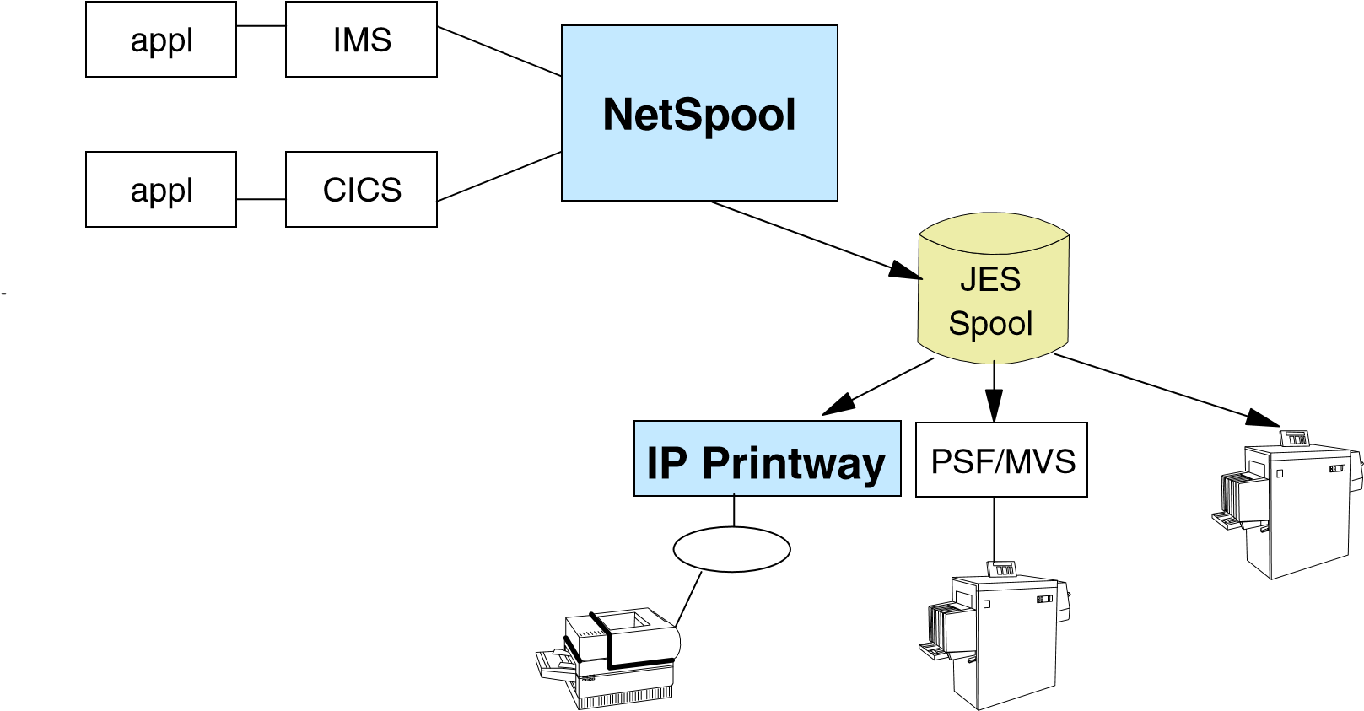
NetSpool and IP Printway

Automated Network Printing
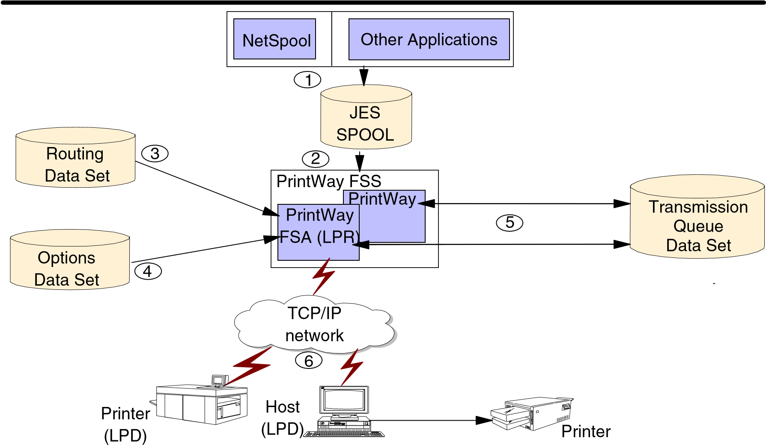

Job Network Example
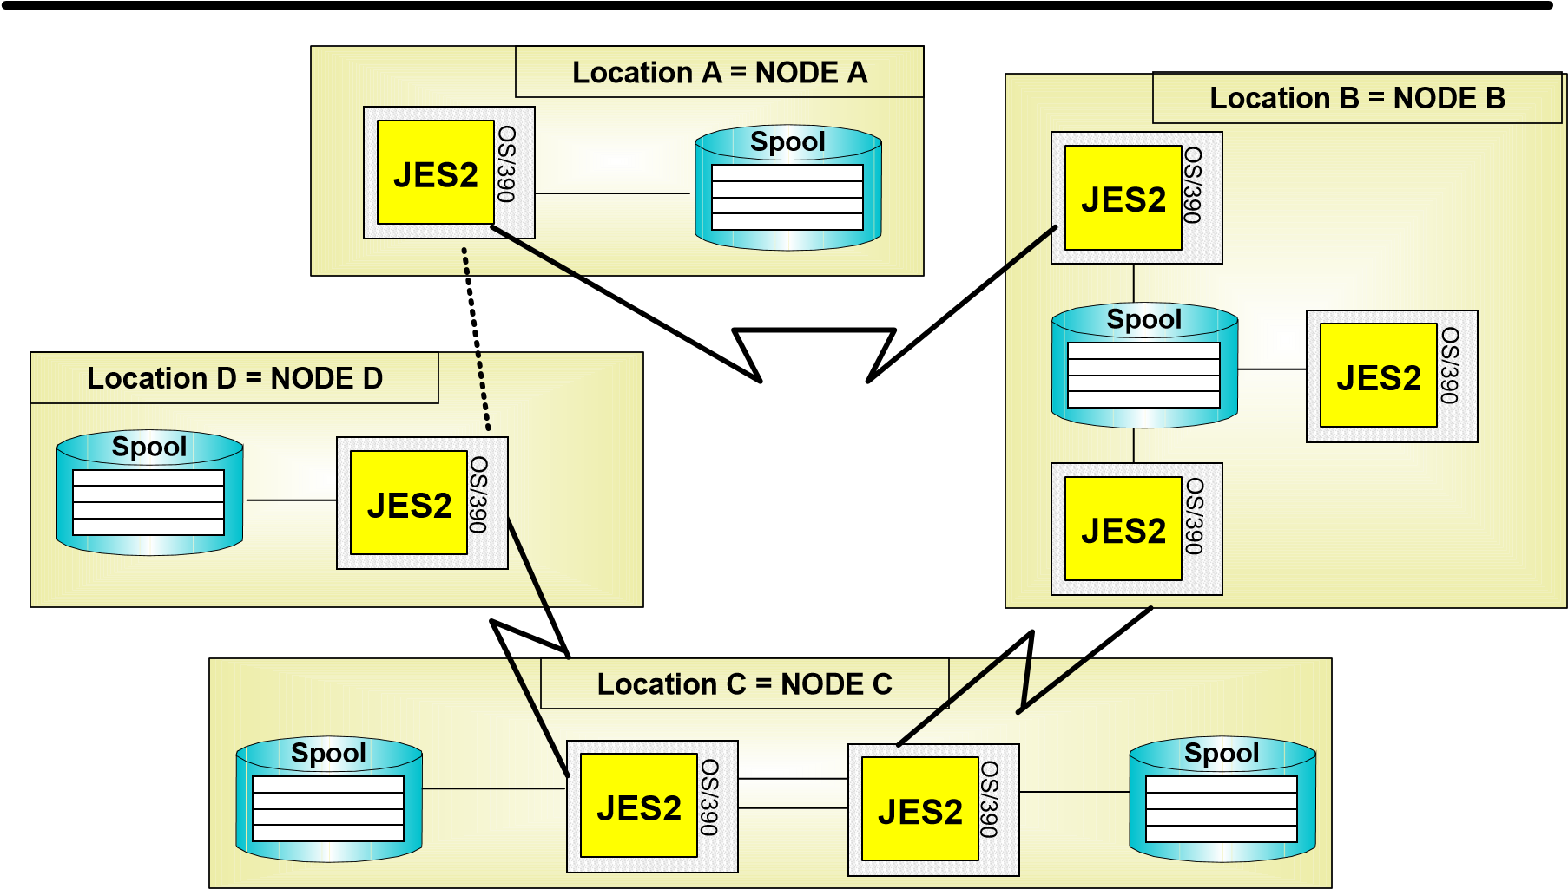

Job Network with Communication Controllers
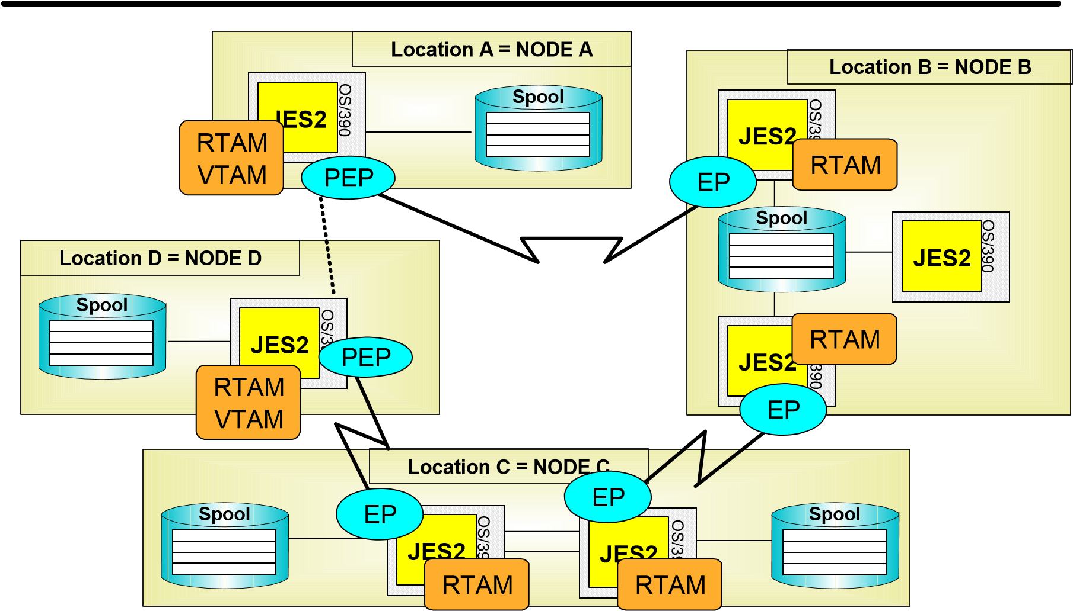

Data Flow across BSC Connections

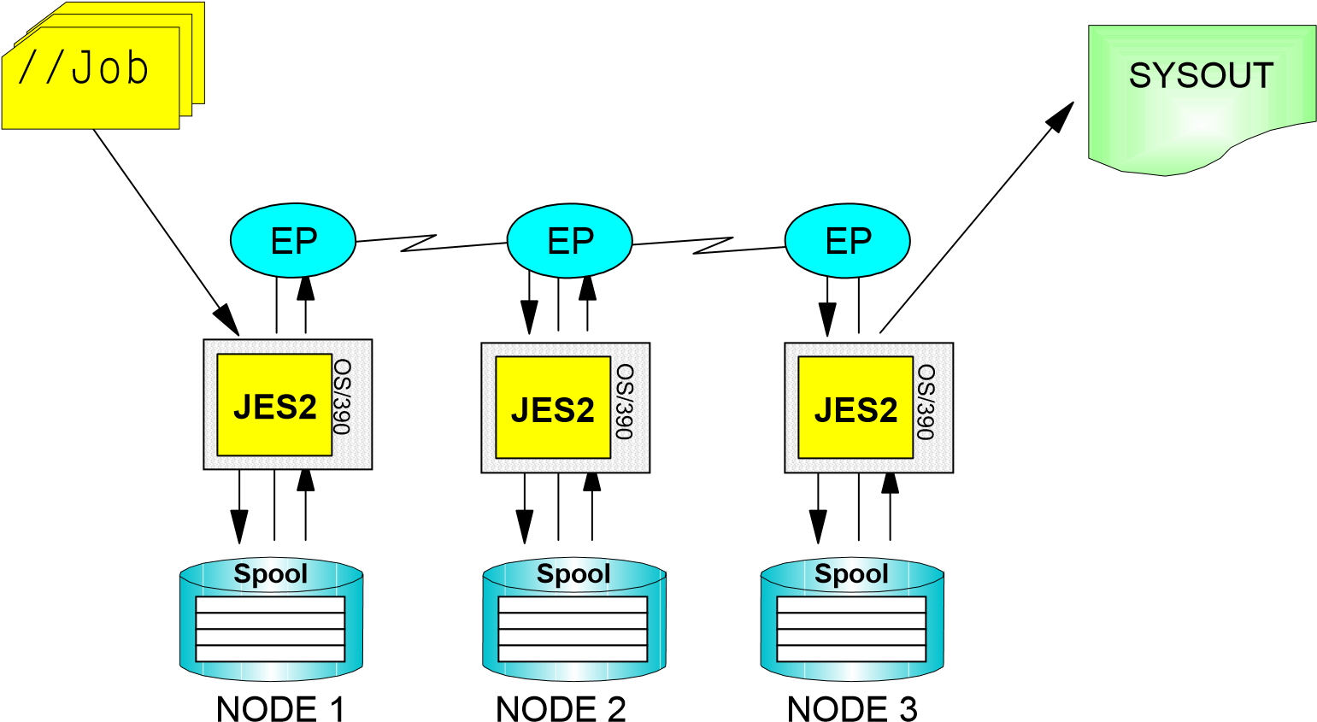

Data Flow across SNA Sessions

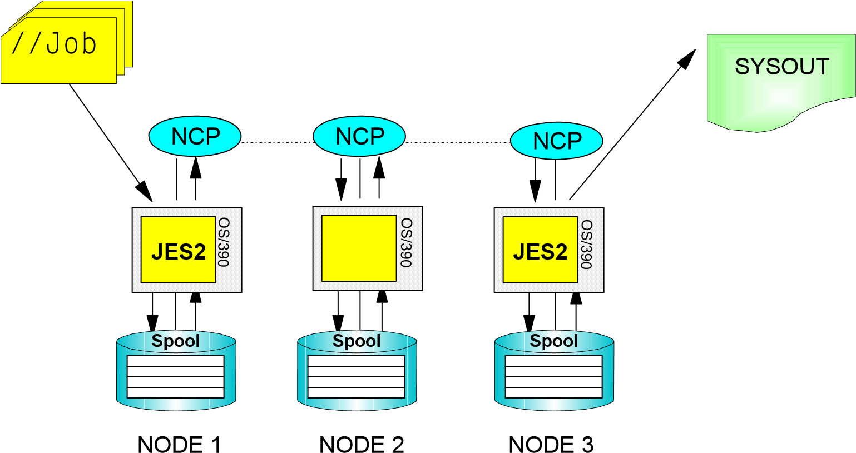

Activating a BSC / CTCA Connection

Spool
O
S
/
3
9
0
JES2
Spool
O
S
/
3
9
0
JES2
$S LNE1  $HASP000 OK | $S LNE1  $HASP0000 OK
$S N,LNE1
$HASP200 PLACEC STARTED ON LINE1
$S N,LNE1
$HASP200 PLACED STARTED ON LINE1

Activating an SNA Session

O
S
/
3
9
0
JES2
Spool
Spool
O
S
/
3
9
0
JES2
$S LGN1  $HASP000 OK | $S LGN1  $HASP0000 OK
$S LNE2  $HASP000 OK | $S LNE1  $HASP000 OK
$S N,LNE2,A=PLACEA
$HASP200 PLACEA STARTED ON LINE2
SESSION PLACEA
$S N,LNE1,A=PLACED
$HASP200 PLACED STARTED ON LINE1
SESSION PLACED

NJE Operator Commands

$E LGNn
Immediately interrupt and restart the JES2/VTAM interface in case of SNA
$P LGNn
Stop the JES2/VTAM interface in case of SNA
$T LGNn,E=.,TR=.
Diagnose SNA problems
$E LNEn
Immediately interrupt and restart a connection
$P LNEn
Stop a connection
$T LNEn,D=
Interrupt a connection at the end of the current job or SYSOUT transmission
$T LNEn,E=.,TR=.
Diagnose line problems
$E Ln.JT
$P Ln.ST
$S Ln.JR
$TNODE(x),TRANSMIT={JOBS|SYSOUT|NONE|BOTH},RECEIVE={JOBS|SYSOUT|NONE|BOTH}

NJE Operator Commands (new)
$TNODE(x),TRANSMIT={JOBS|SYSOUT|NONE|BOTH}
Selectivly transmit for a specific node number x
$TNODE(x),RECEIVE={JOBS|SYSOUT|NONE|BOTH}
Selectivly receive from a specific node number x
$TNODE(nodename)
Set commands using symbolic nodenames
$ADD CONNECT
Add a static connection
$DEL CONNECT
Delete an existing static connection

$T CONNECT
Change characteristics for an existing static connection
$D CONNECT
Diplay information about an existing static connection
$D SUBNET
Display all nodes belonging to a specific SUBNET
$D PATH
Display the existing pathes to a specific node

Specifying the Execution Node under NJE

By the user with a JECL statement
/*RouteXEQ node-name
/*XEQ node-name
/*XMIT node-name

By the system programmer via initialization statements By the JES2 operator
R(nnnn).RD(m) XEQNODE=nnnn,...
$R XEQ,J=jobname,D=node-name
$G R node-name,XEQ,'jobname',D=node-name

Routing SYSOUT Data under NJE

By the user via JCL statements
//ddname DD SYSOUT=A,DEST=node-name
//name OUTPUT DEST=node-name

By the user via JCL statements By the system programmer via initialization statements By the JES2 operator By another JES2 operator with
/*ROUTE PRINT node-name
R(nnnn).RD(m) PRNODE=nnnn,PUNODE=nnnn
$R ALL,D=node-name
$G R node-name,OUT,'jobname',D=node-name

Routing Messages and Commands through the Network

Routing Messsages Routing Commands to a JES2 Node
$D M,D=node-name,'msg-text'
$R,D=node-name;Command
$Rnode-number;Command
Routing Commands to Any Node
$G global command

JES2 Enhancements by Release
OS/390 Release 1
Spool Offload Enhancements
OS/390 Release 3
SYSOUT App. Pgmg Interface (SAPI)
OS/390 Release 4
Workload Manager Support for Batch Initiators
Resource Affinity Scheduling
Command Enhancements
Constraint Relief: 32K Nodes, RMTs, Lines, PRTs, Unnnnn, 64K Jobs (OW20844)
OS/390 Release 5
Print Server Support
OS/390 Release 7
FiCon (Fibre Connection) Support
OS/390 Release 8
CF rebuild for checkpoint structure

SDSF Enhancements
Display Filter View Print Options Help
-------------------------------------------------------------------------------
HQX1900------------------ SDSF PRIMARY OPTION MENU --------------------------
COMMAND INPUT ===> SCROLL ===> PAGE
LOG - Display the system log Punch Display DA - Display active users in the sysplex Reader Display
I - Display jobs in the JES2 input queue O - Display jobs in the JES2 output queue Default log panel
H - Display jobs in the JES2 held output queue Security conversion assist facility
ST - Display status of jobs in the JES2 queues Scheduling Environment Display
PR - Display JES2 printers on this system Resource Display INIT - Display JES2 initiators on this system Job Information Display
MAS - Display JES2 members in the MAS LINE - Display JES2 lines on this system Job Class Display
NODE - Display JES2 nodes on this system
SO - Display JES2 spool offload for this system
PUN - Display JES2 punches on this system
RDR - Display JES2 readers on this system
JC - Display job classes in the MAS
SE - Display scheduling environments in the MAS or sysplex
RES - Display WLM resources in the MAS or sysplex
F1=HELP F2=SPLIT F3=END F4=RETURN F5=IFIND F6=BOOK
F7=UP F8=DOWN F9=SWAP F10=LEFT F11=RIGHT F12=RETRIEVE

Controlling Job Initiation

Batch Initiators may be managed by WLM on a job class basis
JOBCLASS(x) MODE=WLM
Jobs in WLM-mode job classes queued by WLM service class

Traditional JES-managed initiators still exist but will not select from WLM job classes Maximum number of jobs $T JOBCLASS,MODE={WLM|JES}
JOBCLASS(x) MODE=JES
XEQCOUNT= (executed concurrently in a job class)
Change jobs between JES2 and WLM Mode

Controlling Job Initiation

JES2 Initiator Commands
$D I Display
$P I Stop
$S I Start
$T I Assign Job Classes
$Z I Halt
JES2 Initiator and WLM Initiator Commands
$P XEQ Prevent Job Initiation
$S XEQ Resume Job Initiation

Checkpoint Performance

Unneeded I/Os were eliminated if using CF If in DUPLEX Mode
No reads done to CKPT2 data set
Write to CKPT2 (backup data set) only after 10 writes to CKPT1
This may affect customers that only DUPLEX
(DUPLEX=ON) on some members for performance Impact of all members having DUPLEX=ON reduced

Résumé

JES2 et WLM (Work Load Manager)
JES2 dans un sysplex z/OS Print Server NJE, RJE et SNA
Améliorations apportées à JES2

