BEANS
1 pound dried kidney beans or other
red beans
6 cups water
1(13.5-ounce)can cOconut milk, or
2 cups homemade
Coconut Milk
(page 97)
6 garlic cloves:
3 smashed and
peeled, 3 minced
1 teaspoon allspice
berries, crushed
1 yellow onion, diced 5 scallions, thinly sliced 2 teaspoons fresh
thyme leaves
1 Scotch bonnet
pepper
2 teaspoons
kosher salt, plus
more as needed
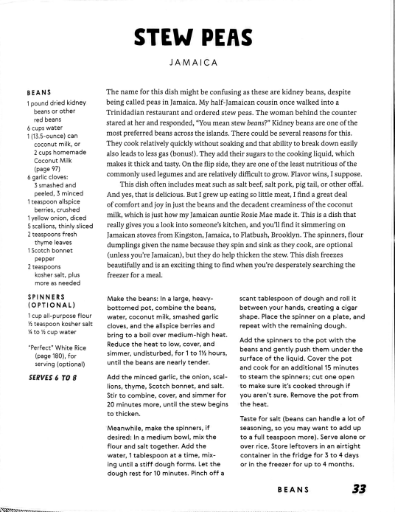
STEW PEAS
JAMAICA
The name for this dish might be confusing as these are kidney beans, despite being called peas in Jamaica. My half-Jamaican cousin once walked into a Trinidadian restaurant and ordered stew peas. The woman behind the counter stared at her and responded, "You mean stew beans?" Kidney beans are one of the most preferred beans across the islands. There could be several reasons for this. They cook relatively quickly without soaking and that ability to break down easily also leads to lessgas (bonus!). They add their sugars to the cooking liquid, which makes it thick and tasty. On the flip side, they are one of the least nutritious of the commonly used legumes and are relatively difficult to grow. Flavor wins, I suppose.
This dish often includes meat such as salt beef, salt pork, pig tail, or other offal. And yes, that is delicious. But I grew up eating so little meat, I find a great deal of comfort and joy in just the beans and the decadent creaminess of the coconut milk, which is just how my Jamaican auntie Rosie Mae made it. This is a dish that really gives you a look into someone's kitchen, and you'll find it simmnering on Jamaicanstoves from Kingston, Jamaica, to Flatbush, Brooklyn. The spinners, flour
dumplings given the name because they spin and sink as they cook, are optional (unless you're Jamaican), but they do help thicken the stew. This dish freezes beautifully and is an exciting thing to find when you're desperately searching the freezer for a meal.
SPINNERS
(OPTIONAL)
1 cup all-purpose flour ½ teaspoon kosher salt ½ to h cup water
"Perfect" White Rice (page 180), for
serving (optional) SERVES 6 TO 8
Make the beans: In a large, heavy bottomed pot, combine the beans, water, coconut milk, smashed garlic cloves, and the allspice berries and bring to a boil over medium-high heat. Reduce the heat to low, cover, and simmer, undisturbed, for 1 to 1% hours, until the beans are nearly tender.
Add the minced garlic, the onion, scal lions, thyme, Scotch bonnet, and salt. Stir to combine, cover, and simmer for 20 minutes more, until the stew begins to thicken.
Meanwhile, make the spinners, if desired: In a medium bowl, mix the flour and salt together. Add the water, 1 tablespoon at a timne, mix ing until a stiff dough forms. Let the dough rest for 10 minutes. Pinch off a
scant tablespoon of dough and roll it between your hands, creating a cigar shape. Place the spinner on a plate, and repeat with the remaining dough.
Add the spinners to the pot with the beans and gently push them under the surface of the liquid. Cover the pot and cook for an additional 15 minutes to steam the spinners; cut one open to make sure it's cooked through if you aren't sure. Remove the pot from the heat.
Taste for salt (beans can handle a lot of seasoning, so you may want to add up to a full teaspoon more). Serve alone or over rice. Store leftovers in an airtight
container in the fridge for 3 to 4 days or in the freezer for up to 4 months.
BEANS 33
Created with Scanner Pro
GRATIN AU CHRISTOPHINE CHEESE-STUFFED CHAYOTES O MARTINIQUE
2 or 3 large chayotes, halved and pitted (see page 80)
1 tablespoon plus ½ teaspoon
kosher salt
3 slices bacon, diced (optional; see Note) 1 small shallot, diced 2 garlic cloves, minced 2 tablespoons
all-purpose flour
½ cup whole milk
There are three recipes for stuffed chayote in this book (you'll find the others on pages 83 and 86), but this version is somewhat unusual in Caribbean cuisine. Generally, dairy is not often the star of most dishes. However, this dish is likely a nod to the French influence, with its dairy and béchamel sauce. Nevertheless, the islands manage to give a little Caribbean tilt to the culinary hat and make it our own. The bacon in this dish is kind of divine, but you can absolutely make it vegetarian-though decidedly not vegan-by omitting the bacon (see Note). Still delicious. Don't skip the breadcrumbs; something about the crunch helps cut all the lavish dairy.
1 tablespoon minced fresh parsley
1 teaspoon fresh
thyme leaves,
minced
Grating of nutmeg Freshly ground
black pepper
% cup grated sharp cheddar cheese
1 tablespoon
breadcrumbs
SERVES 4 TO 6
Note: Ifyou're not using bacon, cook the shallots in 2 tablespoons butter instead of the baconfat.
Place the chayote in a large pot or saucepan and add 1 tablespoon of the salt and water to cover by 1 inch. Turn the heat to high and cook for 20 to 30 minutes, until the chayote is very tender and easily pierced with a fork. Drain the chayote and set aside until cool enough to handle.
Preheat the oven to 350°F.
Scoop the chayote flesh into a bowl with a small spoon, leaving enough behind to keep the fruit intact and
make a vessel. If the skin tears in a few spots during this process, don't worry! The cheesy filling will hide most of the flaws. Using a fork or potato masher,
mash the scooped-out flesh and set it aside. Place the chayote skins in a bak ing dish and set them aside as well.
In a medium saucepan, cook the bacon over medium-high heat until crispy, about 8 minutes. Spoon off about 2 tablespoons of the rendered fat from the pot and discard it (or save it for another use, if bacon fat is your thing!). Add the shallot to the pot and cook in the remaining fat until soft, 3 to 5 minutes. Add the garlic and cook for
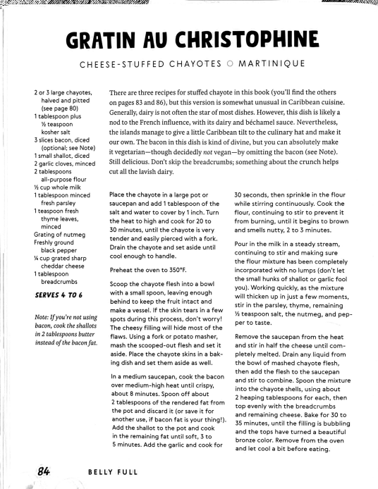
30 seconds, then sprinkle in the flour while stirring continuously. Cook the flour, continuing to stir to prevent it from burning, until it begins to brown
and smells nutty, 2 to 3 minutes.
Pour in the milk in a steady stream, continuing to stir and making sure the flour mixture has been completely incorporated with no lumps (don't let the small hunks of shallot or garlic fool you). Working quickly, as the mixture will thicken up in just a few moments, stir in the parsley, thyme, remaining ½ teaspoon salt, the nutmeg, and pep per to taste.
Remove the saucepan from the heat and stir in half the cheese until com pletely melted. Drain any liquid from
the bowl of mashed chayote flesh, then add the flesh to the saucepan and stir to combine. Spoon the mixture into the chayote shells, using about 2 heaping tablespoons for each, then top evenly with the breadcrumbs and remaining cheese. Bake for 30 to 35 minutes, until the filling is bubbling and the tops have turneda beautiful bronze color. Remove from the oven and let cool a bit before eating.
84
BELLY FULL
Created with Scanner Pro
TAMAL EN CAZUELA
CORNMEAL AND PORK SHOULDER CASSEROLE O CUBA
1½ pounds pork
shoulder, fat
trimmed, cut into 2-inch cubes
6 garlic cloves, minced ½ cup sour orange juice (see page 14) 1 teaspoon dried
oregano
2 teaspoons
kosher salt, plus
more if needed
1 cup cornmeal
h cup corn kernels (cut fresh from
This dish screams "comfort food" and is something your favorite auntie mayhave made. Tamal en cazuela may have originated with the people indigenous to Cuba, and the pork would have been an addition inspired by all the wild pigs that ended up roaming all the islands after they were introduced by the Europeans. It's also easy to see how it would have been adopted by enslaved Africans, who may have been the ones to add the cornmeal. For this recipe, I use the Haitian method of simmering the pork first to make it extra tender and infuse it with flavor (it feels right because, historically, Cuba and Haiti had a close relationship). If you want to keep it traditionally Cuban, be sure to marinate the pork with the garlic, sour orange juice, oregano, and salt for at least an hour, then remove the excess marinade and brown the pork for 4 to 5 minutes per side.
the cob, canned, or frozen)
2 tablespoons extra virgin olive oil
1 small yellow onion, diced
½ green bell pepper, finely diced
2 tablespoons dry white wine
½ cup tomato sauce 2 cups water
SERVES 6 TO 8
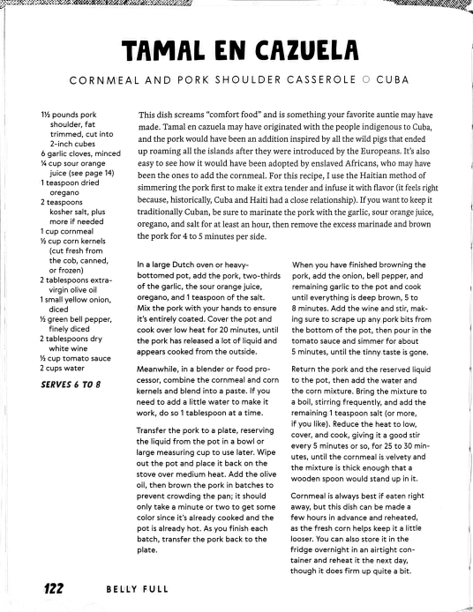
In a large Dutch oven or heavy bottomed pot, add the pork, two-thirds of the garlic, the sour orange juice, oregano, and 1 teaspoon of the salt. Mix the pork with your hands to ensure it's entirely coated. Cover the pot and cook over low heat for 20 minutes, until the pork has released a lot of liquid and appears cooked from the outside.
Meanwhile, in a blender or food pro cessor, combine the cornmeal and corn kernels and blend into a paste. If you need to add a little water to make it work, do so 1 tablespoon at a time.
Transfer the pork to a plate, reserving the liquid from the pot in a bowl or large measuring cup to use later. Wipe out the pot and place it back on the stove over medium heat. Add the olive oil, then brown the pork in batches to prevent crowding the pan; it should only take a minute or two to get some color since it's already cooked and the pot is already hot. As you finish each batch, transfer the pork back to the plate.
When you have finished browning the pork, add the onion, bell pepper, and remaining garlic to the pot and cook
until everything is deep brown, 5 to 8 minutes. Add the wine and stir, mak ing sure to scrape up any pork bits from the bottom of the pot, then pour in the tomato sauce and simmer for about 5 minutes, until the tinny taste is gone.
Return the pork and the reserved liquid to the pot, then add the water and the corn mixture. Bring the mixture to a boil, stirring frequently, and add the
remaining 1 teaspoon salt (or more, if you like). Reduce the heat to low, cover, and cook, giving it a good stir every 5 minutes or so, for 25 to 30 min utes, until the cornmeal is velvety and the mixture is thick enough that a wooden spoon would stand up in it.
Cornmeal is always best if eaten right away, but this dish can be made a few hours in advance and reheated,
as the fresh corn helps keep it a little looser. You can also store it in the fridge overnight in an airtight con tainer and reheat it the next day, though it does firm up quite a bit.
122
BELLY FULL
Created with Scanner Pro
1 tablespOon extra virgin olive oil
1 small yellow onion, diced
3 garlic cloves, minced h green bell pepper, diced
½ Scotch bonnet
pepper, minced
2 teaspoons fresh
thyme leaves
2 Roma (plum)
tomatoes, diced
h pound salted cod, desalted (see
page 197) and
shredded
1(19-ounce) can
ackee, drained
2 scallions, thinly sliced h teaspoon
freshly ground
black pepper
SERVES 4 TO 6
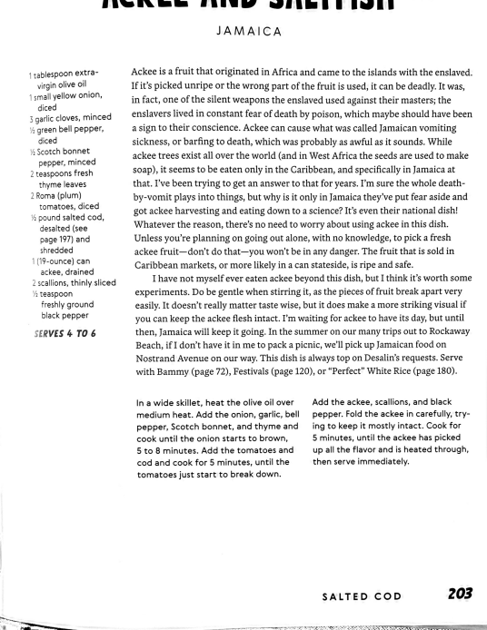
JAMAICA
Ackee is a fruit that originated in Africa and came to the islands with the enslaved. If it's picked unripe or the wrong part of the fruit is used, it can be deadly. It was, in fact, one of the silent weapons the enslaved used against their masters; the enslavers lived in constant fear of death by poison, which maybe should have been a sign to their conscience. Ackee can cause what was called Jamaican vomiting sickness, or barfing to death, which was probably as awful as it sounds. While ackee trees exist all over the world (and in West Africa the seeds are used to make soap), it seems to be eaten only in the Caribbean, and specifically in Jamaica at that. I've been trying to get an answer to that for years. I'm sure the whole death
by-vomit plays into things, but why is it only in Jamaicathey've put fear aside and got ackee harvesting and eating down to a science? It's even their national dish! Whatever the reason, there's no need to worry about using ackee in this dish. Unless you're planning on going out alone, with no knowledge, to pick a fresh ackee fruit-don't do that--you won't be in any danger. The fruit that is sold in
Caribbean markets, or more likely in a can stateside, is ripe and safe. I have not myself ever eaten ackee beyond this dish, but I think it's worth some experiments. Do be gentle when stirring it, as the pieces of fruit break apart very easily. It doesn't really matter taste wise, but it does make a more striking visualif you can keep the ackee flesh intact. I'm waiting for ackee to have its day, but until then, Jamaica will keep it going. In the summer on our many trips out to Rockaway Beach, ifI don't have it in me to pack a picnic, we'll pick up amaican food on Nostrand Avenue on our way. This dish is always top on Desalin's requests. Serve with Bammy (page 72), Festivals (page 120), or “Perfect" White Rice (page 180).
In a wide skillet, heat the olive oil over medium heat. Add the onion, garlic, bell pepper, Scotch bonnet, and thyme and cook until the onion starts to brown, 5 to 8 minutes. Add the tomatoes and cod and cook for 5 minutes, until the tomatoes just start to break down.
Add the ackee, scallions, and black pepper. Fold the ackee in carefully, try ing to keep it mostly intact. Cook for 5 minutes, until the ackee has picked up all the flavor and is heated through, then serve immediately.
_{SALTED COD} 203
Created with Scanner Pro
BULJOL
STEWED SALTED COD O TRINIDAD AND TOBAGO
1 tablespoon extra virgin olive oil
1 small yellow onion, sliced
4 garlic cloves, minced 4 thin scallions (or 2 fat ones), thinly
sliced
1 seasoning pepper, minced (optional;
see page 14)
½ to 1 Scotch bonnet pepper, minced
(optional)
3 culantro leaves, or ½ cup fresh cilantro, chopped
1 pound salted
cod, desalted
(see page 197)
and flaked
2 Roma (plum)
tomatoes, diced
Kosher salt
Since salted cod is so connected to the slave trade (see page 196) and cured fish is such an integral part of West and Central African cuisine, every Caribbean nation has some version of this dish. Trinidadians make buljol fresh as a salad or stewed like this, but I grew up eating only the latter. Though my father remembers Mom calling it buljol, I only remember her referring to it as simply "saltish." Most often eaten for breakfast in Trinidad, it was a staple weeknight dinner in myhouse growing up. It was one of those things Mom cooked so often that when your daily
what's-for-dinner question was answered with "Saltfish!" you'd roll your eyesand sigh, "Again?" Nevertheless, once I was sitting in front of it, I would always eat it enthusiastically. In Trinidad, it is most often served with fry bake (a fried flatbread my mother never made at home, much to my dismay), but we usually ate it with sada roti, Coconut Bake (page 103), or over rice.
This dish is simple to prepare with a short list of ingredients; just make sure to factor desalting the fish into your cooking time. Mom never added culantro (called chadon beni in Trinidad), but it's a pretty standard ingredient for others. This preparation is identical to how it's made in other English-speaking islands such as Barbados, Jamaica, Saint Vincent, and many more. Whenever I make this, I can see my mother in the kitchen, whipping it up.
SERVES 4 TO 6 206
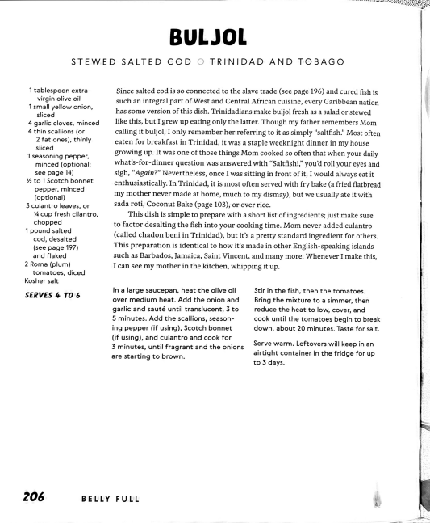
In a large saucepan, heat the olive oil over medium heat. Add the onion and garlic and sauté until translucent, 3 to 5 minutes. Add the scallions, season
ing pepper (if using), Scotch bonnet
(if using), and culantro and cook for
3 minutes, until fragrant and the onions are starting to brown.
BELLY FULL
Stir in the fish, then the tomatoes. Bring the mixture to a simmer, then reduce the heat to low, cover, and cook until the tomatoes begin to break down, about 20 minutes. Taste for salt.
Serve warm. Leftovers will keep in an airtight container in the fridge for up to 3 days.
Created with Scanner Pro

