OI MUCHIM
SWEET-AND-SOUR7UP PICKLED CUCUMBERS
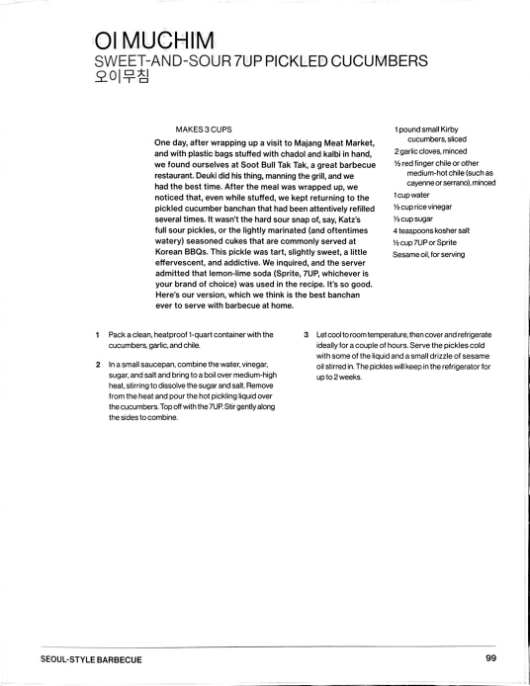
MAKES 3 CUPS
One day, after wrapping up a visit to Majang Meat Market, and with plastic bags stuffed with chadol and kalbi in hand, we found ourselves at Soot Bull Tak Tak, a great barbecue
restaurant. Deuki did his thing, manning the grill, and we had the best time. After the meal was wrapped up, we noticed that, even while stuffed, we kept returning to the pickled cucumber banchan that had been attentively refilled several times. It wasn't the hard sour snap of, say, Katz's full sour pickles, or the lightly marinated (and oftentimes watery) seasoned cukes that are commonly served at Korean BBQS. This pickle was tart, slightly sweet, a little
effervescent, and addictive. We inquired, and the server admitted that lemon-lime soda (Sprite, 7UP, whichever is your brand of choice) was used in the recipe. It's so good. Here's our version, which we think is the best banchan ever to serve with barbecue at home.
1pound small Kirby
cUcumbers, sliced
2 garlic cloves, minced
Va red finger chile or other medium-hot chile (such as cayenne or serrano),minced 1cupwater
½ cup rice vinegar
scup sugar
4 teaspoons kosher salt
½ cup 7UPor Sprite
Sesame oil, for serving
¹ 3
Packa clean, heatproof 1-quart container with the cucumbers, garlic, and chile.
2
Inasmall saucepan, combinethe water, vinegar,
sugar, and salt and bring to a boil over medium-high heat, stirring to dissolve the sugar and salt. Remove from the heat and pour the hot pickling liquid over the cucumbers. Top off with the 7UP.Stir gently along the sides to combine.
Let cool to room temperature, then cOver and refrigerate ideally fora couple of hours. Serve the pickles cold with some of the liquid and a small drizzle of sesame oil stirred in. The pickles wil keep in the refrigerator for up to 2 weeks.
_{SEOUL-STYLE BARBECUE} 99 Created with Scanner Pro
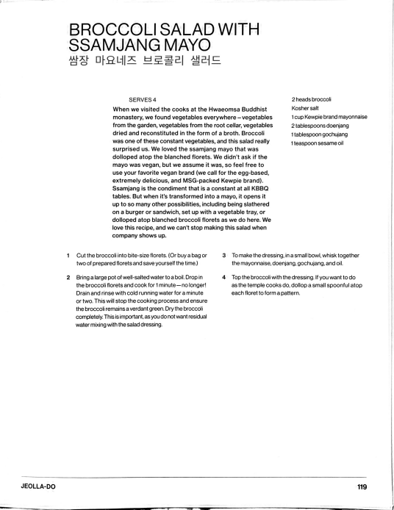
BROCCOLI SALAD WITH SSAMJANG MAYO
SERVES 4
When we visited the cooks at the Hwaeomsa Buddhist monastery, we found vegetables everywhere -vegetables from the garden, vegetables from the root cellar, vegetables dried and reconstituted in the form of a broth. Broccoli
was one of these constant vegetables, and this salad really surprised us. We loved the ssamjang mayo that was
dolloped atop the blanched florets. We didn't ask if the mayo was vegan, but we assume it was, so feel free to
use your favorite vegan brand (we call for the egg-based, extremely delicious, and MSG-packed Kewpie brand).
Ssamjang is the condiment that is a constant at all KBBQ tables. But when it's transformed into a mayo, it opens it up to so many other possibilities, including being slathered
on a burger or sandwich, set up with a vegetable tray, or dolloped atop blanched broccoli florets as we do here. We love this recipe, and we can't stop making this salad when company shows up.
2 heads broccoli
Kosher salt
1cup Kewpie brand mayonnaise 2 tablespoons doenjang
1 tablespoon gochujang
1 teaspoon sesame oil
1
Cut the broccoli into bite-size florets. (Or buy a bag or two of prepared florets and save yourself the time.)
Bringa large pot of well-salted water to a boil. Drop in
2
the broccoli florets and cook for 1 minute-no longer! Drain and rinse with cold running water for a minute or two. This will stop the cooking process and ensure the broccoli remains a verdant green. Dry the broccoli completely. This is important, as you do not wantresidual water mixing with the salad dressing.
3 Tomake the dressing, in a small bowl, whisk together the mayonnaise, doenjang. gochujang, and oi.
4 Top the broccoli with the dressing. If you want to do as the temple cooks do, dollop a small spoonful atop each floret to form a pattern.
JEOLLA-DO 119 Created with Scanner Pro
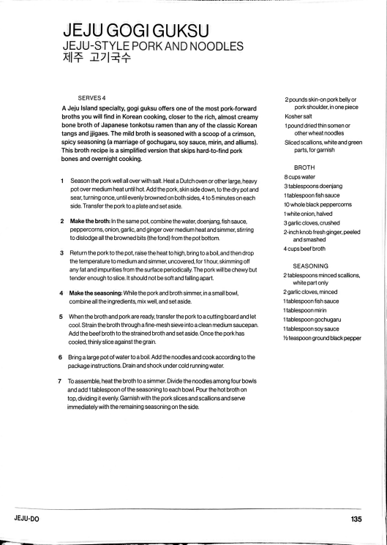
JEJU GOGI GUKSU
JEJU-STYLE PORKAND NOODLES
SERVES4
A Jeju Island specialty, gogi guksu offers one of the most pork-forward broths you will find in Korean cooking, closer to the rich, almost creamy bone broth of Japanese tonkotsu ramen than any of the classic Korean tangs and jigaes. The mild broth is seasoned with a scoop of a crimson, spicy seasoning (a marriage of gochugaru, soy sauce, mirin, and alliums). This broth recipe is a simplified version that skips hard-to-find pork bones and overnight cooking.
2 pounds skin-on pork belly or pork shoulder, in one piece Kosher salt
1pound dried thin somen or other wheat noodles
Sliced scallions, white and green parts, for garnish
BROTH
1
Season the pork well all over with salt. Heat a Dutch oven or other large, heavy pot over medium heat until hot. Add the pork, skin side down, to the dry pot and sear, turning once, until evenly browned on both sides, 4 to 5 minutes on each side. Transfer the pork to a plate and set aside.
2
Makethe broth: In the same pot, combine the water, doenjang, fish sauce, peppercorns, onion, garlic, and ginger over medium heat and simmer, stirring to dislodge allthe browned bits (the fond) from the pot bottom.
8 cups water
3 tablesp0ons doenjang
1 tablespoon fish sauce
10 whole black peppercorns 1 white onion, halved
3 garlic cloves, crushed
2-inch knob fresh ginger, peeled and smashed
3 Return the pork to the pot, raise the heat to high, bring to a boil, and then drop the temperature to medium and simmer, uncovered, for 1 hour, skimming off any fat and impurities from the surface periodically. The pork will be chewy but tender enough to slice. It should not be softand faling apart.
4 cups beef broth
SEASONING
2 tablespoons minced scallions, white partonly
Make the seasoning: While the pork and broth simmer, in a small bowl,
4
combine all the ingredients, mix well, and set aside.
When the broth and pork are ready, transfer the pork to a cutting board and let
5
cool. Strain the broth through a fine-mesh sieve into a clean medium saucepan. Add the beef broth to the strained broth and set aside. Once the pork has cooled, thinly slice against the grain.
Bring a large pot of water to a boil. Add the noodles and cook according to the
6
package instructions. Drain and shock under cold running water. 7
To assemble, heat the broth to a simmer. Divide the noodles among four bowls and add 1 tablespoon of the seasoning to each bowl. Pour the hot broth on top, dividing it evenly. Garnish with the pork slices and scallions and serve immediately with the remaining seasoning on the side.
2 garlic cloves, minced
1tablespoon fish sauce
1 tablespoon mirin
1tablespOongochugaru
1tablesp0onsoysauce
Va teaspoon ground black pepper
^{JEJU-DO} 135 Created with Scanner Pro

