He heard quiet steps behind him. That didn't bode well. Who could be following him this late at night and in this deadbeat part of town? And at this particular moment, just after he pulled off the big time and was making off with the greenbacks.

Introduction

Quick reference
    - Location plan (see application map at part Error: Reference source not found Error: Reference source not found for larger scale representation):
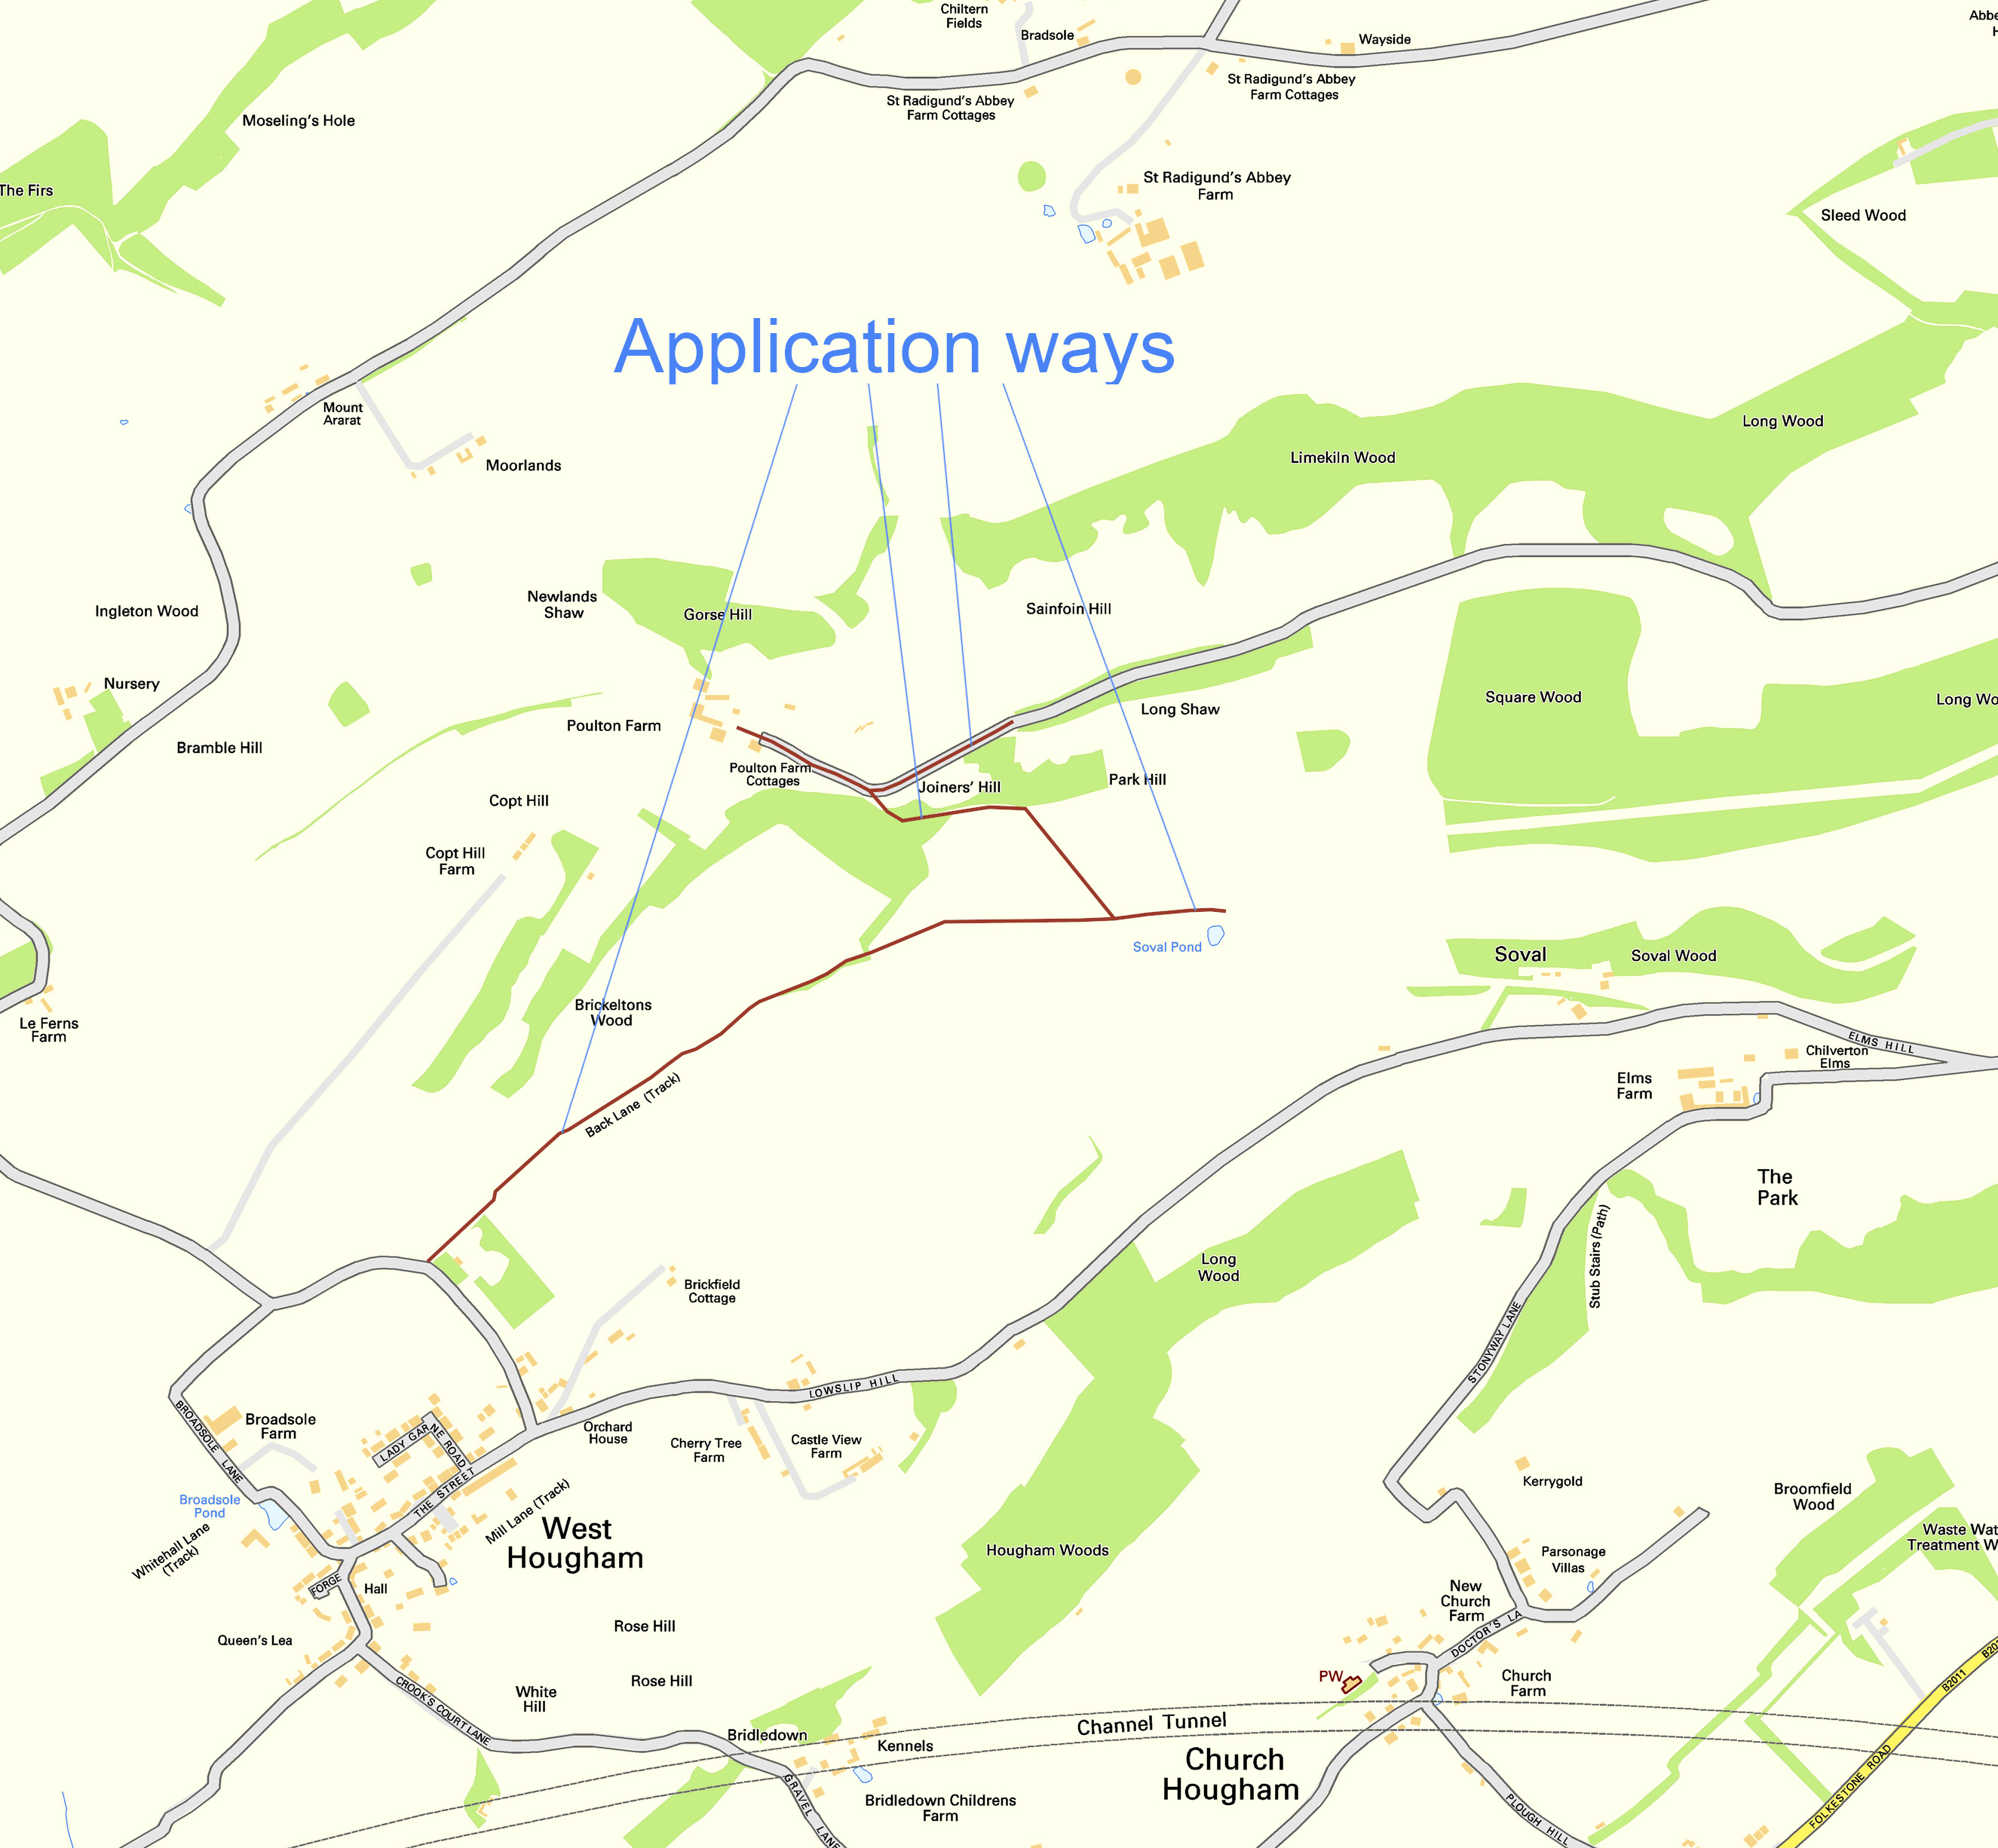Illustration i
    - Existing recorded public rights of way comprised in application way: ER218B, ER218A, ER217

