Click or tap here to enter text.

Click or tap here to enter text.

Pulling from SQL server the following should be displayed circled in red below.
SELECT 'Line 1' + CHAR(13) + 'Line 2'
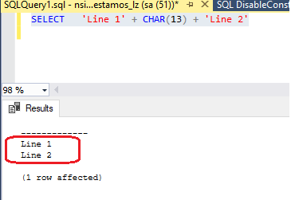
Libre Office version 7.2.7.2 works correctly.
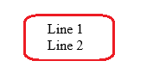
We are getting the following with the latest version 7.5.1.2.


