ECEN 106 Laboratory: Logic Gates

Overview
This laboratory has five parts: 74LS04 NOT gate, 74LS08 AND gate, 74LS32 OR gate, 74LS86 XOR gate, and Logic Circuit. You will test the operation of the logic gates, wire a simple logic circuit using NOT, AND, and OR gates, and then verify the circuits’ correct operation.

Background
The 74LS04 NOT gate, also called an inverter, is an electronic circuit that implements the NOT function. The output is the opposite of the input. If the input is HIGH, the output is LOW and vice versa. This integrated circuit (IC) contains six NOT gates.
Figure 1

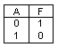
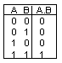
The 74LS08 AND gate implements the AND function. The output is HIGH only if all the inputs are HIGH. If any input is LOW, the output is LOW. This IC contains four AND gates.
Figure 2

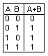
The 74LS32 OR gate implements the OR function. The output is LOW only if all the inputs are LOW. If any input is HIGH, the output is HIGH. This IC contains four OR gates.
Figure 3

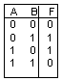
The 74LS86 XOR gate implements the Exclusive OR (XOR) function. The output is HIGH when an odd number of the inputs are HIGH. Otherwise, the output is LOW. This IC contains four XOR gates.
Figure 4

Preparation
- Watch the video How to Use a Breadboard (12 minutes)
- Watch these two videos:
  - ECEN 106 Logic Gates Lab: Getting Started (6 minutes)
  - ECEN 106 Logic Gates Lab: Debugging the EXOR Circuit (8 minutes)

Required Data Sheets
These data sheets show the pin connections and electrical characteristics of electronic components. Engineers use these data sheets; the instructions in this worksheet cover all of the information you need to know, but you are welcome to review the data sheets for additional learning opportunities.
74LS04 Hex Inverter Gates
74LS08 Quad 2-Input AND Gates
74LS32 Quad 2-Input OR Gates
74LS86 Quad 2-Input Exclusive-OR Gates

Required Equipment and Materials
- 74LS04 NOT Gate Integrated Circuit (1)
- 74LS08 AND Gate Integrated Circuit (1)
- 74LS32 OR Gate Integrated Circuit (1)
- 74LS86 XOR Gate Integrated Circuit (1)
- Solderless breadboard (1)
- Power Supply Module LAFVIN Super Starter Kit for Uno R3 (1)
- Arduino Uno (1)
- 9V battery (1)
  - NOTE: Sometimes LAFVIN includes this in the kit and sometimes it does not.
- Battery connector (1)
- Red LED (1)
- 220 Ohm resistor (1)
- Male-to-male jumper wires (20)

Connect Power and Ground to the Breadboard
There are two ways you can supply power to the circuits used in this laboratory: (1) the power supply module, or (2) the Arduino UNO.

Method 1: Use the Power Supply Module
1. Plug the power supply module into the solderless breadboard as shown in Figure 5.
2. On the power supply module, there are two yellow jumpers. The yellow jumpers are adjustable brackets on the edge of the module. There are four prongs which provides the jumpers three positions to be in: 3.3V, Off, or 5V. Move the two yellow jumpers to the 5V position, as shown in Figure 5.
3. Insert four male-to-male jumper wires across the middle of the negative and positive lines of both busses as shown by the red wires in Figure 5. This step is important to extend the 5V and GND busses along the entire length of the board.
NOTE: The male-to-male jumper wires from your kit will look different than the wires shown in Figure 5, but they can be used for this.
4. Connect the 9V battery to the power supply module using [cord]. Ensure it is correctly connected by pressing the white button next to the green LED. This will turn the power on and the LED will turn on.
5. Turn the power supply module off by pushing the button again. The LED will turn off. Do not continue the project until you have the power off.
GND Bus
5V Bus
GND Bus
5V Bus
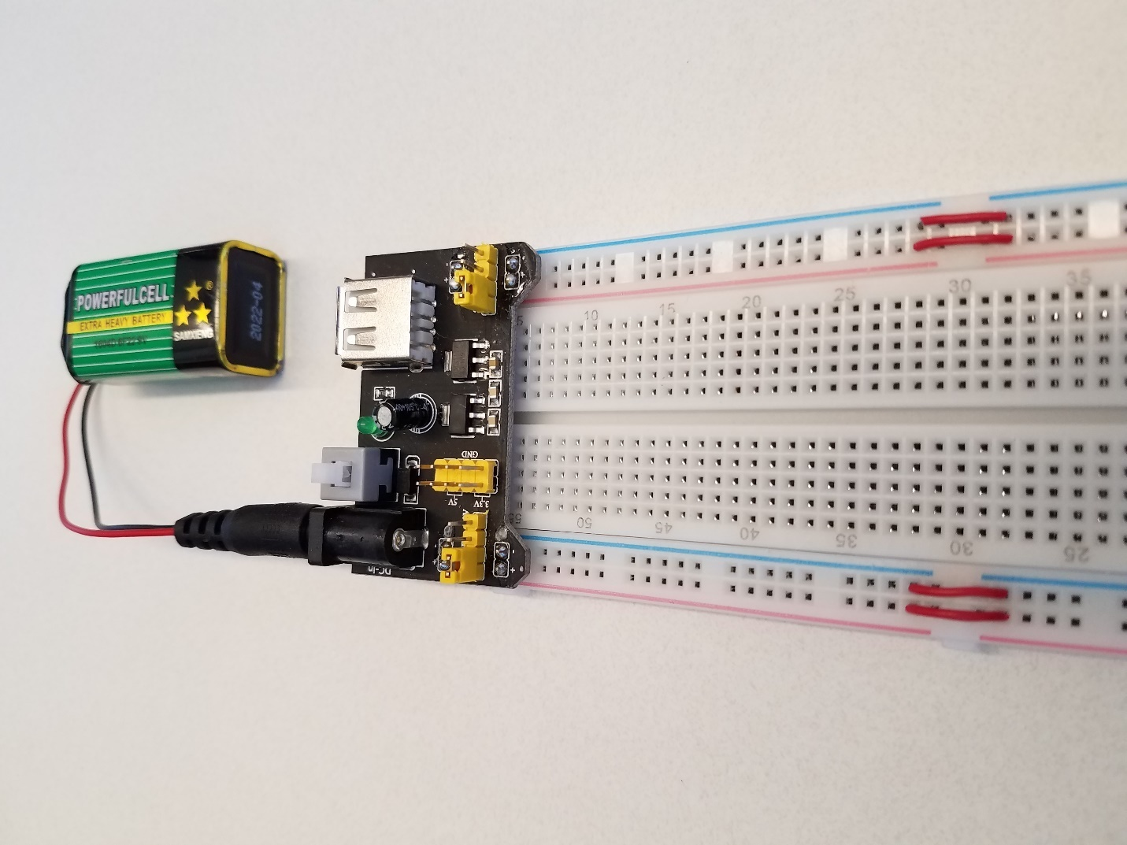
Figure 5

Method 2: Use the Arduino UNO
1. Connect a male-to-male jumper wire from the 5V pin on the Arduino Uno to the 5V bus (near the red line) on the solderless breadboard as shown by the diagonal red wire in Figure 6.
2. Use a male-to-male jumper wire to connect the 5V bus on the top side of the board to the 5V bus on the other side of the board as shown by the vertical red wire in Figure 6.
3. Connect a male-to-male jumper wire from the GND pin on the Arduino Uno to the GND bus (near the blue line) on the solderless breadboard as shown by the diagonal black wire in Figure 6.
4. Use a male-to-male jumper wire to connect the GND bus on the top side of the board to the GND bus on the other side of the board as shown by the vertical black wire in Figure 6.
5. Insert four male-to-male jumper wires across the middle of the negative and positive lines of both busses as shown by the horizontal black and red wires in Figure 6. This step is important to extend the 5V and GND busses along the entire length of the board.
NOTE: The male-to-male jumper wires from your kit will look different than the wires shown in Figure 6, but they can be used.
6. Cut the power from the solderless breadboard before continuing. Do so by unplugging the Arduino board from your computer before proceeding.
GND Bus
5V Bus
GND Bus
5V Bus
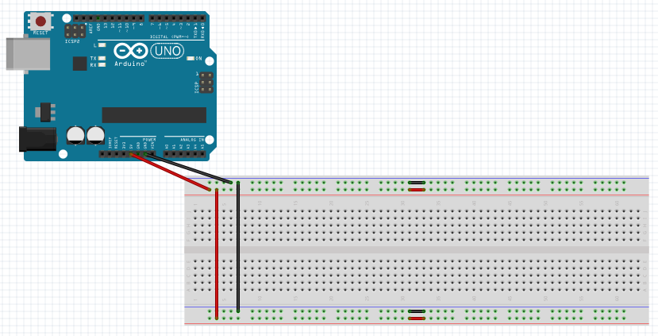
Figure 6

Part 1: 74LS04 NOT Gate
The first three steps construct the output circuit that will be used with all the other circuits in this laboratory.
1. Plug a 220 Ohm resistor into the solderless breadboard (Figure 7).
2. Plug in a red LED with the long lead in the same column as the resistor (Figure 7).
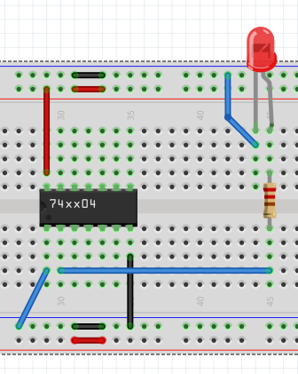
3. Connect the short lead of the LED to the GND bus with a jumper wire (Figure 7).
The 220 Ohm resistor in the LAFVIN Super Starter Kit for UNO R3 has five color bands: red, red, black, black, brown.

Figure 7

Continue with connecting the NOT gate.
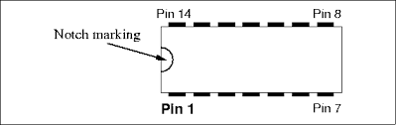
4. Plug the 74LS04 into the solderless breadboard. You may have to bend the pins slightly inward to line them up with the holes in the solderless breadboard (Figure 7). Be sure the 74LS04 is plugged into the board with the notch marking toward the power supply module. See the pin diagram for a 14-pin integrated circuit (IC) in Figure 8.
Figure 8

5. Connect pin 7 to GND bus as shown by the vertical black wire in Figure 7.
6. Connect pin 14 to 5V bus as shown by the vertical red wire in Figure 7.
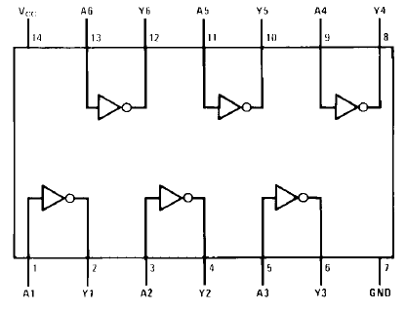
NOTE: There are six NOT gates in the 74LS04 IC (Figure 9).
Figure 9

7. Connect the output Y of the first NOT gate (pin 2) to the resistor as shown by the horizontal blue wire in Figure 7.
8. Connect the input A of the first NOT gate (pin 1) to GND bus (logic 0) as shown by the diagonal blue wire in Figure 7.
9. Connect power to the solderless breadboard by pushing the button on the power supply module or connecting the Arduino board to your computer.
10. Observe the LED. If the LED is on, the output is HIGH (logic 1). If the LED is off, the output is LOW (logic 0).
A | Actual  Output
0
1
11. Record the output’s value (0 or 1) in the first row of the NOT gate truth table in Figure 10.

Figure 10

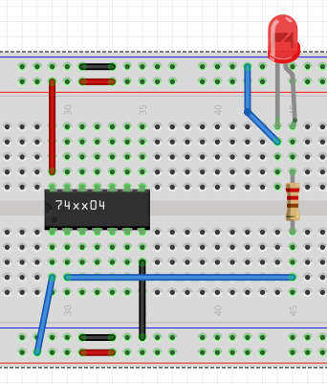
12. Connect the input A of the first NOT gate (pin 1) to 5V bus (logic 1) as shown by the diagonal blue wire in Figure 11.
Figure 11

13. Record the output’s value (0 or 1) in the second row of the NOT gate truth table in
Figure 10.
14. Verify that the outputs you obtained are the same as what you expected.
15. Disconnect power from the solderless breadboard.
16. Carefully remove the 74LS04 by prying up both ends with a pencil or pen. You must lift it straight out to avoid bending and breaking the pins. The 5V and GND wires remain in the same place for the 74LS08.

Part 2: 74LS08 AND Gate
1. Plug the 74LS08 into the solderless breadboard (Figure 12).
2. Connect pin 7 to GND bus as shown by the vertical black wire in Figure 12.
3. Connect pin 14 to 5V bus as shown by the vertical red wire in Figure 12.
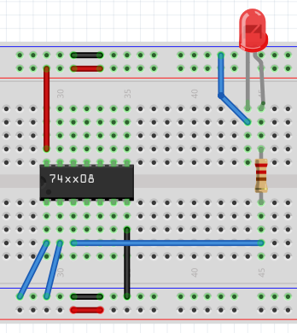
Figure 12

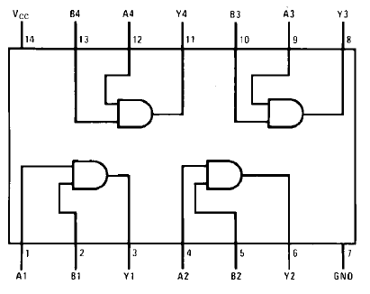
Note: There are four AND gates in the 74LS08 IC. You can see them below in Figure 13.
Figure 13

4. Connect the output Y of the first AND gate (pin 3) to the resistor as shown by the horizontal blue wire in Figure 12.
5. Connect input A of the first AND gate (pin 1) to GND (logic 0) as shown by the diagonal blue wire in Figure 12.
6. Connect input B of the first AND gate (pin 2) to GND (logic 0) as shown by the diagonal blue wire in Figure 12.
7. Connect power to the solderless breadboard.
8. Record the output’s value (0 or 1) in the first row of the AND gate truth table in Figure 14.
A | B | Actual  Output
0 | 0
0 | 1
1 | 0
1 | 1

Figure 14

9. Connect input A of the first AND gate (pin 1) to GND (logic 0) as shown by the diagonal blue wire in Figure 15.
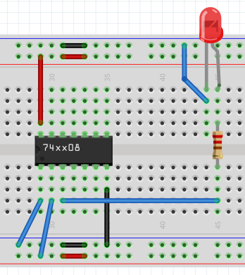
10. Connect input B of the first AND gate (pin 2) to 5V (logic 1) as shown by the diagonal blue wire in Figure 15.
Figure 15

11. Record the output’s value (0 or 1) in the second row of the AND gate truth table in Figure 14.
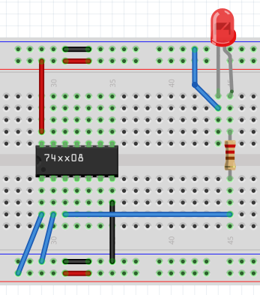
12. Connect input A of the first AND gate (pin 1) to 5V (logic 1) as shown by the diagonal blue wire in Figure 16.
13. Connect input B of the first AND gate (pin 2) to GND bus (logic 0) as shown by the diagonal blue wire in Figure 16.
Figure 16

14. Record the output’s value (0 or 1) in the third row of the AND gate truth table in
Figure 14.
15. Connect input A of the first AND gate (pin 1) to 5V (logic 1) as shown by the diagonal blue wire in Figure 17.
16. Connect input B of the first AND gate (pin 2) to 5V (logic 1) as shown by the diagonal blue wire in Figure 17.

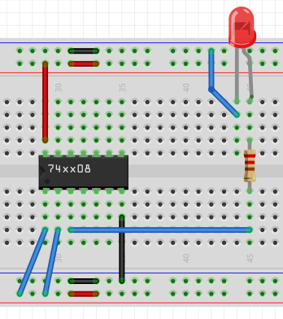
Figure 17

17. Record the output’s value (0 or 1) in the fourth row of the AND gate truth table in Figure 14.
18. Verify that the outputs you obtained are the same as what you expected.
19. Disconnect power from the solderless breadboard.
20. Carefully remove the 74LS08.

Part 3: 74LS32 OR Gate
1. Plug the 74LS32 into the solderless breadboard.
2. Connect pin 7 to GND bus as shown by the vertical black wire in Figure 18.
3. Connect pin 14 to 5V bus as shown by the vertical red wire in Figure 18.

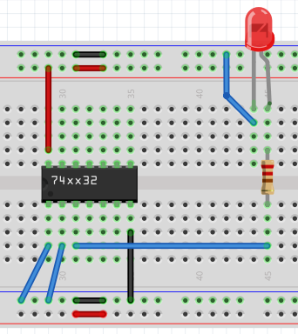

Figure 18

Note: There are four OR gates in the 74LS32 IC. You can see them below in Figure 19.
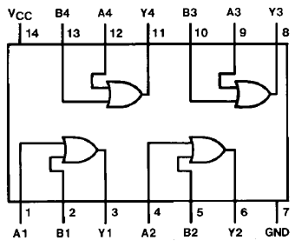

Figure 19

4. Connect the output Y of the first OR gate (pin 3) to the resistor as shown by the horizontal blue wire in Figure 18.
5. Connect input A of the first OR gate (pin 1) to GND bus (logic 0) as shown by the diagonal blue wire in Figure 18.
6. Connect input B of the first OR gate (pin 2) to GND bus (logic 0) as shown by the diagonal blue wire in Figure 18.
7. Connect power to the solderless breadboard.
8. Record the output’s value (0 or 1) in the first row of the OR gate truth table in Figure 20.
A | B | Actual  Output
0 | 0
0 | 1
1 | 0
1 | 1

Figure 20

9. Continue testing the other three combinations of inputs and outputs and recording the output values in the corresponding row of the truth table in Figure 20.
10. Verify that the outputs you obtained are the same as what you expected.
11. Disconnect power from the solderless breadboard.
12. Carefully remove the 74LS32.

Part 4: 74LS86 XOR Gate
1. Plug the 74LS86 into the solderless breadboard.
2. Connect pin 7 to GND bus as shown by the vertical black wire in Figure 21.
3. Connect pin 14 to 5V bus as shown by the vertical red wire in Figure 21.

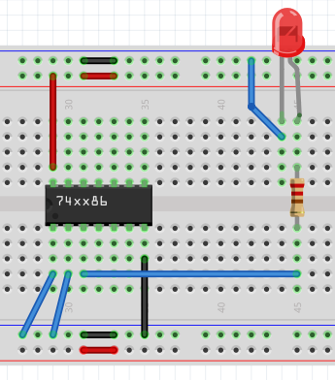

Figure 21

Note: There are four XOR gates in the 74LS86 IC. You can see them below in Figure 22.
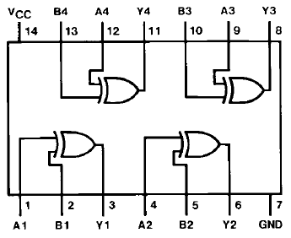

Figure 22

4. Connect the output Y of the first AND gate (pin 3) to the resistor as shown by the horizontal blue wire in Figure 21.
5. Connect input A of the first XOR gate (pin 1) to GND (logic 0) as shown by the diagonal blue wire in Figure 21.
6. Connect input B of the first XOR gate (pin 2) to GND (logic 0) as shown by the diagonal blue wire in Figure 21.
7. Connect power to the solderless breadboard.
8. Record the output’s value (0 or 1) in the first row of the XOR gate truth table in Figure 23.

A | B | Actual  Output
0 | 0
0 | 1
1 | 0
1 | 1

Figure 23

9. Continue testing the other three combinations of inputs and outputs and recording the output values in the corresponding row of the truth table in Figure 23.
10. Verify that the outputs you obtained are the same as what you expected.
11. Disconnect power from the solderless breadboard.
12. Carefully remove the 74LS86.

Part 5: Logic Circuit
The XOR gate is not really a simple logic gate. It is really a circuit composed of NOT, AND, and OR gates, but it is used so often in computers that the circuit has its own logic gate symbol. In this part of the laboratory, you will design and construct the actual XOR logic circuit from its truth table.
The truth table for this circuit is shown in Figure 24.
Figure 24

1. Type the logic equation for the circuit into the box below:
F =

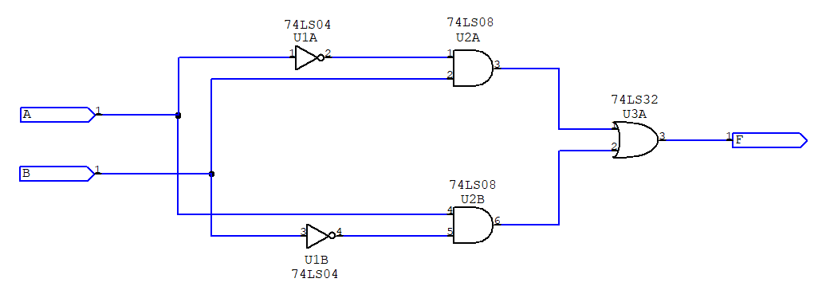
2. Verify that your logic equation is equivalent to the circuit shown in Figure 25.
Figure 25

3. Construct the circuit by following these steps:
- Insert the 74LS04, 74LS08, and 74LS32 ICs into the solderless breadboard as shown in Figure 26.
- Connect 5V bus to pin 14 of each IC using three jumper wires. They are shown as the vertical red wires in Figure 26.
- Connect GND bus to pin 7 of each IC using three jumper wires. They are shown as the vertical black wires in Figure 26.
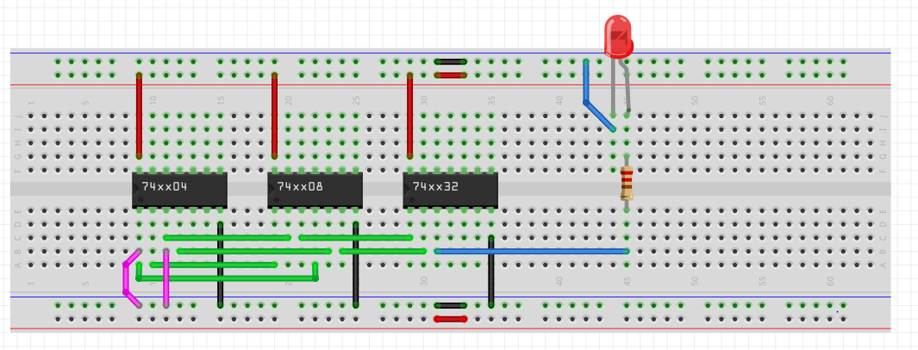
Figure 26

- Connect pin 1 of the 74LS04 to pin 4 of the 74LS08.
- Connect pin 2 of the 74LS04 to pin 1 of the 74LS08.
- Connect pin 3 of the 74LS04 to pin 2 of the 74LS08.
- Connect pin 4 of the 74LS04 to pin 5 of the 74LS08.
- Connect pin 3 of the 74LS08 to pin 1 of the 74LS32.
- Connect pin 6 of the 74LS08 to pin 2 of the 74LS32.
- Pin 3 of the 74LS32 is the F output. Connect it to the bottom of the 220 Ohm resistor.
- Connect the top of the resistor to the long lead of the LED.
- Connect the short lead of the LED to GND.
- Pin 1 of the 74LS04 is the A input and pin 3 of the 74LS04 is the B input. They are shown as the pink wires in Figure 26.
4. Test the circuit for proper operation by following these steps:
- Connect power to the solderless breadboard.
- Connect input A and input B to GND bus.
- Observe the LED connected to output F. In the first row of the Actual Output truth table in Figure 26, enter a 0 if the LED is off or a 1 if it is on.
- Leaving input A connected to GND bus, connect input B to 5V bus.
- Enter the value of output F in the second row of the Actual Output truth table in Figure 27.
- Connect input A to 5V bus and input B to GND bus.
- Enter the value of output F in the third row of the Actual Output truth table in Figure 27.
- Leaving input A connected to 5V bus, connect input B to 5V bus.
- Enter the value of output F in the fourth row of the Actual Output truth table in Figure 27.
A | B | Actual  Output
0 | 0
0 | 1
1 | 0
1 | 1
Figure 27
2
- Compare the outputs of Figure 24 with Figure 27. If they are not the same, check your circuit connections and test the circuit again.
- Disconnect power from the solderless breadboard.
- Carefully remove the 74LS04, 74LS08, and 74LS32.

Submit Your Laboratory Report
After completing this laboratory and filling in all the blanks on this instruction sheet, submit it for credit through I-Learn.

