xxuux
The Paleoindian period was followed by the Archaic, a time when major changes occurred in the landscape and the settlement of the territory of Quebec. With the end of glaciation, the inhabitable territory increased in size and the environment (such as climate, vegetation, lakes and rivers) became increasingly stable. Migrations became rarer and moving around became a seasonal activity necessary for hunting, fishing or gathering
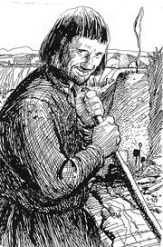Figure 1: jean

I anchored the image on the first “The” and left justified it, just like in the master document. It appears stable in this document.

