- hello
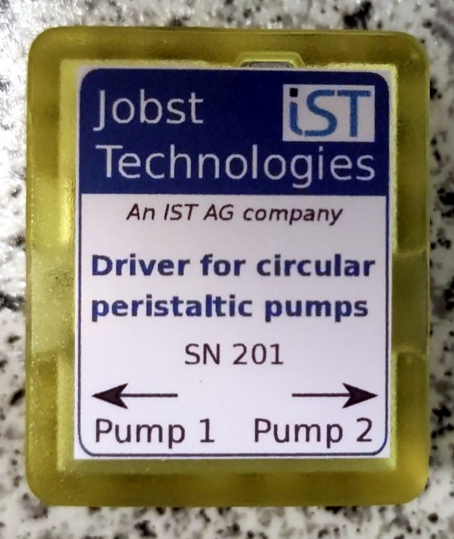Figure 1: Label on the pump driver housing.
- hello

