
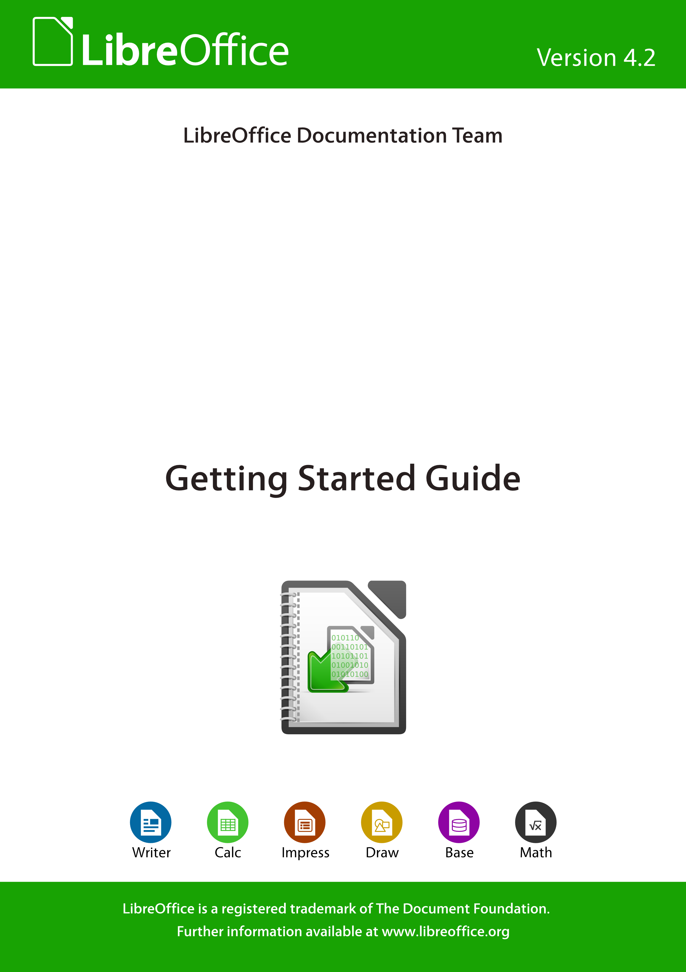
Getting Started
with
LibreOffice 4.2

Copyright
This document is Copyright © 2010–2014 by the LibreOffice Documentation Team. Contributors are listed below. You may distribute or modify it under the terms of either the GNU General Public License (http://www.gnu.org/licenses/gpl.html), version 3 or later, or the Creative Commons Attribution License (http://creativecommons.org/licenses/by/4.0/), version 4.0 or later.
Contributors
Jean Hollis Weber Peter Schofield Ron Faile Jr.
Martin Fox Dan Lewis David Michel
Andrew Pitonyak Hazel Russman Jeremy Cartwright
John A Smith Martin Saffron Laurent Balland-Poirier
Bruce Byfield Reizinger Zoltán
Cover art:
Klaus-Jürgen Weghorn Jean Hollis Weber
Acknowledgements
This book is adapted and updated from Getting Started with OpenOffice.org 3.3. The contributors to that book are listed on page 14.
Feedback
Please direct any comments or suggestions about this document to the Documentation Team’s mailing list: documentation@global.libreoffice.org
Note: Everything you send to a mailing list, including your email address and any other personal information that is written in the message, is publicly archived and cannot be deleted.
Publication date and software version
Published 18 June 2014. Based on LibreOffice 4.2.
Contents
Copyright 2
Preface 9
Who is this book for? 10
What's in this book? 10
Where to get more help 10
What you see may be different 11
Using LibreOffice on a Mac 12
What are all these things called? 12
Who wrote this book? 13
Acknowledgements 13
Frequently asked questions 14
What’s new in LibreOffice 4.2? 14
Chapter 1 Introducing LibreOffice 15
What is LibreOffice? 16
Advantages of LibreOffice 17
Minimum requirements 18
How to get the software 18
How to install the software 18
Extensions and add-ons 18
Starting LibreOffice 18
Parts of the main window 21
Starting new documents 25
Opening existing documents 26
Saving documents 27
Renaming and deleting files 29
Open and Save As dialogs 29
Using the Navigator 30
Undoing and redoing changes 31
Closing a document 31
Closing LibreOffice 31
Chapter 2 Setting up LibreOffice 33
Choosing options for all of LibreOffice 34
Choosing Load/Save options 49
Choosing language settings 53
Choosing Internet options 58
Controlling LibreOffice’s AutoCorrect functions 59
Chapter 3 Using Styles and Templates 61
What is a template? 62
What are styles? 62
Applying styles 63
Modifying styles 65
Creating new (custom) styles 67
Copying styles from a template or document 68
Deleting styles 69
Using a template to create a document 69
Creating a template 70
Editing a template 71
Adding templates obtained from other sources 72
Setting a default template 73
Associating a document with a different template 74
Organizing templates 74
Examples of style use 76
Chapter 4 Getting Started with Writer 79
What is Writer? 80
The Writer interface 80
Changing document views 85
Moving quickly through a document 85
Working with documents 86
Working with text 87
Formatting text 96
Formatting pages 101
Adding comments to a document 105
Creating a table of contents 106
Creating indexes and bibliographies 107
Working with graphics 107
Printing 107
Using mail merge 107
Tracking changes to a document 108
Using fields 108
Linking to another part of a document 108
Using master documents 111
Creating fill-in forms 111
Chapter 5 Getting Started with Calc 113
What is Calc? 114
Spreadsheets, sheets and cells 114
Calc main window 114
Opening a CSV file 119
Saving spreadsheets 121
Navigating within spreadsheets 122
Selecting items in a spreadsheet 126
Working with columns and rows 128
Working with sheets 129
Viewing Calc 132
Using the keyboard 134
Speeding up data entry 138
Sharing content between sheets 141
Validating cell contents 141
Editing data 142
Formatting data 143
AutoFormat of cells 147
Using themes 148
Using conditional formatting 148
Hiding and showing data 149
Sorting records 150
Using formulas and functions 151
Analyzing data 151
Printing 152
Chapter 6 Getting Started with Impress 157
What is Impress? 158
Starting Impress 158
Main Impress window 159
Workspace views 162
Creating a new presentation 166
Formatting a presentation 169
Adding and formatting text 173
Adding pictures, tables, charts, and media 178
Working with slide masters and styles 181
Adding comments to a presentation 187
Setting up a slide show 188
Chapter 7 Getting Started with Draw 191
What is Draw? 192
Draw main window 192
Choosing and defining colors 197
Drawing basic shapes 198
Glue points and connectors 203
Drawing geometric shapes 205
Selecting objects 207
Moving and adjusting object size 208
Rotating and slanting an object 210
Editing objects 211
Formatting area fill 214
Using styles 215
Positioning objects 215
Applying special effects 216
Combining multiple objects 219
Arranging, aligning and distributing objects 221
Inserting and editing pictures 221
Working with 3D objects 221
Exporting graphics 221
Inserting comments in a drawing 222
Chapter 8 Getting Started with Base 223
Introduction 224
Types of database 224
Planning your database 225
Creating a new Base file 226
Opening an existing database 227
Main database window and its parts 228
Database objects 230
Tables: use wizard to create tables 230
Forms: using the Forms Wizard 241
Queries: using the Query Wizard 248
Reports: use wizard to create reports 258
Mixing Base with the rest of LibreOffice 263
Using Base with other data sources 264
Chapter 9 Getting Started with Math 265
What is Math? 266
Getting started 266
Entering a formula 267
Formula layout 273
Changing the appearance of formulas 278
Formulas in Writer documents 281
Customizations 284
Math commands – Reference 287
Chapter 10 Printing, Exporting, and E-mailing 289
Quick printing 290
Controlling printing 290
Exporting to PDF 298
Exporting to other formats 304
E-mailing documents 304
Digital signing of documents 307
Removing personal data 308
Chapter 11 Graphics, the Gallery, and Fontwork 309
Introduction 310
Adding images to a document 310
Modifying and positioning graphics 313
Managing the LibreOffice Gallery 314
Creating an image map 317
Using LibreOffice’s drawing tools 318
Using Fontwork 320
Chapter 12 Creating Web Pages 327
Introduction 328
Relative and absolute hyperlinks 328
Creating hyperlinks 328
Creating web pages using the Web Wizard 332
Saving documents as web pages 335
Chapter 13 Getting Started with Macros 341
Introduction 342
Your first macros 342
Creating a macro 348
Macro recorder failures 351
Macro organization 352
How to run a macro 356
Extensions 358
Writing macros without the recorder 359
Finding more information 359
Chapter 14 Customizing LibreOffice 361
Introduction 362
Customizing menu content 362
Customizing toolbars 365
Assigning shortcut keys 368
Assigning macros to events 371
Adding functionality with extensions 371
Appendix A Keyboard Shortcuts 373
Introduction 374
General keyboard shortcuts 375
Navigating and selecting with the keyboard 376
Controlling dialogs 377
Macros 377
Getting help 377
Managing documents 378
Editing 378
Selecting rows and columns in a database table opened by F4 379
Shortcut keys for drawing objects 379
Defining keyboard shortcuts 380
Further reading 380
Appendix B Open Source, Open Standards, OpenDocument 381
Introduction 382
A short history of LibreOffice 382
The LibreOffice community 382
How is LibreOffice licensed? 383
What is “open source”? 383
What are “open standards”? 383
What is OpenDocument? 383
File formats LibreOffice can open 384
File formats LibreOffice can save to 386
Exporting to other formats 388
Index 389

Preface

Who is this book for?
Anyone who wants to get up to speed quickly with LibreOffice will find this Getting Started Guide valuable. You may be new to office software, or you may be familiar with another office suite.

What's in this book?
This book introduces the main components of LibreOffice:
- Writer (word processing)
- Calc (spreadsheets)
- Impress (presentations)
- Draw (vector graphics)
- Base (database
- Math (equation editor)
It also covers some of the features common to all components, including setup and customization, styles and templates, macro recording, and printing. For more detail, see the user guides for the individual components.

Where to get more help
This book, the other LibreOffice user guides, the built-in Help system, and user support systems assume that you are familiar with your computer and basic functions such as starting a program, opening and saving files.

Help system
LibreOffice comes with an extensive Help system. This is your first line of support for using LibreOffice.
To display the full Help system, press F1 or select LibreOffice Help from the Help menu. In addition, you can choose whether to activate Tips, Extended tips, and the Help Agent (using Tools > Options > LibreOffice > General).
If Tips are enabled, place the mouse pointer over any of the icons to see a small box (“tooltip”) with a brief explanation of the icon’s function. For a more detailed explanation, select Help > What's This? and hold the pointer over the icon.

Free online support
The LibreOffice community not only develops software, but provides free, volunteer-based support. See Table 1 and this web page: http://www.libreoffice.org/get-help/
You can get comprehensive online support from the community through mailing lists and the Ask LibreOffice website. Other websites run by users also offer free tips and tutorials. This forum provides community support for LibreOffice: http://en.libreofficeforum.org/
This site provides support for LibreOffice, among other programs:
http://forum.openoffice.org/en/forum/
Table 1: Free support for LibreOffice users
Free LibreOffice support
Ask LibreOffice | Questions and answers from the LibreOffice community  http://ask.libreoffice.org/en/questions/
Documentation | User guides, how-tos, and other documentation. http://www.libreoffice.org/get-help/documentation/  https://wiki.documentfoundation.org/Documentation/Publications
FAQs | Answers to frequently asked questions  http://wiki.documentfoundation.org/Faq
Mailing lists | Free community support is provided by a network of experienced users  http://www.libreoffice.org/get-help/mailing-lists/
International support | The LibreOffice website in your language.  http://www.libreoffice.org/international-sites/  International mailing lists  http://wiki.documentfoundation.org/Local_Mailing_Lists
Accessibility options | Information about available accessibility options. http://www.libreoffice.org/get-help/accessibility/

Paid support and training
Alternatively, you can pay for support services. Service contracts can be purchased from a vendor or consulting firm specializing in LibreOffice.

What you see may be different

Illustrations
LibreOffice runs on Windows, Linux, and Mac OS X operating systems, each of which has several versions and can be customized by users (fonts, colors, themes, window managers). The illustrations in this guide were taken from a variety of computers and operating systems. Therefore, some illustrations will not look exactly like what you see on your computer display.
Also, some of the dialogs may be differ because of the settings selected in LibreOffice. You can either use dialogs from your computer system (default) or dialogs provided by LibreOffice. To change to using LibreOffice dialogs:
- On Linux and Windows operating systems, go to Tools > Options >LibreOffice > General on the main menu bar to open the dialog for general options.
- On a Mac operating system, go to LibreOffice > Preferences > General on the main menu bar to open the dialog for general options.
- Select Use LibreOffice dialogs in Open/Save dialogs and, in Linux and Mac OS X operating systems only, Print dialogs to display the LibreOffice dialogs on your computer display.
- Click OK to save your settings and close the dialog.

Icons
The icons used to illustrate some of the many tools available in LibreOffice may differ from the ones used in this guide. The icons in this guide have been taken from a LibreOffice installation that has been set to display the Galaxy set of icons.
If you wish, you can change your LibreOffice software package to display Galaxy icons as follows:
- On Linux and Windows operating systems, go to Tools > Options >LibreOffice > View on the main menu bar to open the dialog for view options.
- On a Mac operating system, go to LibreOffice > Preferences > View on the main menu bar to open the dialog for view options.
- In User interface > Icon size and style select Galaxy from the options available in the drop-down list.
- Click OK to save your settings and close the dialog.
Note | Some Linux operating systems, for example Ubuntu, include LibreOffice as part of the installation and may not include the Galaxy set of icons. You should be able to download the Galaxy icon set from the software repository for your Linux operating system.

Using LibreOffice on a Mac
Some keystrokes and menu items are different on a Mac from those used in Windows and Linux. The table below gives some common substitutions for the instructions in this chapter. For a more detailed list, see the application Help.
Windows or Linux | Mac equivalent | Effect
Tools > Options menu selection | LibreOffice > Preferences | Access setup options
Right-click | Control+click and/or right-click depending on computer setup | Open a context menu
Ctrl (Control) | z (Command) | Used with other keys
F5 | Shift+z+F5 | Open the Navigator
F11 | z+T | Open the Styles and Formatting window

What are all these things called?
The terms used in LibreOffice for most parts of the user interface (the parts of the program you see and use, in contrast to the behind-the-scenes code that actually makes it work) are the same as for most other programs.
A dialog is a special type of window. Its purpose is to inform you of something, or request input from you, or both. It provides controls for you to use to specify how to carry out an action. The technical names for common controls are shown in Figure 1. In most cases we do not use the technical terms in this book, but it is useful to know them because the Help and other sources of information often use them.
- Tabbed page (not strictly speaking a control).
- Radio buttons (only one can be selected at a time).
- Checkbox (more than one can be selected at a time).
- Spin box (click the up and down arrows to change the number shown in the text box next to it, or type in the text box).
- Thumbnail or preview.
- Drop-down list from which to select an item.
- Push buttons.
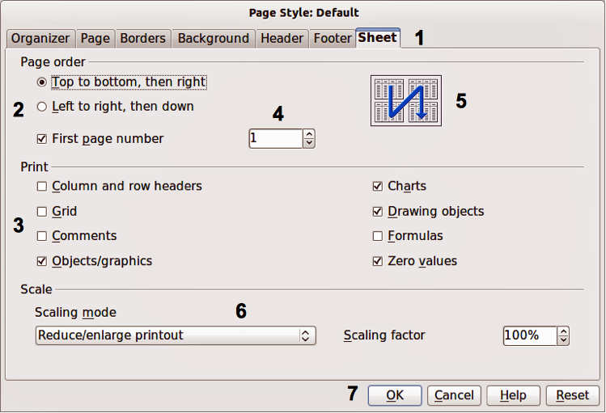
Figure 1: Dialog showing common controls
In most cases, you can interact only with the dialog (not the document itself) as long as the dialog remains open. When you close the dialog after use (usually, clicking OK or another button saves your changes and closes the dialog), then you can again work with your document.
Some dialogs can be left open as you work, so you can switch back and forth between the dialog and your document. An example of this type is the Find & Replace dialog.

Who wrote this book?
This book was written by volunteers from the LibreOffice community. Profits from sales of the printed edition will be used to benefit the community.

Acknowledgements
This book is adapted and updated from Getting Started with OpenOffice.org 3.3. The contributors to that book are:
Jean Hollis Weber Michele Zarri Magnus Adielsson
Thomas Astleitner Richard Barnes Agnes Belzunce
Chris Bonde Nicole Cairns Daniel Carrera
JiHui Choi Richard Detwiler Alexander Noël Dunne
Laurent Duperval Spencer E. Harpe Regina Henschel
Peter Hillier-Brook Richard Holt John Kane
Rachel Kartch Stefan A. Keel Jared Kobos
Michael Kotsarinis Peter Kupfer Ian Laurenson
Dan Lewis Alan Madden Michel Pinquier
Andrew Pitonyak Carol Roberts Iain Roberts
Hazel Russman Gary Schnabl Robert Scott
Joe Sellman Janet Swisher Jim Taylor
Alex Thurgood Barbara M. Tobias Claire Wood
Linda Worthington

Frequently asked questions
How is LibreOffice licensed?
LibreOffice 4.2 is distributed under the Open Source Initiative (OSI) approved Mozilla Public License (MPL). The MPL license is available from http://www.mozilla.org/MPL/2.0/.
May I distribute LibreOffice to anyone? May I sell it? May I use it in my business?
Yes.
How many computers may I install it on?
As many as you like.
Is LibreOffice available in my language?
LibreOffice has been translated (localized) into over 40 languages, so your language probably is supported. Additionally, there are over 70 spelling, hyphenation, and thesaurus dictionaries available for languages, and dialects that do not have a localized program interface. The dictionaries are available from the LibreOffice website at: www.libreoffice.org.
How can you make it for free?
LibreOffice is developed and maintained by volunteers and has the backing of several organizations.
I am writing a software application. May I use programming code from LibreOffice in my program?
You may, within the parameters set in the MPL. Read the license: http://www.mozilla.org/MPL/2.0/.
Why do I need Java to run LibreOffice? Is it written in Java?
LibreOffice is not written in Java; it is written in the C++ language. Java is one of several languages that can be used to extend the software. The Java JDK/JRE is only required for some features. The most notable one is the HSQLDB relational database engine.
Note: Java is available at no cost. If you do not want to use Java, you can still use nearly all of the features of LibreOffice.
How can I contribute to LibreOffice?
You can help with the development and user support of LibreOffice in many ways, and you do not need to be a programmer. To start, check out this webpage: http://www.documentfoundation.org/contribution/
May I distribute the PDF of this book, or print and sell copies?
Yes, as long as you meet the requirements of one of the licenses in the copyright statement at the beginning of this book. You do not have to request special permission. We request that you share with the project some of the profits you make from sales of books, in consideration of all the work we have put into producing them.

What’s new in LibreOffice 4.2?
The LibreOffice 4.2 Release Notes (changes from version 4.1) are here: https://wiki.documentfoundation.org/ReleaseNotes/4.2.
You may also want to read the LibreOffice 4.1 Release Notes (changes from version 4.0) here: https://wiki.documentfoundation.org/ReleaseNotes/4.1.

Chapter 1
Introducing LibreOffice

What is LibreOffice?
LibreOffice is a freely available, fully-featured office productivity suite. Its native file format is Open Document Format (ODF), an open standard format that is being adopted by governments worldwide as a required file format for publishing and accepting documents. LibreOffice can also open and save documents in many other formats, including those used by several versions of Microsoft Office.
LibreOffice includes the following components.

Writer (word processor)
Writer is a feature-rich tool for creating letters, books, reports, newsletters, brochures, and other documents. You can insert graphics and objects from other components into Writer documents. Writer can export files to HTML, XHTML, XML, Adobe Portable Document Format (PDF), and several versions of Microsoft Word files. It also connects to your email client.

Calc (spreadsheet)
Calc has all of the advanced analysis, charting, and decision making features expected from a high-end spreadsheet. It includes over 300 functions for financial, statistical, and mathematical operations, among others. The Scenario Manager provides “what if” analysis. Calc generates 2D and 3D charts, which can be integrated into other LibreOffice documents. You can also open and work with Microsoft Excel workbooks and save them in Excel format. Calc can also export spreadsheets in several formats, including for example Comma Separated Value (CSV), Adobe PDF and HTML formats.

Impress (presentations)
Impress provides all the common multimedia presentation tools, such as special effects, animation, and drawing tools. It is integrated with the advanced graphics capabilities of LibreOffice Draw and Math components. Slideshows can be further enhanced using Fontwork special effects text, as well as sound and video clips. Impress is compatible with Microsoft PowerPoint file format and can also save your work in numerous graphics formats, including Macromedia Flash (SWF).

Draw (vector graphics)
Draw is a vector drawing tool that can produce everything from simple diagrams or flowcharts to 3D artwork. Its Smart Connectors feature allows you to define your own connection points. You can use Draw to create drawings for use in any of the LibreOffice components, and you can create your own clip art then add it to the Gallery. Draw can import graphics from many common formats and save them in over 20 formats, including PNG, HTML, PDF, and Flash.

Base (database)
Base provides tools for day-to-day database work within a simple interface. It can create and edit forms, reports, queries, tables, views, and relations, so that managing a relational database is much the same as in other popular database applications. Base provides many new features, such as the ability to analyze and edit relationships from a diagram view. Base incorporates HSQLDB as its default relational database engine. It can also use dBASE, Microsoft Access, MySQL, or Oracle, or any ODBC compliant or JDBC compliant database. Base also provides support for a subset of ANSI-92 SQL.

Math (formula editor)
Math is the LibreOffice formula or equation editor. You can use it to create complex equations that include symbols or characters not available in standard font sets. While it is most commonly used to create formulae in other documents, such as Writer and Impress files, Math can also work as a standalone tool. You can save formulae in the standard Mathematical Markup Language (MathML) format for inclusion in web pages and other documents not created by LibreOffice.

Advantages of LibreOffice
Here are some of the advantages of LibreOffice over other office suites:
- No licensing fees. LibreOffice is free for anyone to use and distribute at no cost. Many features that are available as extra cost add-ins in other office suites (like PDF export) are free with LibreOffice. There are no hidden charges now or in the future.
- Open source. You can distribute, copy, and modify the software as much as you wish, in accordance with either of the LibreOffice Open Source licenses.
- Cross-platform. LibreOffice runs on several hardware architectures and under multiple operating systems, such as Microsoft Windows, Mac OS X and Linux.
- Extensive language support. The LibreOffice user interface is available in over 40 languages and the LibreOffice project provides spelling, hyphenation, and thesaurus dictionaries in over 70 languages and dialects. LibreOffice also provides support for both Complex Text Layout (CTL) and Right to Left (RTL) layout languages (such as Urdu, Hebrew, and Arabic).
- Consistent user interface. All the components have a similar “look and feel,” making them easy to use and master.
- Integration. The components of LibreOffice are well integrated with one another.
  - All the components share a common spelling checker and other tools, which are used consistently across the suite. For example, the drawing tools available in Writer are also found in Calc, with similar but enhanced versions in Impress and Draw.
  - You do not need to know which application was used to create a particular file. For example, you can open a Draw file from Writer.
- Granularity. Usually, if you change an option, it affects all components. However, LibreOffice options can be set at a component level or even at document level.
- File compatibility. In addition to its native OpenDocument formats, LibreOffice includes PDF and Flash export capabilities, as well as support for opening and saving files in many common formats including Microsoft Office, HTML, XML, WordPerfect, and Lotus 1-2-3 formats. An extension (included) provides the ability to import and edit some PDF files.
- No vendor lock-in. LibreOffice uses OpenDocument, an XML (eXtensible Markup Language) file format developed as an industry standard by OASIS (Organization for the Advancement of Structured Information Standards). These files can easily be unzipped and read by any text editor, and their framework is open and published.
- You have a voice. Enhancements, software fixes, and release dates are community-driven. You can join the community and affect the course of the product you use.
You can read more about LibreOffice and The Document Foundation on their websites at http://www.libreoffice.org/ and http://www.documentfoundation.org/.

Minimum requirements
LibreOffice 4.2 requires one of the following operating systems:
- Microsoft Windows XP, Vista, Windows 7, or Windows 8
- GNU/Linux Kernel version 2.6.18, glibc2 v2.5 or higher, and gtk v2.10.4 or higher
- Mac OS X 10.6 (Snow Leopard) or higher for LibreOffice 4.1 and 4.2; for LibreOffice versions up to 4.0, Mac OS X 10.4 or higher
Administrator rights are needed for the installation process.
Some LibreOffice features (wizards and the HSQLDB database engine) require that the Java Runtime Environment (JRE) is installed on your computer. Although LibreOffice will work without Java support, some features will not be available.
For a more detailed listing of requirements, see the LibreOffice website, http://www.libreoffice.org/get-help/system-requirements/.

How to get the software
The software can be downloaded from http://www.libreoffice.org/download. You can also download the software by using a Peer-to-Peer client, such as BitTorrent, at the same address.
Linux users will find LibreOffice included in many of the latest Linux distributions; Ubuntu is just one example.

How to install the software
Information on installing and setting up LibreOffice on the various supported operating systems is given here: http://www.libreoffice.org/get-help/install-howto/.

Extensions and add-ons
Extensions and add-ons are available to enhance LibreOffice. Several extensions are installed with the program and you can get others from the official extensions repository, http://extensions.libreoffice.org/. See Chapter 14 Customizing LibreOffice for more information on installing extensions and add-ons.

Starting LibreOffice
The most common way to launch any component of LibreOffice is by using the system menu, the standard menu from which most applications are started. On Windows, it is called the Start menu. On GNOME, it is called the Applications menu. On KDE it is identified by the KDE logo. On Mac OS X, it is the Applications menu. On Windows 8 you will see tiles on the Start screen, which has replaced the Start menu.
When LibreOffice was installed on your computer, a menu entry for LibreOffice and each LibreOffice component was added to your system menu if your computer uses a Linux or Windows operating system. On computers operating Mac OS X, only a menu entry for LibreOffice is added to the Applications menu.
Clicking on the LibreOffice menu entry or tile opens the LibreOffice Start Center (Figure 2) from where you can select the individual components of LibreOffice. You can also select to open an existing file or use a template.
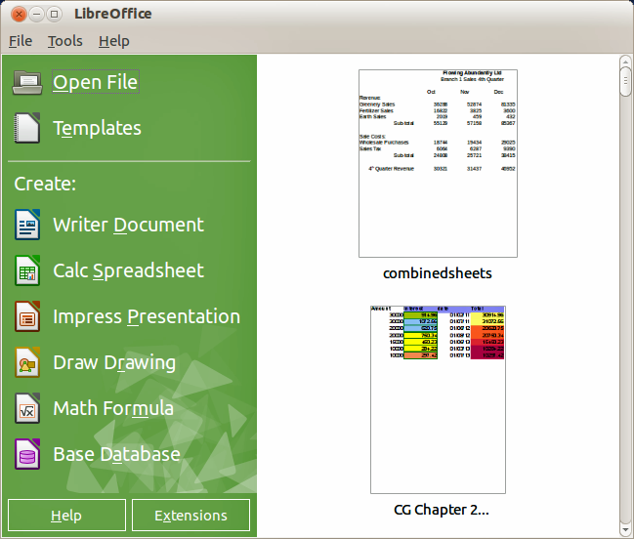
Figure 2: LibreOffice Start Center

Starting from an existing document
You can start LibreOffice by double-clicking the filename of an ODF document in a file manager such as Windows Explorer. The appropriate component of LibreOffice will start and the document will be loaded.
If Microsoft Office is installed on your computer and you have associated Microsoft Office file types with LibreOffice, when you double-click on the file:
- For a Word file (*.doc or *.docx), it opens in Writer.
- For an Excel file (*.xls or *.xlsx), it opens in Calc.
- For a PowerPoint file (*.ppt or *.pptx), it opens in Impress.
If you did not associate the file types and Microsoft Office is installed on your computer, then when you double-click on a Microsoft Office file, it opens using the appropriate Microsoft Office component.
For more information on opening files, see “Opening existing documents” on page 28.

Quickstarter
When LibreOffice is installed on computers running Windows or Linux, a Quickstarter feature may also be installed. When Quickstarter is activated, the necessary library files are loaded when the computer system is started, resulting in a shorter startup time for LibreOffice components.
Computers with a Mac operating system do not have a Quickstarter.

Activating Quickstarter
On computers operating a Linux or Windows operating system, the default installation of LibreOffice does not set the Quickstarter to load automatically. To activate it:
- Open LibreOffice.
- Go to Tools > Options > LibreOffice > Memory on the menu bar and select Load LibreOffice during system start-up (if using Windows) or select Enable systray Quickstarter (if using Linux).
- Close and restart LibreOffice to have Quickstarter appear.

Using Quickstarter on Windows or Linux
After Quickstarter has been activated, an icon  is installed into the system tray at the bottom of the display. Quickstarter is then available at all times, whether LibreOffice is open or not.
To start a LibreOffice component directly by using Quickstarter:
- Right-click the Quickstarter icon in the system tray to open a pop-up menu (Figure 3).
- Select the LibreOffice component you want to open to create a new document, or select From Template to open the Template Manager, or select Open Document to open an existing document.
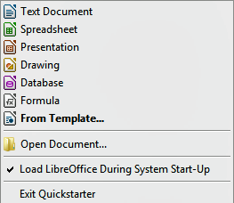
Figure 3: Quickstarter menu in Windows

Disabling Quickstarter
To temporarily close Quickstarter on a computer using a Windows operating system, right-click on the Quickstarter icon in the system tray and select Exit Quickstarter in the pop-up menu. However, when the computer is restarted, Quickstarter will be loaded again.
To prevent the Quickstarter from loading during system startup, do one of the following:
- Right-click on the Quickstarter icon and deselect Load LibreOffice during system start-up on the pop-up menu (on Windows) or select Disable systray Quickstarter (on Linux).
- Go to Tools > Options > LibreOffice > Memory on the menu bar and deselect Load LibreOffice during system start-up (on Windows) or deselect Enable systray Quickstarter on Linux.

Reactivating Quickstarter
If Quickstarter has been disabled, you can reactivate it by using the instructions given in “Activating Quickstarter” above.

Parts of the main window
The main window is similar for each component of LibreOffice, although some details vary. See the relevant chapters in this guide about Writer, Calc, Draw, and Impress for descriptions of those details.
Common features include the menu bar, standard toolbar, and formatting toolbar at the top of the window and the status bar at the bottom.

Menu bar
The menu bar is located across the top of the LibreOffice window, just below the title bar. When you select one of the menus listed below, a sub-menu drops down to show commands.
- File – contains commands that apply to the entire document such as Open, Save, and Export as PDF.
- Edit – contains commands for editing the document such as Undo: xxx (where xxx is the command to undo) and Find & Replace. It also contains commands to cut, copy, and paste selected parts of your document.
- View – contains commands for controlling the display of the document such as Zoom and Web Layout.
- Insert – contains commands for inserting elements into your document such as Header, Footer, and Picture.
- Format – contains commands, such as Styles and Formatting and AutoCorrect, for formatting the layout of your document.
- Table – contains all commands to insert and edit a table in a text document.
- Tools – contains functions such as Spelling and Grammar, Customize, and Options.
- Window – contains commands for the display window.
- Help – contains links to the LibreOffice Help file, What’s This?, and information about the program.

Toolbars
LibreOffice has two types of toolbars: docked (fixed in place) and floating. Docked toolbars can be moved to different locations or made to float, and floating toolbars can be docked.
In a default LibreOffice installation, the top docked toolbar, just under the menu bar, is called the Standard toolbar. It is consistent across the LibreOffice applications.
The second toolbar at the top, in a default LibreOffice installation, is the Formatting bar. It is context-sensitive; that is, it shows the tools relevant to the current position of the cursor or the object selected. For example, when the cursor is on a graphic, the Formatting bar provides tools for formatting graphics; when the cursor is in text, the tools are for formatting text.

Displaying or hiding toolbars
To display or hide toolbars, go to View > Toolbars on the main menu bar, then click on the name of a toolbar from the drop-down list. An active toolbar shows a check-mark beside its name. Toolbars created from tool palettes are not listed in the View menu.
To close a toolbar, click on the X on the right of the toolbar title or go to View > Toolbars on the main menu bar and deselect the toolbar.

Sub-menus and tool palettes
Toolbar icons with a small triangle to the right will display sub-menus, tool palettes, and alternative methods of selecting items, depending on the icon.
Tool palettes can be made into a floating toolbar. Figure 4 shows an example of a tool palette from the Drawing toolbar made into a floating toolbar. See “Moving toolbars” and “Floating toolbars” below for more information on moving and floating these toolbars created from tool palettes.
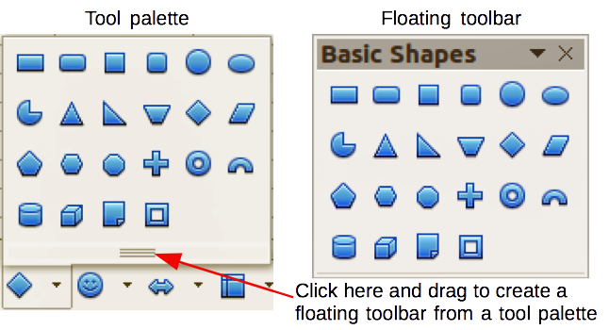
Figure 4: Example of tearing off a tool palette

Moving toolbars
Docked toolbars can be undocked and moved to a new docked position or left as a floating toolbar.
- Move the mouse cursor over the toolbar handle, which is the small vertical bar to the left of a docked toolbar and highlighted in Figure 5.
- Hold down the left mouse button and drag the toolbar to the new location. The toolbar can be docked in a new position at the top, sides or bottom of the main window, or left as a floating toolbar.
- Release the mouse button.
- To move a floating toolbar, click on its title bar and drag it to a new floating location or dock the toolbar at the top or bottom of the main window.
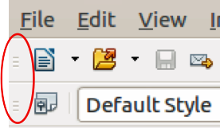
Figure 5: Toolbar handles
Note | You can also dock a floating toolbar by holding down the Ctrl key and double clicking in the title bar of the toolbar.

Floating toolbars
LibreOffice includes several additional toolbars, whose default setting appear as floating toolbars in response to the current position of the cursor or selection. You can dock these toolbars to the top or bottom of the main window, or reposition them on your computer display (see “Moving toolbars” above).
Some of these additional toolbars are context sensitive and will automatically appear depending on the position of the cursor. For example, when the cursor is in a table, a Table toolbar appears, and when the cursor is in a numbered or bullet list, the Bullets and Numbering toolbar appears.

Customizing toolbars
You can customize toolbars in several ways, including choosing which icons are visible and locking the position of a docked toolbar. You can also add icons and create new toolbars, as described in Chapter 14 Customizing LibreOffice. To access the customization options for a toolbar, right-click in an empty space between the icons on a toolbar to open a context menu as follows:
- To show or hide icons defined for the selected toolbar, click Visible Buttons. Visible icons on a toolbar are indicated by an outline around the icon (Figure 6) or by a check mark beside the icon, depending on your operating system. Select or deselect icons to hide or show them on the toolbar.
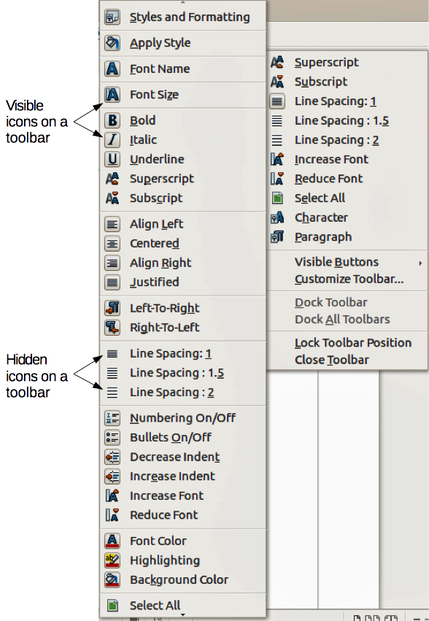
Figure 6: Selection of visible toolbar icons
- Click Customize Toolbar to open the Customize dialog, see Chapter 14 Customizing LibreOffice for more information.
- Click Dock Toolbar to dock the selected toolbar. By default, a toolbar will dock at the top of the workspace. You can reposition the toolbar to a different docked position, see “Moving toolbars” on page 24.
- Click Dock All Toolbars to dock all floating toolbars. By default, toolbars will dock at the top of the workspace. You can reposition the toolbars to different docked positions, see “Moving toolbars” on page 24.
- Click Lock Toolbar Position to lock a docked toolbar into its docked position.
- Click Close Toolbar to close the selected toolbar.

Docking/floating dialogs
When dialogs open, they are floating dialogs, unless they have been docked when LibreOffice was last opened. These floating dialogs can be docked by holding down the Ctrl key and double-clicking in a vacant area near the icons at the top of the floating dialog. The dialog will then dock in its last docked position on the workspace. After docking, you can resize the docked dialog and reposition in a new docked position.
To undock a docked dialog and make it floating, hold down the Ctrl key and double-click in a vacant area near the icons at the top of the docked dialog. Alternatively, click and hold in a vacant area near the icons at the top of the docked dialog and drag it to a floating position.

Context menus
Context menus are a quick access to many menu functions and are opened by right-clicking on a paragraph, graphic, or other object. When a context menu opens, the functions or options available will be dependent on the object that has been selected. A context menu can be the easiest way to reach a function, especially if you are not sure where a function is located in the menus or toolbars.

Status bar
The status bar is located at the bottom of the workspace provides information about the document and convenient ways to quickly change some features. It is similar in Writer, Calc, Impress, and Draw, but each LibreOffice component includes some component-specific items. An example of the Writer status bar is shown in Figure 7.
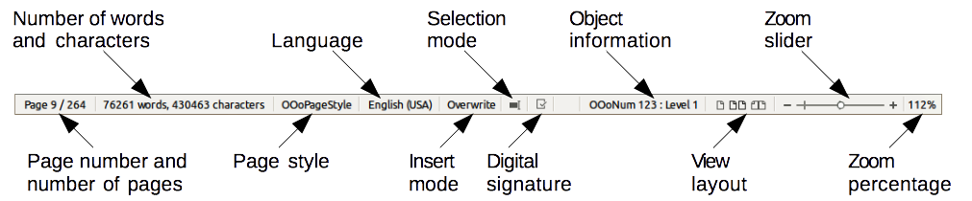
Figure 7: Example status bar from Writer
Page, sheet, or slide number and page count
Shows the current page, sheet, or slide number and the total number of pages, sheets, or slides in the document. Double-click on this field to open the Navigator. Other uses of this field depend on the LibreOffice component.
Words and characters
Shows the total number of words and characters in the document or in the selection.
Page style or slide design
Shows the current page style or slide design. To edit the current page style or slide design, double-click on this field.
Language
Shows the current language of the whole document.
Insert mode
Shows the type of insert mode the program is in. This field is blank if the program is in Insert mode. Each time the Ins key is pressed the mode toggles between Insert and Overwrite.
Unsaved changes
An icon appears here if changes to the document have not been saved.
Digital signature
If the document has been digitally signed, an icon shows here. You can double-click the icon to view the certificate.
Object information
Displays information relevant to the position of the cursor or the selected element of the document. Double-clicking in this area usually opens a relevant dialog.
View layout
Select between Single Page, Multiple Pages and Double Sided Pages on how your document is displayed.
Zoom slider
Drag the Zoom slider, or click on the + and – signs to change the view magnification of your document.
Zoom percentage
Indicates the magnification level of the document. Right-click on the percentage figure to open a list of magnification values from which to choose. Double-clicking on this percentage figure opens the Zoom & View Layout dialog.

Sidebar
To activate the Sidebar, select View > Sidebar from the Menu Bar. The sidebar is located on the right side of the edit views of Writer, Calc, Impress, and Draw. It contains one or more panels, based on the current document context. Panels are organized into decks. A tab bar on the right side of the sidebar allows you to switch between different decks.
All components contain the Properties, Styles and Formatting, Gallery, and Navigator decks. Some components have additional decks, such as Master Pages, Custom Animation, and Slide Transition for Impress and Functions for Calc.
A panel is like a combination of a toolbar and a dialog. For example, you can freely mix working in the main edit window to enter text and use the Properties panel in the sidebar to change text attributes.
Tool bars and sidebar panels share many functions. For example, the buttons for making text bold or italic exist in both the Formatting toolbar and the Properties panel.
For more detail, see the Sidebar explanation in the relevant LibreOffice component’s user guide.

Starting new documents
You can start a new, blank document in LibreOffice in several ways.
When LibreOffice is open but no document is open, the Start Center (Figure 2 on page 21) is shown. Click one of the icons to open a new document of that type, or click the Templates icon to start a new document using a template.
You can also start a new document in one of the following ways:
- Use File > New on the menu bar and select the type of document from the context menu.
- Use the keyboard shortcut Ctrl+N to create a new document. The type of document created depends on which LibreOffice component is open and active. For example, if Calc is open and active, a new spreadsheet is created.
- Use File > Wizards on the menu bar and select the type of document from the context menu.
- If a document is already open in LibreOffice, click the New icon on the Standard toolbar and a new document of the same type is created in a new window. For example, if Calc is open and active, a new spreadsheet is created. The New icon changes depending on which component of LibreOffice is open.
- If a document is already open in LibreOffice, click on the small triangle to the right of the New icon on the Standard toolbar and select the type of document from the context menu that opens.
- On Windows or Linux, use the Quickstarter feature included with LibreOffice. See “Quickstarter” on page 21 for more information.
Note | If all documents are closed without closing LibreOffice, then the Start Center will be displayed.

Opening existing documents
You can also open an existing document in one of the following ways:
- When no document is open, click Open File in the Start Center to reach the Open dialog.
- Go to File > Open on the menu bar the reach the Open dialog.
- Use the keyboard shortcut Ctrl+O to reach the Open dialog.
- If a document is already open, click the Open icon on the Standard toolbar and select from a list of available documents from the Open dialog.
- Click the small triangle to the right of the Open icon and select from a list of recently opened documents.
- When no document is open, double-click on a thumbnail of recently opened documents displayed in the Start Center. You can scroll up or down in the Start Center to locate a recently opened document.
When using the Open dialog, navigate to the folder you want and select the file you want, and then click Open. If a document is already open in LibreOffice, the second document opens in a new window.
In the Open dialog, you can reduce the list of files by selecting the type of file you are looking for. For example, if you choose Text documents as the file type, you will only see documents Writer can open (including .odt, .doc, .txt); if you choose Spreadsheets, you will see .ods, .xls, and other files that Calc opens.
You can also open an existing document that is in a format that LibreOffice recognizes by double-clicking on the file icon on the desktop or in a file manager such as Windows Explorer. LibreOffice has to be associated with file types that are not ODF files for the appropriate LibreOffice component to open.
Note | You can choose whether to use the LibreOffice Open/Save dialogs or the ones provided by your computer’s operating system. See “Open and Save As dialogs” on page 31 for more information.

Saving documents
You can save documents as follows:
- Save command – use if you are keeping the document, its current filename and location.
- Save As command – use if you want to create a new document, or change the filename and/or file format, or save the file in a different location on your computer.
- Password protection – use if you want to restrict who can open and read the document, or open and edit the document.

Save command
To save a document if you are keeping the document, its current filename and location, do one of the following:
- Use the keyboard shortcut Ctrl+S.
- Go to File > Save on the main menu bar.
- Click the Save icon on the Standard toolbar.
Using the Save command will overwrite the last saved version of the file.

Save As command
To save a document if you want to create a new document, or change the filename and/or file format, or save the file in a different location on your computer:
- Use the keyboard shortcut Ctrl+Shift+S.
- Go to File > Save As on the main menu bar.
When the Save As dialog (Figure 8) or Save dialog opens, enter the file name, change the file type (if applicable), navigate to a new location (if applicable), and click Save.
The dialog that opens when using the Save As command depends on the options that have been set in LibreOffice. See “Open and Save As dialogs” on page 31 for more information.
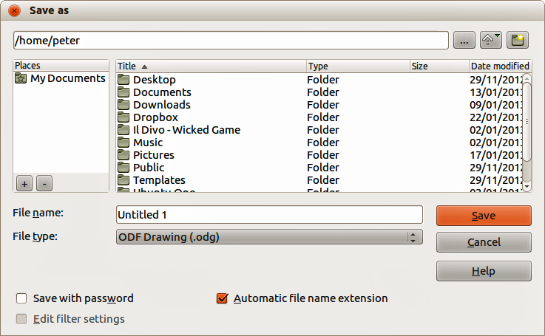
Figure 8: Example of LibreOffice Save As dialog

Password protection
To protect a document and restrict who can open and read the document, or open and edit the document, you have to use password protection.
- Using the Save As command above, select the Save with password option in the Save As dialog or Save dialog.
- Click Save and the Set Password dialog opens (Figure 9).
- In File encryption password, enter a password to open the document and then enter the same password as confirmation.
- To restrict who can edit the document, click the More Options button. This button changes to Fewer Options when clicked.
- In File sharing password, select Open file read only and enter a password to allow editing and then enter the same password as confirmation.
- Click OK and the dialog closes. If the passwords match, the document is saved password protected. If the passwords do not match, you receive an error message.
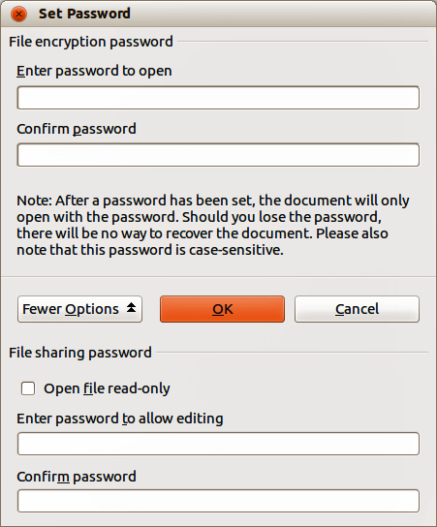
Figure 9: Set Password dialog
Caution   | LibreOffice uses a very strong encryption mechanism that makes it almost impossible to recover the contents of a document if you lose or forget the password.

Changing the password
When a document is password-protected, you can change the password while the document is open. Go to File > Properties > General on the menu bar and click the Change Password button in the Properties dialog. This opens the Set Password dialog where you can enter a new password.

Saving documents automatically
LibreOffice can save files automatically as part of the AutoRecovery feature. Automatic saving, like manual saving, overwrites the last saved state of the file. To set up automatic file saving:
- Go to Tools > Options > Load/Save > General on the menu bar.
- Select Save AutoRecovery information every and set the time interval.
- Click OK.

Renaming and deleting files
You can rename or delete files within the LibreOffice dialogs, just as you can in a file manager. Select a file and then right click to open a context menu. Select either Delete or Rename, as appropriate. However, you cannot copy or paste files within the dialogs.

Open and Save As dialogs
You can choose whether to use the LibreOffice Open and Save As dialogs or the ones provided by your operating system.
- To use LibreOffice dialogs for saving or opening files, go to Tools > Options > LibreOffice > General and check the option Use LibreOffice dialog boxes. An example of a LibreOffice dialog is shown in Figure 8 on page 29.
- To use the operating system dialogs for saving or opening files, go to Tools > Options > LibreOffice > General and uncheck the option Use LibreOffice dialog boxes.
The three icons in the top right of the LibreOffice Open and Save As dialogs are as follows:
- Connect To Server – a dialog opens allowing you to connect to a network server if the file you want is not located on your computer.
- Up One Level – moves up one folder in the folder hierarchy. Click and hold the mouse button on this icon to display a drop down a list of higher level folders. Move the cursor over a higher level folder and release the mouse button to navigate to that folder
- Create New Folder – creates a new sub-folder in the folder that is displayed in the dialog.
Use the File type field to specify the type of file to be opened or the format of the file to be saved.
The Read-only option on the Open dialog opens the file for reading and printing only. Most of the icons and most menu options are disabled on the toolbars. The Edit File icon becomes active on the Standard toolbar. Click on this icon to open the file for editing.

Using the Navigator
The LibreOffice Navigator lists objects contained within a document, collected into categories. For example, in Writer it shows Headings, Tables, Text frames, Comments, Graphics, Bookmarks, and other items, as shown in Figure 10. In Calc it shows Sheets, Range Names, Database Ranges, Graphics, Drawing Objects, and other items. In Impress and Draw it shows Slides, Pictures, and other items.
To open the Navigator, click the Navigator icon on the Standard toolbar, or press the F5 key, or go to View > Navigator on the menu bar.
You can dock the Navigator to either side of the main LibreOffice window or leave it floating (see “Docking/floating dialogs“ on page 26 for more information).
Click the marker (+ or triangle) by any of the categories to display the list of objects in that category.
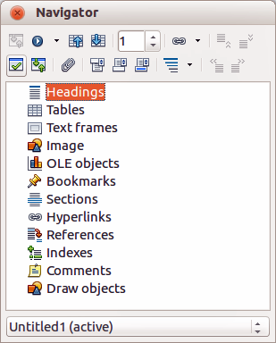
Figure 10: Navigator in Writer
The Navigator provides several convenient ways to move around a document and find items in it:
- When a category is showing the list of objects in it, double-click on an object to jump directly to that object location in the document.
- Objects are much easier to find if you have given them recognizable names when creating them, instead of keeping the LibreOffice default names, for example Sheet1, Table1, Table2, and so on. The default names may not correspond to the actual position of the object in the document.
- Each Navigator in the individual LibreOffice components has a different range of functions and these functions are further explained in the appropriate user guides for each LibreOffice component.

Undoing and redoing changes
To undo the most recent change in a document, use the keyboard shortcut Ctrl+Z, or click the Undo icon on the Standard toolbar, or go to Edit > Undo on the menu bar. Click the small triangle to the right of the Undo icon to get a list of all the changes that can be undone. You can select multiple changes and undo them at the same time.
After changes have been undone, you can redo changes. To redo a change use the keyboard shortcut Ctrl+Y, or click the Redo icon , or go to Edit > Redo on the menu bar. As with Undo, click on the triangle to the right of the arrow to get a list of the changes that can be reapplied.
To modify the number of changes LibreOffice remembers, go to Tools > Options > LibreOffice > Memory on the menu bar. In the Undo section increase or decrease the Number of steps. Be aware that asking LibreOffice to remember more changes consumes more computer memory.

Closing a document
If only one document is open and you want to close that document, go to File > Close on the menu bar or click on the X on the right side of the menu bar. The document closes and the LibreOffice Start Center opens.
If more than one document is open and you want to close one of them, go to File > Close on the menu bar or click on the X on the title bar of that document’s window. The X may be located on either the right or left end of the title bar.
If the document has not been saved since the last change, a message box is displayed. Choose whether to save or discard your changes.
Caution | Not saving your document could result in the loss of recently made changes, or worse still, the entire file.

Closing LibreOffice
To close LibreOffice completely, go to File > Exit on the menu bar in Windows and Linux operating systems. In a Mac operating system, go to LibreOffice > Quit LibreOffice on the menu bar.
When you close the last document using the X on the Title bar of the window, then LibreOffice will close completely. A Mac operating system does not have this function; instead, you need to go to LibreOffice > Quit LibreOffice on the menu bar.
You can also use a keyboard shortcut as follows:
- In Windows and Linux – Ctrl+Q
- In Mac OS X – Command ⌘+Q
If any documents have not been saved since the last change, a message box is displayed. Choose whether to save or discard your changes.

Chapter 2
Setting up LibreOffice
Choosing options to suit the way you work

Choosing options for all of LibreOffice
This section covers some of the settings that apply to all the components of LibreOffice. For information on settings not discussed here, see the Help.
Click Tools > Options. The list in the left-hand box of the Options – LibreOffice dialog varies depending on which component of LibreOffice is open. The illustrations in this chapter show the list as it appears when a Writer document is open.
Click the marker (+ or triangle) by LibreOffice on the left-hand side. A list of pages drops down. Selecting an item in the list causes the right-hand side of the dialog to display the relevant page.
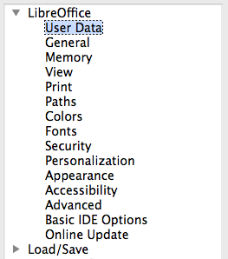
Figure 11: LibreOffice options
Note | The Revert button, located in the lower right of the full Options dialog, has the same effect on all pages of the dialog. It resets the options to the values that were in place when you opened the dialog.
If you are using a version of LibreOffice other than US English, some field labels may be different from those shown in the illustrations.

User Data options
Because LibreOffice can use the name or initials stored in the LibreOffice – User Data page for several things, including document properties (created by and last edited by information) and the name of the author of comments and changes, you will want to ensure that the correct information appears here.
Fill in the form (not shown here), or amend or delete any existing information. If you do not want user data to be part of the document’s properties, clear the box at the bottom.

General options
The options on the LibreOffice – General page are described below.
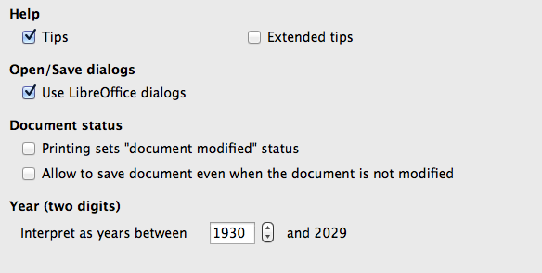
Figure 12: Setting general options for LibreOffice
Help – Tips
When Tips is active, one or two words will appear when you hold the mouse pointer over an icon or field, without clicking.
Help – Extended tips
When Extended tips is active, a brief description of the function of a particular icon or menu command or a field on a dialog appears when you hold the mouse pointer over that item.
Open/Save dialogs – Use LibreOffice dialogs
To use the standard Open and Save dialogs for your operating system, deselect the Use LibreOffice dialogs option. When this option is selected, the Open and Save dialogs supplied with LibreOffice will be used. See Chapter 1, Introducing LibreOffice, for more about the LibreOffice Open and Save dialogs. This book uses the LibreOffice Open and Save dialogs in illustrations.
Document status – Printing sets “document modified” status
If this option is selected, then the next time you close the document after printing, the print date is recorded in the document properties as a change and you will be prompted to save the document again, even if you did not make any other changes.
Document status – Allow to save document even when the document is not modified
Normally when a document has not been modified, the File > Save menu option and the Save button on the Standard toolbar are disabled and the keyboard shortcut Ctrl+S has no effect. Select this option to allow documents to be saved even when they have not been modified.
Year (two digits)
Specifies how two-digit years are interpreted. For example, if the two-digit year is set to 1930, and you enter a date of 1/1/30 or later into your document, the date is interpreted as 1/1/1930 or later. An “earlier” date is interpreted as being in the following century; that is, 1/1/20 is interpreted as 1/1/2020.

Memory options
The options on the LibreOffice – Memory page control how LibreOffice uses your computer’s memory and how much memory it requires. Before changing them, you may wish to consider the following points:
- More memory can make LibreOffice faster and more convenient (for example, more undo steps require more memory); but the trade-off is less memory available for other applications and you could run out of memory altogether.
- If your documents contain a lot of objects such as images, or the objects are large, LibreOffice’s performance may improve if you increase the memory for LibreOffice or the memory per object. If you find that objects seem to disappear from a document that contains a lot of them, increase the number of objects in the cache. (The objects are still in the file even if you cannot see them on screen.)
- To load the Quickstarter when you start your computer, select the option near the bottom of the dialog. This makes LibreOffice start faster; the trade-off is LibreOffice uses some memory even when not being used. This option is called Enable systray quickstarter on Linux. It is not available on Mac OS X or on systems where the Quickstarter module has not been installed.
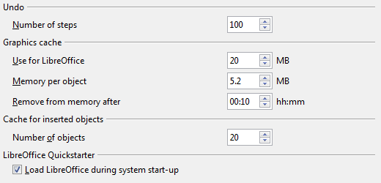
Figure 13: Choosing Memory options for the LibreOffice applications

View options
The options on the LibreOffice – View page affect the way the document window looks and behaves. Some of these options are described below. Set them to suit your personal preferences.
User Interface – Scaling
If the text in the help files or on the menus of the LibreOffice user interface is too small or too large, you can change it by specifying a scaling factor. Sometimes a change here can have unexpected results, depending on the screen fonts available on your system. However, it does not affect the actual font size of the text in your documents.
User Interface – Icon size and style
The first box specifies the display size of toolbar icons (Automatic, Small, or Large). The Automatic icon size option uses the setting for your operating system. The second box specifies the icon style (theme); here the Automatic option uses an icon set compatible with your operating system and choice of desktop: for example, KDE or Gnome on Linux.
User Interface – Use system font for user interface
If you prefer to use the system font (the default font for your computer and operating system) instead of the font provided by LibreOffice for the user interface, select this option.
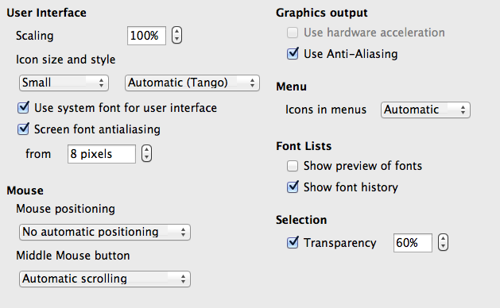
Figure 14: Choosing View options for LibreOffice applications
User interface – Screen font anti-aliasing
(Not available in Windows.) Select this option to smooth the screen appearance of text. Enter the smallest font size to apply anti-aliasing.
Menu – icons in menus
Causes icons as well as words to be visible in menus.
Font Lists – Show preview of fonts
Causes the font list to look like Figure 15, Left, with the font names shown as an example of the font; with the option deselected, the font list shows only the font names, not their formatting (Figure 15, Right). The fonts you will see listed are those that are installed on your system.
Fonts which are tuned for use with a specific script, such as Arabic, Hebrew, Malayalam, and so on, now show an additional preview of some sample text in the target script.
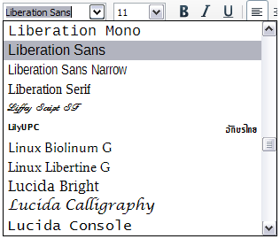 | 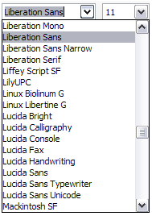
Figure 15: Font list (Left) With preview; (Right) Without preview
Font Lists – Show font history
Causes the last five fonts you have assigned to the current document to be displayed at the top of the font list. Otherwise fonts are shown in alphabetical order.
Graphics output – Use hardware acceleration
Directly accesses hardware features of the graphical display adapter to improve the screen display. Not supported on all operating systems and LibreOffice distributions.
Graphics output – Use anti-aliasing
Enables and disables anti-aliasing, which makes the display of most graphical objects look smoother and with fewer artifacts. Not supported on all operating systems and LibreOffice distributions.
Tip | Press Shift+Ctrl+R to restore or refresh the view of the current document after changing the anti-aliasing settings, to see the effect.
Mouse positioning
Specifies if and how the mouse pointer will be positioned in newly opened dialogs.
Middle mouse button
Defines the function of the middle mouse button.
- Automatic scrolling – dragging while pressing the middle mouse button shifts the view.
- Paste clipboard – pressing the middle mouse button inserts the contents of the “Selection clipboard” at the cursor position.
The “Selection clipboard” is independent of the normal clipboard that you use by Edit > Copy/Cut/Paste or their respective keyboard shortcuts. Clipboard and “Selection clipboard” can contain different contents at the same time.
Function | Clipboard | Selection clipboard
Copy content | Edit > Copy Ctrl+C | Select text, table, or object.
Paste content | Edit > Paste Ctrl+V pastes at the cursor position. | Clicking the middle mouse button pastes at the mouse pointer position.
Pasting into another document | No effect on the clipboard contents. | The last marked selection is the content of the selection clipboard.
Selection – Transparency
Determines the appearance of selected text or graphics, which appear on a shaded background. To make the shaded background more or less dark, increase or decrease the Transparency setting.
If you prefer selected material to appear in reversed color (typically white text on a black background), deselect this option.

Print options
On the LibreOffice – Print page, set the print options to suit your default printer and your most common printing method. Most of these options should be self-explanatory.
The option PDF as Standard Print Job Format is not available on Windows. Select this option to change the internal print job format from a Postscript document description to a PDF description. This format has a number of advantages over Postscript. For more information, see http://www.linuxfoundation.org/collaborate/workgroups/openprinting/pdf_as_standard_print_job_format
Deselecting this option reverts to the Postscript document workflow system.
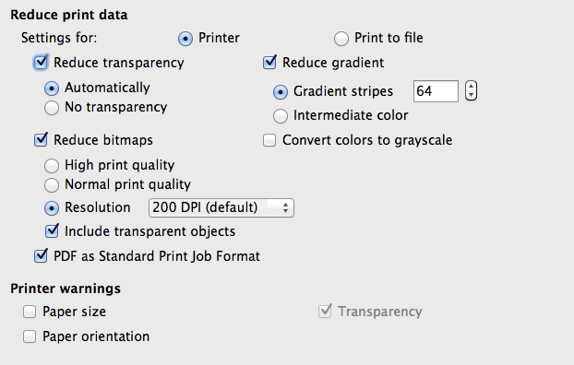
Figure 16: Choosing general printing options to apply to all LibreOffice components
In the Printer warnings section near the bottom of the page, you can choose whether to be warned if the paper size or orientation specified in your document does not match the paper size or orientation available for your printer. Having these warnings turned on can be quite helpful, particularly if you work with documents produced by people in other countries where the standard paper size is different from yours.
Tip | If your printouts are incorrectly placed on the page or chopped off at the top, bottom, or sides, or the printer is refusing to print, the most likely cause is page size incompatibility.

Paths options
On the LibreOffice – Paths page, you can change the location of files associated with, or used by, LibreOffice to suit your working situation. In a Windows system, for example, you might want to store documents by default somewhere other than My Documents.
To make changes, select an item in the list shown in Figure 17 and click Edit. On the Select Path dialog (not shown; may also be titled Edit Paths), add or delete folders as required, and then click OK to return to the Options dialog. Note that some items can have at least two paths listed: one to a shared folder (which might be on a network) and one to a user-specific folder (normally on the user’s personal computer).
Tip | You can use the entries on the LibreOffice – Paths page to compile a list of files, such as those containing AutoText, that you need to back up or copy to another computer.
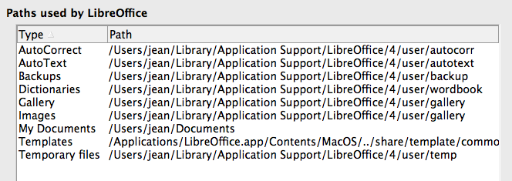
Figure 17: Viewing the paths of files used by LibreOffice

Color options
On the LibreOffice – Colors page, you can specify colors to use in LibreOffice documents. You can select a color from a color table, edit an existing color, and define new colors. These colors are stored in your color palette and are then available in all components of LibreOffice.
To modify a color:
- Select the color to modify from the list or the color table.
- Enter the new values that define the color. You can choose the RGB (Red, Green, Blue) or the CMYK (Cyan, Magenta, Yellow, Black) system to specify your color. The changed color appears in the lower of the two color preview boxes at the top.
- Modify the Name as required.
- Click the Modify button. The newly defined color is now listed in the Color table.
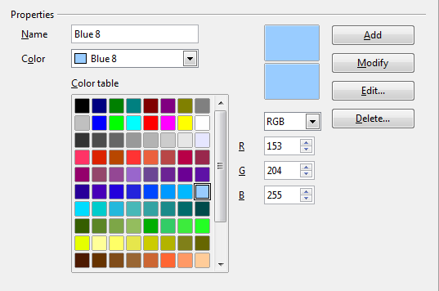
Figure 18: Defining colors to use in color palettes in LibreOffice
Alternatively, click the Edit button to open the Color Picker dialog, shown in Figure 19. Here you can select a color from the window on the left, or you can enter values on the right using your choice of RGB, CMYK, or HSB (Hue, Saturation and Brightness) values.
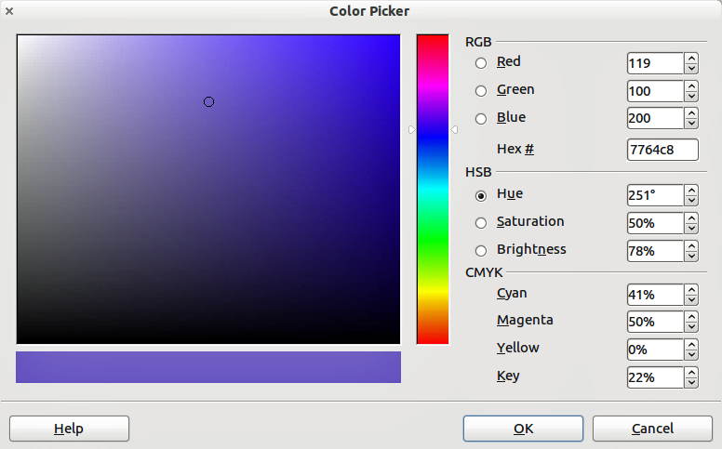
Figure 19: Editing colors
The color window on the left is linked directly with the color input fields on the right; as you choose a color in the window, the numbers change accordingly. The color field at the lower left shows the value of the selected color on the left and the currently set value from the color value fields on the right.
Modify the color components as required and click OK to exit the dialog. The newly defined color now appears in the lower of the color preview boxes shown in Figure 18. Type a name for this color in the Name box, then click the Add button. A small box showing the new color is added to the Color table.
Another way to define or alter colors is through the Colors page of the Area dialog, where you can also save and load palettes, a feature that is not possible here. In Calc, draw a temporary draw object and use the context menu of this object to open the Area dialog. If you load a palette in one component of LibreOffice, it is only active in that component; the other components keep their own palettes.

Fonts options
You can define replacements for any fonts that might appear in your documents. If you receive from someone else a document containing fonts that you do not have on your system, LibreOffice will substitute fonts for those it does not find. You might prefer to specify a different font from the one that the program chooses.
On the LibreOffice – Fonts page:
- Select the Apply Replacement Table option.
- Select or type the name of the font to be replaced in the Font box. (If you do not have this font on your system, it will not appear in the drop-down list in this box, so you need to type it in.)
- In the Replace with box, select a suitable font from the drop-down list of fonts installed on your computer.
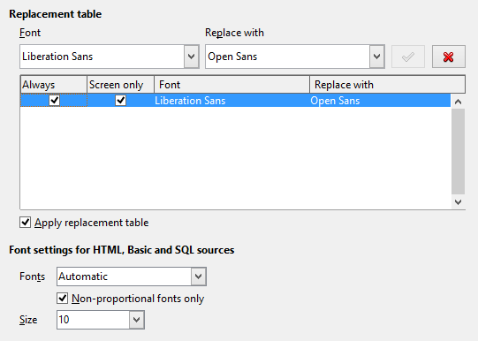
Figure 20: Defining a font to be substituted for another font
- The check mark to the right of the Replace with box turns green. Click on this check mark. A row of information now appears in the larger box below the input boxes. Select Always to replace the font, even if the original font is installed on your system. Select Screen only to replace the screen font only and never replace the font for printing. The results of combining these selections are given in Table 2.
- In the bottom section of the page, you can change the typeface and size of the font used to display source code such as HTML and Basic (in macros).
Table 2. Font substitution replacement actions
Always checkbox | Screen only checkbox | Replacement action
checked | blank | Font replacement on screen and when printing, whether the font is installed or not.
checked | checked | Font replacement only on screen, whether the font is installed or not.
blank | checked | Font replacement only on screen, but only if font is not available.
blank | blank | Font replacement on screen and when printing, but only if font is not available.

Security options
Use the LibreOffice – Security page to choose security options for saving documents and for opening documents that contain macros.
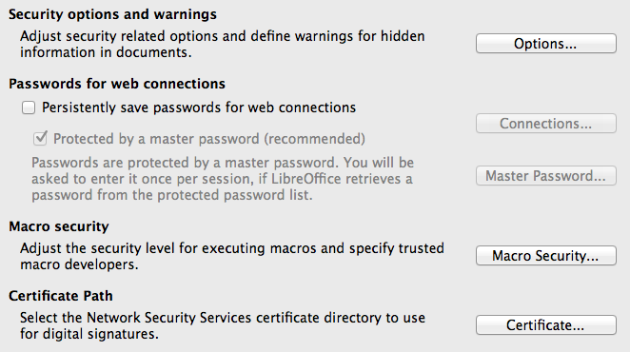
Figure 21: Choosing security options for opening and saving documents
Security options and warnings
If you record changes, save multiple versions, or include hidden information or notes in your documents, and you do not want some of the recipients to see that information, you can set warnings to remind you to remove it, or you can have LibreOffice remove some of it automatically. Note that (unless removed) much of this information is retained in a file whether the file is in LibreOffice’s default OpenDocument format, or has been saved to other formats, including PDF.
Click the Options button to open a separate dialog with specific choices (Figure 23). See “Security options and warnings” below.
Passwords for web connections
You can enter a master password to enable easy access to websites that require a user name and password. If you select the Persistently save passwords for web connections option, a new dialog opens (Figure 22). LibreOffice will securely store all passwords that you use to access files from web servers. You can retrieve the passwords from the list after you enter the master password.
Macro security
Click the Macro Security button to open the Macro Security dialog (not shown here), where you can adjust the security level for executing macros and specify trusted sources.
Certificate Path
Note | This option appears only on Linux and Mac systems. On Windows, LibreOffice uses the default Windows location for storing and retrieving certificates.
Users can digitally sign documents using LibreOffice. A digital signature requires a personal signing certificate. Most operating systems can generate a self-signed certificate. However, a personal certificate issued by an outside agency (after verifying an individual's identity) has a higher degree of trust associated with it than does a self-signed certificate. LibreOffice does not provide a secure method of storing these certificates, but it can access certificates that have been saved using other programs. Click Certificate and select which certificate store to use.
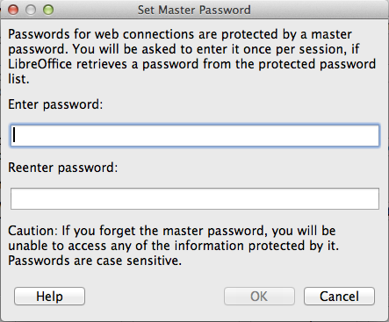
Figure 22: Set Master Password dialog for web connections

Security options and warnings
The following options are on the Security options and warnings dialog (Figure 23).
Remove personal information on saving
Select this option to always remove user data from the file properties when saving the file. To manually remove personal information from specific documents, deselect this option.
Ctrl-click required to follow hyperlinks
The default behavior in LibreOffice is to Ctrl+click on a hyperlink to open the linked document. Many people find creation and editing of documents easier when accidental clicks on links do not activate the links. To set LibreOffice to activate hyperlinks using an ordinary click, deselect this option.
The other options on this dialog should be self-explanatory.
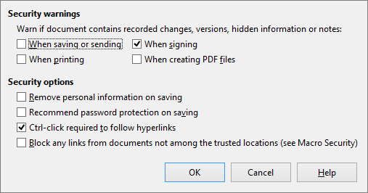
Figure 23: Security options and warnings dialog

Personalization
You can customize the overall appearance of LibreOffice with themes designed for Mozilla Firefox. On the LibreOffice – Personalization page (left side of Figure 24), select either of the themes options and then click Select Theme, the dialog shown on the right opens. Click Visit Firefox Themes to open the Firefox theme page in the default web browser (an internet connection is required). Select a theme, copy the contents of the browser's address bar, and paste the address into the Theme address field.
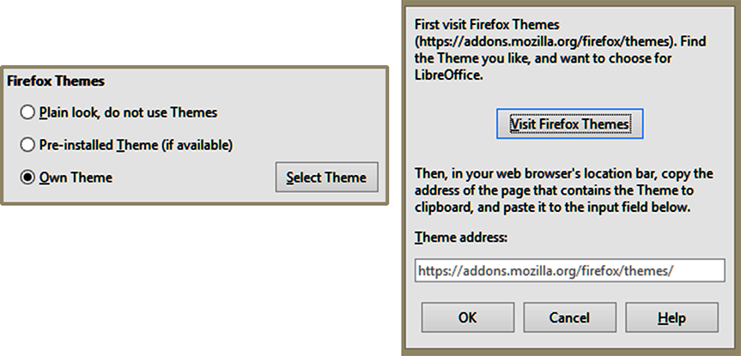
Figure 24: Personalization dialogs
Click OK and after a brief pause the appearance of LibreOffice will refresh and reflect the selected theme. An example is shown in Figure 25. For full details about themes, visit the Mozilla website: https://www.addons.mozilla.org/firefox/themes
Figure 25: Sample personalized theme

Appearance options
Writing, editing, and (especially) page layout are often easier when you can see the page margins (text boundaries), the boundaries of tables and sections (in Writer documents), page breaks in Calc, grid lines in Draw or Writer, and other features. In addition, you might prefer to use colors that are different from LibreOffice’s defaults for such items as comment indicators or field shadings.
On the LibreOffice – Appearance page (Figure 26), you can specify which items are visible and the colors used to display various items.
- To show or hide items such as text boundaries, select or deselect the options next to the names of the items.
- To change the default colors for items, click the down-arrow in the Color Setting column by the name of the item and select a color from the list box. Note that you can change the list of available colors as described in “Color options” on page 42.
- To save your color changes as a color scheme, click Save, type a name in the Scheme box, and then click OK.
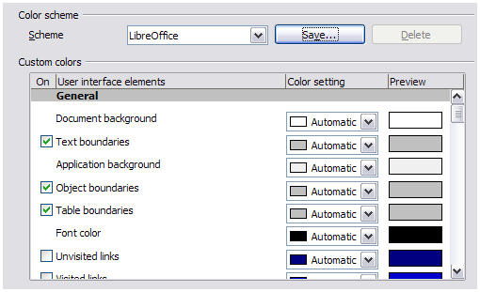
Figure 26: Showing or hiding text, object, and table boundaries

Accessibility options
Accessibility options include whether to allow animated graphics or text, how long help tips remain visible, some options for high contrast display, and a way to change the font for the user interface of the LibreOffice program.
Accessibility support relies on the Java Runtime Environment for communication with assistive technology tools. The Support assistive technology tools option is not shown on all LibreOffice installations. See Assistive Tools in LibreOffice in the Help for other requirements and information.
Select or deselect the options as required.
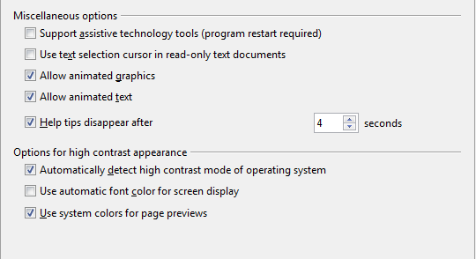
Figure 27: Choosing accessibility options

Advanced options
Java options
If you install or update a Java Runtime Environment (JRE) after you install LibreOffice, or if you have more than one JRE installed on your computer, you can use the LibreOffice – Advanced options page to choose the JRE for LibreOffice to use.
If you are a system administrator, programmer, or other person who customizes JRE installations, you can use the Parameters and Class Path pages (reached from the Java page) to specify this information.
If you do not see anything listed in the middle of the page, wait a few minutes while LibreOffice searches for JREs on the hard disk.
If LibreOffice finds one or more JREs, it will display them there. You can then select the Use a Java runtime environment option and (if necessary) choose one of the JREs listed.
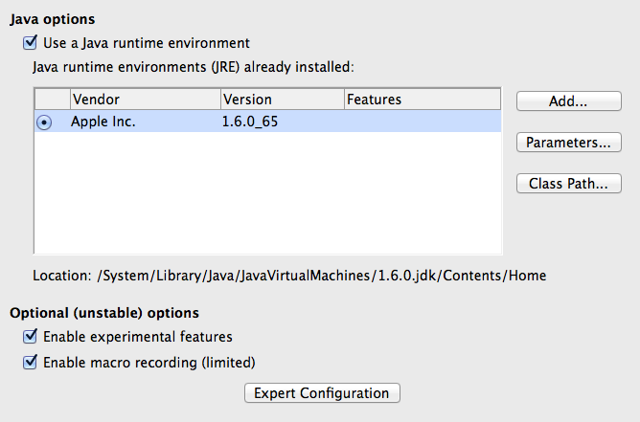
Figure 28: Choosing a Java runtime environment
Optional (unstable) options
Enable experimental features
Selecting this option enables features that are not yet complete or contain known bugs. The list of these features is different version by version.
Enable macro recording (limited)
This option enables macro recording with some limitations. Opening a window, switching between windows, and recording in a different window to that in which the recording began, is not supported. Only actions relating to document contents are recordable, so changes in Options or customizing menus are not supported. For more about macro recording, see Chapter 13, Getting Started with Macros.
Expert Configuration
Most users will have no need to use this. Click the Expert Configuration button to open a new window in which you can fine-tune the LibreOffice installation. The page offers detailed configuration options for many aspects of LibreOffice's appearance and performance. Double-click on a listed preference to enter a value to configure the preference.

Basic IDE options
The Basic IDE Options are available after Enable experimental features has been selected on the Advanced page of the Options dialog and the options have been saved. These options are for macro programmers and are not discussed here.
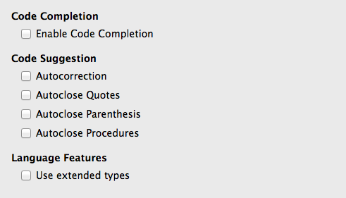
Figure 29: Basic IDE Options dialog

Online update options
On the LibreOffice – Online Update page (Figure 30), you can choose whether and how often to have the program check the LibreOffice website for program updates. If the Check for updates automatically option is selected, an icon appears at the right-hand end of the menu bar when an update is available. Click this icon to open a dialog where you can choose to download the update.
If the Download updates automatically option is selected, the download starts when you click the icon. To change the download destination, click the Change button and select the required folder in the file browser window.
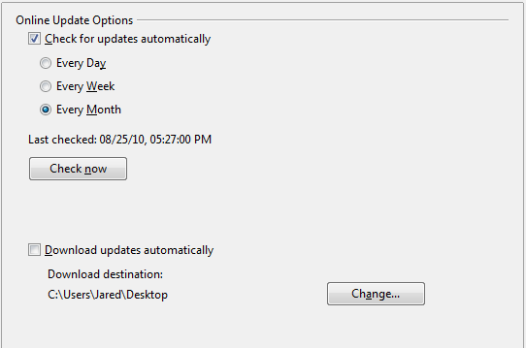
Figure 30: Online update options

Choosing Load/Save options
You can set the Load/Save options for loading and saving documents to suit the way you work.
If the Options dialog is not already open, click Tools > Options. Click the expansion symbol (+ or triangle) to the left of Load/Save.

General
Most of the choices on the Load/Save – General page are familiar to users of other office suites. Some items of interest are described below.
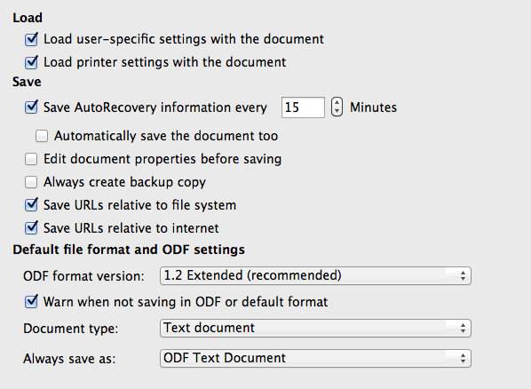
Figure 31: Choosing Load and Save options
Load user-specific settings with the document
A LibreOffice document contains certain settings that are read from the user’s system. When you save a document, these settings are saved with it.
Select this option so that when a document loads, it ignores the stored settings in favor of the settings on your computer.
Even if you do not select this option, some settings are taken from your LibreOffice installation:
- Settings available in File > Print > Options
- Name of Fax
- Spacing options for paragraphs before text tables
- Information about automatic updating for links, field functions and charts
- Information about working with Asian character formats.
The following setting is always loaded with a document, whether or not this option is marked:
- Data source linked to the document and its view.
If you deselect this option, the user’s personal settings do not overrule the settings in the document. For example, your choice (in the options for LibreOffice Writer) of how to update links is affected by the Load user-specific settings option.
Load printer settings with the document
If enabled, the printer settings will be loaded with the document. This can cause a document to be printed on a distant printer (perhaps in an office setting), if you do not change the printer manually in the Print dialog. If disabled, your standard printer will be used to print this document. The current printer settings will be stored with the document whether or not this option is selected.
Save AutoRecovery information every __ Minutes
Choose whether to enable AutoRecovery and how often to save the information used by the AutoRecovery process.
AutoRecovery in LibreOffice saves the information needed to restore all open documents in case of a crash. If you have this option set, recovering your document after a system crash will be easier.
Automatically save the document too
Specifies that LibreOffice saves all open documents when saving auto recovery information. Uses the same time interval as AutoRecovery does.
Edit document properties before saving
If you select this option, the Document Properties dialog pops up to prompt you to enter relevant information the first time you save a new document (or whenever you use Save As).
Always create backup copy
Saves the previous version of a document as a backup copy whenever you save a document. Every time LibreOffice creates a backup copy, the previous backup copy is replaced. The backup copy gets the extension BAK. Authors whose work may be very lengthy should always consider using this option.
Save URLs relative to file system / internet
Use this option to select the default for relative addressing of URLs in the file system and on the Internet. Relative addressing is only possible if the source document and the referenced document are both on the same drive.
A relative address always starts from the directory in which the current document is located. In contrast, absolute addressing always starts from a root directory. The following table demonstrates the difference in syntax between relative and absolute referencing:
Examples | File system | Internet
relative | ../images/img.jpg | ../images/img.jpg
absolute | file:///c|/work/images/img.jpg | http://myserver.com/work/images/img.jpg
If you choose to save relatively, the references to embedded graphics or other objects in your document will be saved relative to the location in the file system. In this case, it does not matter where the referenced directory structure is recorded. The files will be found regardless of location, as long as the reference remains on the same drive or volume. This is important if you want to make the document available to other computers that may have a completely different directory structure, drive or volume names. It is also recommended to save relatively if you want to create a directory structure on an Internet server.
If you prefer absolute saving, all references to other files will also be defined as absolute, based on the respective drive, volume or root directory. The advantage is that the document containing the references can be moved to other directories or folders, and the references remain valid.
Default file format and ODF settings
ODF format version. LibreOffice by default saves documents in OpenDocument Format (ODF) version 1.2 Extended. While this allows for improved functionality, there may be backwards compatibility issues. When a file saved in ODF 1.2 Extended is opened in an editor that uses earlier versions of ODF (1.0/1.1), some of the advanced features may be lost. Two notable examples are cross-references to headings and the formatting of numbered lists. If you plan to share documents with people who use editors that use older versions of ODF, you may wish to save the document using ODF version 1.0/1.1.
Document type. If you routinely share documents with users of Microsoft Office, you might want to change the Always save as attribute for documents to one of the Microsoft Office formats. Current versions of Microsoft Word can open ODT files, so this may no longer be needed.

VBA Properties
On the VBA Properties page, you can choose whether to keep any macros in Microsoft Office documents that are opened in LibreOffice.
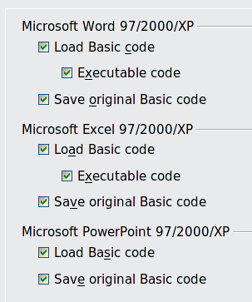
Figure 32: Choosing Load/Save VBA Properties
If you choose Load Basic code, you can edit the macros in LibreOffice. The changed code is saved in an ODF document but is not retained if you save into a Microsoft Office format.
If you choose Save original Basic code, the macros will not work in LibreOffice but are retained unchanged if you save the file into Microsoft Office format.
If you are importing a Microsoft Word or Excel file containing VBA code, you can select the option Executable code. Whereas normally the code is preserved but rendered inactive (if you inspect it with the StarBasic IDE you will notice that it is all commented), with this option the code is ready to be executed.
Save original Basic code takes precedence over Load Basic code. If both options are selected and you edit the disabled code in LibreOffice, the original Microsoft Basic code will be saved when saving in a Microsoft Office format.
To remove any possible macro viruses from the Microsoft Office document, deselect Save original Basic code. The document will be saved without the Microsoft Basic code.

Microsoft Office
On the Load/Save – Microsoft Office page, you can choose what to do when importing and exporting Microsoft Office OLE objects (linked or embedded objects or documents such as spreadsheets or equations).
Select the [L] options to convert Microsoft OLE objects into the corresponding LibreOffice OLE objects when a Microsoft document is loaded into LibreOffice (mnemonic: “L” for “load”).
Select the [S] options to convert LibreOffice OLE objects into the corresponding Microsoft OLE objects when a document is saved in a Microsoft format (mnemonic: “S” for “save”).
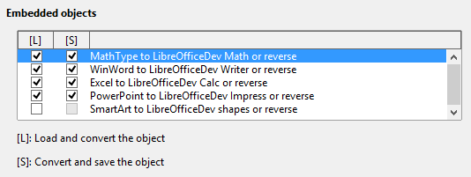
Figure 33: Choosing Load/Save Microsoft Office options

HTML compatibility
Choices made on the Load/Save – HTML Compatibility page affect HTML pages imported into LibreOffice and those exported from LibreOffice. See HTML documents; importing/exporting in the Help for more information.
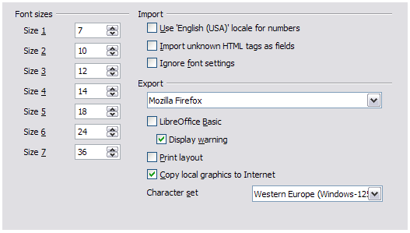
Figure 34. Choosing HTML compatibility options
Font sizes
Use these fields to define the respective font sizes for the HTML <font size=1> to <font size=7> tags, if they are used in the HTML pages. (Many pages no longer use these tags.)
Import – Use 'English (USA)' locale for numbers
When importing numbers from an HTML page, the decimal and thousands separator characters differ according to the locale of the HTML page. The clipboard, however, contains no information about the locale. If this option is not selected, numbers will be interpreted according to the Locale setting in Tools > Options > Language Settings > Languages (see page 56). If this option is selected, numbers will be interpreted as for the English (USA) locale.
Import – Import unknown HTML tags as fields
Select this option if you want tags that are not recognized by LibreOffice to be imported as fields. For an opening tag, an HTML_ON field will be created with the value of the tag name. For a closing tag, an HTML_OFF will be created. These fields will be converted to tags in the HTML export.
Import – Ignore font settings
Select this option to have LibreOffice ignore all font settings when importing. The fonts that were defined in the HTML Page Style will be used.
Export
To optimize the HTML export, select a browser or HTML standard from the Export box. If LibreOffice Writer is selected, specific LibreOffice Writer instructions are exported.
Export – LibreOffice Basic
Select this option to include LibreOffice Basic macros (scripts) when exporting to HTML format. You must activate this option before you create the LibreOffice Basic macro; otherwise the script will not be inserted. LibreOffice Basic macros must be located in the header of the HTML document. Once you have created the macro in the LibreOffice Basic IDE, it appears in the source text of the HTML document in the header.
If you want the macro to run automatically when the HTML document is opened, choose Tools > Customize > Events. See Chapter 13, Getting Started with Macros, for more information.
Export – Display warning
When the LibreOffice Basic option (see above) is not selected, the Display warning option becomes available. If the Display warning option is selected, then when exporting to HTML a warning is shown that LibreOffice Basic macros will be lost.
Export – Print layout
Select this option to export the print layout of the current document as well. The HTML filter supports CSS2 (Cascading Style Sheets Level 2) for printing documents. These capabilities are only effective if print layout export is activated.
Export – Copy local graphics to Internet
Select this option to automatically upload the embedded pictures to the Internet server when uploading using FTP.
Export – Character set
Select the appropriate character set for the export.

Choosing language settings
To customize the language settings in LibreOffice, you can do any of the following:
- Install the required dictionaries
- Change some locale and language settings
- Choose spelling options

Install the required dictionaries
LibreOffice automatically installs several dictionaries with the program. To add other dictionaries, be sure you are connected to the Internet, and then choose Tools > Language > More Dictionaries Online. LibreOffice will open your default web browser to a page containing links to additional dictionaries that you can install. Follow the prompts to select and install the ones you want.

Change some locale and language settings
You can change some details of the locale and language settings that LibreOffice uses for all documents, or for specific documents.
In the Options dialog, click Language Settings > Languages. The exact list shown depends on the Enhanced language support settings (see Figure 36).
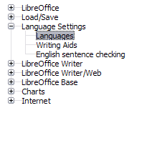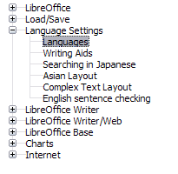
Figure 35: LibreOffice language options, without and with Asian and CTL options enabled
On the right-hand side of the Language Settings – Languages page, change the User interface, Locale setting, Default currency, and Default languages for documents as required. In the example, English (USA) has been chosen for all the appropriate settings.
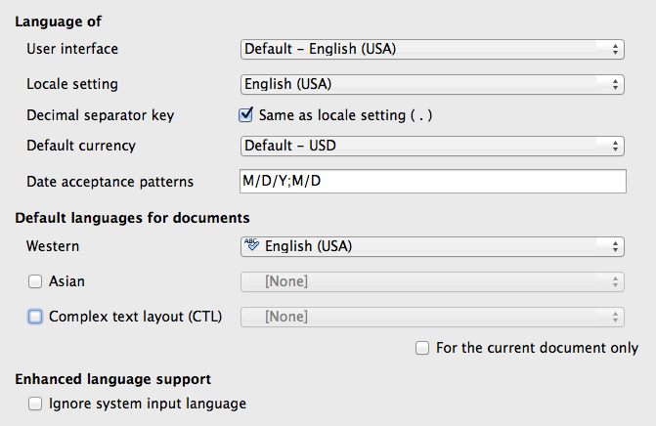
Figure 36: Choosing language options
User interface
The language of the user interface is usually set at the time LibreOffice is installed to match the language of the operating system. If more than one language has been installed for LibreOffice, you can select which language will be used for menus, dialogs, and help files.
Locale setting
The local setting is the basis for many other settings within LibreOffice, for example defaults for numbering, currency, and units of measure. Unless you select something else here, the locale of the operating system will be set as default.
Decimal separator key
If the Decimal separator key option is selected, LibreOffice will use the character defined by the default locale. If this option is not selected, the keyboard driver defines the character used.
Default currency
The Default currency is that used in the country entered as Locale. The default currency determines the proper formatting of fields formatted as currency. If the locale setting is changed, the default currency changes automatically. If the default currency is changed, all dialogs involving currency and all currency icons will be changed in all open documents. Documents that were saved with one currency as the default will open using the new currency defaults.
Date acceptance patterns
Date acceptance patterns define how LibreOffice recognizes input as dates. Locale also defines the default expression of dates. You can define additional date patterns, separated by semicolons, using Y, M, & D for Year, Month, and Day. LibreOffice will always correctly interpret dates entered in ISO 8601 format as Y-M-D and YYYY-MM-DD.
Caution | Data entered into a Calc spreadsheet or a Writer table must be entered in a format defined by Local in order to be recognized as dates.
Default languages for documents
Select the languages used for the spelling checker, thesaurus, and hyphenation features of LibreOffice. If these options are only for the current document, select For the current document only.
If necessary, select the options to enable support for Asian languages (Chinese, Japanese, Korean) and support for CTL (complex text layout) languages such as Urdu, Thai, Hebrew, and Arabic. If you choose either of these options, the next time you open this dialog, you will see some extra choices under Language Settings, as shown in Figure 35. These choices (Searching in Japanese, Asian Layout, and Complex Text Layout) are not discussed here.
Enhanced language support – Ignore system input language
Default language settings depend on the Locale setting. The default locale is based on that of the computer's operating system. A keyboard layout is normally based on the language used by the operating system but can be changed by the user. If this option is not selected, and there is a change in keyboard layout, input from the keyboard will be different from what is expected.

Choose spelling options
To choose the options for checking spelling, click Language Settings > Writing Aids. In the Options section of the page (Figure 37), choose the settings that are useful for you.
Some considerations:
- If you do not want spelling checked while you type, deselect Check spelling as you type. This option can also be deselected using the AutoSpellcheck button on the Standard toolbar.
- If you want grammar to be checked as you type, you must have Check spelling as you type enabled too.
- If you use a custom dictionary that includes words in all upper case and words with numbers (for example, AS/400), select Check uppercase words and Check words with numbers.
- Check special regions includes headers, footers, frames, and tables when checking spelling.
Here you can also check which user-defined (custom) dictionaries are active by default, and add or remove user-installed dictionaries, by clicking the New or Delete buttons. Dictionaries installed by the system cannot be deleted.
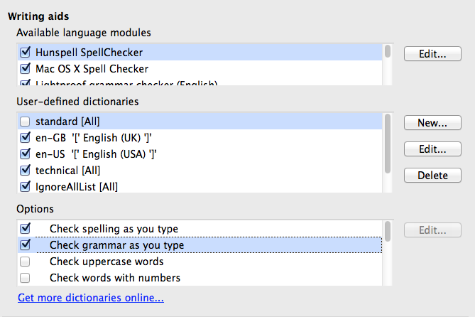
Figure 37: Choosing languages, dictionaries, and options for checking spelling

English sentence checking
On the Language Settings > English sentence checking page, you can choose which items are checked for, reported to you, or converted automatically. This menu is also found in the English dictionaries extension installed by default by LibreOffice. Select Tools > Extension Manager, select the English spelling dictionaries and click the Options button to reveal the menu. Select which of the optional features you wish to check.
After selecting the additional grammar checks, you must restart LibreOffice, or reload the document, for them to take effect.
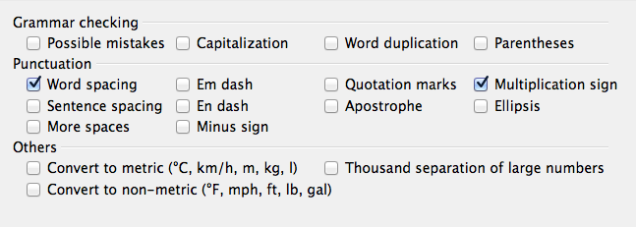
Figure 38: Choosing options for checking sentences in English

Grammar checking
Possible mistakes
Checks for things such as; with it's, he don't, this things and so on.
Capitalization
Checks for the capitalization of sentences. The sentence boundary detection depends on abbreviations.
Word duplication
Checks for all word duplication, rather than just the default words ‘and’, ‘or’, ‘for’, and ‘the’.
Parentheses
Checks for pairs of parentheses and quotation marks.

Punctuation
Word spacing
This option is selected by default. It checks for single spaces between words, indicating instances of double or triple spaces, but not of more than that.
Sentence spacing
Checks for a single space between sentences, indicating when one or two extra spaces are found.
More spaces
Checks word and sentence spacing for more than two extra spaces.
Em dash; En dash
These options force a non-spaced em dash to replace a spaced en dash, or force a spaced en dash to replace a non-spaced em dash, respectively.
Quotation marks
Checks for correct typographical double quotation marks.
Multiplication sign
This option is selected by default. It replaces an 'x' used as a multiplication symbol with the correct typographical symbol.
Apostrophe
Replaces an apostrophe with the correct typographical character.
Ellipsis
Replaces three consecutive periods (full stops) with the correct typographical symbol.
Minus sign
Replaces a hyphen with the correct minus typographical character.

Others
Convert to metric; Convert to non-metric
Converts quantities in a given type of unit to quantities in the other type of unit: metric to imperial or imperial to metric.
Thousands separation of large numbers
Converts a number with five or more significant digits to a common format, that is one which uses the comma as a thousands separator, or to the ISO format which uses a narrow space as a separator.

Choosing Internet options
The Internet options available depend on your operating system.
Use the Proxy page (if available) to save proxy settings for use with LibreOffice.
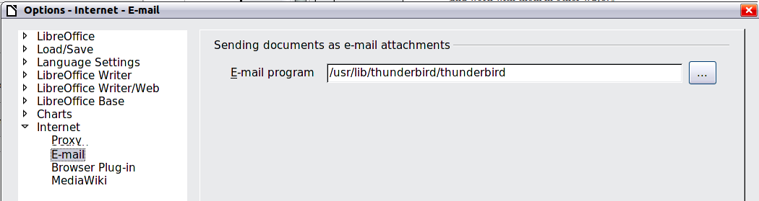
Figure 39: Internet options, showing E-mail page available to Linux users
If you are using a Mozilla browser (such as Firefox) on Windows or Linux, you can enable the Browser Plug-in so you can open LibreOffice files in your browser, print them, save them, and work with them in other ways.
If you are using a Unix- or Linux-based operating system (including Mac OS X), an additional page of E-mail options is available, where you can specify the e-mail program to use when you send the current document as e-mail. Under Windows the operating system’s default e-mail program is always used.
A MediaWiki publisher is included on Windows and Linux. To enable it, select MediaWiki in the Internet options, then click the Add button to open the dialog shown in Figure 40. Here you can specify the address (URL) and log-in information for a wiki. You can add several wikis to the list.
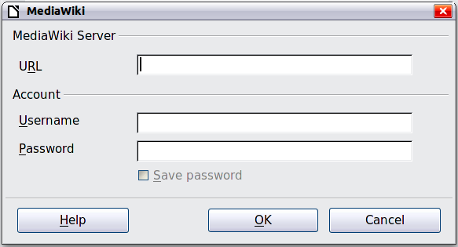
Figure 40: Specifying a MediaWiki server account

Controlling LibreOffice’s AutoCorrect functions
Some people find some or all of the items in LibreOffice’s AutoCorrect function annoying because they change what you type when you do not want it changed. Many people find some of the AutoCorrect functions quite helpful; if you do, then select the relevant options. But if you find unexplained changes appearing in your document, this is a good place to look to find the cause.
To open the AutoCorrect dialog, click Tools > AutoCorrect Options. (You need to have a document open for this menu item to appear.) In Writer, this dialog has five tabs, as shown in Figure 41. In other components of LibreOffice, the dialog has only four tabs. More details are given in the component guides.
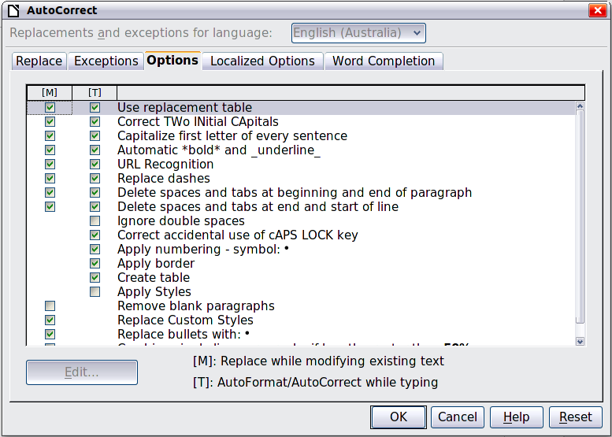
Figure 41: The AutoCorrect dialog in Writer, showing some of the choices on the Options tab

Chapter 3
Using Styles and Templates
Using consistent formatting in your documents

What is a template?
A template is a model document that you use to create other documents. For example, you can create a template for business reports that has your company’s logo on the first page. New documents created from this template will all have your company’s logo on the first page.
Templates can contain anything that regular documents can contain, such as text, graphics, a set of styles, and user-specific setup information such as measurement units, language, the default printer, and toolbar and menu customization.
All documents in LibreOffice are based on templates. You can create a specific template for any document type (text, spreadsheet, drawing, presentation). If you do not specify a template when you start a new document, then the document is based on the default template for that type of document. If you have not specified a default template, LibreOffice uses the blank template for that type of document that is installed with LibreOffice. See “Error: Reference source not found” on page Error: Reference source not found for more information.

What are styles?
A style is a set of formats that you can apply to selected pages, text, frames, and other elements in your document to quickly change their appearance. Often applying a style means applying a whole group of formats at the same time.
Many people manually format paragraphs, words, tables, page layouts, and other parts of their documents without paying any attention to styles. They are used to writing documents according to physical attributes. For example, you might specify the font family, font size, and any formatting such as bold or italic.
Styles are logical attributes. Using styles means that you stop saying “font size 14pt, Times New Roman, bold, centered”, and you start saying “Title” because you have defined the “Title” style to have those characteristics. In other words, using styles means that you shift the emphasis from what the text (or page, or other element) looks like, to what the text is.
Styles help improve consistency in a document. They also make major formatting changes easy. For example, you may decide to change the indentation of all paragraphs, or change the font of all titles. For a long document, this simple task can require making individual changes in dozens of places. By contrast, when you use styles, you only need to make a single change.
In addition, styles are used by LibreOffice for many processes, even if you are not aware of them. For example, Writer relies on heading styles (or other styles you specify) when it compiles a table of contents. Some common examples of style use are given in “Error: Reference source not found” on page Error: Reference source not found.
LibreOffice supports the following types of styles:
- Page styles include margins, headers and footers, borders and backgrounds. In Calc, page styles also include the sequence for printing sheets.
- Paragraph styles control all aspects of a paragraph’s appearance, such as text alignment, tab stops, line spacing, and borders, and can include character formatting.
- Character styles affect selected text within a paragraph, such as the font and size of text, or bold and italic formats.
- Frame styles are used to format graphic and text frames, including text wrap, borders, backgrounds, and columns.
- List styles allow you to select, format, and position numbers or bullets in lists.
- Cell styles include fonts, alignment, borders, background, number formats (for example, currency, date, number), and cell protection.
- Graphics styles in drawings and presentations include line, area, shadowing, transparency, font, connectors, dimensioning, and other attributes.
- Presentation styles include attributes for font, indents, spacing, alignment, and tabs.
Different styles are available in the various components of LibreOffice, as listed in Table 3.
LibreOffice comes with many predefined styles. You can use the styles as provided, modify them, or create new styles, as described in this chapter.
Table 3. Styles available in LibreOffice components
Style Type | Writer | Calc | Draw | Impress
Page | X | X
Paragraph | X
Character | X
Frame | X
Numbering | X
Cell |  | X
Presentation |  |  | X | X
Graphics | (included in Frame styles) |  | X | X

Applying styles
LibreOffice provides several ways for you to select styles to apply:
- Styles and Formatting window
- Fill Format Mode
- Apply Style List
- Keyboard shortcuts

Using the Styles and Formatting window
The Styles and Formatting window includes the most complete set of tools for styles. To use it for applying styles:
- Select the Styles and Formatting button located at the left-hand end of the Formatting toolbar, or select Format > Styles and Formatting, or press F11 (⌘+T on a Mac) or click the Styles and Formatting tab in the Sidebar (View > Sidebar to open it).
The Styles and Formatting window shows the types of styles available at the current position of the mouse cursor. Figure 42 shows the window for Writer, with Paragraph Styles visible. You can move this window to a convenient position on the screen or dock it to the right edge (hold down the Ctrl key and drag it by the title bar to where you want it docked).
- Select one of the buttons at the top left of the Styles and Formatting window to display a list of styles in a particular category.
- To apply an existing style, position the insertion point in the paragraph, frame, page, or word, and then double-click the name of the style in one of these lists. To apply a character style to more than one word, select the characters first.
Tip | At the bottom of the Styles and Formatting window is a drop-down list. In Figure 42 the window shows Automatic, meaning the list includes only a standard set of styles suggested by LibreOffice. You can choose to show all styles or other groups of styles, for example only custom styles.
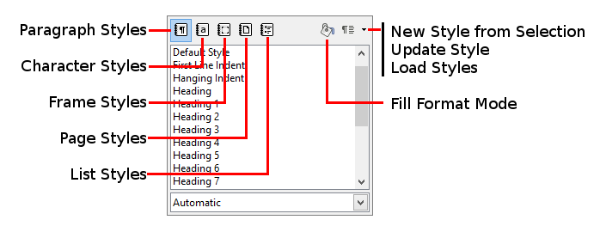
Figure 42: The Styles and Formatting window for Writer, showing paragraph styles

Using Fill Format Mode
Use Fill Format to apply a style to many different areas quickly without having to go back to the Styles and Formatting window and double-click every time. This method is quite useful when you need to format many scattered paragraphs, cells, or other items with the same style:
- Open the Styles and Formatting window and select the style you want to apply.
- Select the Fill Format Mode button.
- To apply a paragraph, page, or frame style, hover the mouse over the paragraph, page, or frame and click. To apply a character style, hold down the mouse button while selecting the characters. Clicking a word applies the character style for that word.
- Repeat step 3 until you have made all the changes for that style.
- To quit Fill Format mode, click the Fill Format Mode button again or press the Esc key.
Caution | When this mode is active, a right-click anywhere in the document undoes the last Fill Format action. Be careful not to accidentally right-click and undo actions you want to keep.

Using the Apply Style list
After you have used a style at least once in a document, the style name appears on the Apply Style list near the left-hand end of the Formatting toolbar, next to the Styles and Formatting button.
You can open this list and click the style you want, or you can use the up and down arrow keys to move through the list and then press Enter to apply the highlighted style.
Tip | Select More at the bottom of the Apply Style list to open the Styles and Formatting window.
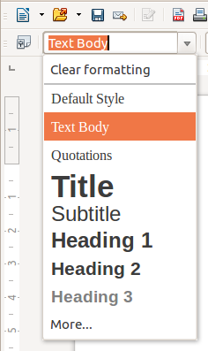
Figure 43: The Apply Style list on the Formatting toolbar

Using keyboard shortcuts
Some keyboard shortcuts for applying styles are predefined. For example, in Writer Ctrl+0 applies the Text body style, Ctrl+1 applies the Heading 1 style, and Ctrl+2 applies the Heading 2 style. You can modify these shortcuts and create your own; see Chapter 14, Customizing LibreOffice, for instructions.
Caution | Manual formatting (also called direct formatting) overrides styles, and you cannot get rid of the manual formatting by applying a style to it.  To remove manual formatting, select the text, right-click, and choose Clear Direct Formatting from the context menu, or use Ctrl+M after selecting the text.

Modifying styles
LibreOffice includes predefined styles, but you can also create custom styles. You can modify both types of styles in several ways:
- Change a style using the Style dialog
- Update a style from a selection
- Use AutoUpdate (paragraph and frame styles only)
- Load or copy styles from another document or template
Note | Any changes you make to a style are effective only in the current document. To change styles in more than one document, you need to change the template or copy the styles into the other documents as described on page 68.

Changing a style using the Style dialog
To change an existing style using the Style dialog, right-click on the required style in the Styles and Formatting window and select Modify from the pop-up menu.
The Style dialog displayed depends on the type of style selected. Each Style dialog has several tabs. See the chapters on styles in the user guides for details.

Updating a style from a selection
To update a style from a selection:
- Open the Styles and Formatting window.
- In the document, select an item that has the format you want to adopt as a style.
Caution | When updating a paragraph style, make sure that the selected paragraph contains unique properties. If it mixes font sizes or font styles, those mixed properties will remain the same as before.
- In the Styles and Formatting window, select the style to update, then click on the arrow next to the New Style from Selection icon and click Update Style.
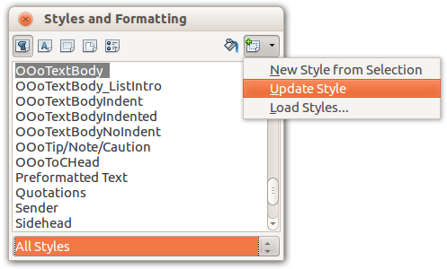
Figure 44: Updating a style from a selection

Using AutoUpdate
AutoUpdate applies to paragraph and frame styles only. If the AutoUpdate option is selected on the Organizer page of the Paragraph Style or Frame Style dialog, applying direct formatting to a paragraph or frame using this style in your document automatically updates the style itself.
Tip | If you are in the habit of manually overriding styles in your document, be sure that AutoUpdate is not enabled.

Updating styles from a document or template
You can update styles by copying or loading them from a template or another document. See “Copying styles from a template or document” on page 70.

Creating new (custom) styles
You may want to add some new styles. You can do this by using either the Styles dialog or the New Style from Selection tool.

Creating a new style using the Style dialog
To create a new style using the Styles dialog, right-click in the Styles and Formatting window and select New from the pop-up menu.
If you want your new style to be linked with an existing style, first select that style and then right-click and select New.
If you link styles, then when you change the base style (for example, by changing the font from Times to Helvetica), all the linked styles will change as well. Sometimes this is exactly what you want; other times you do not want the changes to apply to all the linked styles. It pays to plan ahead.
The dialogs and choices are the same for defining new styles and for modifying existing styles. See the chapters on styles in the user guides for details.

Creating a new style from a selection
You can create a new style by copying an existing manual format. This new style applies only to this document; it will not be saved in the template.
- Open the Styles and Formatting window and choose the type of style you want to create.
- In the document, select the item you want to save as a style.
- In the Styles and Formatting window, select on the New Style from Selection icon.
- In the Create Style dialog, type a name for the new style. The list shows the names of existing custom styles of the selected type. Click OK to save the new style.
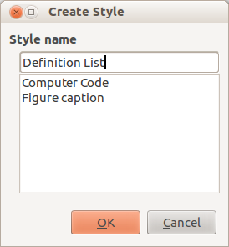
Figure 45: Naming a new style created from a selection

Select some text and drag it to the Styles and Formatting window. If Paragraph Styles are active, the paragraph style will be added to the list. If Character Styles are active, the character style will be added to the list.
Calc

- into.

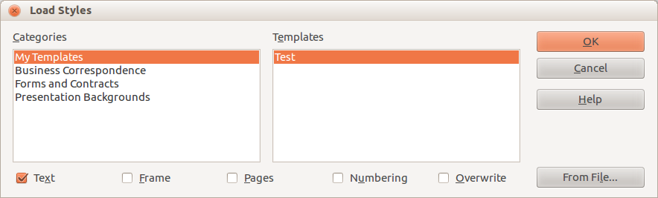
Figure 46: Copying styles from a template into the open document

- selected, you will only copy styles whose names are not used in the original document.
- Click OK to copy the styles.
Caution | If your document has a table of contents, and if you have used custom styles for headings, the heading levels associated with outline levels in Tools > Outline Numbering will revert to the defaults of Heading 1, Heading 2, and so on when you load Text styles from a file that does not use the same custom styles. You will need to change these back to your custom heading styles.

Deleting styles
You cannot remove (delete) any of LibreOffice’s predefined styles from a document or template, even if they are not in use.
You can remove any user-defined (custom) styles; but before you do, you should make sure the styles are not in use in the current document. If an unwanted style is in use, you can replace it with a substitute style.

- pop-up window. Click Close to close this pop-up window.
- Select the required template. A new document based on the selected template opens in LibreOffice.

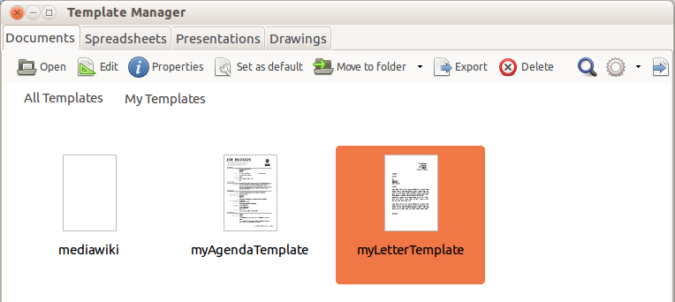
Figure 47: Template Manager dialog, showing a selected template

