Additional information for Libre Office Bugzilla 20240326
I opened a document in Libre Office which automatically selected ‘Ahom Manuscript’ font at 12 points
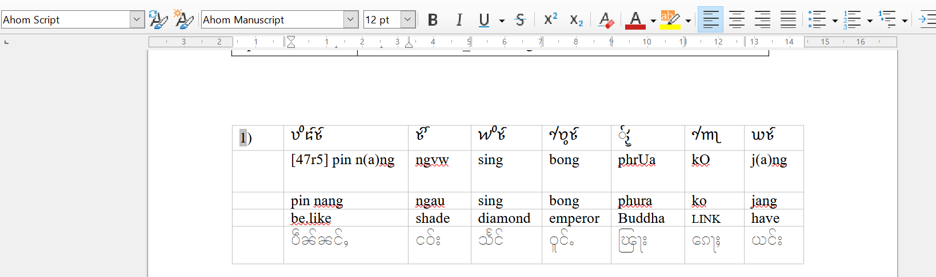

Opening the same document in Word, without saving or altering, it opens using Noto Serif Ahom font at a larger size, 26 point.
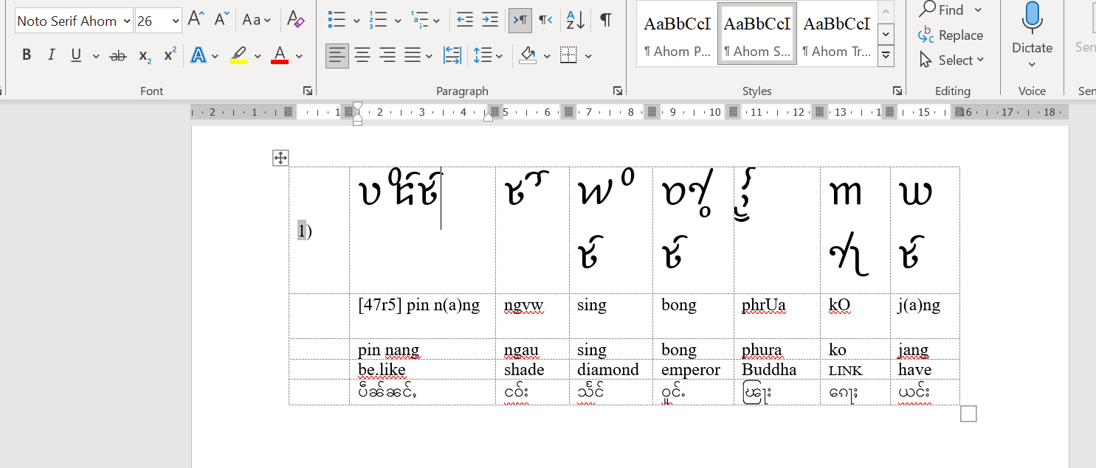

If, in Microsoft Word, I then change the Noto Serif Ahom font to 12 point across the document, save that in word, it will look like this:
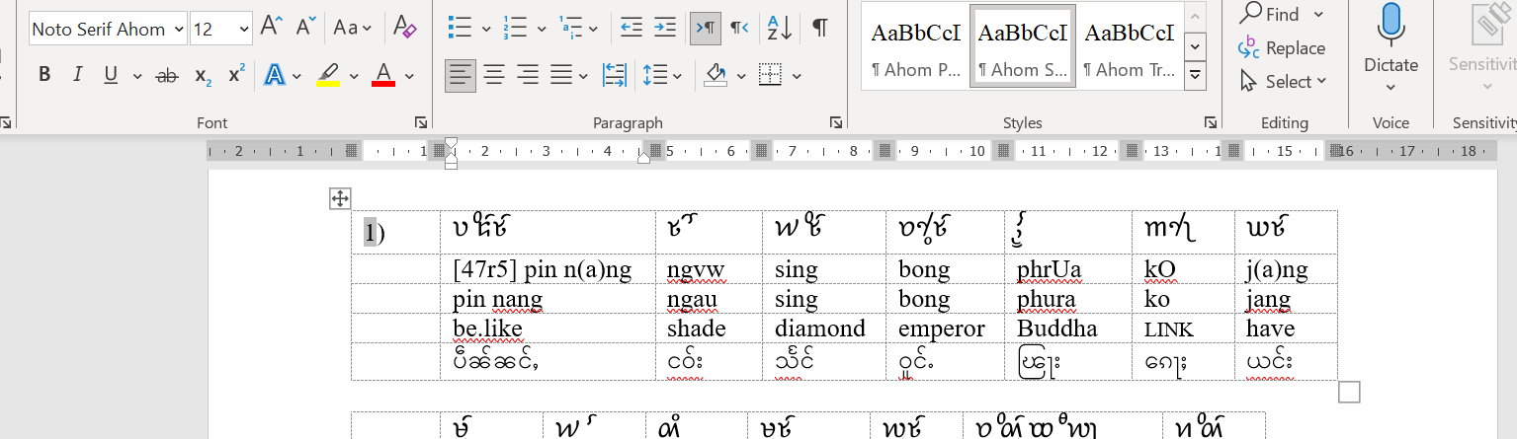

Noto Serif Ahom is now chosen at 12 point.

When this newly saved document is opened in Libre Office, the font still shows as Ahom Manuscript, not as Noto Serif Ahom. Why is that?
