Little Sensation Podcast Activity
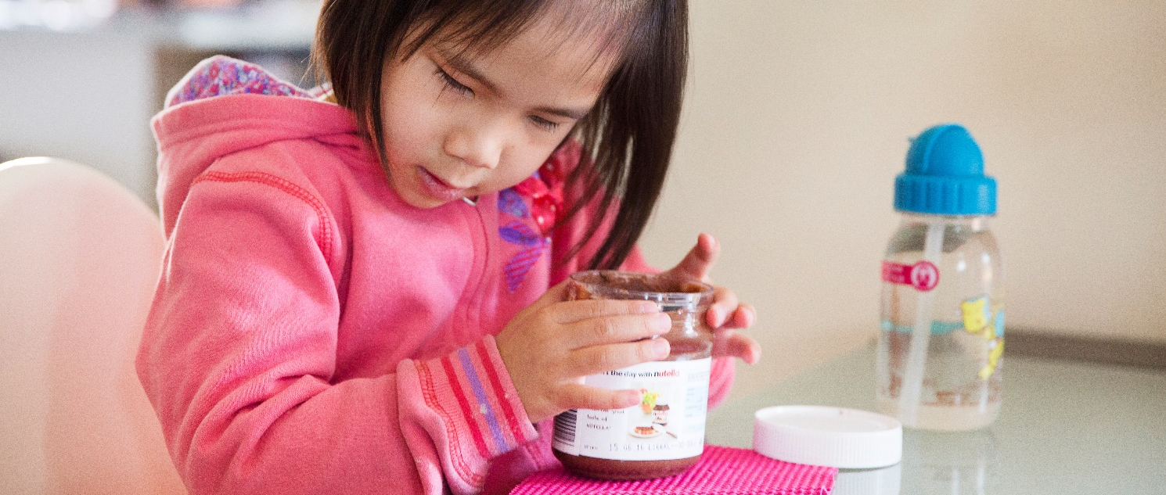

Who is this activity for?
- Coach: this includes parents, support people, educators, and service providers. The coach can help set up the activity and support learning.
- Children aged 3 to 6 years.

Activity goals
- Help children to practice using their different senses.
- Assist parents, support people and professionals to help children to develop their different senses.
- Explore likes and dislikes.

Before you start
For sighted people, vision plays a key role in bringing together the information you get from all your other senses, from what you hear, touch, smell, and taste, and also about what your body is doing in space. Children who are blind or have low vision need to learn to use their senses differently to get all the information they need. This does not happen automatically so fun activities and practice really help.
This activity sheet will help you to set up for the Little Sensation podcast activity. In this podcast your child will explore a range of objects as well as their environment, using all their different senses.

Preparation and materials
For activity 1, your child will be asked to identify what they sense with different body parts and explore the environment around them. You may like to start in a familiar place, for example the kitchen or the living room. As your child’s skills develop, you can increase the challenge of the activity by doing this in less familiar or in busy places.
For activity 2, your child will be asked to explore a sensory tool kit. The tool kit in this podcast is simply a collection of edible items that your child can lick, put in their mouth and bite. This is important for the tasting part of the activity. Each time you play the podcast you can choose different items to put in the kit. Here are some tips for preparing a sensory tool kit:
- It can be an existing drawer in the kitchen, or a combination of objects that ‘lives’ on your coffee table, for example. But you can also create a box with items.
- Use objects your child has some knowledge of for this activity. You may also like to choose items that relate to the environment your child is in, so they learn to make connections between the item and where they are. For example, if you are in the garden, you could have a collection of fruits and veggies from the garden.
- You don’t need to include a lot of objects. Variety is more important. Think about how you can let your child experience objects that make different sounds, have different sizes, textures, smells, weight. Have some objects that have movable parts and some that don’t. If your child is still very young, limit the number to perhaps 6 or 7 objects. As they get older you can increase this number.
- Use objects that either ‘live’ in the environment you are in or have a function there. For example, if your child is doing the activity in their bedroom, use objects from their bedroom.
- As your child gets older, you could throw in a surprise object that doesn’t belong there, for example a fork when they are in the bathroom.

For activity 3, your child will be asked to explore moving their body and ‘wake up their arms, legs, toes and fingers’.
You can pause the podcast anytime so that your child has time to complete the activity.
It is not expected that your child will have mastered using all their senses by the end of the podcast. Your child can do this podcast many times with different objects and in different environments including indoors or outdoors. Learning these skills and developing their sensory efficiency takes time and is best learnt through repetition within daily routines.

Now it’s time to listen to the podcast with your child. Be ready to have fun and be encouraging. Remember children learn through doing.

Activity instructions

Exploring your environment
Environments are full of sensory information, even if we’re not always aware of it. There are things to see, hear, smell, feel, and often taste. The first step to sensory efficiency is for your child to become aware of this information, and then to work out what it can tell them about their environment. This activity will encourage you and your child to take some time to pay attention to things you may have missed.

Exploring the sensory tool kit
For sighted children vision is the main sense that helps them make sense of the world. It is also what they use to combine the information they get from other senses.
Your child will need to develop their own way of using their senses and work out what they are all telling them about what things are and what they are used for. In this activity you will get a chance to explore a sensory tool kit.

Exploring movement
Movement and balance are also important senses for your child to develop. The previous 2 activities allow your child to be sitting still. In this activity, your child gets to explore movement and balance.
Here are some other ideas on how to include movement and balance in your daily routine:
- Games like ‘Simon says…’ or singing the song “head, shoulder, knees and toes” are fun ways for your child to learn about how their body moves and how balance works.
- You could also develop a game for waking up arms, legs, fingers and toes after your child has been sitting for a while. This could involve separate movements for arms, legs, fingers and toes, as well as moving their whole body.

Tips
- Sometimes too much sensory information at once can be overwhelming or background noise can interfere with hearing other things happening in the area. Turn off TVs and other background noise so that other sounds like the fridge and quieter sounds can be noticed.
- Remember children learn through doing and developing their senses is best done when they feel they’re in control. Encourage them to reach and explore with as little assistance as possible so they can do it at their pace. If they need help to reach for an object, resist grabbing their hands but instead ask them to hold yours, so that your hands are under their hands or elbow so that you can gently guide them to the object.

Linked resources
- Podcast Little Sensation

For more information about Sensory Efficiency and the Expanded Core Curriculum please speak with your Vision Australia Service Provider
This information is based on the following publication:
Smith, M. (2014). Sensory Efficiency. In C.B. Allman, S. Lewis, & S.J. Spungin (Eds.) ECC essentials: Teaching the expanded core curriculum to students with visual impairments (pp. 117-186). New York: AFB Press.
Used with permission by American Printing House for the Blind.

