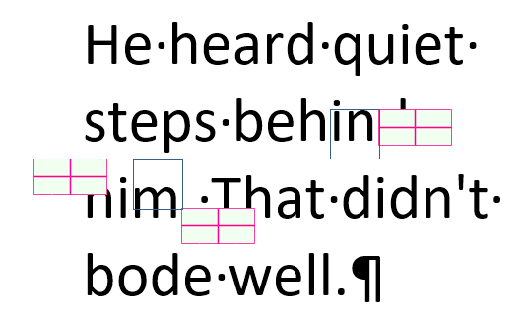

He heard quiet steps behind him. That didn't bode well.

