To:
Franco Guthrie Plc
Dolorem irure ut in
87901 Neque dolorum invent
Debitis possimus re
Labore culpa enim p

Octavia Franklin | Kevyn Howell
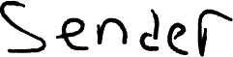 | ${receiver_signature}



