The Law
In Britain, Illegal drugs are called “controlled substances”. They are split into three groups (A,B and C).
Class A are considered the most harmful and/or most addictive. Different penalties are given for possession of these drugs and dealing the drugs.

IT IS A CRIMINAL OFFENSE TO:
- possess a controlled substance unlawfully
- possess a controlled substance with intent to supply
- supply, or offer to supply a controlled drug
- Allow your property to be used for drug taking
Gateway Drugs
Gateway drugs are drugs that lead you to getting into “harder” drugs. They’re not particularly harmful, although they are addictive, which is the reason behind a person getting into other harder drugs. When/if the human body becomes “immune” to the drug, as it is weak; it is going to want a more effective drug. Examples are marijuana and tobacco.
A GUIDE FOR TEENAGERS

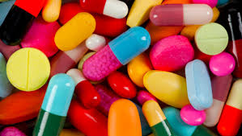

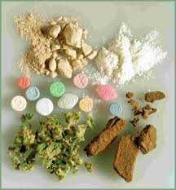

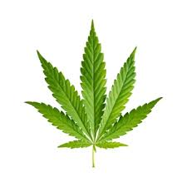
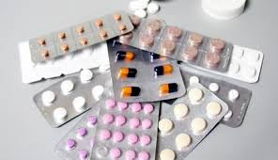
D
R
U
G
S

Top 10 most commonly used illegal drugs

- Heroin
  - Taken through and injection
  - Gives feeling of wellbeing
- Crack Cocaine
  - Creates sense of euphoria and hallucinations
- Methamphetamine
  - Popularly referred to as “meth”
  - Can cause depression, anxiety and drug craving
- Cocaine
  - A stimulant
  - Increases energy levels, pulse rate and heartbeat
- Marijuana
  - Usually smoked
  - A gateway drug
- Opium
  - Conatins morphine
  - Morphine is an addictive painkiller
- Ecstasy
  - Increases self awareness
- LSD
  - Causes hallucinations
- PCP
  - “Phencyclidine” gives hallucinations
- Psilocybin Mushrooms
  - Aka “Magic Mushrooms”
  - Creates severe hallucinations

What is a Drug?

A drug is anything that affects the way the body works, e.g., raising the heartbeat or blurred vision.

An estimated one in three adults (around 12 million people) will take an illegal drug in their lifetime

Some examples of illegal drugs are LSD, Cannabis, Speed, Ecstasy and Heroin

As well as illegal drugs, there are also legal drugs, most of which are used for a medicinal purpose. Some examples are antibiotics, paracetamol, nicotine (cigarettes) and caffeine (coffee)

Stimulants and Depressants
Stimulants give a person a feeling of boundless energy and can be very addictive. It can also change a person’s behavior and personality. Some examples of stimulants are amphetamine (Speed), cocaine, coffee and methedrine.

Depressants are usually barbiturates, which means that they have a kind of sedative, or sleep inducing drug in it. Depressants can slow down a person’s body and can be dangerous. An example of a depressant is alcohol.

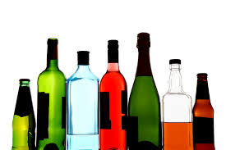
Effects of Drugs

Some drugs have a positive effect and can heal people with certain conditions. These drugs are usually legal.

However other drugs can have bad effects, for example some illegal drugs can cause hallucinations and a feeling of boundless energy. Some can also lead to dehydration and overheating which could result in death.

Another symptom is that most illegal drugs are quite addictive, which could mean serious damage if someone is quite addicted to the drug.

Pain killers can also affect the human body, although they are legal, as they are very addictive a and can cause degeneration of a person’s life.

