Extra Practice
Construct Linear Functions

1. The height of a falling rock is shown on the graph. Find and interpret the rate of change and initial value. Then write the equation of the function in the form y = mx + b. (Example 1)  The rate of change is –6, so the rock is falling 6 meters per second. The initial value is 90, so the initial height of the rock is 90 meters; y = –6x + 90 | 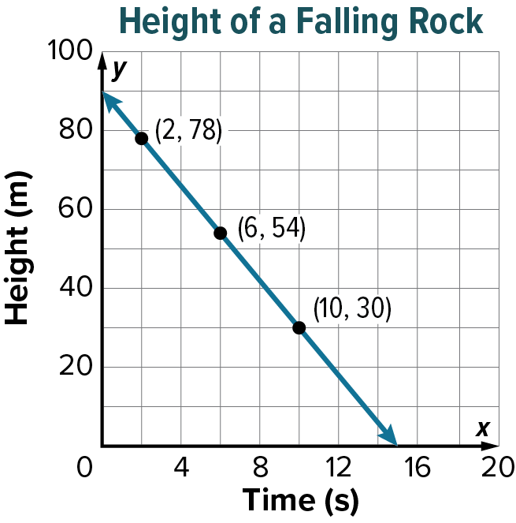

2. The number of trees Bud plants in the riparian zone is shown on the graph. Find and interpret the rate of change and initial value. Then write the equation of the function in the form y = mx + b. (Example 1)  The rate of change is 3, so Bud plants 3 trees per hour. The initial value is 7, so 7 trees have already been planted; y = 3x + 7 | 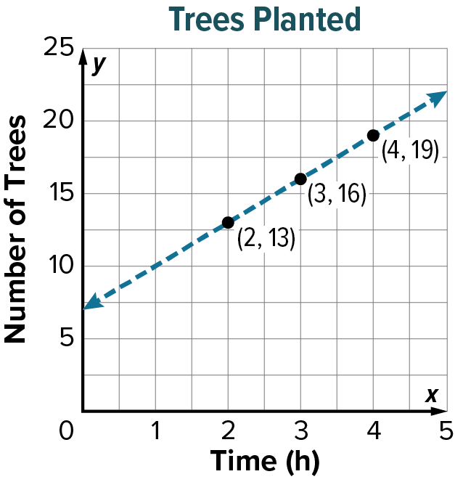

3. The amount of snow that falls during a snowstorm is shown on the graph. Find and interpret the rate of change and initial value. Then write the equation of the function in the form y = mx + b. (Example 1)  The rate of change is 2, so 2 inches of snow fall every hour. The initial value is 8, so there are 8 inches of snow on the ground when the storm begins; y = 2x + 8 | 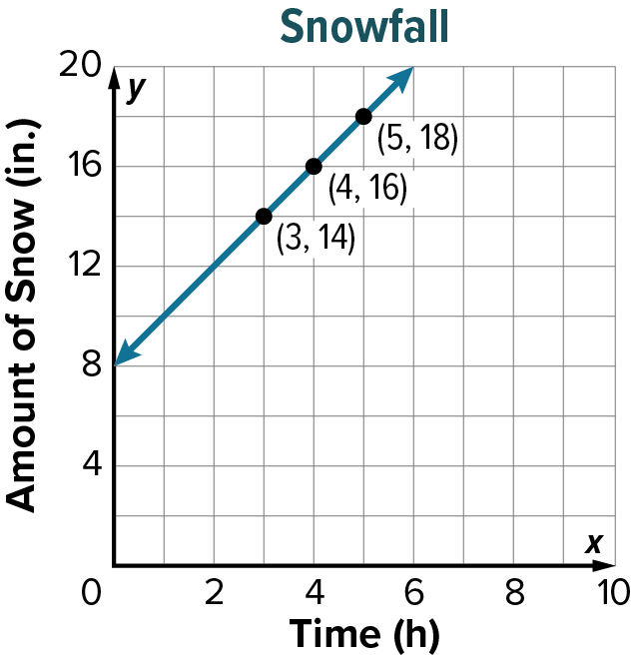

4. The growth rate of a Saint Bernard puppy is shown on the graph. Find and interpret the rate of change and initial value. Then write the equation of the function in the form y = mx + b. (Example 1)  The rate of change is 6, so the puppy gains 6 kilograms each month. The initial value is 1, so the puppy has a mass of 1 kilogram at birth; y = 6x + 1 | 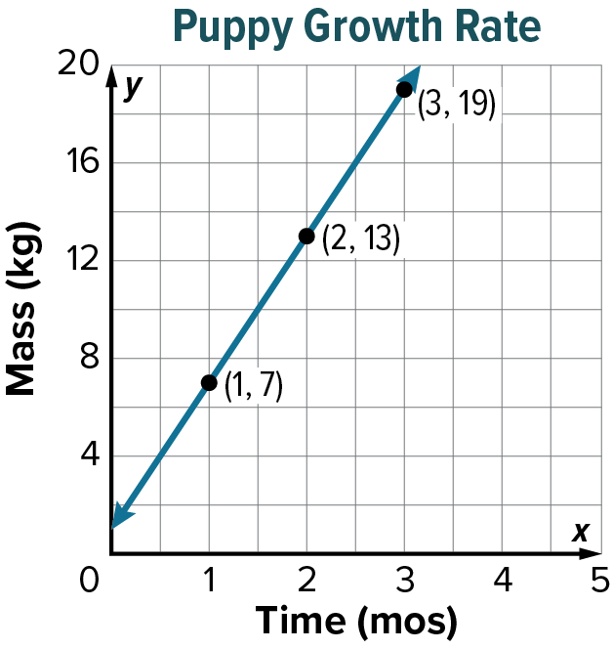

5. The number of math problems Jerry solves is shown on the graph. Find and interpret the rate of change and initial value. Then write the equation of the function in the form y = mx + b. (Example 1)  The rate of change is 5, so the number of problems solved each hour is 5. The initial value is 15, so 15 problems have already been solved; y = 5x + 15 | 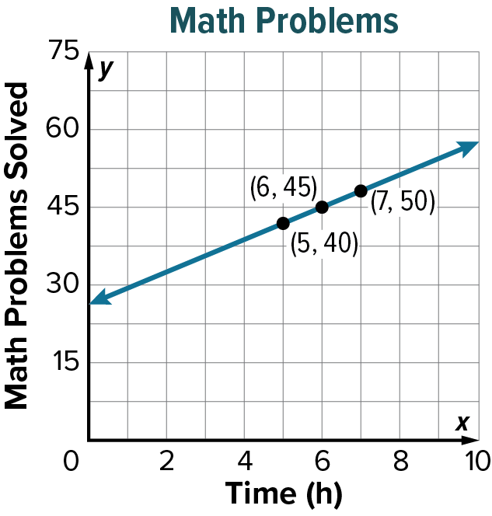

6. Dan is on a backpacking trip. His distance from the trailhead is shown on the graph. Find and interpret the rate of change and initial value. Then write the equation of the function in the form y = mx + b. (Example 1)  The rate of change is –20, so Dan’s distance from the trailhead decreases by 20 miles each day. The initial value is 300, so Dan’s initial distance from the trailhead is 300 miles; y = –20x + 300 | 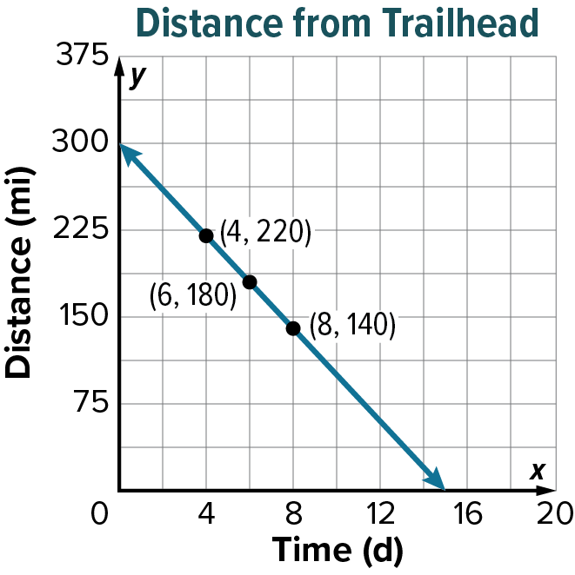

7. The table shows the amount of flour remaining after baking loaves of banana bread. Assume the relationship between the two quantities is linear. Find and interpret the rate of change and initial value. Then write the equation of the function in the form y = mx + b. (Example 2)  The rate of change is –2, so the amount of flour used for each loaf is 2 cups. The initial value is 20, so there were initially 20 cups of flour available; y = –2x + 20
  Loaves of Banana Bread, x | Flour Remaining (c), y
  2 | 16
  4 | 12
  6 | 8
  8 | 4

8. The table shows the temperature of an oven as it preheats. Assume the relationship between the two quantities is linear. Find and interpret the rate of change and initial value. Then write the equation of the function in the form y = mx + b. (Example 2)  The rate of change is 40, so the temperature of the oven increases by 40°F each minute. The initial value is 75, so the temperature of the oven was initially 75°F; y = 40x + 75
  Time (min), x | Oven Temperature (°F), y
  2 | 155
  4 | 235
  6 | 315
  8 | 395

9. The table shows the amount of water that leaks from a pool. Assume the relationship between the two quantities is linear. Find and interpret the rate of change and initial value. Then write the equation of the function in the form y = mx + b. (Example 2)  The rate of change is –50, so water is leaking from the pool at a rate of 50 gallons per minute. The initial value is 1,200, so the pool initially held 1,200 gallons; y = –50x + 1,200
  Time (h), x | Water Remaining (gal), y
  3 | 1,050
  5 | 950
  7 | 850
  9 | 750

10. The table shows the battery life of a flashlight. Assume the relationship between the two quantities is linear. Find and interpret the rate of change and initial value. Then write the equation of the function in the form y = mx + b. (Example 2)  The rate of change is –3, so the battery life is decreasing 3% per hour. The initial value is 95, so the flashlight initially had 95% battery life; y = –3x + 95
  Time (h), x | Battery Life (%), y
  5 | 80
  10 | 65
  15 | 50
  20 | 35

11. The table shows the height of a hot-air balloon over time. Assume the relationship between the two quantities is linear. Find and interpret the rate of change and initial value. Then write the equation of the function in the form  y = mx + b. (Example 2)  The rate of change is 25, so the hot-air balloon is rising 25 meters per minute. The initial value is 75, so the initial height of the hot-air balloon is 75 meters; y = 25x + 75
  Time (min), x | Height (m), y
  4 | 175
  6 | 225
  8 | 275
  10 | 325

12. The table shows the number of lattés Dana prepares in a coffee shop. Assume the relationship between the two quantities is linear. Find and interpret the rate of change and initial value. Then write the equation of the function in the form y = mx + b. (Example 2)  The rate of change is 4, so the number of lattés Dana prepares each hour is 4. The initial value is 9, so 9 lattés have already been made; y = 4x + 9
  Time (h), x | Lattés  Prepared, y
  3 | 21
  4 | 25
  5 | 29
  6 | 33

13. Angelica reads 15 pages of a book each day. In 10 days, she reads 200 pages. Assume the relationship is linear. Find and interpret the rate of change and initial value. Then write the equation of the function in the form y = mx + b, where x represents the number of days and y represents the total number of pages read. (Example 3)  The rate of change is 15, so the number of pages Angelica reads each day is 15. The initial value is 50, so 50 pages have already been read; y = 15x + 50 | 14. Maria collects baseball cards. She collects 20 cards each week. After 9 weeks, Maria has 250 cards. Assume the relationship is linear. Find and interpret the rate of change and initial value. Then write the equation of the function in the form y = mx + b, where  x represents the number of weeks and y represents the total number of baseball cards collected. (Example 3)  The rate of change is 20, so the number of baseball cards collected per week is 20. The initial value is 70, so 70 baseball cards have already been collected; y = 20x + 70
15. Northside Elementary School’s PTO holds a fundraiser. The PTO already has some savings, but it needs to raise $100 per week for the next 5 weeks to reach its $2,200 goal. Assume the relationship is linear. Find and interpret the rate of change and initial value. Then write the equation of the function in the form y = mx + b, where x represents the number of weeks and y represents the total amount of money raised. (Example 3)  The rate of change is 100, so the weekly amount raised is $100. The initial value is 1,700, so the PTO already has $1,700 in savings; y = 100x + 1,700 | 16. Dwayne needs to score 35 points per game for the next 6 games to reach 1,000 points scored in his career. Assume the relationship is linear. Find and interpret the rate of change and initial value. Then write the equation of the function in the form  y = mx + b, where x represents the number of games and y represents the total points scored. (Example 3)  The rate of change is 35, so the number of points to score per game is 35. The initial value is 790, so Dwayne already scored  790 points; y = 35x + 790
17. A large block of ice is melting and losing 5 grams of mass every minute. After 11 minutes, the ice has lost 70 grams. Assume the relationship is linear. Find and interpret the rate of change and initial value. Then write the equation of the function in the form y = mx + b, where  x represents the number of minutes and y represents the total mass lost. (Example 3)  The rate of change is –5, so the ice is melting at a rate of 5 grams per minute. The initial value is 125, so the ice had an initial mass of 125 grams; y = –5x + 125 | 18. Sally sews squares on a quilt. She sews  7 squares in 1 hour. After 5 hours, Sally has sewn 43 squares. Assume the relationship is linear. Find and interpret the rate of change and initial value. Then write the equation of the function in the form y = mx + b, where  x represents the number of hours and  y represents the total number of squares sewn. (Example 3)  The rate of change is 7, so the number of squares sewn each hour is 7. The initial value is 8, so 8 squares have already been sewn on the quilt; y = 7x + 8

