Simple shape without text or caption
Simple shape with textbox
Triangle
Triangle
An image with caption
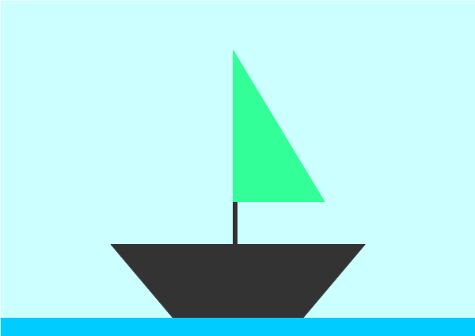Figure 1: Ship

