Highlights from the 1st virtual conference on Co-Packaged Optics (CPO).
by Bob Wheeler and Vlad Kozlov
July 22, 2025
Last week LightCounting held its 1st virtual conference on CPO and related technologies. The event attracted more than 700 live attendees and even more people registered to watch a recording. The next event is planned for July 15th 2026.
The event included three sessions and a closing discussion:
- Session 1: Established suppliers of CPO – Broadcom and Coherent.
- Session 2: CPO startups – Avicena, Celestial Ai, LightMatter and Nubis Communications
- Session 3: Providers of supporting technologies for CPO - Alfalume, Lumentum, POET, Scintil Photonics and Senko.
- Closing discussion with Brad Booth of NLM Photonics – Was COBO ahead of it’s time?
Figure 1 below illustrates the differences between CPO and pluggable optics.
Figure 1: Re-timed (DSP), Linear Drive (LPO) pluggable and CPO
Source: Broadcom
LightCounting shared the latest forecast for CPO, shown in Figure 2, to get the event started. The level of development activity on CPO is at an all time high now with high volume deployments likely in 2027. Deployments of LPO are starting now and millions of them will be deployed next year (we include half-retimed (LRO) modules into our LPO forecast). Re-timed pluggables are not going away – shipments of 800G and higher speed transceivers will triple from 2025 to 2030.
Figure 2: Market Forecast for shipments of re-timed optical transceivers (TRXs), linear drive pluggables (LPO) and co-packages optics (CPO) ports.
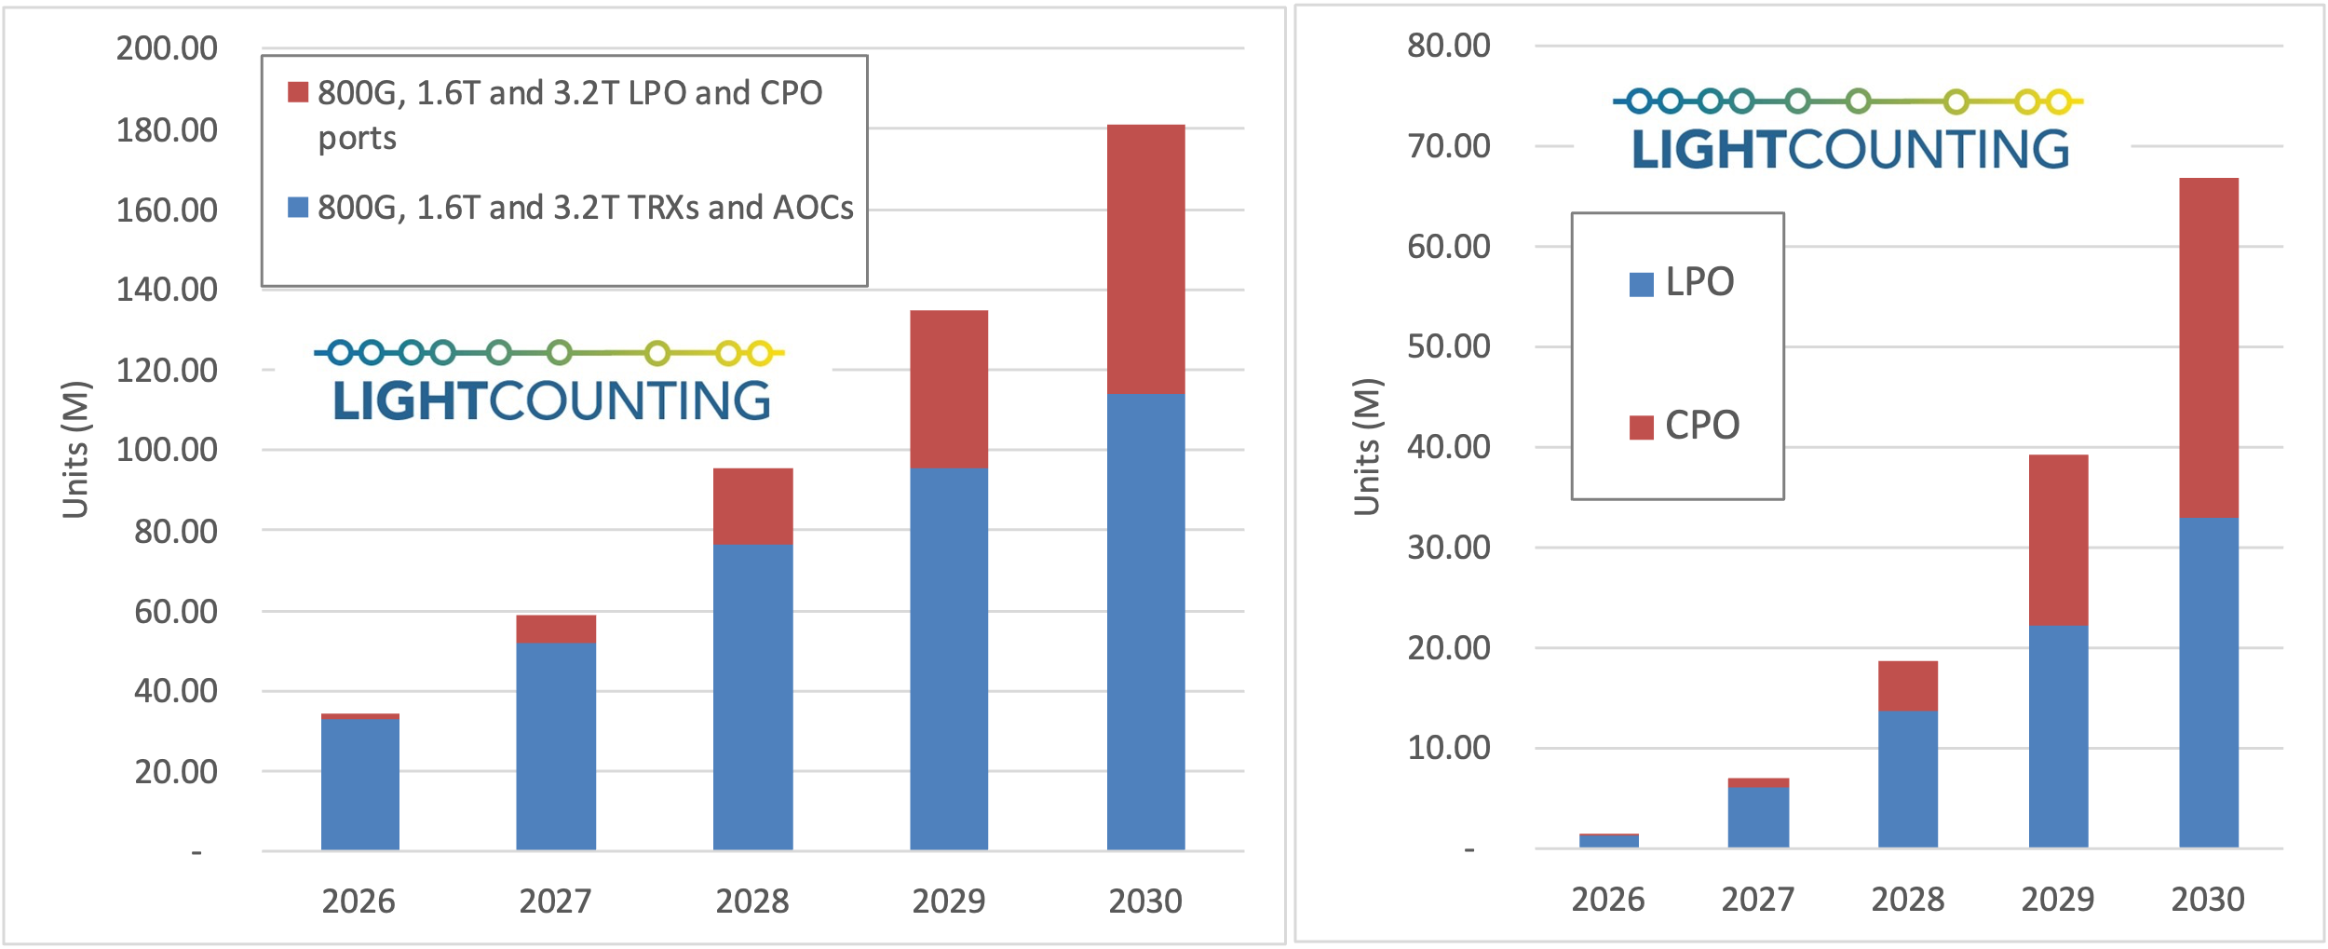 Source: May 2025 Report – Silicon Photonics, Linear Drive Pluggable (LPO) and Co-Packaged Optics (CPO)
LightCounting increased the forecast for CPO in the end of last year to account for future applications in scale-up networks. Current implementations of CPO by Broadcom and Nvidia include Ethernet and InfiniBand switches for scale-out networks. We expect that Nvidia will use CPO on their future versions of NVLink switches.
Broadcom recently announced the Tomahawk Ultra switch designed for scale-up networks and we expect to see CPO on this product soon. It is a 100G per lane switch – a mature CPO design at Broadcom. Last section of this research note includes more details on Tomahawk Ultra.
Full text of the research note is available at no charge here: add a link to download.

