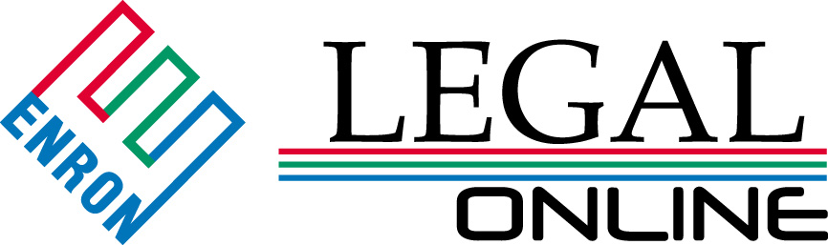

Providing Innovative Legal Solutions

Welcome!!!

As Enron pursues opportunities in an ever-changing business environment, it is essential that Enron Wholesale Services’ Legal Department continually explore ways to supply the innovation both you, our clients, and Enron demand. We have chosen to use the slogan “Providing Innovative Legal Solutions” and this web site to convey our continued commitment to tackling tough business challenges by providing consistent and accurate legal solutions.

Through “LEGALOnline“, you will be able to better understand who we are, what we do and how we integrate with your business needs.

At the current time, “LEGALOnline” provides information about our members and their respective roles within the Department, as well as a comprehensive overview of Department logistics. Information is also provided on basic policies vital to the continued success of our business. Certain areas of the site are restricted for internal Department use; however, the information in these areas is being shared with all members of the Department, thereby ensuring the proliferation of a basic Enron value – communication.

In the near future, “LegalOnline” will house interactive education programs and be a portal to valuable internet resources. Education programs will closely mirror the needs each operating unit will have as new and challenging business opportunities are pursued. Education programs will also be made available to members of the Department to ensure we remain current with legal trends and methodologies applicable to new business prospects. This, in turn, will ensure the continued provision of sound legal advice. Internet resources will be used to move processes from traditionally paper intensive to paperless and will included the integration of technologies such as “on-line” document negotiation and signing.

Overall, our goal is to continue to provide you, our client, open access to vital legal resources and to provide these resources to you promptly, efficiently and properly.

Finally, we sincerely welcome any comments, questions or suggestions through our Feedback area found in the Training & Education section of the site.

Thank you and welcome once again to “LEGALOnline”.

