STATE OF CALIFORNIA GRAY DAVIS, Governor
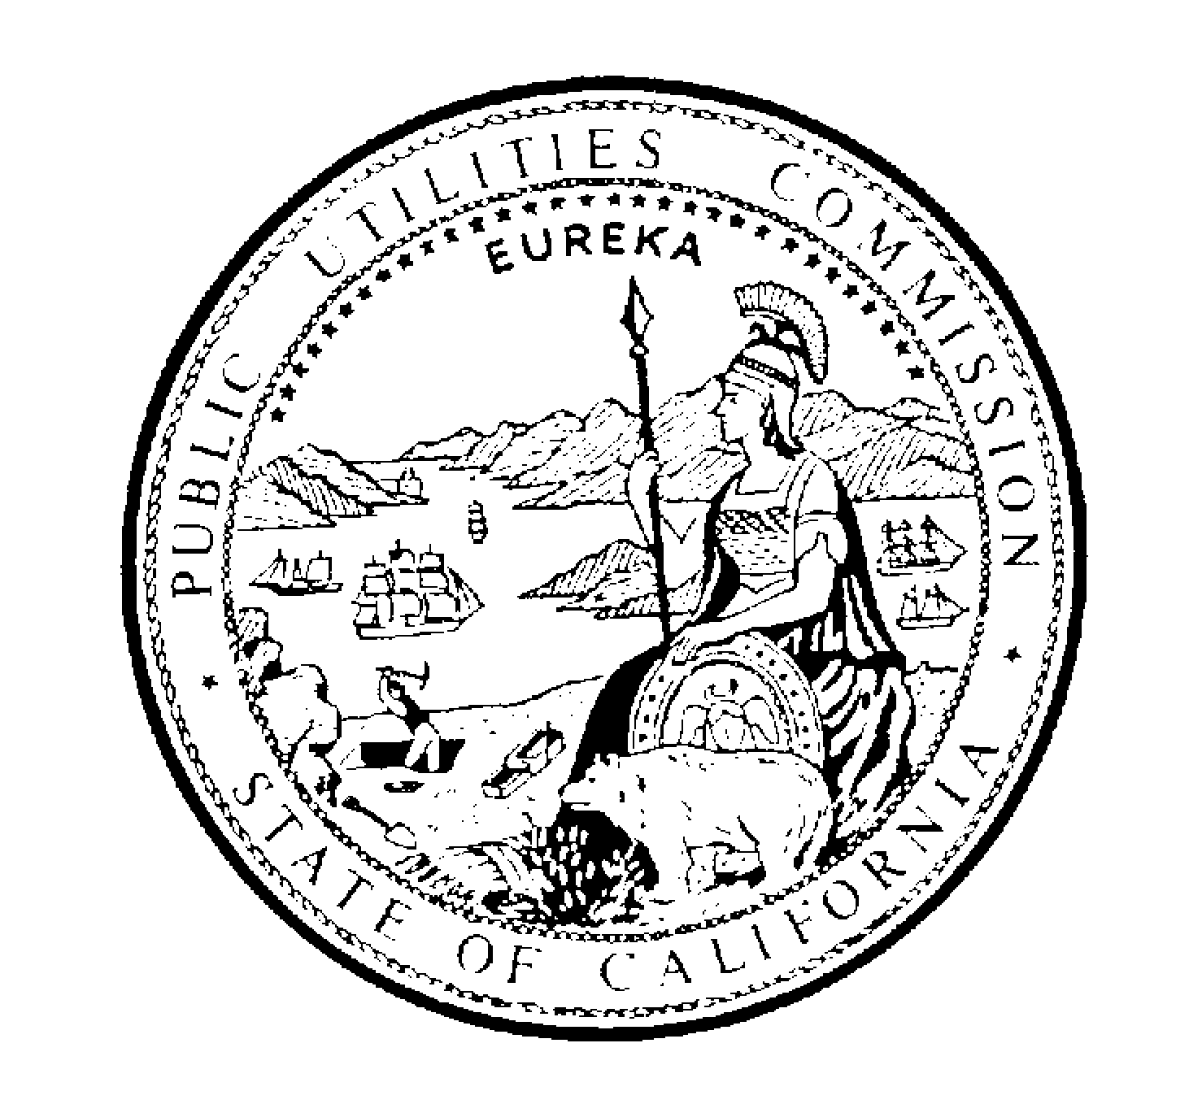PUBLIC UTILITIES COMMISSION
505 VAN NESS AVENUE
SAN FRANCISCO, CA 94102-3298

Via E-Mail

October 2, 2001

Re: A.99-01-016, et al., and A.00-11-038, et al.

To All Parties of the Above Proceedings:

The Commission and Southern California Edison have entered into a settlement agreement in Southern California Edision v. Lynch, et al., Case No. 00-12056-RSWL. The settlement agreement has been posted on the Commission’s Web site. The settlement provides that the parties will present a stipulated judgment to the Court for it to enter. Parties in the above proceedings who are not parties in the litigation may wish to seek leave to appear as amicus curiae with respect to the settlement. The Court has ordered that with respect to the settlement, any comments must be filed by 4:30 p.m. on Wednesday, October 3, 2001.

Sincerely,

Gary M. Cohen
General Counsel

