STATE OF CALIFORNIA GRAY DAVIS, Governor
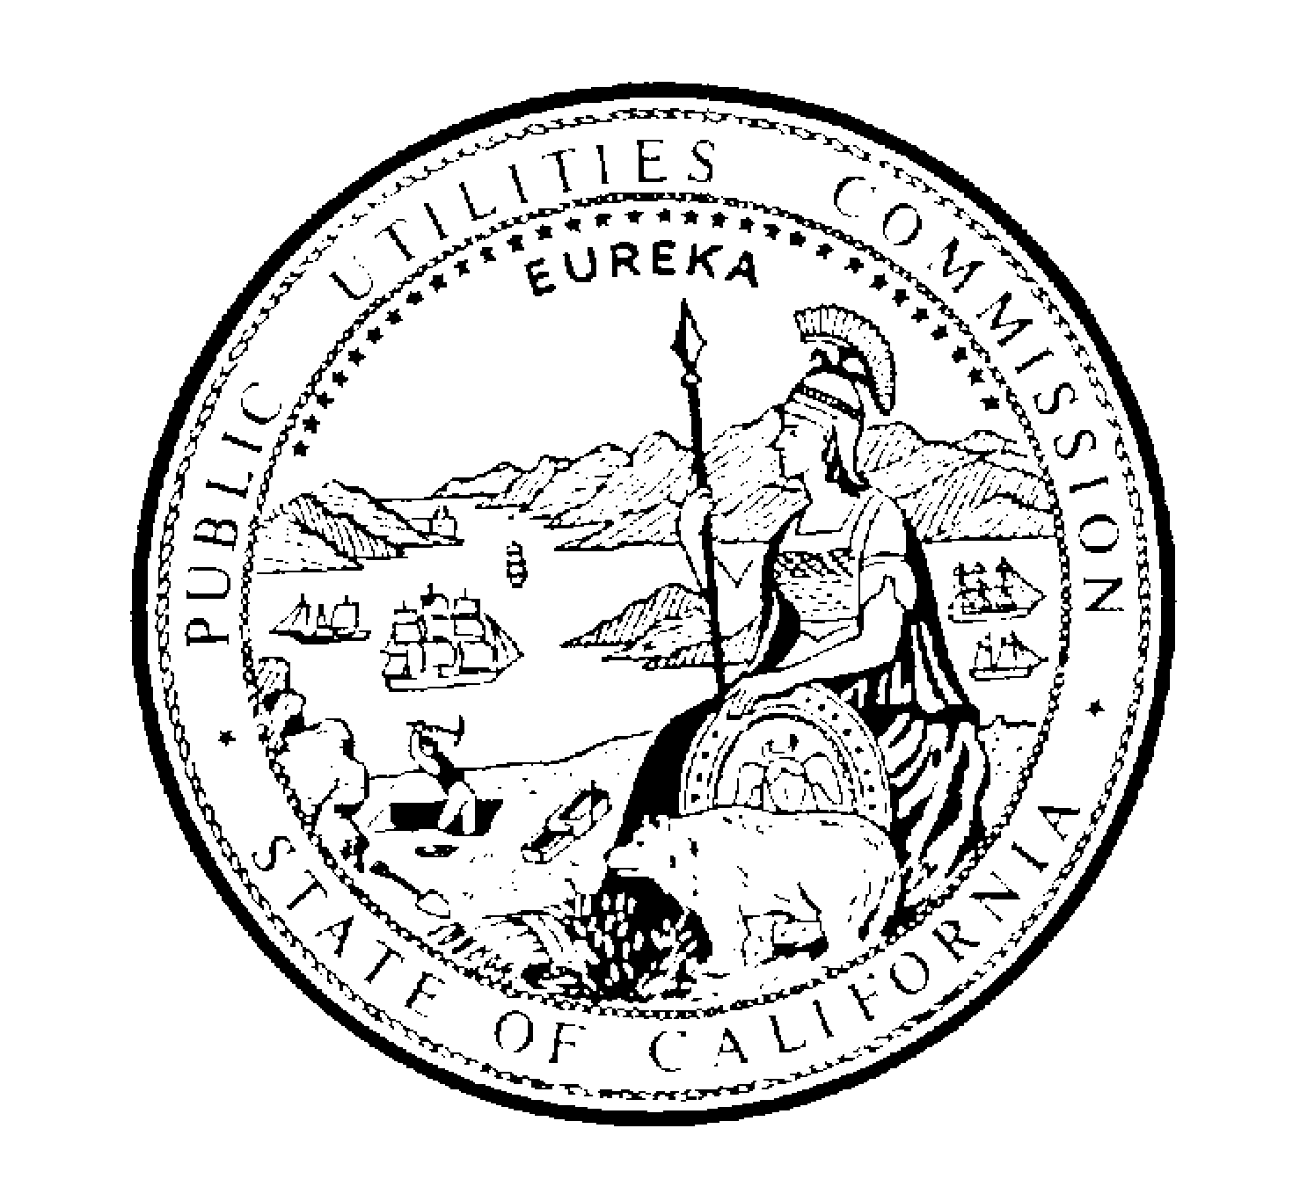PUBLIC UTILITIES COMMISSION
505 VAN NESS AVENUE
SAN FRANCISCO, CA 94102-3298

July 19, 2001

TO: PARTIES OF RECORD IN APPLICATION 00-11-038 ET AL.

This is the draft decision of Administrative Law Judge (ALJ) Christine Walwyn. It will be on the Commission’s agenda at the meeting on August 2, 2001. The Commission may act then, or it may postpone action until later.

When the Commission acts on the draft decision, it may adopt all or part of it as written, amend or modify it, or set it aside and prepare its own decision. Only when the Commission acts does the decision become binding on the parties.

Pursuant to Rule 77.7(f)(9), comments on the draft decision must be filed within seven days of its mailing and no reply comments will be accepted.

In addition to service by mail, parties should send comments in electronic form to those appearances and the state service list that provided an electronic mail address to the Commission, including ALJ Walwyn at cmw@cpuc.ca.gov. Finally, comments must be served separately on the Assigned Commissioner, and for that purpose I suggest hand delivery, overnight mail, or other expeditious methods of service.

/s/ LYNN T. CAREW
Lynn T. Carew, Chief
Administrative Law Judge

LTC:tcg

Attachments

