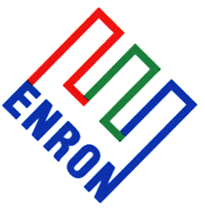 Enron Americas
Competitive Analysis

To: Lloyd Will
From: Kristin Walsh and Kelly Holman
Date: May 15, 2001
Re: UPDATE 2: New Generation Project

Below is a summary of the current situation regarding the New Generation project. If you have any questions, please feel free to contact me directly (x39510) or Kelly Holman (x39844).

Great River Energy
Lakefield Junction
- The Lakefield Junction peaker plant will be composed of six 85 MW units. According to our source, one of the units has already been tested and will be made available to the grid for commercial use on 05/18 or 05/19. The plant will conduct the state-mandated emissions monitoring test and submit the data to the relevant state office. Upon acceptance of the data, the plant will be certified to operate and supply power to the grid. Upon startup, each unit takes 20 minutes to reach full output. After 05/19, each subsequent unit will be similarly certified on a rolling basis with units coming online every 2 to 3 days. All six units are expected to be online by 06/01.

Connectiv
New Castle
- The New Castle plant has three 120-MW simple-cycle, gas-fired generators. A source stated that the plant has conducted some testing but is not finished with the testing process. The project was described as on time, on schedule and on budget with one generator to come online in June, one in July, and one in August.
- The source indicated future plans include the addition of a combined-cycle steam generator and turbine to operate from heat generated by the three gas turbines. This unit is planned to be online in June 2002.

Carolina Power & Light
MEAG/Merchant
- Our source indicates that the one unit, 155-MW plant is currently testing. The plant has an expected commercial operation date of 06/01 to meet CP&L’s contract requirement with Dynegy.

