Immediate Sale of 2 x ABB GT11N Gas Turbines

Enron Canada Corp. (Enron) has available in Eastern Canada two (2) used ABB GT11N units for immediate delivery on an AS IS, WHERE IS basis, WITH ALL FAULTS OF ALL AND ANY KIND WHATSOEVER:

1. 1991 vintage, originally fuel oil fired;
- Excellent condition, with 500 actual operating hours, and 5,000 equivalent operating hours. Enron Engineering and Construction Company and ABB conducted technical due diligence at the time of purchase by Enron, including a boroscopic inspection and full load test and found no issues;
- Since Enron purchased the units, the previous owner has maintained and preserved the units according to OEM recommendations under agreement with Enron;
- Enron has contracted with Power Systems Manufacturing (“PSM”) for conversion of the units to a dry low emissions natural gas combustion system guaranteed for 25 PPM NOx. This work is underway and will be completed early in 2001. Based on PSM’s current assessment, the actual NOx emissions will be significantly lower than 25 PPM. As part of the fuel conversion the units will have a new PLC control system and a warranty on the fuel combustion system and controls;
- Spare parts from the fuel conversion will be available to the new owner for potential sale in its discretion. These parts may consist of the top ½ of the combustor, fuel nozzles, ignitors, water injection nozzles, fuel forwarding pumps and ABB control systems.
- The combustion turbines are part of a complete power plant and include self cleaning inlet filters, exhaust stack, expansion joint and silencers, 230 kV switchyard including transformers, starting devices, generator and utility protection, and heated ventilated enclosures with fire protection;
- The units are available in Millbank, New Brunswick, Canada. The buyer will be responsible for disassembly, transportation and re-erection at their new location and all associated costs therewith;
- Noise analyses are available on the turbines and associated equipment, under fuel oil firing and water injection.

Attachments: Scope of supply, site photograph

This turbine sale profile is for discussion purposes only. The description and any commercial terms referred to in this turbine sale profile are indicative only and are subject to revision. This turbine sale profile does not, and is not intended to, create an offer for acceptance, an agreement between the parties, an obligation to negotiate, or other binding obligation, and no party may assert (and expressly releases) any claim or allegation that any such binding obligation exists.

The property to be transferred as part of this Purchase Agreement is two (2) complete ABB 11N gas turbines including the following individual items:

- GAS TURBINE BLOW OFF SILENCER ADDER
- GAS TURBINE AIR INTAKE MANIFOLD
- GAS TURBINE PLATFORMS, LADDERS, ETC.
- GAS TURBINE AIR INTAKE DUCT
- INTAKE EXPANSION JOINT
- GAS TURBINE AIR INTAKE FILTER INCLUDING ELECTRICAL/CONTROL PANEL AIR INTAKE FILTER HOUSING AND FILTER ELEMENTS
- GAS TURBINE EXHAUST GAS STACK INCLUDING ANCHOR BOLTS, INSULATION, SILENCERS ETC.
- CLOSED COOLING WATER EXPANSION VESSEL
- GAS TURBINE CLOSED COOLING WATER PUMPS
- GAS TURBINE LUBE-OIL SYSTEM & OIL/WATER COOLER
- GAS TURBINE WATER/AIR-COOLERS & ASSOCIATED EQUIPMENT (FANS, MOTORS, PUMPS, VALVES, JUNCTION BOXES, ETC.)
- FIRE EXTINGUISHING GAS SYSTEM GAS TURBINE-OUTDOOR-ENCLOSURE
- GAS TURBINE NOx INJECTION WATER FILTERING & PUMP INCLUDING ELECTRICAL MOTOR, ASSOCIATED PIPING AND INSTRUMENTATION WITH JUNCTION BOX, EXCLUDING THE MOTOR CONTROL CUBICLE
- GAS TURBINE COOLING WATER & VARIOUS VALVES
- HANGERS
- GAS TURBINE GENERATOR BUS DUCT WITH ACCESSORIES BETWEEN GENERATOR AND GENERATOR CIRCUIT BREAKER
- 230 KV STEP-UP TRANSFORMERS
- GAS TURBINE-OUTDOOR ENCLOSURE INCLUDING LIGHTING & VENTILATION
- GAS TURBINE THERMAL BLOCK
- GAS TURBINE COMBUSTION CHAMBER AND BURNER INCLUDING INSULATION, CONTROL PARTS, ETC.
- MISCELLANEOUS GAS TURBINE EQUIPMENT ASSOCIATED DIRECTLY TO THE UNIT
- GAS TURBINE HYDRAULIC CONTROL & AUXILIARY BLOCK & CONTROL/COOLING-AIR COOLERS COMPLETE ASSEMBLED AND FOUNDATION ANCHORS.
- COMPRESSOR BLOW OFF SYSTEM & SILENCER
- GAS TURBINE INTERMEDIATE BLOCK & SHAFT & VIBRATION
- GAS TURBINE WATER INJECTION CONTROL BLOCK
- GAS TURBINE OIL FUEL PUMP BLOCK
- GAS TURBINE IGNITION BLOCK
- GAS TURBINE EXHAUST GAS DIFFUSER INCLUDING INSULATION
- GAS TURBINE GENERATOR, EXCITER, COOLERS
- GAS TURBINE GENERATOR BREAKER
- GAS TURBINE GENERATOR BREAKER MODULE DD
- GAS TURBINE GENERATOR OUTPUT CUBICLE
- EGATROL GAS TURBINE CONTROL SYSTEM
- GAS TURBINE AVR CUBICLE UNITROL
- GAS TURBINE GENERATOR PROTECTION CUBICLE GSX10
- CONTROLS ENCLOSURE MODULE AA
- BATTERIES
- FUEL FORWARDING (BOOSTER) PUMP
- HIGH VOLTAGE MOTORIZED DISCONNECT SWITCH – 240 KV
- STACK (INCLUDING SILENCER)
- OPERATIONS AND MAINTENANCE MANUALS (1 COPY)
- DRAWINGS (1 SET)
- GT STARTING DEVICE *
- STATION TRANSFORMER (13.8KV TO 4.16KV)*
- AVAILABLE TOOLS ASSOCIATED WITH MILLBANK UNITS 3&4, INCLUDING PORTABLE COMPUTER WITH ABB DIAGNOSTIC HARDWARE & SOFTWARE

46. EXCLUDES CENTRAL CONTROL ROOM, WATER TREATMENT PLANT, FUEL TANKS, AND 240 KV TRANSMISSION STRUCTURES.

End of Equipment list (46 items)
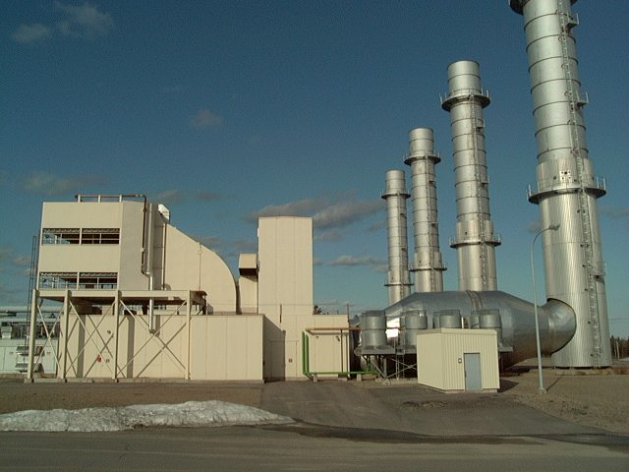
*NOTE: There is only one Starting Device and one Station Service Transformer to service the two combustion turbines.

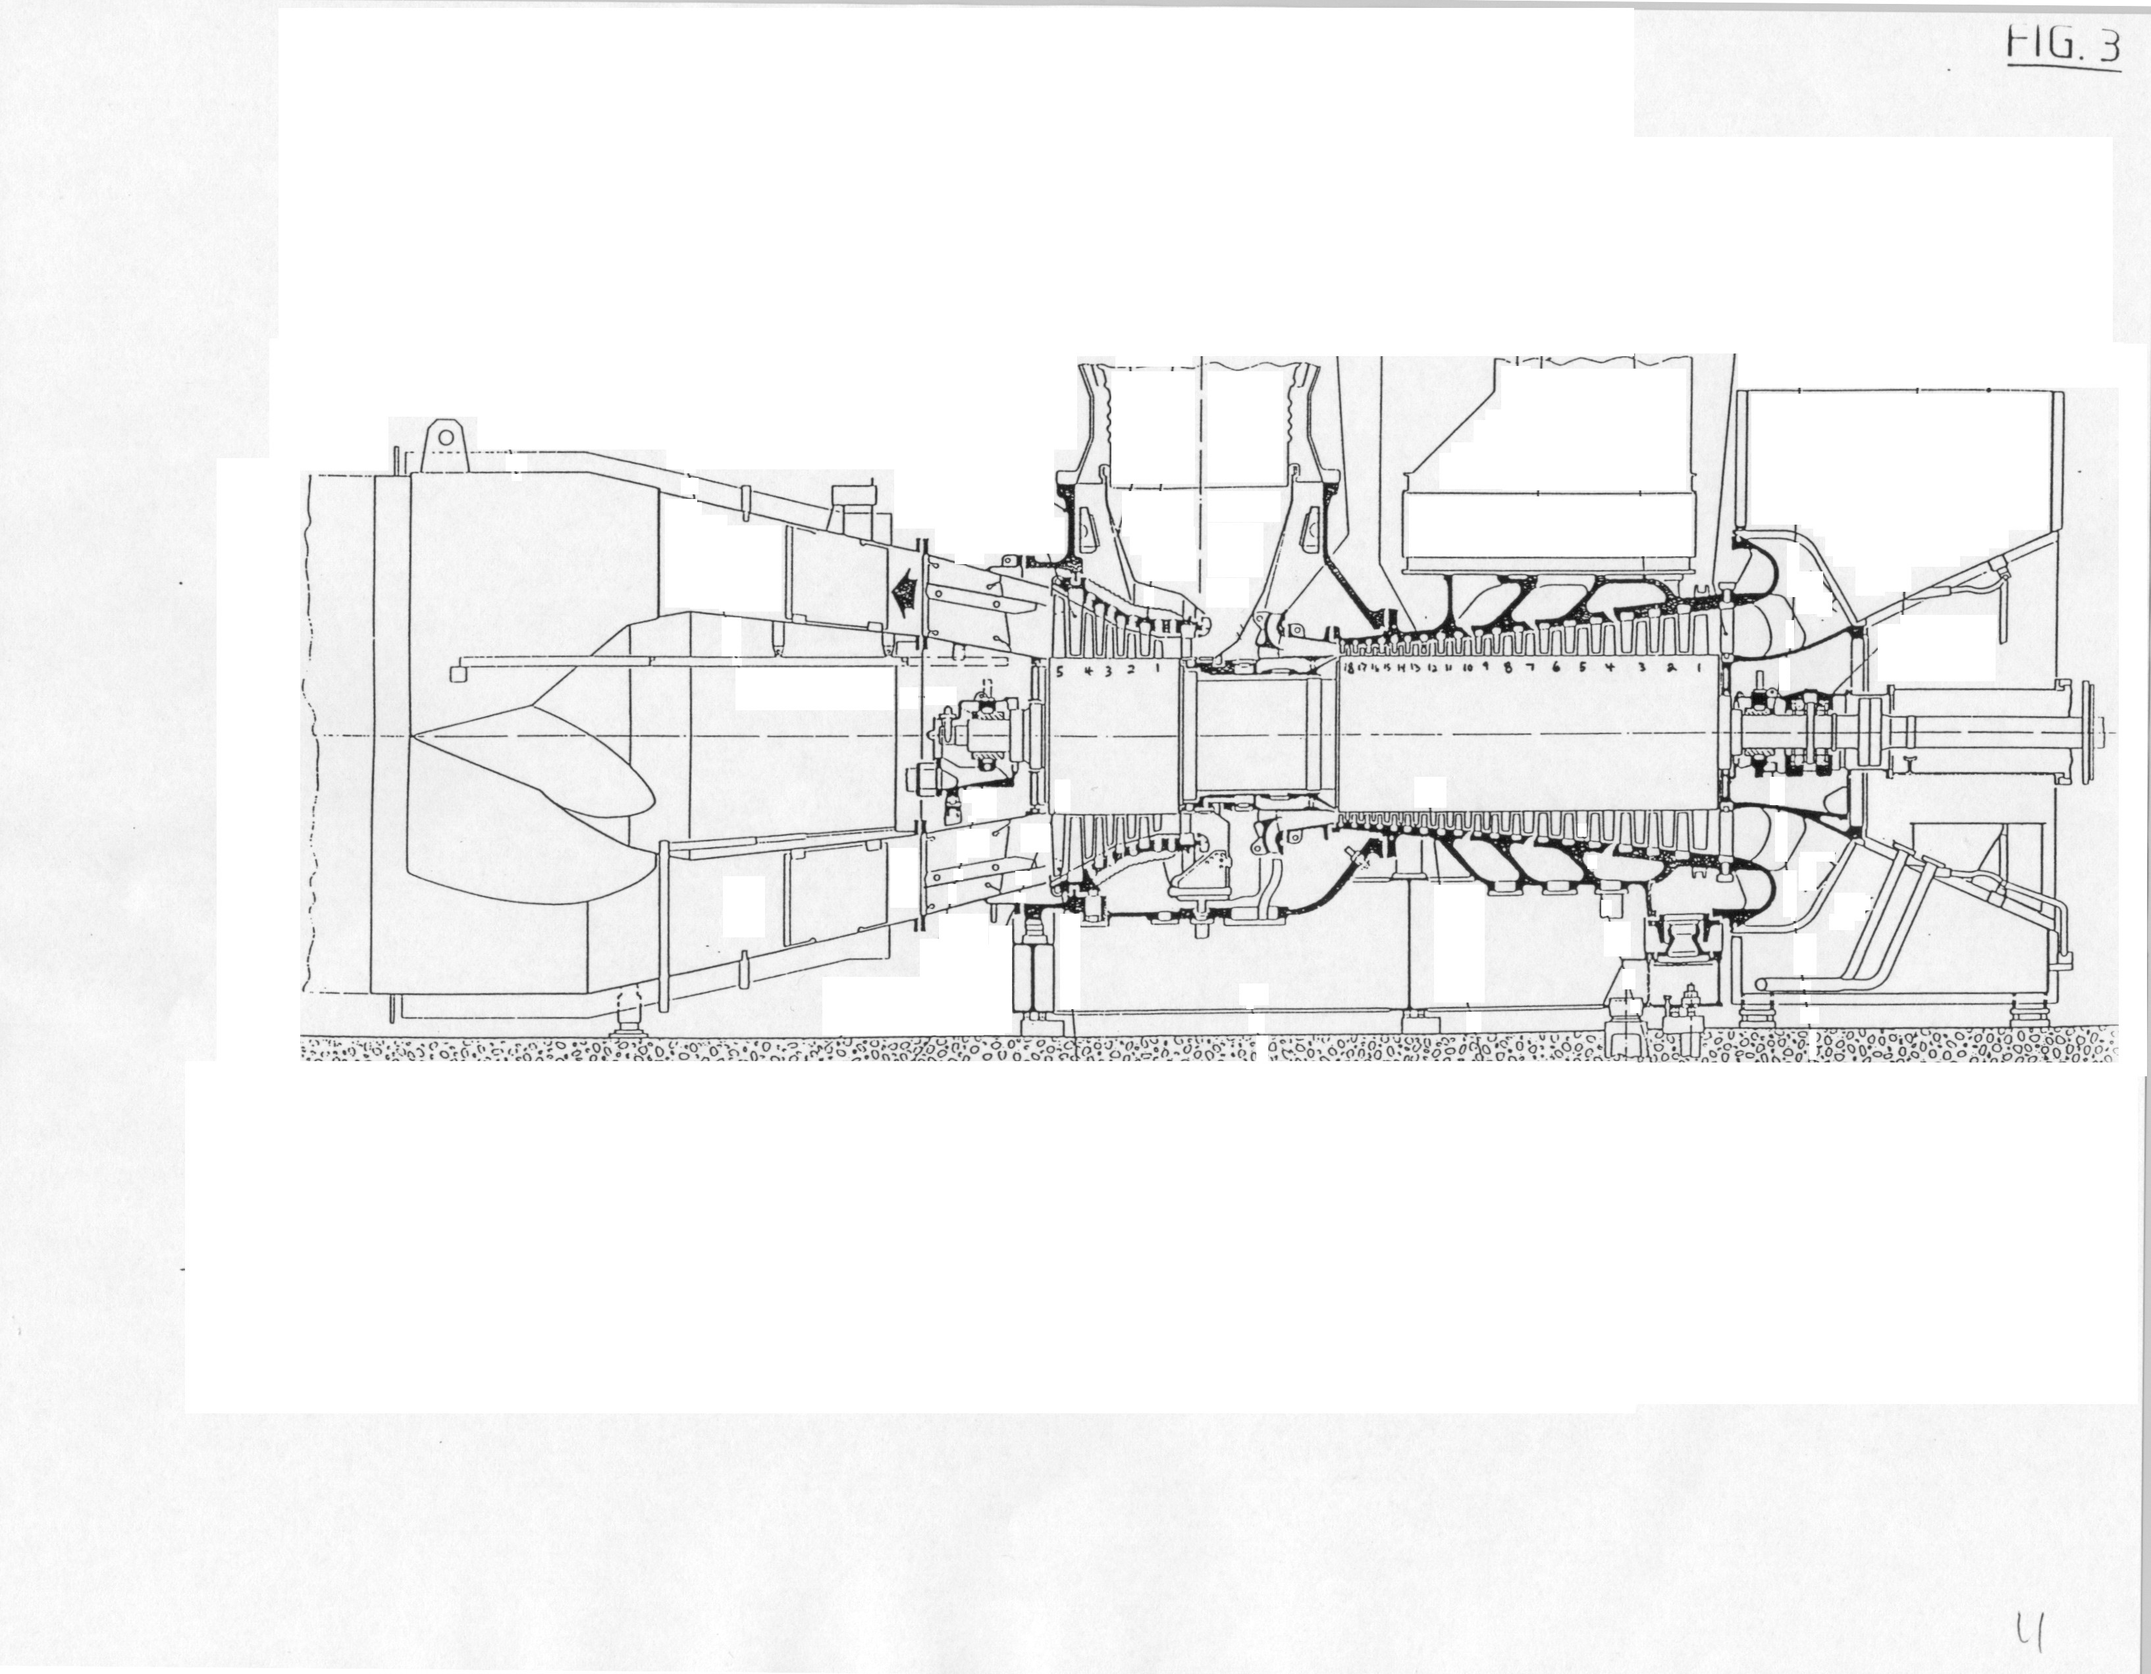
ABB 11N Engine

