Summary Report: Meeting on 6/7/2001

Jinbaek Kim (jinbaek.kim@enron.com)

Bid-Ask Spread: Empirical study on market data

In the exchange, sales price(ask price) and purchasing price(bid price) for an asset are different

Bid-Ask spread: the difference between sales price and purchasing price

Empirical study shows that the bid-ask spread on an asset increases as
- Trading volume decreases
- Price/share increases
- Price volatility increases

Bid-Ask Spread Why: Three Factors

- Order processing cost
- Inventory holding cost
- Variability of value
- Uncertainty of order flows
- Loss from informed traders
- Bid-ask spread to make up through revenue from uninformed traders (traders for liquidity)

Papers in the Collection(16 papers)

Empirical study in the collection
- Demsetz(1968)
- Tinic(1972)
- Lawrence et al(1993)
- Huang and Stoll(1997)
- Madhavan and Sofianos(1998)

Analytical study in the collection
- Inventory holding cost:
Stoll(1978), Amihud and Mendelson(1980), Ho and Stoll(1981), Cohen et al.(1981), Blume et al.(1982), O’Hara and Oldfield(1983)
- Loss from informed traders
Glosten and Milgrom(1985), Copeland and Galai(1986)
- Inventory + Information asymmetry:
Madhaven and Smidt(1991), Stoll(1978; focus on inventory)
- Competition among dealers
Ho and Stoll(1980)
We will look for more papers in near future

Papers of Today

Demsetz(1968): “The cost of transacting”
- Seminal paper focused on inventory (providing immediacy)
- Purpose: explain intuition behind bid-ask spread
- Empirical study (Econometric Analysis)

Copeland and Galai(1983): “Information effects on the bid-ask spread”
- Focused on the loss from informed traders
- Purpose: explain reality
- Modeling and Analysis

O’Hara and Oldfield(1986): “The microeconomics of market making”
- Focused on inventory holding cost – the variability of value and uncertainty of order flow
- Purpose: find solution for bid-ask setting problem
- Modeling and Solution

For each paper we will explain
Assumptions
Objective
Optimal Solution
- Modeling and Problem Solving Techniques
Analysis of optimal solution:
- Intuitions
- Comparative statics

Demsetz (1968)
Noted bid-ask is caused by providing immediacy
Economic Intuition behind this:
Supply unit price goes up if goods are provided immediately.
Demand unit price goes down if goods are purchased immediately
Intersection with immediate curve and ordinary curve: Bid-Ask spread

Conjecture: bid-ask spread for high trade volume security is smaller than low trade volume security Because value of providing immediacy is smaller. He showed this by analyzing NYSE data

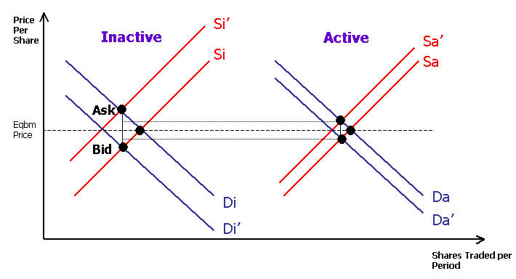
Figure 1. Bid-Ask spread model (Demsetz)

Copeland and Galai (1983)

Assumptions
Single dealer, single security
Two trader types: informed trader and liquidity trader
Dealer makes commitment to buy security at a (i.e. ask price) and sell security at b (i.e. bid price) a fixed quantity to the first arrived trader
Dealer changes prices a and b after a transaction with informed trader
Dealer is risk neutral (expected value maximizer)
$S_{0}$: true value of security perceived by the dealer and liquidity traders
$S$: true value, stochastic process following ~ f(S)

Probability of trader type
$P_{I}$: probability that the arrived trader is an informed trader
$P_{L}$: probability that the arrived trader is a liquidity trader ($P_{I}+P_{L}=1$)
$P_{\text{LT}}$: probability that the liquidity trader will make transaction
$P_{\text{LN}}$: probability that the liquidity trader will make transaction ($P_{\text{LT}}+P_{\text{LN}}=1$)
$P_{\text{TS}}$: probability that the liquidity transaction is “sell”
$P_{\text{TB}}$: probability that the liquidity transaction is “buy” ($P_{\text{LT}}=P_{\text{TS}}+P_{\text{TB}}$)
Two quotation scenarios: Instantaneous quotes and open quote interval

1) Instantaneous Quote Scenario
E [Revenue] =$(1−p_{I})\left\{p_{\text{BL}}(a−S_{0})+p_{\text{SL}}(S_{0}−b)+p_{\text{NL}}0\right\}$
E [Loss] = $p_{I}\left\{\int{(S−a)f(S)\text{dS}}+\int{(K_{B}−S)f(S)\text{dS}}\right\}$

Assumption (1)
$\frac{∂p_{\text{BL}}}{∂a}|_{S_{0}}<0$ and $\frac{∂p_{\text{SL}}}{∂b}|_{S_{0}}>0$

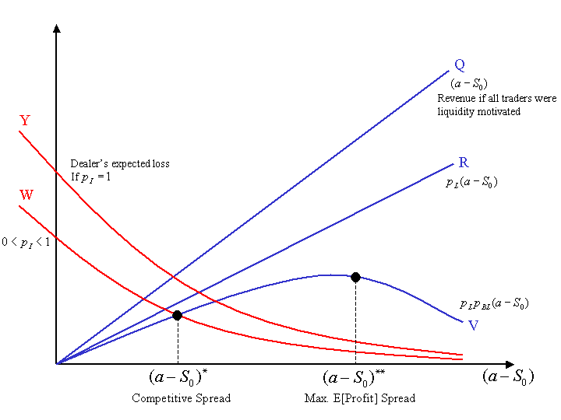
Figure 2. Ask spread determined by revenue from liquidity trader (Q,R,V) and loss from informed trader (Y,W) (Instantaneous Quote Model)

2) Open Quote Interval Scenario
E [Revenue] = $(1−p_{I})\left\{p_{\text{BL}}(a−S_{0})+p_{\text{SL}}(S_{0}−b)\right\}$
E [Loss] = $p_{I}[C(a)+P(b)]$

Risk neutral valuation of options when risk-neutral interest rate r = 0
$$C(a)=S_{0}N(d_{1})−\text{aN}(d_{2})$$
$$P(b)=−S_{0}N(−d_{3})+K_{B}N(−d_{4})$$
where
$θ^{2}=σ^{2}τ$, $d_{1}=\frac{\text{ln}({S_{0}}/a)+{θ^{2}}/2}{θ}$, $d_{2}=d_{1}−θ$, $d_{3}=\frac{\text{ln}({S_{0}}/b)+{θ^{2}}/2}{θ}$, $d_{4}=d_{3}−θ$

Intuition on the Bid-Ask spread
- Bid-Ask spread increases as volatility increases.
Because as volatility increases, cost of free option becomes high and to make up that increased cost the dealer must increase the bid-ask spread
- Bid-Ask spread increases as price/share increases
To see this, let’s multiply $λ$ to both $S_{0}$ and $a$ and consider ask spread first. Expected loss becomes $λ$$p_{I}[C(a)]$ and expected revenue becomes $λ$$(1−p_{I})\left\{p_{\text{BL}}(a−S_{0})\right\}$. $p_{\text{BL}}$ decreases with large $λ$ (e.g. $λ>1$), because the difference between new price per share $S'_{0}={λS}_{0}$ and $a'=λa$ increases to $λ(a−S_{0})$ and $p_{\text{BL}}$ decreases as the difference between price/share and ask price increases by assumption (1). Thus as price per share increases to $a'=λa$, the dealer must set new ask price higher than $λa$ to make up the loss from the informed trader because revenue with $λa$ becomes is $λ$$(1−p_{I})\left\{p_{\text{BL}}(a−S_{0})\right\}$ and now $p_{\text{BL}}$ is smaller. If $λ<1$, similarly, due to increased $p_{\text{BL}}$ the dealer may set ask price lower than $a'=λa$ to make up the loss.

Summary: Copeland and Galai
Objective
- In monopoly case, maximize
E [Revenue from liquidity trader – Loss from informed trader]
- In competitive case, set price to recover the loss from informed trader
Modeling and problem solving technique:
- Expected value
- Option pricing model
Analysis of solution
- Instantaneous quotation scenario
  - Comparative statics
  - Competitive and monopoly case
  - Change of solution depending on the probability of informed traders(PI) and transaction(PLT and PTB)
- Open quote interval scenario
  - Option pricing model
  - Change of solution depending on price volatility and price/share in competitive case

O’Hara and Oldfield (1986)

Assumptions
- Single dealer, single security
- Each day has n trading periods
- Dealer sets bid/ask prices at the beginning of the trading period
- Each trading period is a call market where market orders arrive depending on the price
- At the beginning of the trading period, dealer knows submitted limit orders and has expectation of market orders
- There exists an overnight market for security
- Inventory can be negative: can be borrowed from the overnight market with paying interest r
- Positive inventory yields return through overnight market
- Dealer is risk averse expected utility maximizer

Limit buy function: $\int{q_{a}(a_{t})}{\text{da}}_{t}=α^{L}−γ^{L}a_{t}$
Limit sell function: $\int{q_{b}(b_{t})}{\text{db}}_{t}=β^{L}−φ^{L}b_{t}$

Market buy function: ${\tilde{A}}_{t}^{m}=α^{m}−a_{t}γ^{m}+{\tilde{ω}}_{t}$
Market sell function: ${\tilde{B}}_{t}^{m}=β^{m}−b_{t}φ^{m}+{\tilde{ε}}_{t}$

Total buy function: ${\tilde{A}}_{t}^{m}=\begin{aligned}\left\{α−a_{t}γ+{\tilde{ω}}_{t}\text{if} α^{L}−γ^{L}a_{t}≥0 | \right.\end{aligned}$

$${\tilde{B}}_{t}^{m}=\begin{aligned}\left\{β−b_{t}φ+{\tilde{ε}}_{t}\text{if} β^{L}−φ^{L}b_{t}≥0 | \right.\end{aligned}$$

Objective:
$$\begin{aligned}\text{max}\underset{(b_{1},⋯,b_{n})}{\begin{aligned}(a_{1},⋯a_{n})\end{aligned}}\end{aligned}E[U(\sum_{t=1}^{n}{{\tilde{π}}_{t}})+V({\tilde{I}}_{n})]s\text{.}t\text{.}α^{L}−γ^{L}a_{t}≥0∀t=1,⋯,nβ^{L}−φ^{L}b_{t}≥0$$

Last Period
$$\begin{aligned}\underset{(a_{n},b_{n})}{\text{max}}E[U(\sum_{t=1}^{n−1}{{\tilde{π}}_{t}}+a_{n}(α−a_{n}γ+{\tilde{ω}}_{n})−b_{n}(β−b_{n}φ+\tilde{ε})+r\tilde{p}(I_{n−1}+β+b_{n}φ+\tilde{ε}−α+a_{n}γ−{\tilde{ω}}_{n})) \\ + V(I_{n−1}+β+b_{n}φ+\tilde{ε}−α+a_{n}γ−{\tilde{ω}}_{n})] \\ s\text{.}t\text{.}α^{L}−γ^{L}a_{n}≥0 \\ β^{L}−φ^{L}b_{n}≥0\end{aligned}$$
From Kuhn-Tucker Condition
$$a_{n}=α/2γ+E[U'{\tilde{ω}}_{n}]/E[U']2γ+\text{rE}[U'\tilde{p}]/2E[U']+E[V']/2E[U']$$
$$b_{n}={−β}/2φ−E[U'{\tilde{ε}}_{n}]/E[U']2φ+\text{rE}[U'\tilde{p}]/2E[U']+E[V']/2E[U']$$

where
$$U'≡∂U/∂π_{n}$$
$$V'≡∂V/∂π_{n}$$
$U'$ : function of $I_{n−1},a_{n},b_{n}$
$a_{n},b_{n}$ : function of $I_{n−1}$

Bid-Ask Spread
$$a_{n}−b_{n}=(\text{αφ}+\text{βγ})/2\text{φγ}+(φE[ω_{n}]+γE[ε_{n}])/2\text{γφ}+(φ\text{Cov}(U\text{',}ω_{n})+γ\text{Cov}(U\text{',}ε_{n}))/2\text{φγ}E[U']$$
For risk averse dealer,
$$\text{Cov}(U\text{',}ω_{n})<0$$
$$\text{Cov}(U\text{',}ε_{n})>0$$

Summary: O’Hara and Oldfield
Objective:
- For each day, maximize
EU [Profit from trade + Return from inventory + Value of inventory]
Modeling and problem solving technique:
- Stochastic Dynamic Programming
- Each stage is a constrained optimization problem (constraints are simple)
Analysis of optimal solution:
- Little – Lost tractability due to detail of the model
- Change of solution depending on the degree of risk averseness

Pros and Cons of Today’s Papers
1) Demsetz (1968)
- Simple and intuitive
- No analytical model (Conjecture and linear regression to test the conjecture)
- Focused on immediacy only – no consideration on the variability of value and uncertainty on the order flow
2) Copeland and Galai (1983)
- Analysis of solution is easy and clear
- Focused on information only
- The model is too simple to model reality
- Determination of optimal quotation time window is not considered
3) O’Hara and Oldfield (1986)
- Incorporates many details of market scenario and risk attitude of dealer
- Lost tractability of solution due to the complexity of model and solution: analysis of solution is hard
- Linear demand
- Focused on inventory only

Next Week
Information focused
- Glosten and Milgrom(1985)
Inventory focused
- Amihud and Mendelson(1980)
Continue discussion

