TABLE OF CONTENTS
1.0 PURPOSE AND OBJECTIVES 1
2.0 MONITORING PROCEDURES 3
3.0 EVALUATION OF DIFFERENTIAL SUBSIDENCE 5

LIST OF FIGURES
FIGURE PAGE

1-1 Location of Napoleonville Storage No. 1 and Monitoring Benchmarks. 2
2-1 Differential Subsidence Report Form for Napoleonville Storage No. 1. 4

0 PURPOSE AND OBJECTIVES
Napoleonville Storage No. 1 (Serial No. 972568), located in the Napoleonville salt dome, is to be converted from brine mining to natural gas storage service. The well is owned and operated by Bridgeline Storage Company, LLC. The surface location of the wellheads for this well and proposed subsidence monitoring benchmarks are illustrated in Figure 1-1.

Bridgeline intends to monitor the natural gas service in Well No. 1 to ensure safe operations. One of the programs that will be initiated by Bridgeline is Differential Subsidence Monitoring. Differential subsidence is the difference in subsidence between two or more surface locations. For the program described in this document, the differential subsidence of interest is that at Well No. 1 relative to the subsidence at adjacent subsidence monitoring benchmarks. The subsidence monitoring benchmarks will be stainless steel rods driven at least 30 feet into the subsurface. A protective enclosure will be installed at the surface for each benchmark.

The purpose of this document is to describe the procedures for the semiannual monitoring and evaluation of the differential subsidence of the well used for natural gas service
RSI-1231-01-011
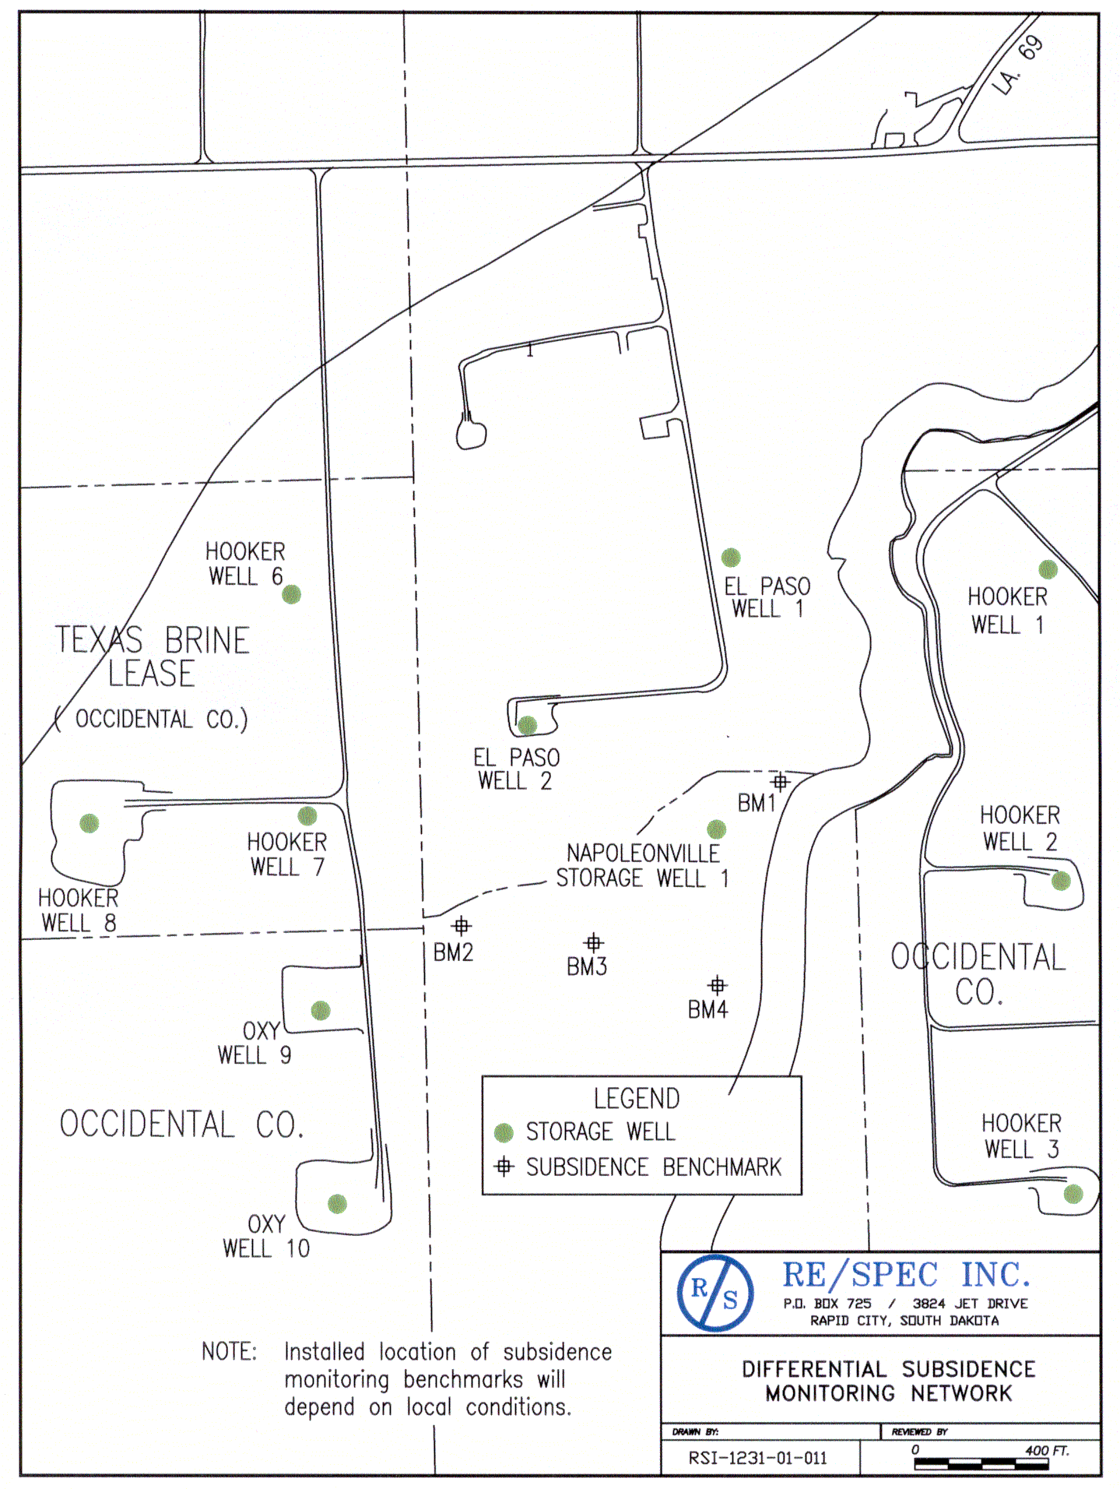
Figure 1-1. Location of Napoleonville Storage No. 1 and Monitoring Benchmarks.

0 MONITORING PROCEDURES
The differential subsidence experienced at the wellhead of Well No. 1 will be monitored on a semiannual basis. The differential subsidence at this well will be determined from the semiannual measurement of the differences in the wellhead elevations between Well No. 1 and the four adjacent subsidence monitoring benchmarks.

The location on the wellhead where the subsidence monitoring will take place will be the underside of the lower flange of the Bradenhead flange. The elevation of the upper surface of the Bradenhead flange will be determined in the precision level survey and the Bradenhead flange on the wellhead will be calipered to determine the elevation of the underside of the lower flange.

On a semiannual basis, the difference in elevation between Well No. 1 and the subsidence monitoring benchmarks will be measured. The elevation differences obtained during the two semiannual surveys will be compiled by Bridgeline on the form illustrated in Figure 2-1. The date on which the wellhead and benchmarks are surveyed will also be noted on the form. Efforts will be made by Bridgeline to use the same surveying contractor to assure consistency of results.
RSI-1231-01-013
Differential Subsidence Report
Napoleonville Storage No. 1
Subsidence  Benchmark | Survey  Date | Elevation Difference  (ft)
Subsidence  Benchmark | Survey  Date | Well No. 1
1
2
3
4
Average

Figure 2-2. Differential Subsidence Report Form for Napoleonville Storage No. 1.

0 EVALUATION OF DIFFERENTIAL SUBSIDENCE
Following each of the semiannual precision level surveys for determining differential subsidence for Well No. 1, the average difference in wellhead elevation between Well No. 1 and the adjacent subsidence monitoring benchmarks will be determined and documented in the form in Figure 2-1.

The time rate of change in the semiannual wellhead evaluation differences for Well No. 1 (the differential subsidence rate) will be evaluated by Bridgeline in comparison to historical data and any changes in differential subsidence rates will be noted and the cause of the differences will be determined.

