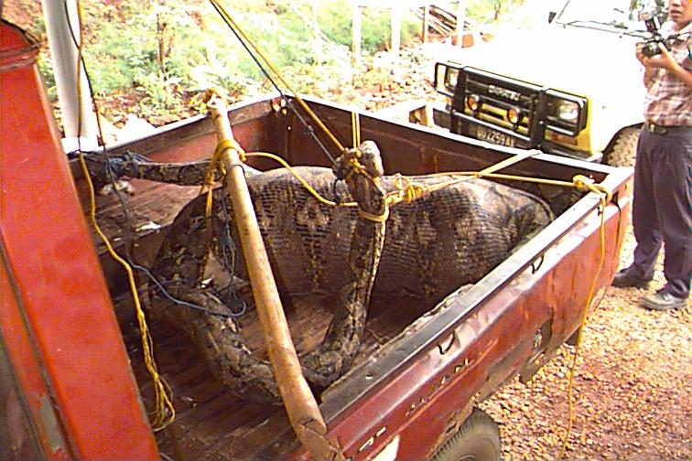
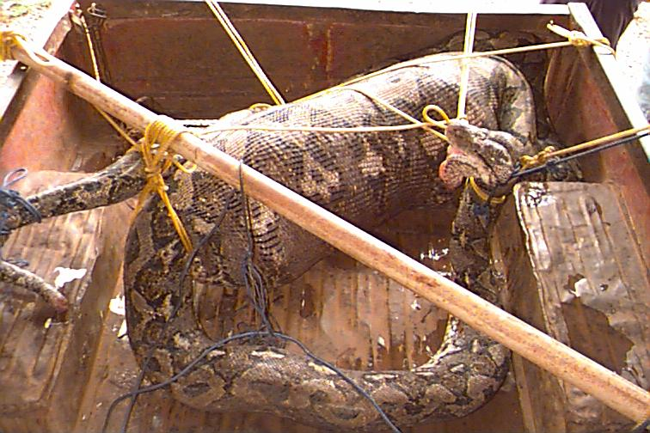
Snake THIS IS FOR REAL!!

A CREW MEMBER ON A LAND OIL RIG IN VENEZUELA WENT OUT AND TOOK A NAP. YES, A NAP. HE WAS MISSING AND THIS IS WHAT THEY FOUND.

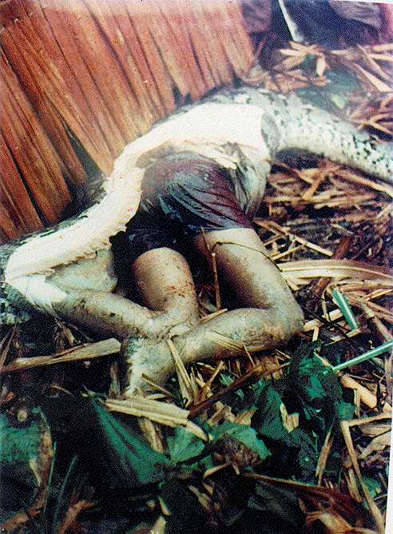

ANYONE WANT TO GO TO VENEZUELA????

