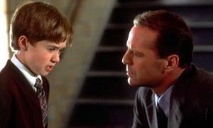

“I see stupid people…
…they’re everywhere…
they walk around like everyone
else…they don’t even know that
they’re dumb.”…

And they all vote in Florida

