The Status of U.S. Electricity Restructuring

Early Movers Among the States
As the previous section indicates, some discrepancies exist between state and federal jurisdictions in the United States when it comes to designing and implementing energy policy and regulatory initiatives. Electric power is no different. California is generally regarded as being first out of the chute among the states in electric utility deregulation, and it has had a great impact on the Federal Energy Regulatory Commission. This body has generally been responsive to individual state or regional initiatives, and supports the concept of interstate commerce as a guiding first principle.

Federal imperatives were already in place, however. The federal Energy Policy Act of 1992 (or EPAct) was an attempt to articulate a national energy policy following the 1991 Gulf War. For electric power, the goal was to create a framework for open wholesale markets nationwide. The notion of bulk energy markets was not new. As natural gas restructuring proceeded during the mid-1980s, with creation of wholesale markets in that industry, the parallels for electric power had already become evident. It was widely expected that the FERC would soon step in with orders to implement the wholesale power market as outlined in the EPAct.

California moved in 1994 to create wholesale power markets with the establishment of an independent system operator (ISO) for third party management of transmission facilities and a “power exchange” for wholesale trading (CalPX), both subject to FERC approval. Retail electricity markets were also opened to competition, giving consumers an opportunity to select new suppliers if they wished. California’s restructuring effort represented a shot across the bow, proposing institutional structures that state decision-makers clearly hoped would be accepted by FERC.

FERC followed in 1996 with Orders 888 and 889, which outlined and clarified conditions for an interstate bulk electricity market. These FERC orders are believed by some to be reflective of California’s influence. Order 888 extended to power transmission the concepts of nondiscriminatory open access and unbundling used for interstate natural gas pipelines, and required the use of ISOs for third party control of electric power transmission. Order 889 established OASIS, an electronic bulletin board system, as the industry standard for conveying information on transmission capacity.

States now had two mandates. The first was to engage in transitions to facilitate the bulk power system, and the second was to consider California’s initiative and possibly move ahead with retail competition. Several northeastern states, burdened by high energy costs in the last recession, saw the logic in competition. Deregulation began to unfold in New York, Pennsylvania and Michigan. Meanwhile, the Texas legislature authorized the Electric Reliability Council of Texas as an independent system operator (ISO) for the state’s power grid.

Latest Entrants
States with large industrial loads had the greatest incentives to move forward with wholesale markets, while those with a heavy base of individual households were more aggressive with respect to creating retail markets. All but eight states have begun some initiative with respect to electric power restructuring, although some have stepped back from the proposition. The map below, from the U.S. Energy Information Administration (U.S. EIA) shows the status of restructuring programs across the Lower 48 states, Alaska and Hawaii.

The map of activity paints a picture of vigorous restructuring efforts nationwide, but caveats exist everywhere. States in the southeastern U.S., for example,
Status of State Restructuring Initiatives in the U.S.
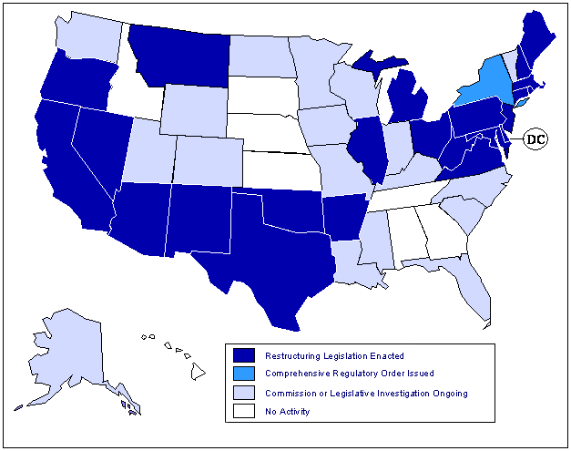
have taken a more cautious stance with regard to restructuring. Recent FERC moves to build larger, more efficient regional electric power markets (see discussion of current trends, below) have clashed with state-level restructuring efforts in some regions. Infrastructure bottlenecks in many locations, such as the Pennsylvania-New Jersey-Maryland region, New York and California, have complicated market development and the pace of restructuring. In some cases, “off-grid” solutions like distributed generation could significantly affect incumbent industry players as well as the restructuring process. Of particular possible consequence is the idea of “net metering”, which allows customers that buy as well as generate to sell power back to the grid.

Recent Trends
A number of changes underway will have a long-term impact on U.S. power markets. Most important of these is the acceleration of FERC Orders 2000 and 2000-A. These orders seek to encourage the creation of larger, more efficient regional markets out of the transmission systems in individual states and the smaller ISOs already in existence. The result will be regional transmission organizations or “RTOs“. Recognizing that emerging problems in the bulk market, with ramifications for retail markets, were associated in large part with barriers in the transmission of electricity, the FERC is attempting to loosen both utility ownership of transmission assets and state jurisdictional control. On 11 July 2001, the FERC issued a directive for the creation of four RTOs, one each in the Northeast, Southeast, Midwest and West (Texas’ Independent System Operator, the Electric Reliability Council of Texas, or ERCOT, remains outside of FERC jurisdiction because of the physical configuration of its system.) FERC’s stated goal is an effort to facilitate seamless transactions within these larger RTOs.

Bulk power markets are more than five years old in the U.S. Third party aggregators, brokers and marketers of electricity quickly moved in that time to build trading and marketing structures that would facilitate large-scale transactions, enhance risk management and allow for the development of attractive service packages for industrial customers. The map on the following page illustrates the locations of the major trading hubs and market centers for electric power in the U.S. (U.S. EIA).

“Rate pancaking” remains a major issue in electric power markets for transactions in which the “contract path” – the theoretical path along which the electricity must travel to get from its source to its consumer - crosses multiple boundaries of transmission asset ownership. Along the path, each utility in control of transmission facilities charges a tariff for use of its assets. These “pancaked rates” can hinder interstate commerce, wholesale market development and competition. Order 2000 was intended to promote the original open access mandate of Order 888 by forcing owners of transmission assets to pool those assets into larger ownership structures with open access tariffs throughout the region served by the RTO.
Electric Power Trading Hubs and Market Centers
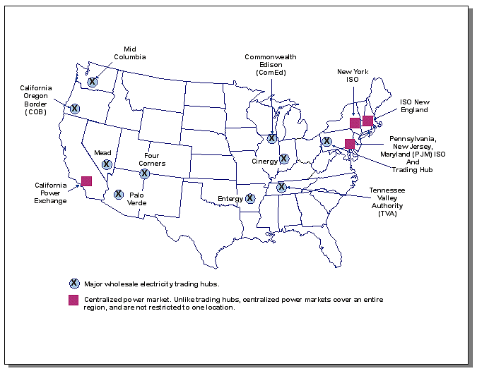

FERC’s original Order No. 2000 and its 11 July directive present both opportunities and challenges. The opportunities lie in the potential to create large regional and national markets that will help to induce price competition, innovation and efficiency. The challenges lie in reconciling FERC’s directives with changes that have already taken place, and current practices among utilities and state regulatory commissions.

A question remains as to how the RTO structures will function with the existing North American Electricity Reliability Council (NERC), which has proposed to transform itself into the North American Electric Reliability Organization (NAERO). This new group would have regulatory powers related to NERC’s mission of coordinating reliability across the interconnected web of the nation’s power transmission grids. NERC has prepared a more compact version of proposed legislation, for presentation to Congress, in conjunction with that body’s energy bill deliberations in autumn 2001.

It is not clear how NAERO will fit into FERC’s four-RTO model. FERC has indicated that it will take a stronger hand in monitoring the bulk market, to include establishing regional offices for this purpose. Many industry observers have questioned whether NERC’s model is the most effective means promoting the evolution of the nation’s power markets. NERC’s proposal would limit FERC jurisdiction over reliability. Though the proposal nominally places NAERO under FERC authority, some experts point out that reliability standards are not always easily separable, nor irrelevant to development of wholesale power markets, and could be more efficiently addressed by a single authority.

The map below depicts the NERC regions in the U.S. Florida separated from the Southeast Electric Reliability Council several years ago to form the separate Florida Reliability Coordinating Council (FRCC), a move widely viewed as one that gave the state body more control over the grid.
NERC Regions in the U.S.
