October 2000
Data Room and Site Visit Procedures
Enron North America Corp.

Table of Contents
1. Data Room Procedures
A. Introduction
B. Registering
C. Viewing Documents
2. Site Visit Procedures
A. Scheduling a Site Visit
B. Project Site Access and Check-In
C. Presentations
D. Confidentiality
Appendix – Data Room Indices

1.
Data Room Procedures
2.
Site Visit Procedures

Appendix – Data Room Indices
Data Room Procedures
- Introduction
Enron North America Corp. (“Enron”) has set up a virtual data room containing an electronic version of all due diligence documents for Round II bidders. This virtual data room is being administered through DealBench™, a secure online transaction platform. Each bidder will be granted access to the due diligence documents relating to the relevant project(s) for which it has been shortlisted to submit a Round II bid. Preliminary indices of these documents are attached as an appendix hereto for your convenience. The majority of the documents are in .pdf format and can be viewed using Adobe Acrobat Reader, which may be downloaded free of charge from http://www.adobe.com/acrobat. Other documents listed in the indices (e.g. some drawings and oversized documents) will be supplied directly by Enron North America Corp. Instructions on how to register for and use DealBench™ are provided below.
Any technical questions regarding Acrobat or DealBench™ may be directed to DealBench™'s Technical Desk at 1-877-367-7170. Technical Support is available seven days a week, 7:00 am to 7:00 pm CDT.
Questions relating specifically to the assets or the Round II bidding process should be directed, preferably in writing by fax, to the following representatives of Credit Suisse First Boston:
James Bartlett | Tel: (212) 325-4841 | Fax: (212) 325-8322
Lou Iaconetti | Tel: (212) 325-5085 | Fax: (212) 325-2760
Omar Al-Farisi | Tel: (212) 325-2565 | Fax: (212) 743-2631
Upon completion of the registration process detailed below, you will have access to a significant amount of confidential information. You are permitted to print all available documents and to make copies of those printed documents. YOU ARE NOT PERMITTED, HOWEVER, UNDER ANY CIRCUMSTANCES, TO SAVE, RETAIN, OR ATTEMPT TO DELIVER VIA E-MAIL, ELECTRONIC VERSIONS OF THE DOCUMENTS. Please be advised that the DealBench™ software allows Enron to monitor access by each Authorized Person (as hereinafter defined). Your activities will be monitored in order to ensure total compliance with the foregoing restrictions.
All information provided on the DealBench™ platform must be kept strictly confidential and treated in the manner set forth in the Confidentiality Agreement executed in favor of Enron.
- Registering
The process for accessing due diligence documents will be as follows:
- Your company should submit a list of names and e-mail addresses of all deal team members, including company officials, counsel, outside consultants, etc., requiring access to the due diligence materials to Jinsung Myung via e-mail (jinsung.myung@enron.com), fax (713-646-8863) or phone (713-853-7330). The list should indicate who will be the deal team leader from your company. Each of the deal team members listed will become an authorized person (an "Authorized Person") and be able to view due diligence documents. Each Authorized Person will have access to all due diligence documents in the electronic data room relating to the relevant project(s) from October 6, 2000 through October 30, 2000. All Authorized Persons must abide by the terms and conditions contained in the Confidentiality Agreement signed in September 2000 between your company and Enron.
- Each individual you identify as an Authorized Person will receive an invitation e-mail, in the form illustrated in Figure 1 below, for each applicable asset which will include a 16-digit Deal Key number (to be found in the highlighted area below).

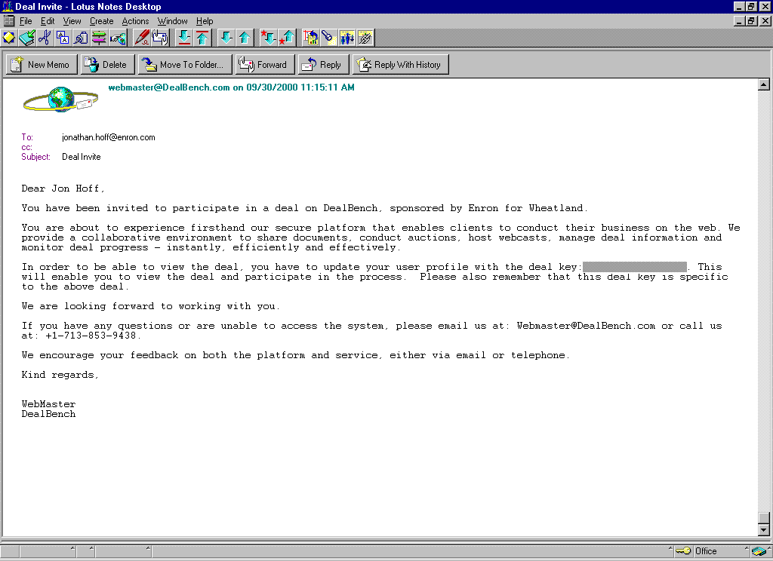
Figure 1

- Using either Microsoft Internet Explorer (version 3.0 or higher) or Netscape Navigator (version 3.0 or higher), go to http://www.DealBench.com/ to register. You will be greeted by the DealBench™ home page, illustrated in Figure 2 below.

Figure 2

- Click on “Register Now” to register and create your Username and Password.
- You will be required to enter the profile information illustrated in Figure 3 below. Usernames and Passwords must be at least eight characters long. Passwords must contain both letters and numerical characters. Be sure to choose a Username and Password that are familiar to you, as you will have to input this information each time you log onto DealBench™. When choosing your Institution/Entity during the registration process please follow these procedures: (1) Click on Select; (2) Click on Search; (3) Click on the name of your institution; and (4) Click on Select. To the extent that your institution’s name is not found, type it in and click on Add New Entity.
- Enter one Deal Key number (received in your invitation e-mail) in the Deal Key field at the bottom of the registration page. You will have an opportunity to enter the other Deal Key numbers once you have completed the registration process.
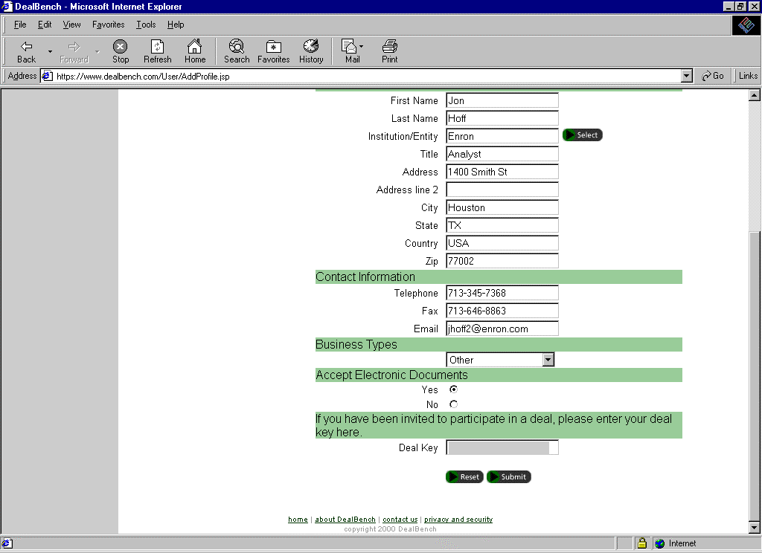
Figure 3

- Log back onto DealBench™ using the username and password you created during the registration process.
- Bidders who receive multiple Deal Keys will have to enter the other Deal Keys into the system. To do this:
On the DealBench™ home page, click on the "Update Profile" button.
Enter the Deal Key number (one at a time) at the bottom of the registration page. Press "Submit" once and on the next page press "Yes" to confirm that the information is correct.
Repeat the process for each additional Deal Key you have received. For example, if you are evaluating three projects, you must receive and enter two additional Deal Key numbers (you have already entered the first one during the initial registration process).
Once you have entered all your Deal Keys and have gained access to the relevant projects, you will have access to these same projects every time you subsequently log onto DealBench™.
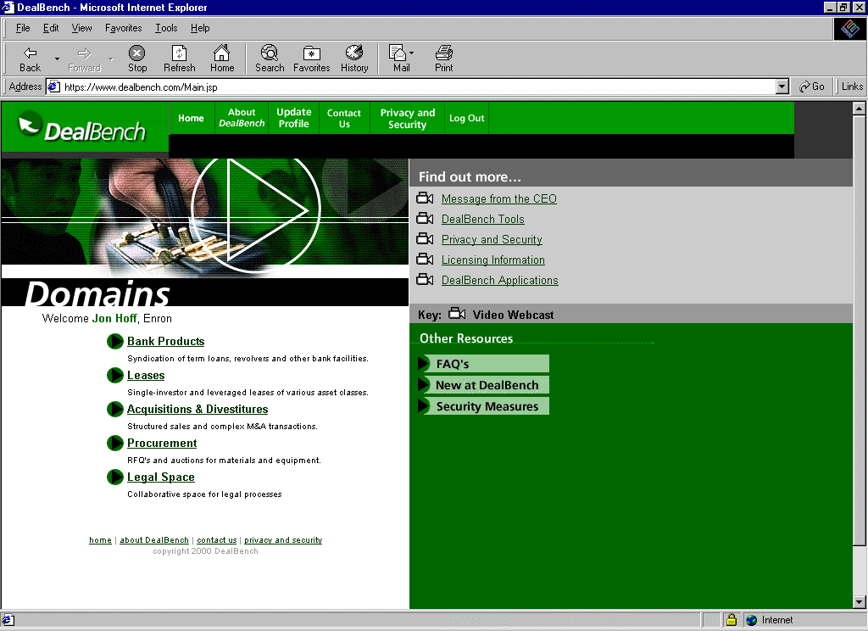
Figure 4
- On the home page click on the “Acquisitions & Divestitures” link (seen in Figure 4 above), which will take you to the list of projects to which you have access.
Viewing Documents
Once you have clicked on a project name, you will be taken to that project's page as illustrated in Figure 5 below.

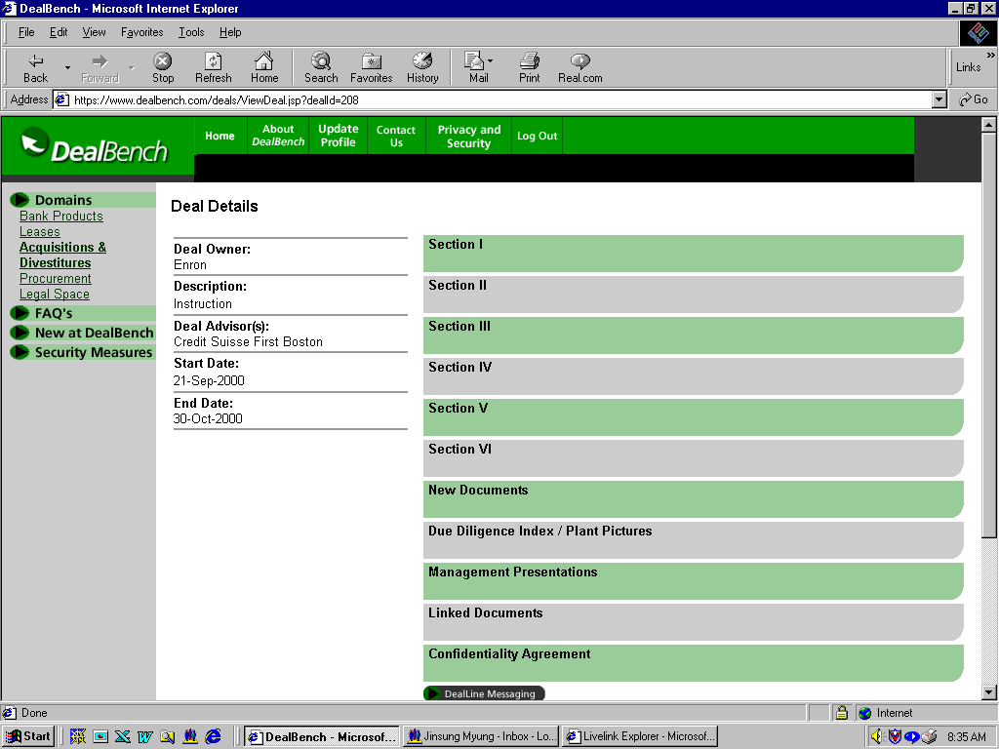
Figure 5
Each project page has the following sections:
Section I - Section VI
These sections should contain all of the project documents. Refer to the initial versions of due diligence indices provided as an appendix hereto for a complete listing of documents in these sections. The names of documents are truncated in DealBench™ and therefore it will prove useful to have a hard copy of the due diligence index in hand. Updated versions of these indices will be posted in the "Due Diligence Index" section.
New Documents
Any new documents added to the due diligence indices, will be posted in the "New Documents" section as well as in the correct location in Sections I-VI. The online version of the due diligence indices will also be updated as appropriate.
Due Diligence Index / Plant Pictures
The most recent versions of the complete due diligence indices will be found here. Also look for color plant pictures here.
Management Presentations
Narrated management presentations may be viewed here.
Linked Documents
Provides a link to the Enron home page.
Confidentiality Agreement
Not Applicable
To view a document click on the document name. The appropriate reader (Acrobat, Excel, Word, etc.) will be opened to view the document.

Site Visit Procedures
Scheduling a Site Visit
Access to the various project sites is strictly limited and is available only by appointment.
Appointments to visit the project sites must be made through the appropriate Site Visit Scheduling Coordinator:
- Peakers: Ben Rogers, Tel: (713) 853-7998, fax (713) 646-8863, e-mail benjamin.rogers@enron.com
- West Assets: Ron Coker, Tel: (713) 345-8992, fax (713) 646-8863, e-mail ron.coker@enron.com
The deadline for scheduling site visits is 5:00 p.m. EDT Friday, October 13, 2000.
Project site visits are limited to one day per company, with the exception of Pastoria, which is one half day.
Prior to your project site visit, Enron must be provided with a list of your team members, their titles, and their employer (for any outside consultants, etc.) as well as the designated deal team leader. Please fax or e-mail all lists to the appropriate Site Visit Scheduling Coordinator.
Upon scheduling an appointment, you will be provided with the relevant directions to the site as well as the contact information for the plant's Project Site Visit Coordinator.
Project Site Access and Check-In
No documentation will be available for review during the project site visit. All review of documentation is to be completed by accessing DealBench™. To the extent that there are documents not contained in DealBench™ that are of the type that are typically maintained at the plant site, please deliver to the appropriate Site Visit Coordinator (at the above indicated contact information) in advance of your site visit, any specific document requests that you may have.
When your group arrives, please proceed as a group to the front gate where a Project Site Visit Coordinator will greet you. Please note that no cameras or other photographic equipment are allowed.
Project site visits will be scheduled from 8:00 a.m. to 5:00 p.m. local time.
A deal team leader must be designated who will represent your company on all questions and requests submitted during your visit.
Any members of your team who are not employees of your company (i.e., outside consultants, engineers, etc.) must agree that they will comply with the terms of the Confidentiality Agreement executed by you.
After check-in, the plant's Project Site Visit Coordinator and other Enron staff members will accompany your team on the site visit.

Presentations
On the day of your visit, your company may be provided with a site overview presentation by the staff at the site.
Confidentiality
You are reminded that any information obtained during the project site visit is to be used by you, your company and any of your team members solely for the purpose of evaluating a possible transaction between your company and Enron with respect to the proposed sale of the subject generating assets and may not be used for any other purpose. Moreover, you are subject to the terms and conditions contained within the previously signed Confidentiality Agreement.

