
Set amidst groves of tall Monterey pines, The Inn overlooks Spanish Bay and the Pacific Ocean, giving it the air of both a secluded retreat and a dynamic playground for vacationers. Conde Nast Traveler's voted The Inn as the No. 1 Mainland Resort in 1993, 1995 and 1996. |  |   In January of 1999 The Inn at Spanish Bay was granted the coveted Mobil Five-Star award from the Mobil Travel Guide. The Resort is among only 44 elite dining and lodging establishments in North America to earn the award in 1999.
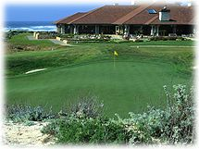
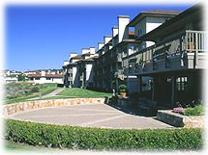 |  |  |  | The contemporary elegance of the Inn at Spanish Bay is reflected in its 270 guest rooms and suites.  Guest Rooms  Every guest room at the Inn has something special accentuated by beautiful views of the ocean, Del Monte Forest and the golf course.
For some guests visiting the Inn at Spanish Bay, recreation consists of relaxing and taking in the panoramic view of and ocean and dunes. But for others, the Resort offers a myriad of recreational options.

The Inn at Spanish Bay offers impressive facilities in its Tennis Pavilion. Eight plexipave courts, two lighted for night play, are available for Resort guests, as well as a full service pro shop, lounge area and fitness facilities. The Tennis Pavilion’s expert professional staff is available for lessons and clinics designed to suit all ability levels.
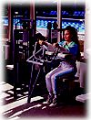
Also accessible to guests of the Resort is The Spanish Bay Club, offering state-of-the-art fitness equipment and professional instruction. The outdoor swimming pool and jacuzzi are complemented by a full indoor gym, plus a massage studio and other facilities to soothe well-exercised muscles.
The roads winding their way through Del Monte Forest offer visitors a chance to feel close to nature, while enjoying the breathtaking sights. The Spanish Bay Nature Walks provide self-guided tours among sand dunes, coastal vegetation, riparian areas, forest conservation area and a large variety of wildlife.
Weather: Daytime temperatures on the Monterey Peninsula range from 50-75 degrees year-round and vary throughout the day. Our mornings are often foggy; our afternoons are frequently balmy. It is best to dress in layers and to carry a water-resistant wind shirt or jacket. Note that it rarely rains between April and October.

There are several airport and air travel options. On the Peninsula, 20 minutes from The Lodge, is Monterey Peninsula Airport. Most large carriers have flights into Monterey. San Jose International Airport is about an hour and a half north of The Lodge; San Francisco International Airport is about two hours north.
Pebble Beach Resorts is a reasonable driving distance from all three airports. About twenty minutes away is Monterey Peninsula Airport; most large carriers have flights into Monterey. San Jose International Airport is about an hour and a half north, and San Francisco International Airport is about two hours north.
To Pebble Beach Resorts from Monterey Peninsula Airport
Turn right at the stoplight outside the airport onto Highway 68 West (to Monterey). Follow the signs to Highway 1 South, and then take the exit for 68 West (Pacific Grove/Pebble Beach).
For The Inn at Spanish Bay: Take 68 West for approximately three miles and bear left onto Sunset Drive. Follow Sunset to the second stop sign and turn left onto 17-Mile Drive. Stay on 17-Mile Drive through the guard gate and turn right at The Inn and Links at Spanish Bay entrance. Inform the guard if you are a guest at The Resorts so your entrance fee will be waived.
To Pebble Beach Resorts from San Jose and San Francisco:
Take Highway 101 South approximately 50 miles to 156 West (Monterey exit). Follow 156 West for about 6.5 miles until it becomes Highway 1 South; stay on Highway 1 for about 15 miles, to the exit for 68 West (Pacific Grove/Pebble Beach).
For The Inn at Spanish Bay: Take 68 West for approximately three miles and bear left onto Sunset Drive. Follow Sunset to the second stop sign and turn left onto 17-Mile Drive. Stay on 17-Mile Drive through the guard gate and turn right at The Inn and Links at Spanish Bay entrance. Inform the guard if you are a guest at The Resorts so your entrance fee will be waived.


Nerves tend to run tight at the start of a round at Pebble Beach, what with the teeing area raised like a stage above the omnipresent gallery of Lodge guests, breakfast diners and tee-time-awaiters. From the first hole, the golfer quickly realizes that this is no typical West Coast resort course, tucked tightly between condos and designed within
economics of scale. This course is larger than life, boasting mature stands of trees, roller coaster greens and bunkers in which you could easily hide one of the bigger sport utility vehicles. But it looks as if the course has taken a hundred years to develop this way and indeed it nearly has. The first 9-hole track was laid out along the cove in 1913.

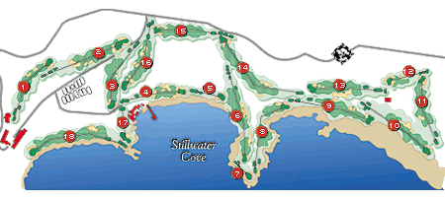

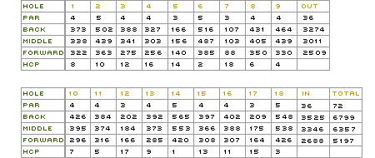


"Spanish Bay is so much like Scotland, you can almost hear the bagpipes."
Tom Watson

Designed by Robert Trent Jones, Jr., Tom Watson and Frank "Sandy" Tatum, The Links at Spanish Bay is America's foremost Scottish-style linksland course; even the rugged Monterey coastline mirrors the natural beauty of Scotland. |  | From the rolling fairways, white sand dunes and gusting winds to the plaintive strains of the bagpipe that signals the end of each day's play, The Links at Spanish Bay is an elegant, challenging journey into golf's beginnings.
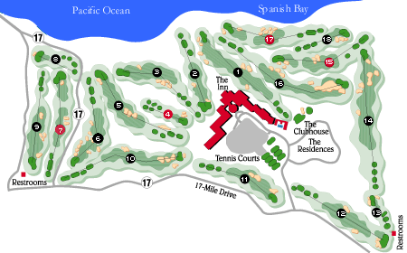
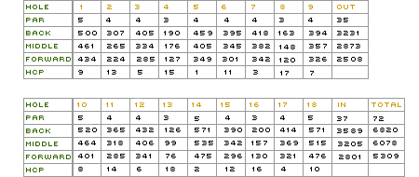


"If it were human, Spyglass would have a knife in its teeth, a patch on its eye,
a ring in its ear, tobacco in its beard and blunderbuss in its hand . . ."
Jim Murray, Los Angeles Times

With a name inspired by the Robert Louis Stevenson novel Treasure Island, Spyglass Hill is the toughest golf course in Northern California and among the most difficult in the world (ratings are from the championship tees). Designed by the legendary Robert Trent Jones and opened in 1966, the course was immediately |  | recognized as a true test of golf skills and an opportunity to utilize every club in the bag. "The Glass" hosts the annual AT&T Pebble Beach National Pro-Am, as well as qualifying rounds for the California State Amateur. Spyglass will be the qualifying course for the 1999 U.S. Amateur, to be held at Pebble Beach.
