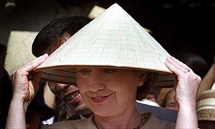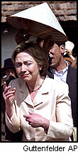
At First she was confused. . . ……………………………….But then she declared herself a candidate for Mayor of Hanoi….

