CHILD MISSING, MAY 4, 2001 FROM LETHBRIDGE, AB.
Please help me find my baby!!!

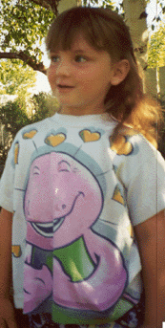

NAME: JESSICA ANN KOOPMANS
AGE: 5 YEARS
SHE WAS LAST SEEN WEARING:
- PINK SANDLES
- LIGHT BLUE DENUM SHORTS
- WHITE TANK TOP WITH BLUE AND PINK STARS AND STRIPES.
IF YOU HAVE INFORMATION REGARDING JESSICA PLEASE CONTACT:
LETHBRIDGE CITY POLICE
(403) 328-4444

PLEASE FORWARD THIS TO EVERYBODY IN YOUR ADDRESS BOOK AND PRINT A COPY AND PUT IT IN A PUBLIC PLACE. Also, please say a prayer for Jessica’s safe return.

