Most Dangerous Terrorists
Bin Lie-in  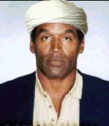  O. J. "the-blade" Simpson | Bin Cheat-in  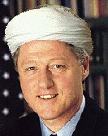  Bill "who's-that-intern" Clinton | Bin Swim-in  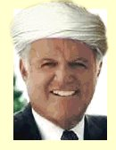  Teddy "the-fish" Kennedy
Bin Bought-in  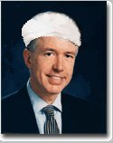  Gray "bought-and-paid-for" Davis | Bin Jive-in  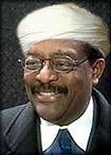  Johnnie "if-the-turban-fits-you-must-convict" Cochran | Bin Snort-in  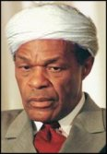  Marion "take-a-hit" Barry
Bin Stroke-in  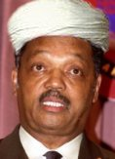  Jessie "never-had-a-job" Jackson | Bin Skate-in  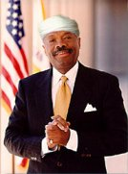  Willie "freeloader" Brown | Bin Bite-in  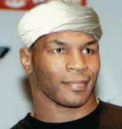  Mike "assault-and-battery" Tyson
Bin Wac-in    Janet "Rambo" Reno | Bin Kneel-in    Monica "is-that-cigar-lit" Lewinsky | Bin Run-in  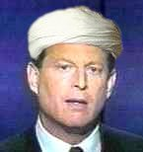  Al "still-counting-chads" Gore
Bin Screech-in    Roseanne" star-spangle-banner" Barr | Bin Steal-in  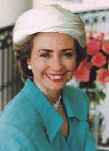  Hillary "take-that-furniture" Clinton | Bin Rat-in    Linda" she-did-it" Tripp

