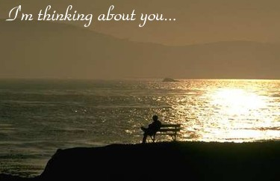

"Some people come into our lives and quickly go. Some stay for awhile and leave footprints on our hearts. And we are never, ever the same." –Unknown

Meliza,
i like typing that. perhaps, u will read this and it will make u smile. maybe u will frown upon my words. u might respond. u might delete these words as if they were never sent. i do not know.
however, as i type this i search for the words. they come easily to me like breathing. yet, i hold them longer than i want to. i don't want to offend, yet, i want them to be honest with U, because i know no other way to be.
i know u'd rather i forget friday's conversations. how can u ask me to walk away? it is as if u've kissed me and u want me to forget. . .u want me to be unaffected. well, i can't remain unaffected. every since july. . .every since the very first day, colours are brighter. . .i hear the songs of birds. . .i think of U. . .i've thought of U. u've haunted me in such a way that i can't be unaffected. do i turn from U and say that i'm not interested? do i say that i don't want to see what can be? Meliza, u are worthy of my time and efforts. even if my words don't touch U. i suppose it only warms to your boyfriend's words. so, be it. i have lost nothing by letting u know what i think of U. and what if i get your attention?
some things are stronger than pride.
i hope u have a beautiful day.
and yes, i'm thinking of U, richard.

richard.

