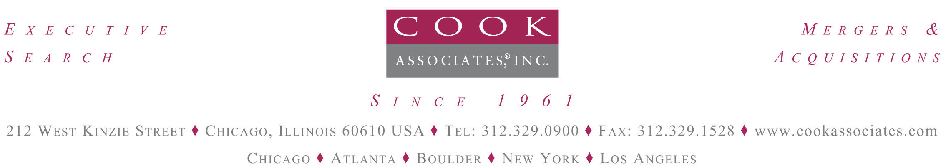

TYPES OF TRANSACTIONS

CEOVisions^{sm} -- Unites the Executive Search and M&A functions to advance CEO’s creative idea from vision to reality. Our Private Equity clients fund executives with $50 million to $500 million in equity to build a new company through acquisition of companies with revenues of $50 million to $2 billion.

Recapitalization -- Cook assists family/closely held companies in finding an equity partner to initiate a recap providing liquidity while assuring independence, a continued equity ownership, and equity capital for the management team to drive growth in their company.

Strategic Transactions – Cook assists public and private companies to acquire strategic middle-market companies.

Corporate Divestitures / Management Buyouts -- Cook assists the executive in finding an equity partner to structure a buyout of their division from the parent company or a buyout of a family owned business, resulting in equity ownership for management and capital for further acquisitions and growth.

Corporate Partnership – Cook facilitates the development of off-balance-sheet funding structures for publicly held and large privately held companies, allowing the corporation to achieve near-term strategic objectives which may not be otherwise possible due to debt, losses or stock price issues. These can include 1) the spin-out of a division keeping a 19.9% or more equity interest vs. selling outright, to maintain strategic ties to the business 2) the creation of a new business off-balance-sheet through acquisitions or 3) on-balance-sheet equity funding (PIPE investment) to back a large acquisition.

Early Stage -- Cook partners with CEOs of early stage companies to assist them in capital raise efforts. The typical profile is a company seeking $10 million+ of equity funding in a Series B or C Round. Cook has developed an extensive network of the nation’s most active financial and corporate venture capital investors. Cook is positioned to bundle Executive Search to assist in building the team, board of directors and strategic partners on a one-stop-shop basis.

Growth Capital Investments -- Cook assists companies seeking growth capital to fund acquisitions or new investments for internal growth initiative. These investments take the form of a minority (less than 50%) equity stake.

Public To Private – Cook assists the management teams of publicly held companies seeking a friendly investor to take the company private. This type of transaction allows management teams to grow their companies in a private equity based environment that encourages maximization of long-term cash flow rather than short-term management of EPS targets.

Industry Consolidations -- Cook assists executives in formulating and executing industry consolidation strategies. The M&A team applies the industry-specific knowledge and contacts of Cook’s Executive Search professionals to assess potential partnerships.

