COM/RB1/acb* ALTERNATE DRAFT Item H-10a
8/23/01

Decision________________

BEFORE THE PUBLIC UTILITIES COMMISSION OF THE STATE OF CALIFORNIA

Application of Pacific Gas and Electric Company for verification, consolidation, and approval of costs and revenues in the transition revenue account. | Application 98-07-003  (Filed July 1, 1998)
In the Matter of The Revenue Adjustment Proceeding (RAP) application of San Diego Gas and Electric Company (U 902-E) for approval of 1) Consolidated changes in 1999 authorized revenue and revised rate components; 2) the CTC rate component and associated headroom calculations; 3) RGTCOMA balances; 4) PX credit computations; 5) disposition of various balancing/memorandum accounts; and 6) electric revenue allocation and rate design changes. | Application 98-07-006  (Filed July 1, 1998)
Application of Southern California Edison Company (U 338-E) to: 1) consolidate authorized rates and revenue requirements; 2) verify residual competition transition charge revenues; 3) review and dispose of amounts in various balancing and memorandum accounts; 4) verify regulatory balances transferred to the transition cost balancing account on January 1, 1998; and 5) propose rate recovery for Santa Catalina Island diesel fuel costs. | Application 98-07-026  (Filed July 1, 1998)

I N T E R I M O P I N I O N

Pursuant to Rule 47 of the Rules of Practice and Procedure, Southern California Edison Company (SCE) requests review on an expedited basis and modification of Decision (D.) 99-06-058 adopting the Stipulation found in Appendix A. Specifically, SCE requests authorization to temporarily suspend payment of Power Exchange (PX) energy credits to energy service providers (ESPs) and direct access customers until a solution to the current energy crisis and SCE’s current liquidity crisis has been achieved. SCE asserts that this temporary suspension is necessitated by the radical increase in the PX energy charge in recent months. SCE says the dramatically inflated market rates that it must pay for electricity for its customers and its current financial crisis, require expeditious action. Because of substantial issues raised in comments to the proposed decision and alternate, we will not address SCE’s petition in this order.

Discussion
We will hold the petition in abeyance for further consideration in a subsequent order.
Today’s decision also does not deal with the outstanding issues surrounding payments and credits remaining due to direct access customers and ESPs, including dual billing issues or reformation of the stipulation approved in D.99-06-058. Both of these sets of issues should be addressed expeditiously. We believe that modification of D.99-06-058 is necessary due to the demise of the Power Exchange. Parties are directed to file comments in 20 days on a modification of D.99-06-058 to adopt a bottoms-up calculation for direct access customers. Reply comments may be filed within 5 days thereafter. Moving to a bottoms-up approach would require direct access customers to pay a rate that reflects only the non-generation cost elements of the utility’s frozen rate (i.e. transmission, distribution, public purpose program costs, nuclear decommissioning and CTC). Such an approach would eliminate the undercollection concerns and disputes over calculation of the credit under the top-down approach required by the stipulation and D99-06-058. A bottoms-up approach would allow direct access customers to pay only for services provided to them, while being consistent with the rate freeze and PU Code Section 368(b).
Recent events in the California electric market have caused radical changes in electric restructuring. First, the Governor’s Proclamation of January 17, 2001, found that an emergency exists in the electricity market in California threatening “the solvency of California’s major public utilities, ….” Second, on February 1, 2001, Assembly Bill (AB) 1X was signed into law which, among other things, requires that the Department of Water Resources (DWR) procure electricity temporarily on behalf of California utilities.
We do not today suspend direct access under Water Code Section 80110 as enacted by AB 1X. That section declares that “After the passage o such period of time after the effective date of this section as shall be determined by the Commission, the right of retail end use customers to require service from other providers shall be suspended until the department [of water resources] no longer supplies power hereunder.” Before any suspension, the Commission should explore, consistent with due process, alternate courses of action regarding our discretion under Water Code Section 80110 over the timing of any such suspension. Direct access serves a useful purpose under the AB 1X approach by decreasing the amount of power DWR must purchase to cover the utilities’ net short position, often power at expensive peak spot prices. Thus, direct access helps conserve State funds expended by DWR, a factor we should consider in timing any suspension.
The Commission may choose to suspend direct access as of a future date consistent with issuance of the DWR Power Purchase Revenue Bonds (Bonds) authorized recently by the Legislature. This would permit customers a period to exercise their choice of providers, and especially of green power, before any direct access window closes. The Commission will also consider whether current direct access customers may renew existing contracts after the suspension date, if any, is established. The Commission should also deal with the right of direct access customers previously returned to the utilities by ESPs, often due to nonpayment of PX credits, to return to direct access.
As part of our consideration of the timing of a possible suspension date, the Commission will also take evidence regarding the concerns underlying Appendix B of bond counsel, DWR, the Department of Finance and the Treasurer over the salability of the Bonds should direct access continue and assess them against the stranded costs of eliminating direct access and extinguishing green power alternatives for environmentally conscious Californians. The Commission will consider whether suspension of any or all direct access is, in fact, necessary to enable the state to float the Bonds. With direct access comprising less than 5% of load, its threat to DWR and the Bonds may be overstated. We will explore whether direct access may co-exist with the Bonds in some percentage amount and, if so, whether renewable power should be preferred over more conventional power sources. In doing so the Commission will explore whether it should time the suspension of direct access in such a way as to phase the suspension to permit a sliding minimum percentage of direct access sales to continue over time. We will also consider in this regard appropriate reporting requirements and whether annual windows for opting in and out of direct access are needed. Concern over modifying AB1X to institute unwieldy exit fees may be able to be allayed by the Legislature revising AB 1X to make the Bond payments nonbypassable or arriving at another way for all customers to pay their fair share of DWR costs without extinguishing direct access. The Bonds are not anticipated to be sold until September at the earliest. Acting consistent with due process prior to any suspension of direct access also will permit the Legislature time to consider the issues we raise here today and to act to moot the suspension issues before us. This may be preferable to stifling customer choice, especially choice of renewable energy resources, and socializing energy choices by way of forced reliance by all Californians on possibly overpriced DWR long term contracts, which, in any event, only cover about 30% of energy purchases but will cause former direct access customers’ bills to rise substantially if they are returned to the utilities. DWR should not be threatened by direct access if it is making prudent energy purchases. Since DWR has refused to give this Commission details of its procurement, it is impossible to assess the perceived threat of direct access to DWR. Only if DWR’s contracts are too expensive relative to market will many customers seek shelter in lower direct access prices. Indeed, retaining direct access as a competitive alternative would place pressure on DWR to make more prudent purchases, an important consideration since AB 1X prevents this Commission from engaging in prudency reviews of DWR.
The Administrative Law Judge is directed to hold a Prehearing Conference on the suspension of direct access issues at 10:00 a.m. September 4, 2001 in San Francisco.

Comments
A reduction of the applicable review and comment period under Rules 77.6(d) and 77.7(b) was required in order for the Commission to consider this matter at its June 28, 2001 meeting. Pursuant to Rule 77.7(f)(9), public necessity requires this action, as the public interest in adopting a decision addressing direct access issues at that time in order to address matters relevant to the current energy crisis outweighs the public interest in having the full public review and comment period.
Comments were filed by The Utility Reform Network (TURN), San Francisco Bay Area Rapid Transit District, SCE, Alliance for Retail Markets and Western Power Trading Forum (AReM), Association of Bay Area Governments Publicly Owned Energy Resources, San Diego Gas & Electric Company, AES New Energy, Inc., New West Energy Corporation (New West), Federal Executive Agencies, California Manufacturers and Technology Association, California Large Energy Consumers Association (CLECA), Green Mountain Energy Company and the Association of California Water Agencies. Letters commenting on this decision were sent by Commonwealth Energy Corporation, Kaiser Permanente, Dick Ely and 3 Phases Energy Services. Only one commenter, TURN, favored the Commission immediately suspending direct access.
Reply comments were filed by New West, Calpine Corporation, SCE and AReM.
The motion of New West Energy Inc. to be added to the service list of these proceedings is granted.
Findings of Fact
- An emergency exists in the electricity market in California.
- Direct access is a necessary component of restoration of functional electricity markets.

- The Commission should consider modifying D.99-06-058 by adopting a bottoms-up calculation for direct access customers.
- The Commission should act expeditiously to address remaining concerns over issues surrounding credits and payments due to direct access customers and ESPS and should consider the timing of any suspension of direct access consistent with due process.
- Pursuant to Water Code Section 80110, this Commission should determine when the right of retail end use customers to acquire service from other providers shall be suspended, but has discretion as to the timing of such a suspension, including a phased approach permitting a minimum residual level of direct access.
- State officials have expressed concerns about the impacts of a continuation of direct access upon the salability of state revenue bonds. The Commission should explore the bases of these concerns and alternatives to a total suspension of direct access that may accommodate valid concerns consistent with our discretion under Water Code Section 80110.
Conclusions of Law
- The petition of SCE should be held in abeyance for further order.
- The determinations we make today regarding potential future suspension of direct access should apply to PG&E and SDG&E, as well as SCE.
- This order should be served on the parties to R.94-04-031 and I.94-04-032.
- The motion of New West Energy, Inc. to be added to the service list of Applications 98-07-003, 98-07-006 and 98-07-026 is granted.
- This order should be effective today so that our findings may be implemented expeditiously.

ORDER

IT IS ORDERED that:
- The petition of Southern California Edison Company (SCE) to modify Decision 99-06-058 is held in abeyance until further order.
- This order shall also apply to Pacific Gas and Electric Company (PG&E) and San Diego Gas & Electric Company (SDG&E).
- Comments on the adoption of a bottoms-up calculation for direct access customers shall be filed in 20 days. Reply comments may be filed 5 days thereafter.
- The assigned Administrative Law Judge shall hold a Prehearing Conference at 10:00 a.m. on September 4, 2001 in San Francisco addressing the issues surrounding the Water Code Section 80110 suspension of direct access, consistent with today’s decision.
This order is effective today.
Dated , at San Francisco, California.

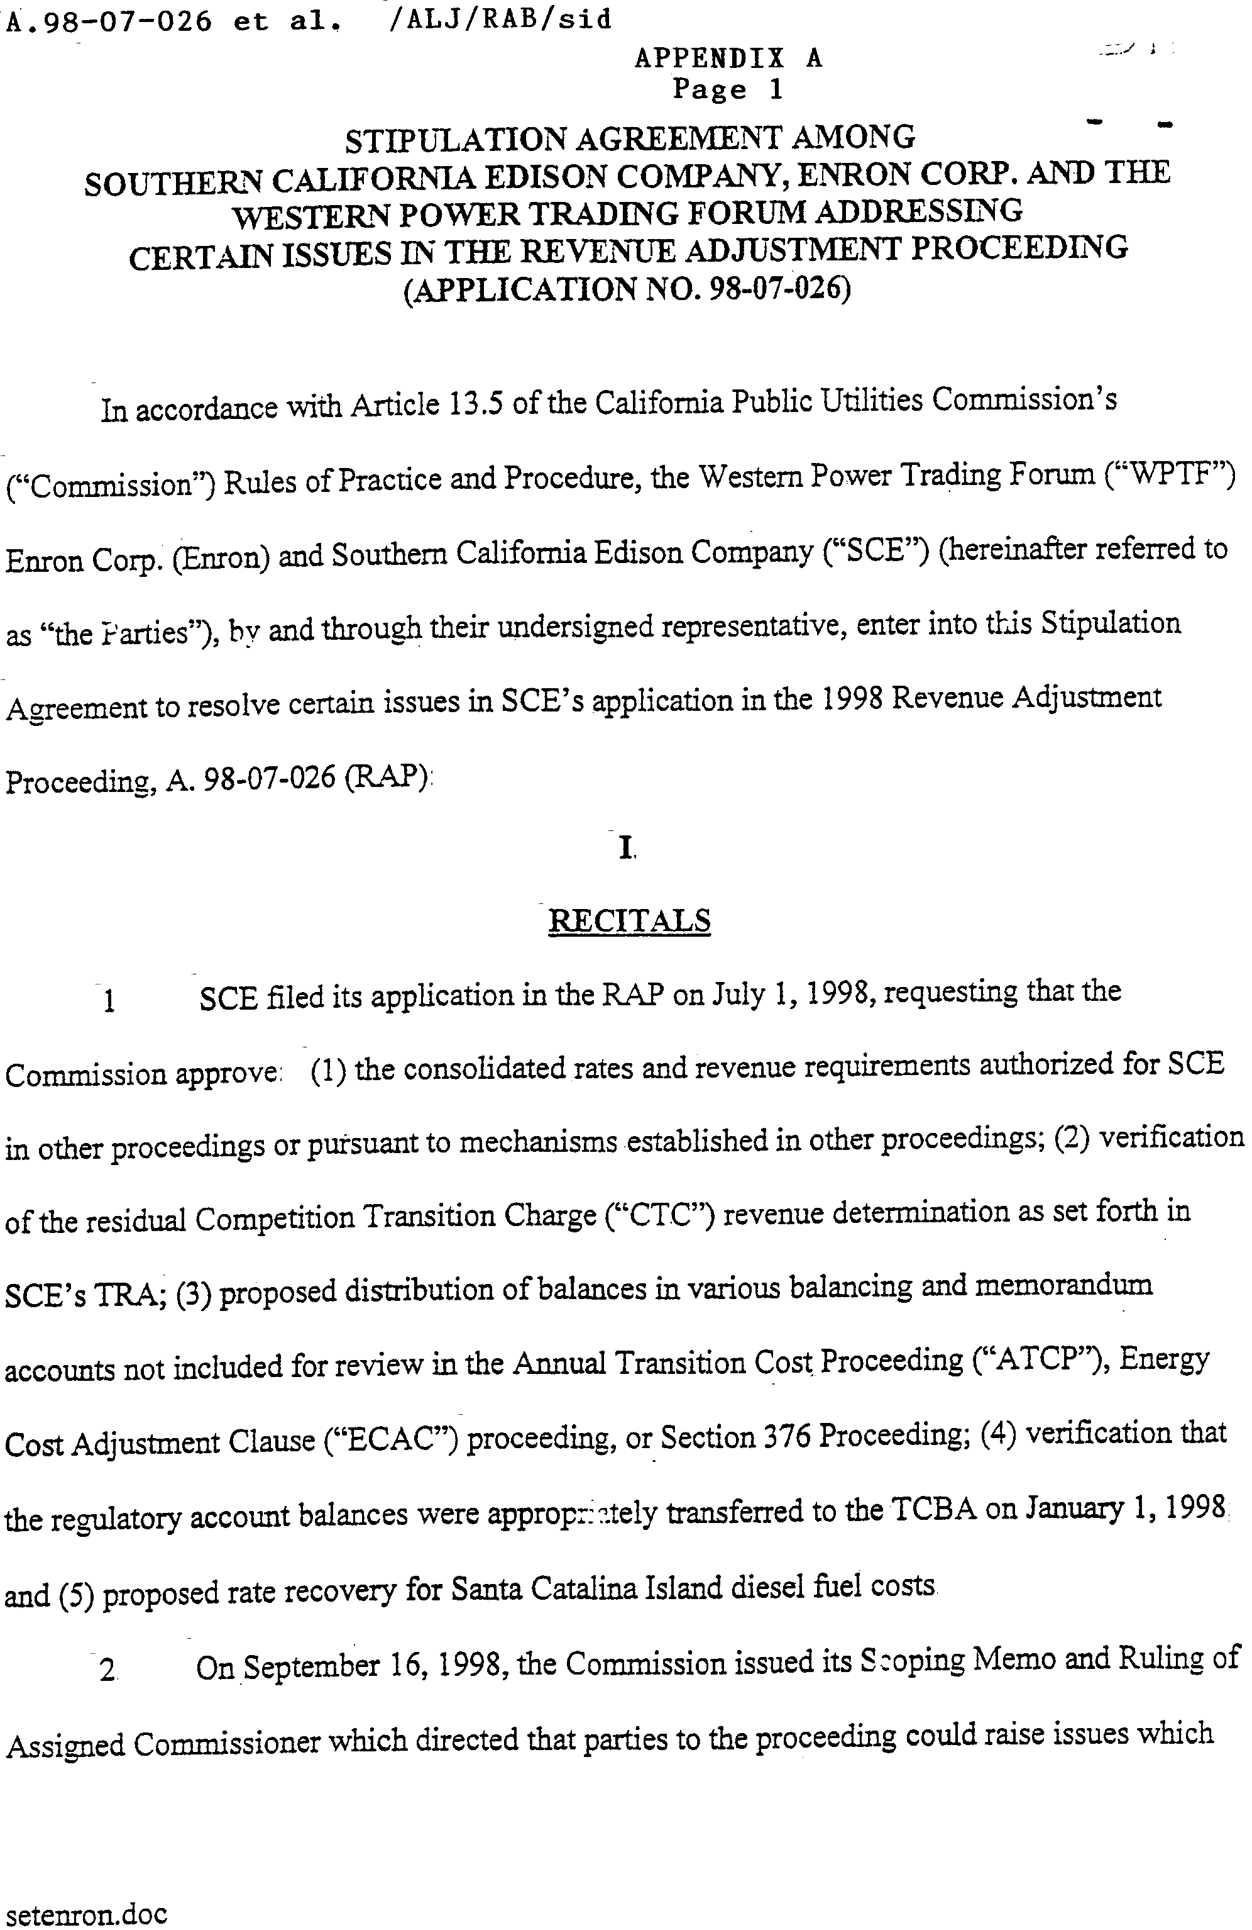
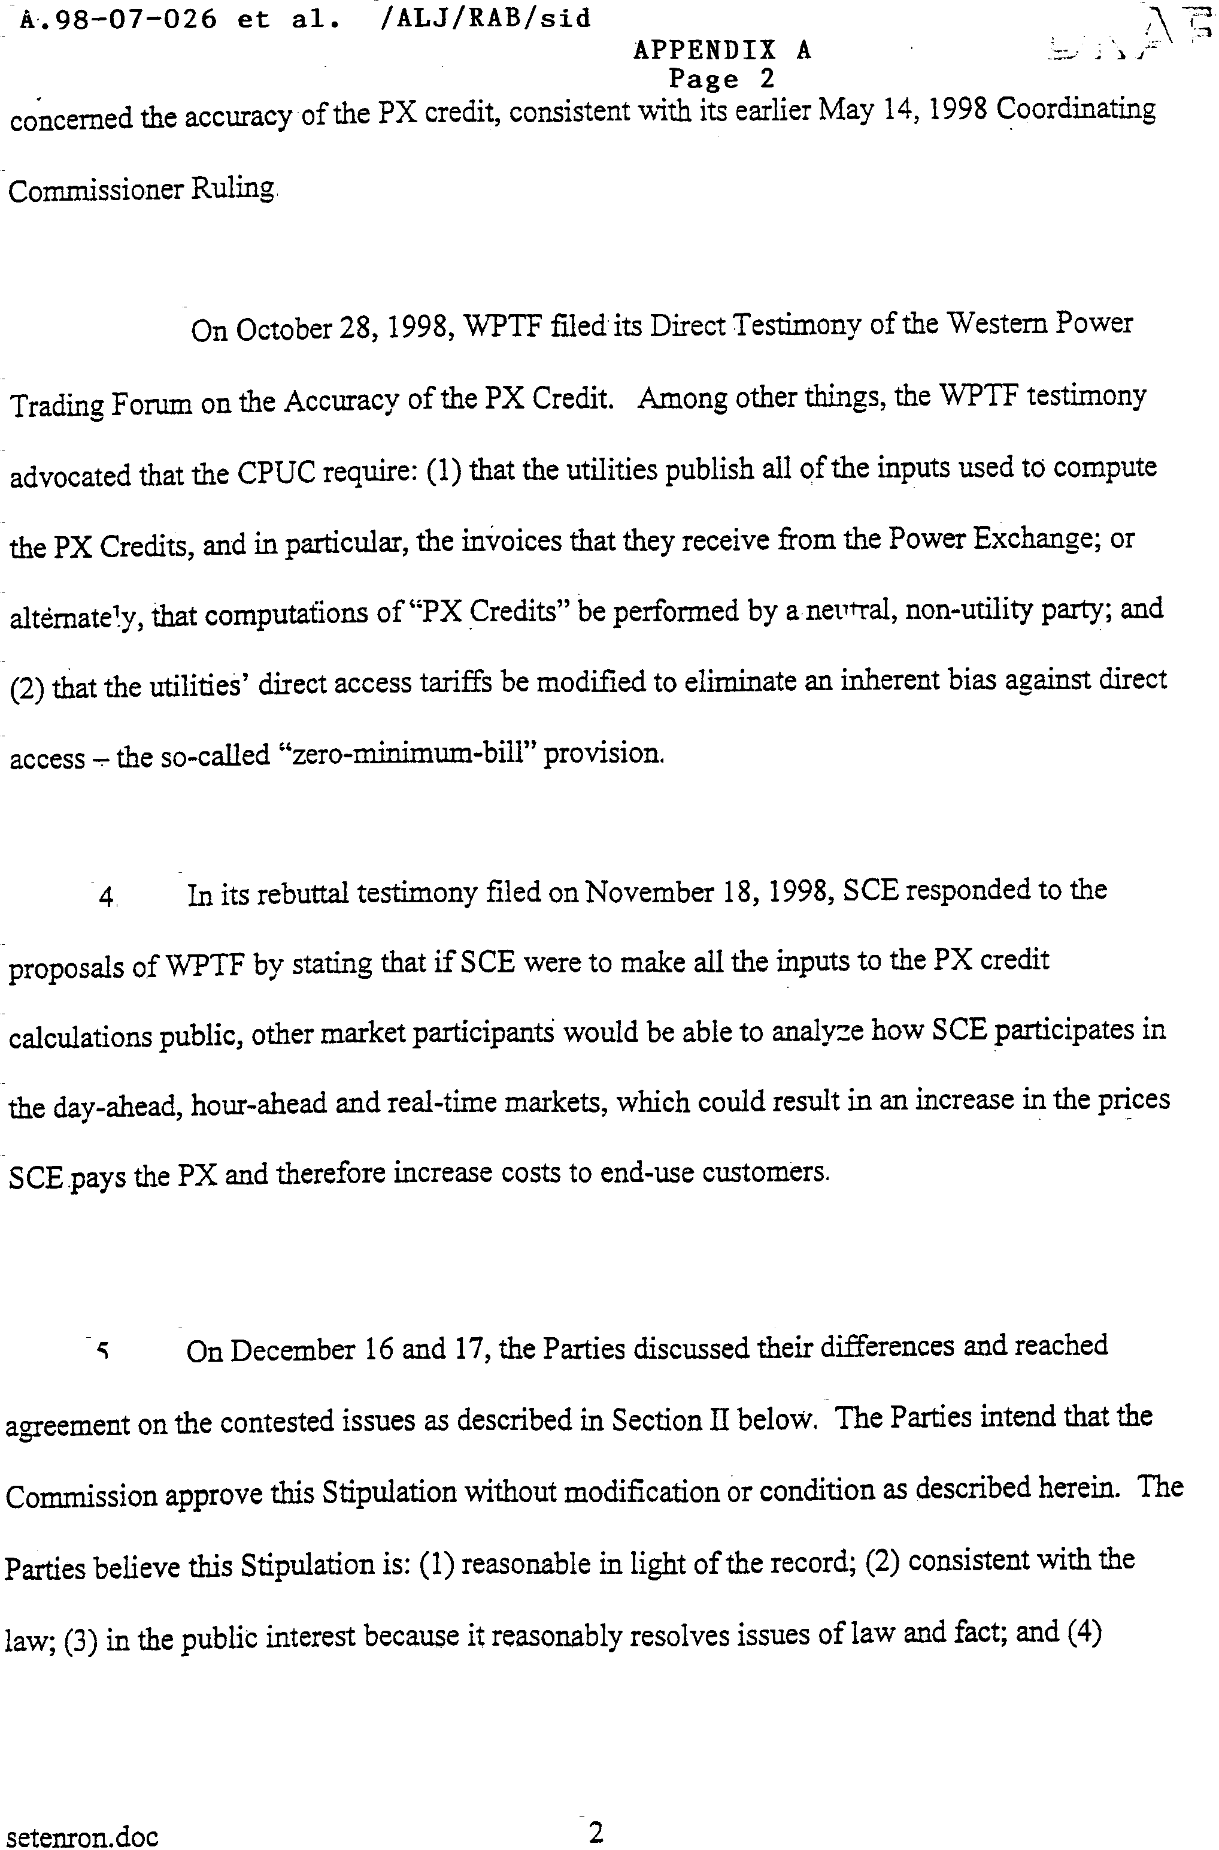
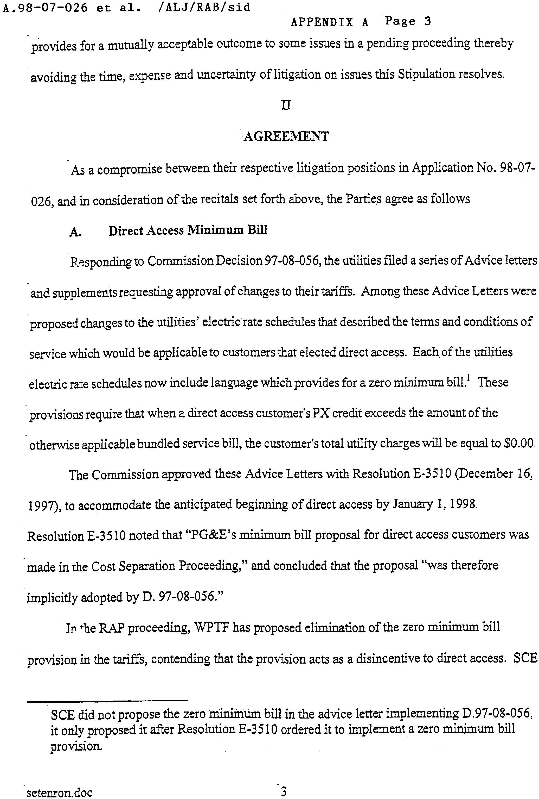
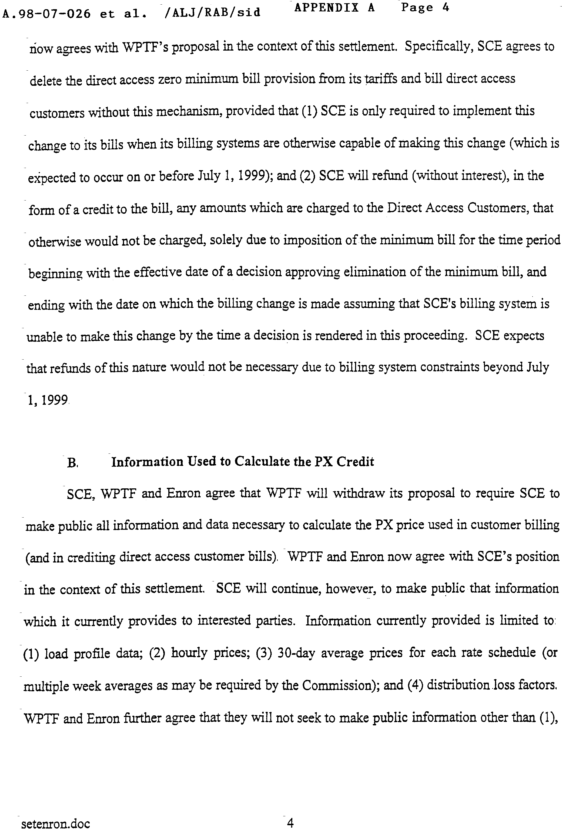
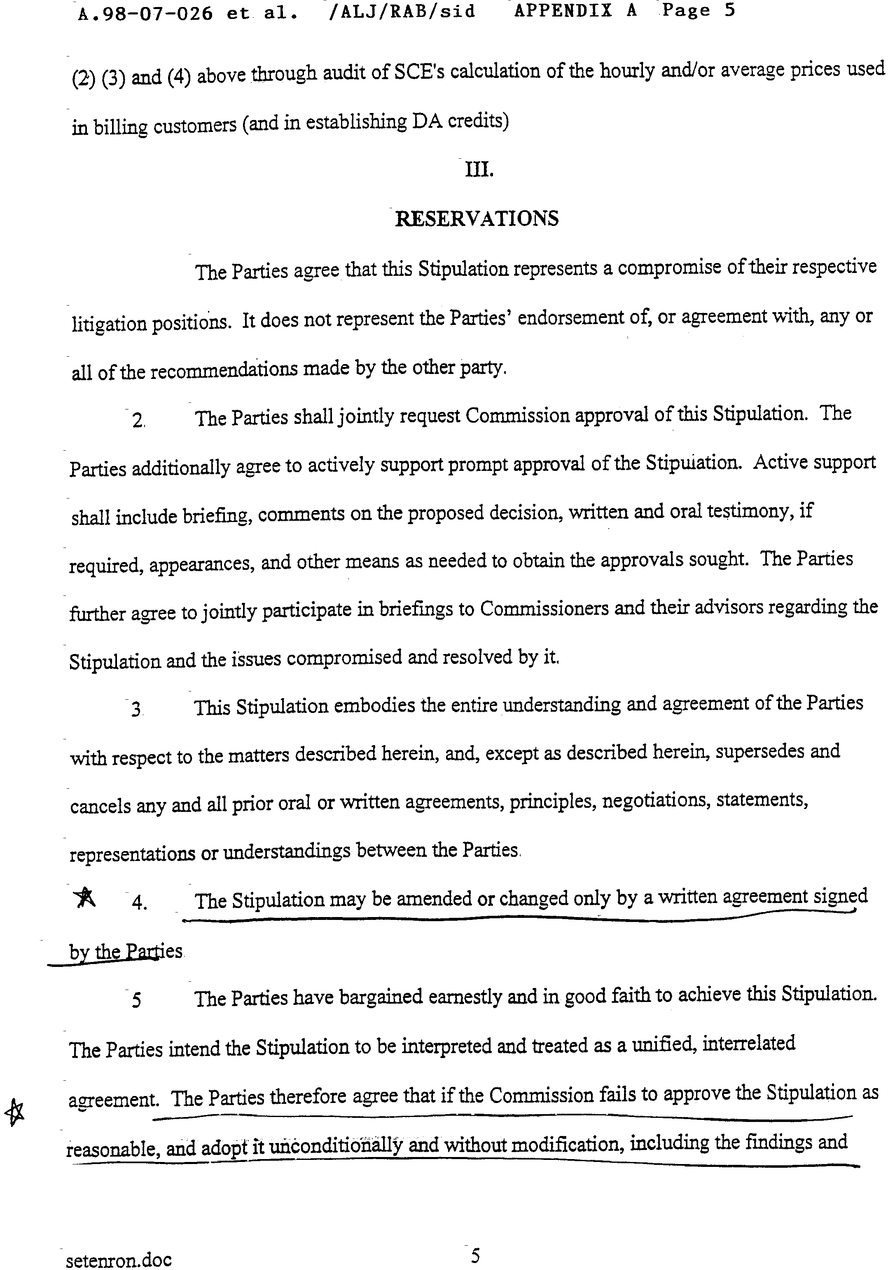
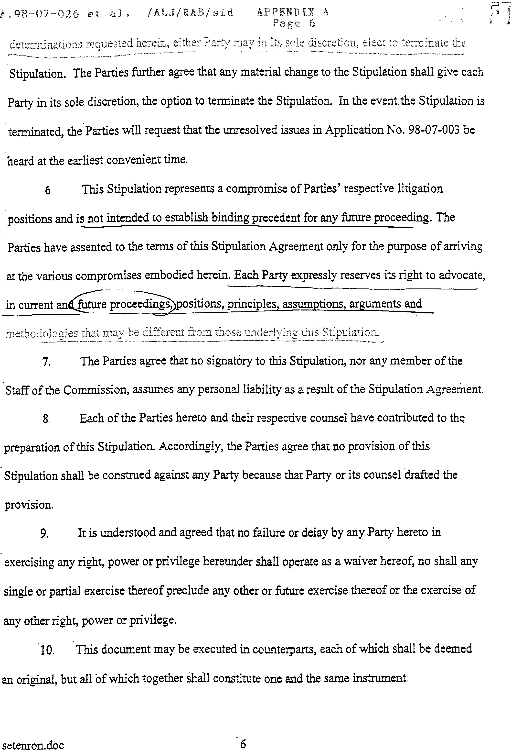
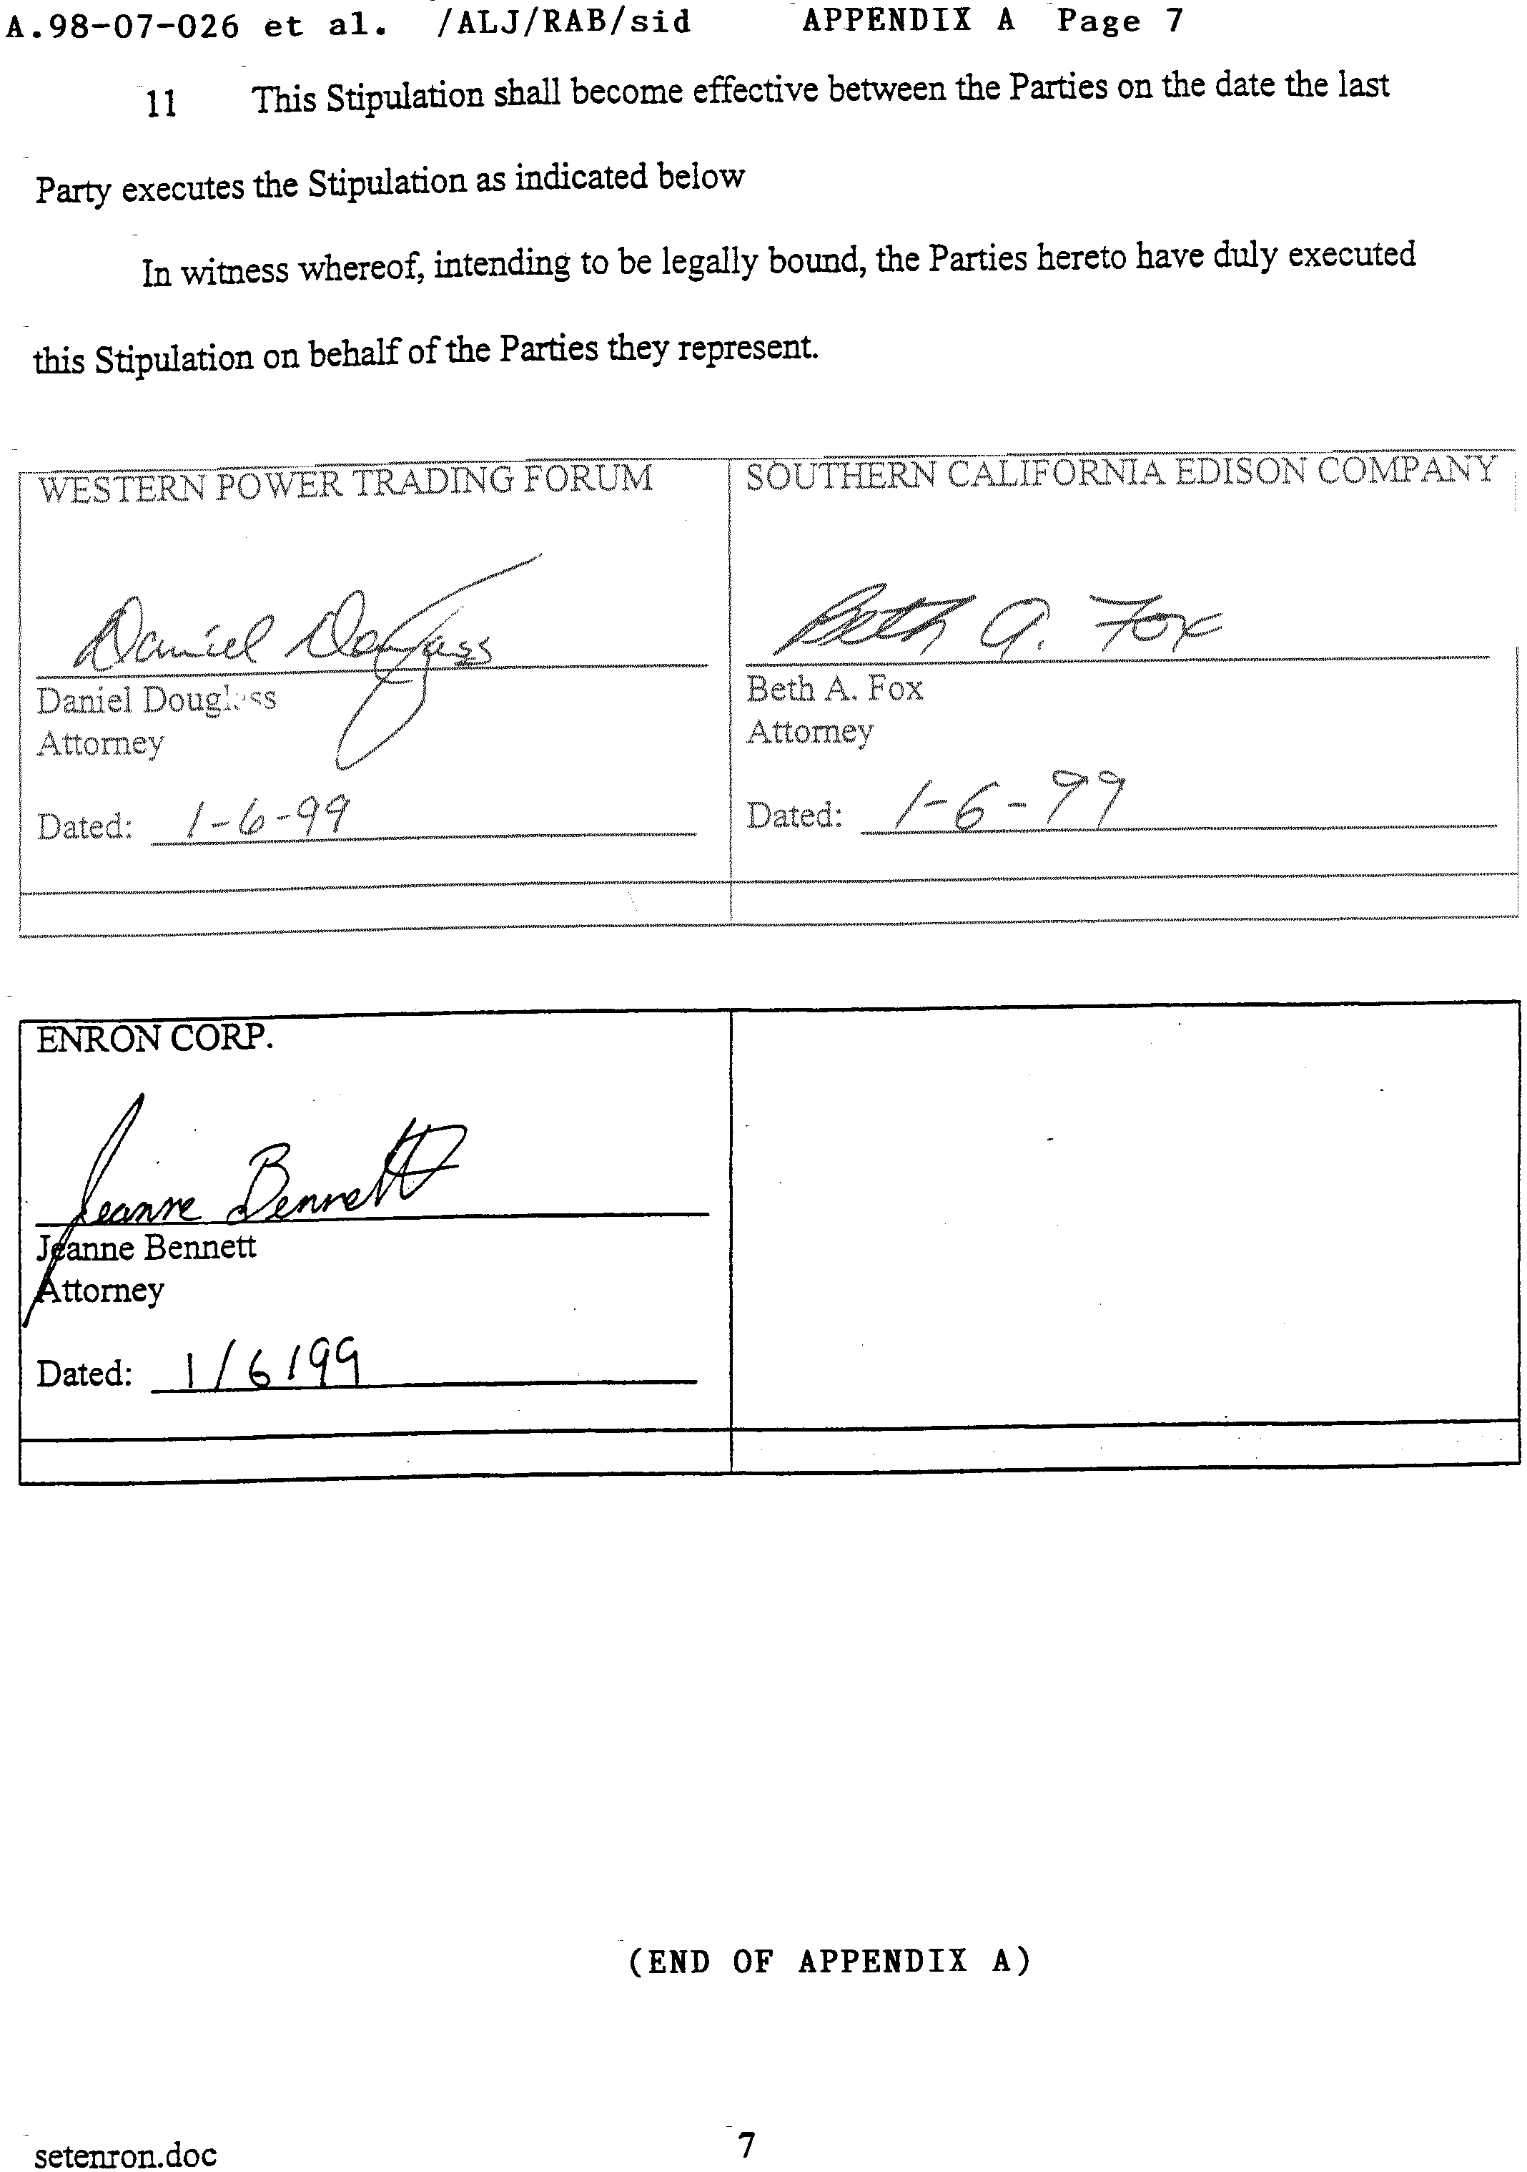
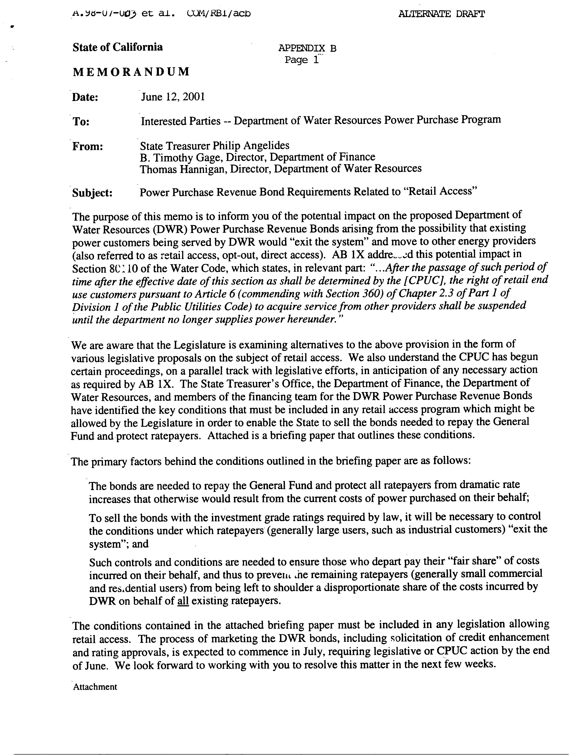
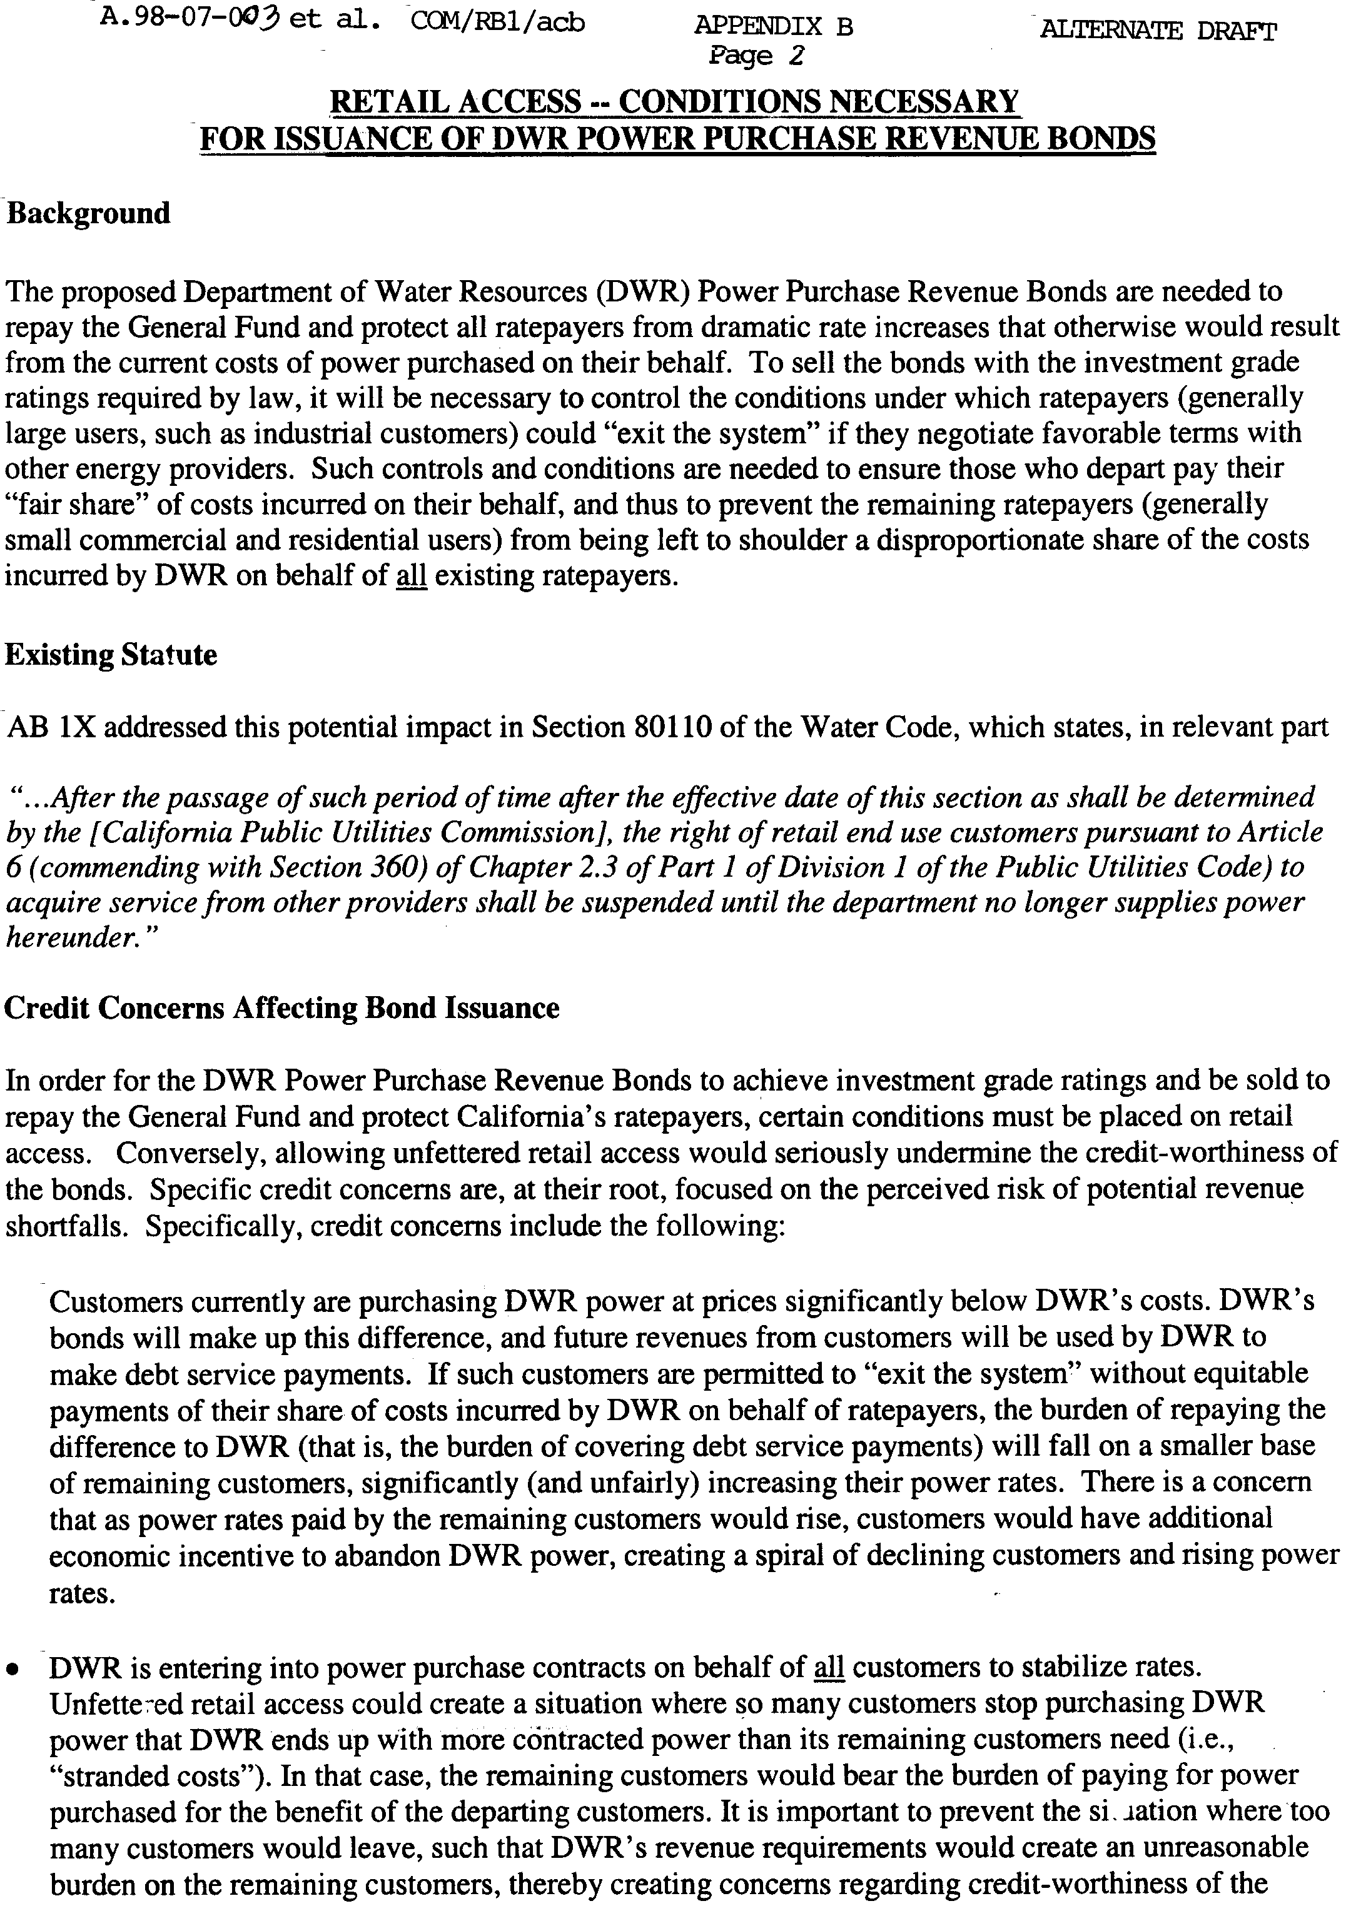
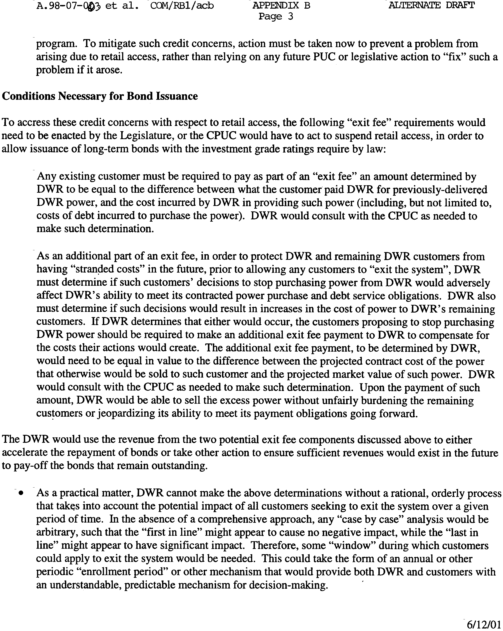

(End of Appendix B)

PG&E and SDG&E entered into similar stipulations with WPTF and Enron.
Exit fees may have the perverse incentive of encouraging high DWR costs because high exit fees will deter movement to direct access.
These interested persons should consult our ex parte rules regarding required filings, especially Rule 5 (h).
Even TURN acknowledges that less draconian approaches to those set forth in Appendix B may exist, but opines that the Legislature, not the Commission, should resolve these issues.

