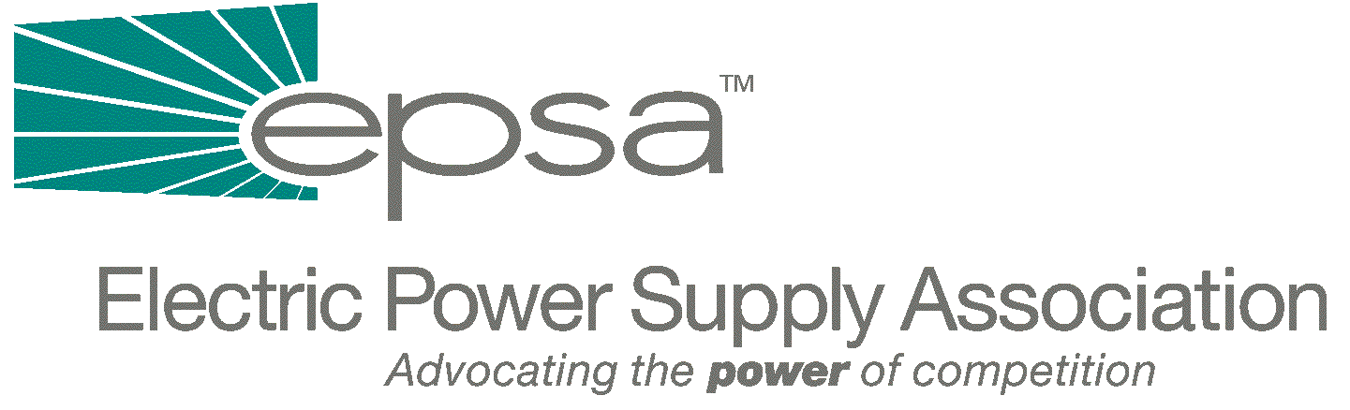
1401 New York Avenue
11th Floor
Washington, DC 20005
202/628-8200
202/628-8260 fax

September 7, 2001

The Honorable Joe Barton
Chairman
House Subcommittee on Energy and Air Quality
2125 Rayburn House Office building
Washington, DC 20515

Dear Chairman Barton:

The Electric Power Supply Association (EPSA) writes to express its views on H.R. 2814, The Interstate Transmission Act, which was recently introduced in the House of Representatives by your colleagues, Congressmen Tom Sawyer and Richard Burr. We ask you to consider several issues raised in this bill as you work on crafting comprehensive electricitly legislation this fall.

EPSA is the national trade association representing competitive power suppliers, including independent power producers, merchant generators and power marketers. EPSA members provide reliable, competitively priced electricity from environmentally responsible facilities in U.S. and global power markets. EPSA seeks to bring the benefits of competition to all power customers.

EPSA welcomes H.R. 2814’s focus on the importance of improving the transmission system. We believe that investment in the transmission system is crucial to a reliable, functioning wholesale market. Upgrades and additions to our transmission system are desperately needed. The Bush Administration’s National Energy Policy states that the demand for electric power is expected to increase by about 25 percent over the next ten years, while – under current plans – electric transmission capacity will increase by only four percent. Transmission constraints hurt consumers – the ISO-New England, for instance, recently estimated that transmission constraints are costing New England customers $200 million to $600 million annually by preventing low cost power from reaching consumers.

We share the point of view embodied in Section 7 of H.R. 2814, that RTOs play a critical role in electricity transmission, and could help with such issues as siting of key transmission lines. However, we oppose language in the bill which would tie FERC's hands on RTOs in the name of improving the system. Section 3 should be amended to remove the language that emphasizes that RTOs are only voluntary, as well as the reference to a transition period and basing transmission rates on a single utility’s costs. Section 6 takes the wrong road by requiring participation in RTOs to be voluntary and says that the form, structure and operating entity of the RTO must be approved by the participating utilities. This would give transmitting utilites a veto over the other market participants, and may shut non-utilities out of crucial RTO governance decisions. Futhermore, this section prohibits FERC from conditioning any order under the Federal Power Act on a utility transferring operational control of facilities to an ISO or RTO, which could hamper FERC’s ability to foster workably competitive markets.
Reducing FERC's authority will make it harder, not easier, to improve the transmission system. Congress can and should address transmission issues without including language making RTOs voluntary. FERC needs the ability to ensure that RTOs are of a size and configuration that parallels natural trading markets and power flows. Power markets and flows currently operate on a regional basis, and can only be effectively overseen on a regional level.

We also have serious concerns about the reliability language included in the bill. EPSA strongly supports mandatory reliability standards; however, we do not believe that the reliability provisions contained in H.R. 2814 will lead to a more effective and reliable electric system. This proposal puts reliability in the hands of an overly complex, prescriptive organization with uncertain delegations of enforcement authority, and it does not reflect recent market developments or the importance of RTOs.

We are encouraged by your commitment to enacting comprehensive electricity legislation, and we look forward to working with you to formulate a bill which expands and improves our nation’s transmission capacity without undermining FERC’s bipartisan initiatives on RTOs.

Thank you again for your work on these important issues. Please don’t hesitate to contact us with further questions or for additional information.

Sincerely yours,
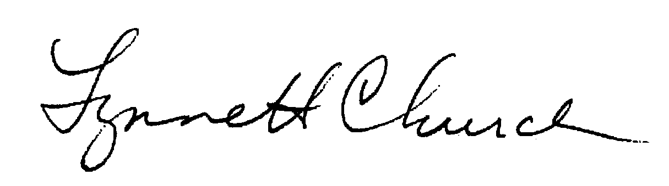
Lynne H. Church
President

