Kudlow's Guest Commentary

Can Monetary Policy Make the Difference?

By Thomas E. Nugent*

October 25, 2001 Kudlow & Co., LLC (212) 644-8610

Background
Here we are, nine months into a dramatic Fed easing and still the economy is sinking rapidly. To be sure, the events of September 11th aggravated economic weakness, but we were heading into a recession even before the terrorist attack. Unfortunately, from an economic perspective, we won’t be able to dissect economic statistics to distinguish between a normal business cycle event and the terrorist induced response. From a financial market perspective, the biggest distortion of all was the emergency role that the Fed had to play immediately after the attack. The Fed had to assume the role of “lender of last resort” and provide enormous liquidity to the financial system to avoid a financial panic. Once the crisis appeared to be manageable, the demand for credit eased and the Fed accommodated the system by withdrawing liquidity. One measure of this temporary change in roles was the growth in the monetary base during this period. The monetary base is that measure of the money supply that the Federal Reserve directly controls. Exhibit #1 tracks changes in the monetary base. Well before the terrorist attack, the Fed was providing increased liquidity to cushion a weakening economy. After the attack, the spurt in the base attests to the fact that the Fed helped avoid a financial panic.

Exhibit #1
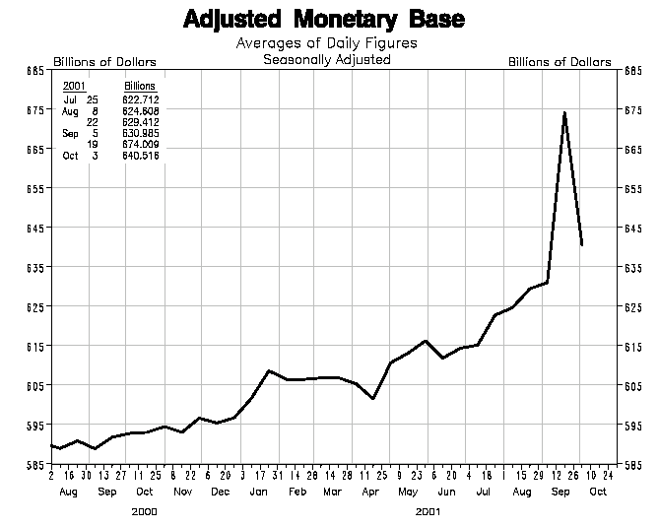
*Thomas E. Nugent is Chief Investment Officer for PlanMember Financial Corporation in California.

How Does the Fed Affect the Economy?

If we rule out the periodic “lender of last resort” role that the Fed plays during times of crisis, the Fed’s normal role is to maintain the value of the currency. This role is critical because the Fed is responsible for keeping inflation at or near zero, thereby encouraging the use of money as a medium of exchange and a store of value. The way in which the Fed accomplishes this goal is to conduct monetary policy based on a price rule. By conducting monetary policy through the analysis of price changes, the Fed can actually maintain the purchasing power of the currency, essentially keeping inflation at zero.

As we pointed out in our previous analysis of monetary policy in a paper entitled: “Is the Fed Still Too Tight?” we made the case that the Fed doesn’t always follow the price rule. Sometimes the Fed likes to tinker with the economy by changing monetary policy to either encourage or discourage economic activity. Often times this switch in policy can be detrimental to the Fed’s most important responsibility -- controlling inflation by maintaining the value of the currency.

Implementing a price rule can be difficult because there are many different measures of prices in the economy. For the Fed as well as for prudent investors, diversification is the key. Historically, economists seeking price stability have anointed gold as the one element that could serve as the basis for a price rule. Unfortunately there can be broad swings in the price of gold due to changing commercial supply and demand relationships not to mention the flight to gold that has historically occurred during times of panic. Therefore the Fed has adopted a few different baskets of what we would call price measures to help guide the conduct of monetary policy. One specific commodity basket that we have used for many years to assess the Fed’s commitment to the price rule is the Dow Jones Spot Commodity Index. By comparing movements in this index to changes in the Fed funds rate, it may be possible to gain confidence in the Fed’s commitment to price stability.

Tracking the Price Rule

In July of 2001, we concluded that the Fed had deviated from the price rule in 1999 and 2000. The reason for our conclusion was an analysis of the relationship between the Dow Jones Spot Index and the Fed funds rate (Exhibit #2). In this exhibit, there is a band defined as the space between 119 and 128 on the commodity index. Our interpretation is that, when the spot commodity index is within this range, the Fed maintains the Fed funds rate. However once the spot commodity index goes above the band, a signal that inflation is returning and a tighter monetary policy, i.e., a higher Fed funds rate is called for. Similarly when the spot commodity index falls below the lower band, an easier policy is appropriate.

Exhibit #2

The Dow Jones Spot Commodity Index vs. the Fed Funds Rate

When commodity prices rose in the mid-90s, the Fed reacted accordingly and increased the Fed funds rate. They didn’t begin to lower rates until late 1998, probably responding to the Asian contagion and the LTCM crisis. Subsequently the Fed decided to abandon the price rule and raise interest rates in 1999 and 2000 even though the spot commodity index remained well under control if not in a price range where an easier, not tighter policy was called for.

Current Interpretation: More Fed Ease

The dramatic easing in Fed policy in 2001 has not stopped the fall in commodity prices. The Dow Jones Spot Index continues to fall, reaching a low point of 95.7 on October 17th. The Fed has taken the Fed funds rate to 2½%, and yet still no response in the marketplace. Ex-secretary of the Treasury, Robert Rubin has recently commented that the Fed can’t do more -- they can’t lower the Fed funds rate below the 2½% level. Milton Friedman, in a recent letter to the editor of the Wall Street Journal has also suggested that the reliquification of the economy through monetary policy is sufficient to facilitate a turnaround.

No matter what the naysayers may think, the Fed must continue to ease policy -- even if it has to take the Fed funds rate below 2%. They must see viable signs that the economy is recovering -- in this case through a rebound in the Dow Jones Spot Commodity index. To the extent that a perception exists that the Fed is providing too much liquidity, just look around -- prices are collapsing everywhere. If the economy turns, the Fed has the power to reverse course.

Recalling how we battled inflation in the Seventies and Eighties, a battle we won through a combination of tight money to control the fall in the value of the currency and tax rate reductions to promote growth, we are now confronted with a different problem: deflation. Monetary policy alone cannot make the difference, although the Fed has done an admirable job of trying, and still has more work to do. As Ronald Reagan so adeptly used a mix of tight money and lower tax-rates to trigger the bull market of the Eighties, President Bush and the Congress must enact similar tax rate cuts along with further reductions in the Fed funds rate. The shape and magnitude of the pending fiscal package will be the most important economic decision of the Bush presidency.

Kudlow & Co. LLC | Lawrence Kudlow, CEO
One Dag Hammarskjold Plaza | Susan Varga, COO
885 Second Avenue, 26th Floor | John Park, Economic Associate
New York, New York 10017 | John Sullivan, VP Sales/Business Development
212-644-8610 (p)
212-588-1636 (f) | www.kudlow.com

