The Third Annual

PoweRisk 2000
Europe’s First and Premier
Energy Risk Management & Trading Conference
October 4th & 5th 2000
Paris

To: Vince Kaminski – Enron
Tel: +713 853 3848
Fax: +713 646 2503
Email: shirley.crenshaw@enron.com

From: Rosemary Fitzgerald - ICBI
Tel: +44 20 7915 5194
Fax: +44 20 7915 5101
Email: rosef@icbi.co.uk

Date: May 17th 2000
Pages:11

Dear Mr. Kaminski

Further to my call this afternoon with your assistant Shirley Crinshaw and my faxes and emails of February 23 and April 18th, I am writing again to introduce myself as the director of ICBI’s PoweRisk conference. Given the exceptional feedback we received from the workshop you co-led with Prof. Helyette Geman and Alexander Eydeland at last year’s conference in Frankfurt, I would very much like to invite you to take part in this year’s PoweRisk 2000 Global Energy Trading Forum, in association with EETAN.

The topic I would like you to speak on is: State-of-the-Art Volatility And Correlation Estimation Techniques for Multiple Energy Portfolios
However, I have attached the complete draft programme for you to read, together with outlines for our proposed Executive Summit Day and Intensive Workshop programmes for this year. If you would be more interested in speaking on one of the other topic areas within the programme, or indeed if you would like to suggest another topic area that I have not covered, I would be more than happy to discuss this with you.

I know that you are taking part in our Energy in Europe conference next month in Berlin for my colleague Alexandra Howells, and that you are co-leading a workshop with Prof Geman at that conference. I would be delighted if you are able to take part in the same workshop with Prof Geman at this year’s PoweRisk conference also.

Other invited speakers for PoweRisk 2000 include: Mark Frevert – Enron * Randall Balhorn – EdF Trading * Paul van Son – ENTRADE * Stefan Judisch – RWE Energy Trading * Ito van Lanschot – Reliant Energy * Mark Williams – Citizens Power * Alexander Eydeland – Southern Energy Prof. Helyette Geman – University of Paris, Dauphine * Prof. Mark Garman – University of California, Berkeley Jose Bogas – Endesa * Christian Geyer – EEX * Dr. Carlhans Uhle – LPX * Jeffrey Sprecher – InterContinentalExchange * Bert den Ouden – APX * Christian Geyer – EEX * Per Hjorth – APX * Dr. Carlhans Uhle – LPX * Trevor Christmas – IPE * Dr. Freidrich Curtis – Bayernwerk * Markus Suessmann – EnBW * Joel Staib – Dynergy * Richard Sandor – Environmental Financial Products * Tom Ulry – Energy.com *James Daly – Enermetrix * Tom James – SwapNet * Pat Patterson – TradeWeather * Jack Cogen – Natsource Tullett – Edward Cazalet – APX * Mark Crosno – Altra * Frank Getman – HoustonStreet Exchange * Vincent di Cosmo – RedMeteor * Barney Rush – Southern Energy * Martin Stanley – TXU Europe Energy Trading * Sven Otten – PreussenElektra * Paul van Son – ENTRADE * Mark Williams – Citizens Power * David Bonnett – Ameren Energy * Hank Jones – AEP * Steve Kromer – Koch Industries * Peter Gakos – Swiss RE * David Pearse – Cargill Investor Services * Stefan Judisch – RWE * Markus Suessman – EnBW * Gevin Ball – BP Power Generators * Dr. Freidrich Curtis – Bayernwerk * Tim Arcedeckne-Butler – Morgan Stanley Dean Witter * Ralph Bauman – VDEW * Aram Sogomonian – Pacificorp * Spyros Maragos – Dynergy *

PoweRisk continues to enjoy the reputation as the first really programme-driven event in this market in Europe, providing an ideal platform from which to advance business development and strategic positioning goals. We are continually striving to surpass this reputation for market-driven, cutting-edge content, unrivalled seniority in our speaker faculty and quality networking opportunities.

I will call your office tomorrow and I would appreciate if you could spare me some time then to discuss this fax, and very much hope that you will be able to join us in Paris in October.

Yours sincerely

Rosemary Fitzgerald
Director, PoweRisk 2000

Tel: +44 207 915 5194

Fax: +44 207 915 5101

Email: rosef@icbi.co.uk

An Introduction To PoweRisk 2000

- PoweRisk was the FIRST major pan European energy risk management & trading conference

- PoweRisk attracts the most SENIOR speakers of any European event

- Over 250 delegates in 1999, having grown from 180 in 1998

- Renowned as the most intellectual and technical event to be held in Europe

- 2000 sees the launch of the annual PoweRisk “state of the industry” survey in conjunction with The European Energy Trading Advisory Network

- All sections of the Energy Value Chain represented, Upstream, Generation, Distribution, Supply, Marketing, Broking, Trading

- Fantastic Trading Technology Showcase – review all the latest e-commerce and trading technical developments for October 2000

- Visit www.icbi-uk.com/powerisk to see the quality of 1999’s programme and see the latest developments

PoweRisk Academy of Speakers:  Just some of our recent speakers have included:  - Jeffrey Skilling, President, Enron Corp  - Heinz Dieter Waffel, Board Member, Preussen  - Barney Rush, President, Southern Energy  - Bruce Williamson, President, Duke Energy  - John Sherriff, Managing Director, Enron Europe  - Richard Ward, CEO, IPE  - Helyette Geman, Professor of Finance, University Paris Dauphine & ESSEC Graduate Business School  - Per Hjorth, Nordpool  - Christian Geyer, EEX  - Bert den Ouden, Managing Director, Amsterdam Power Exchange  - Joseph Gold, Enron Europe  - Grant Thain, Citizens Power  - Louise Burke, NYMEX | 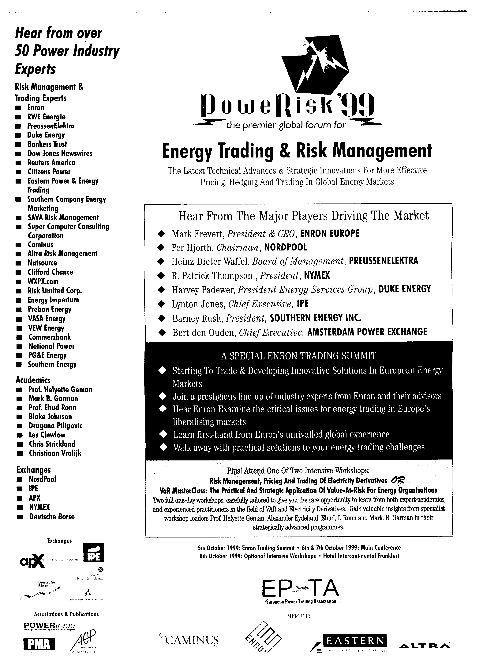

PoweRisk 2000 Delegate Profile

The following profile has been developed from an analysis of the delegate audience attending PoweRisk 98 and PoweRisk 99
Aare Tessin Ltd for Electricity
ABB Power Generation
ABB Treasure Center
AEP Energy Services Inc
Akzo Nobel Chemicals
API Anonima Petroli Italiana Spa
APX
Aquila Energy Corporation
Aquila Energy Limited
Avista Energy
Azienda Elettrica Ticinese
Bayernwerk
BNFL Magnox Generation
British Energy Plc
Caminus Energy
Capcol
Central Dispatch Centre, Czech Republic
Cinergy Corp
Citizens Power
Compagnie Generale de Chauffe
Czechpol Energy
Delta Nutsbedrijven
Deutsche Borse AG
Dexia
Dexia Project & Public Finance Int'l Bank
DGXVII European Commission
Duke Energy International
Dynegy Europe Limited
Dynergy Europe Limited
Eastern Power & Energy Trading Ltd
EdF GdF Services
EFET
Electrabel
Electricite de Strasbourg
Electrogospodarstvo Slovenije
Elektrizitatswerk der Stadt Zurich
Elkraft Power Co.Ltd
EnBW Gesellschaft Fur Stromhandel
Endesa Group
Enel Spa
Energie Noord West NV
Energy Imperium
Enron
Enron Energie
Enron Europe
Enron Europe Limited
Enron Europe Ltd
Enron Trade & Capital Resources
Entergy Trading & Marketing
EPON
ESB
Esis Ltd

Eskom  Europe Power & Energy Trading  EZH  Fortum Corporation  Fortum Power & Heat 04  Gaz De France  Graninge Kraft  Gullspsngs Kraft  Heat and Power Plant Krakow""  HEW  Imatran Voima Oy  INA-Industrija Nafte d.d Zagreb  International Petroleum Exchange | IVO Energy  IVO Group  Japan Electric Power Info Centre  KonkurrenceStyrelsen  Louis Dreyfus  Meridian Energy Ltd  MVV Energie AG  National Electric Regulatory Commission  National Power PLC  New York Mercantile Exchange  NGC Corp  NOK | Nord Pool  Norweb  NOS Kraft AS  NRG Energy  NUON Industry  NV ENECO EHB  Oslo Energi Produksjon  Pacificorp  ParisBourse GmbH  PetroFina  Petrol d.d.  PG& E Energy  PG&E Energy Trading

POWERISK 2000 DRAFT PROGRAMME

Executive Summit Day –3rd October 2000

E-Commerce & The Power Industry
The Future of Electronic Energy Trading

- Executive Panel Discussion: Energy Trading Beyond 2000: What Will The Future Global Energy Trading Markets Look Like?

- Analysing How The Internet And E-Commerce Is Supporting A New Power Marketplace: Improving Trading Conditions And Enhancing Trade Execution

- Developing An E-Commerce Strategy To Maximise The Full Potential Of Internet-Based Trading: From Wholesale Power Trading To An Internet-Based Business-To-Business Model

- Panel Discussion: Addressing The Reluctance of Traders to Trade Electronically: Security and International Legal Issues

- Evaluating The New On-Line Advisory Services To The Energy Industry: What Advantages Are Internet Technologies Offering In Data, Analytics and Financial Information for the Energy Sector?

- Analysing The Effects On Your Power Trading Team: Understanding The Benefits Of Electronic Trading and Its Effects On The Entire Trading Process

- Special Focus on Weather Derivatives and Emission Allowance Trading: How Current Internet Trading Systems Have Facilitate New Market Entrants And Enhanced Market Value

- On-Line Credit Trading: The Development Of An On-Line Platform For Credit Swaps And The Implications For The Industry

- Integrating Your Electronic Energy Trading Platform With Middle And Back Office Trading Management Systems For Real-Time Trading: Ensuring a Robust Price Risk And Transaction Management System

- Assessing The Impact Of Electronic Trading On Exchange Traded Electricity Contracts And Broker Assisted Networks

- The Development of Electronic Exchanges: The Next Step In The Transformation Of The Energy Industry Towards An E-Commerce Base

POWERISK 2000

TWO DAY CONFERENCE PROGRAMME
4th – 5th October 2000

PLENARY SESSIONS

- PowerRisk 2000 Industry Focus Panel: Power Trading In The New Millennium: Key Drivers, Key Players and Key Strategies For Success In Tomorrow’s Energy Market

- Assessing The Future Directions For The Continental European Energy Market And Developing Successful Strategies To Respond To The New Challenges

- NETA & NGTA: Examining The Extent To Which Reforms Of UK Electricity & Gas Trading Will Result In Increased Price Transparency and Liquidity in the UK and Continental Europe

- Examining Progress Towards and Obstacles To The Creation Of A Truly Pan-European Energy Trading Platform: Overcoming the Physical Barriers to Profitable Trading

- The “One-Stop Energy Shop”: Exploiting Opportunities In The Newly Converged Gas & Electricity Markets And Successfully Redefining Structures, Strategies and the Value Chain for the Energy Company of Tomorrow

- Evaluating The Growth In Internet-Based Commodity Trading Systems: Lessons Learnt From The US Electronic OTC Market

STREAMED SESSIONS

Latest Cutting-Edge Risk Management Strategies

- Determining Strategies and Techniques For Spreading Risk Effectively Throughout Your Trading Portfolio

- Successfully Designing A Flexible Hedging Policy For Fast Response To Market Trends

- Measuring, Monitoring and Managing Your Risks: Planning and Implementing an Effective Risk Management Infrastructure In Order to Create An Effective and Dynamic Risk Function

- Analysing The Development Of Hybrid Hedging Tools: Identifying The Synergies Between The Energy Sector and Other Commodities

- Creating Efficient Arbitrage Opportunities Between the Gas and Electricity Markets: Analysing the Development of Comparable Pricing Policies To Increase the Liquidity and Transparency Of Both Spot and Futures Contracts

- Power Trading – Risk or Risk Management? Optimising Your Energy Price Risk Management By Hedging And Trading In Electricity Markets

New Techniques And Strategies For Pricing, Hedging

And Trading In Energy Markets

- Advanced Techniques For Hedging Physical Portfolios Using VaR and PaR: Accurately Measuring The Full Financial Risk Of Volatile Spot Markets

- Analysing New Approaches To Building The Electricity Forward Curve Incorporating Spot Price Behaviour

- State-Of-The-Art Volatility and Correlation Estimation Techniques For Multiple Energy Portfolios

- When Is A Swap / Option More Effective Than A Future?

- Assessing The Effectiveness Of Current Energy Pricing Approaches For Handling Multiple Energy Portfolios

Latest Cutting Edge Research in Electricity Derivatives

- Advanced Techniques For Pricing and Hedging Exotic Energy Options And Cross Commodity Portfolios

- Pricing Weather Derivatives: Analysing The Role of Mean Reversion in the Pricing of Degree Day Options

Exchange Trading

- Creating A Successful Energy Exchange in The UK – Determining The Optimal Structure To Drive Liquidity and Price Transparency

- Exploiting The UK Joint Gas & Electricity Futures Market: Practical Strategies For Leveraging The Advantages of Increased Competition and Comparable Pricing Policies

- Creating A Liquid Futures Power Exchange In Europe: Reconciling the Reality of Multiple Regional Traded Hubs with the Industry Demand For A Pan-European Trading Platform

TPA & Transmission Tariffs

- Trading In The New Power Market Place: Examining Industry Progress Towards Standardised Costs For Transmission Pricing

- Analysing The Key Developments In Negotiated and Regulated TPA in Europe and Forecasting Progress to 2002

- Latest Developments in the Standardisation of Physical and Financial Contracts for Trading European Power

Credit Risk

- Examining Cutting-Edge Credit Exposure Mitigation Techniques: Calculating Settlement And Performance Risk To Determine Total Risk Exposure

- State-Of-The-Art Techniques To Measure and Manage Credit Risk In European Power Markets: Understanding The Application of C-Var For A More Accurate Calculation Of Your Credit Risk Exposure

Weather Derivatives and Emissions Trading

- Assessing The Implementation Of A Trading Based Approach To Emissions Control And The Implications For the Future of The Emissions Credit Market

- Advanced Stochastic Modelling Of Weather Derivatives To Achieve Increased Transparency in Pricing and Reducing The Bid Offer Spread

- Using Weather Derivatives To Manage Commodity Exposure In The Absence Of Liquidity

- Analysing The Development of The European Weather Derivatives Market – How Fast Will It Grow And How Important Will Non-Energy Companies Be In Creating And Maintaining Liquidity?

- Practical Strategies For Calculating Price Movements In The Absence Of Comprehensive and Accurate Weather Data

- Hedging Volumetric Risk: Examining The Growing Demand For US OTC Weather Derivatives - The Quest For The “Perfect Hedge”

- The Last of the Energy Commodities: Effective Pricing Of Shorter Term Coal Contracts

Regional Roundtable Discussion Groups:

Exploring The Latest Developments In The Various Demographic Areas In Europe: Market Conditions; Current State of Liberalisation and Competition; Cross Border Transmission Constraints; Regional Exchange Platforms; Transition From Physical To Financial Markets;

* Germany, Austria, Switzerland * Benelux & France
* Iberia * UK
* Scandinavia * Eastern Europe

E-Commerce For Energy Companies

- Exploiting The Electronic Future – How Will Electronic Trading Transform Global Energy Markets?

- Comparing and Contrasting The Numerous OTC Electronic Electricity Platforms on the Market:

Trading Technology Showcase – Draft Agenda
“Request For Proposal”

Examining The Practical Applications And Integration Of Information Technology For Enhanced Energy Risk Management And Trading

This Unique Showcase Will Demonstrate The Very Latest
Advances In Information Technology For Energy Trading

New IT Strategies And Integrated Trading Solutions For A Liberalised Energy Market: Developing An Integrated Energy Data, Trading and Risk Management System For Your Company

Obtaining The Right System For An Energy Company’s Needs: Realising Innovative Trading Systems Solutions

- Creating a Successful Multi-Commodity Risk Management System: Integrating Electricity, Gas, Weather And Emissions

- Underpinning Your Energy Price Risk Management Programme With Effective Information Technology In A Rapidly Changing Marketplace

- Realising The Competitive Advantage Of Integrated Trading, Risk Management and Commodity Scheduling Systems Within The Energy Industry

- Integrated Energy Trading Solutions For Effective Support Of All Business Processes

- Reducing Your Operations Risks Through Effective Energy Data Management

- Evaluating The Integrated Straight-Through Processing Solutions Currently Available To Facilitate Risk Management To Physical Delivery In The Energy Market

- Online Commodities Trading: An Assessment Of The Future of Electricity Transactions Via Electronic Trading Platforms

- Internet Based Risk Management: Evaluating The Growth Of Specialist Advisory Services Via The Internet

- High Performance Historical Database And Analysis Software: Providing Timely And Accurate Knowledge Extraction For Real Competitive Advantage

Workshops – 6th October 2000

The Latest Techniques For Trading And Risk Managed Structured Energy Contracts and Pricing Physical Assets As Real Options

Focusing on the practical and strategic application of real options, together with the very latest techniques for measuring and managing risk, this intensive hands-on workshop will provide an essential understanding for anyone needing to sharpen their risk management skills to a more advanced level or for those how need to brush up on their knowledge
- Understanding the technicalities of exotic energy derivatives
- Learning how to balance risk management practices with trading activities
- Get to grips with the numerical principles critical to real options
- Sharpen your skills in efficiently pricing physical assets

Credit Risk Masterclass
State-of-the-Art Practical Techniques To Measure And Manage Credit Risk In European Power Markets

Assessing The Impact of Global Market Liberalisation On Credit Risk Management
- Understanding The New European Trading Arrangements And Their Implications For Credit Risk Management
- Lesson Drawing In Credit Risk Management: Learning From The Experience Of The Finance And U.S. Power Industries

The Latest Advances In The Development Of Online Credit Trading Platforms
- Pushing Back The Boundaries Of Credit Risk: Towards The Creation Of an Online Platform For Pricing Credit Swaps
- Identifying The Changing Role of the European Power Exchanges In Credit Risk Management

Cutting-Edge Strategies For Advanced Credit Risk Management
- Examining The Cutting Edge Tools And Practical Techniques For Effective Credit Risk Measurement And Management: RAROC Models; Risk Adjusted Returns
- Effectively Tracking And Reporting Credit Risk Exposure
- How To Effectively Hedge Credit Risk In The Physical And Financial Markets
- Advanced Credit Risk Portfolio Management: Exploiting Credit Enhancement Techniques To Optimise Credit Potential: Credit Derivatives; Stranded Costs; Securitisation

State-of-the-Art Credit Risk Measurement Techniques
- Valuing Credit Risk Using The Latest Monte Carlo Simulation Techniques
- Applying The Electricity Forward Curve To Estimate Credit Exposure
- Optimising The use of C-VAR To Make Credit Decisions
- Overcoming The Challenges To Effectively Integrating Credit Risk And Market Risk Within A Power Company

