Gas Trading Vision II
Inception – Phase II

Inception Document



On behalf of
Enron Net Works, LLC

Document Classification: | Released for Review
Version: | 1.1
Point of contact: | Zhiyong Wei
Date: | April 20, 2001

Sign off

The signatories agree with the definitions, processes and recommendations stated in this document and agree for the first
phase to begin based on this document.

Business Sponsors Name Louise Kitchen

_______________________ Date ______________

Name Geof Storey

_______________________ Date ______________

Name Jeff Gossett

_______________________ Date ______________

IT Sponsors Name Philippe Bibi

_______________________ Date ______________

Name Beth Perlman

_______________________ Date ______________

Name Steve Stock

_______________________ Date ______________

Name Zhiyong Wei

_______________________ Date ______________

Name Dave Nommensen

___________________ Date ___________

Name Jim Ogg

_______________________ Date _____________

Name Bob McAuliffe

___________________ Date ___________

Contents

1 Management summary 4
2 phase ii TASKS 5
3 DEPENDENCIES AND RISK FACTORS……………………………………………………………….10
3.1 dependencies 10
3.2 risk factors 10
4 Project timeline 11
4.1 Estimated Schedule for Phase II 11

Management summary
The purpose of this document is to present a revised set of requirements and timelines for the Phase II of the Gas Trading Vision-II project. The purpose of the Gas Trading Vision-II project is to develop additional systems functionality and to modify the existing business processes to provide the natural gas businesses of Enron North America (US & Canada) with a consolidated position screen/report and enhanced position reporting tools for each of the various gas business units.

Phase I of the Gas Trading Vision-II project was commenced on March 21, 2001, with an estimated go-live date for June 4, 2001.

The requirements and tasks for Phase II are being addressed in this document, along with the proposed IT development timeline.

Phase II Tasks

Task 1: Capability for desk roll-ups on an ad-hoc basis:

The roll-up capability with predefined desks has been available in the production environment of TDS. In this phase, traders need to have the ability of defining roll-up desks on an ad-hoc basis. Also, the various portfolios do not need to be shared, and the portfolio calculation should be performed only on the actively viewed portfolios.

The IT development timeline for this task is provided towards the end of this document.

Task 2: Option Grid:

The Gas Trading group would like to have modifications made to the Option Grid that is currently in existence. A screen shot of the existing Option Grid is as follows:

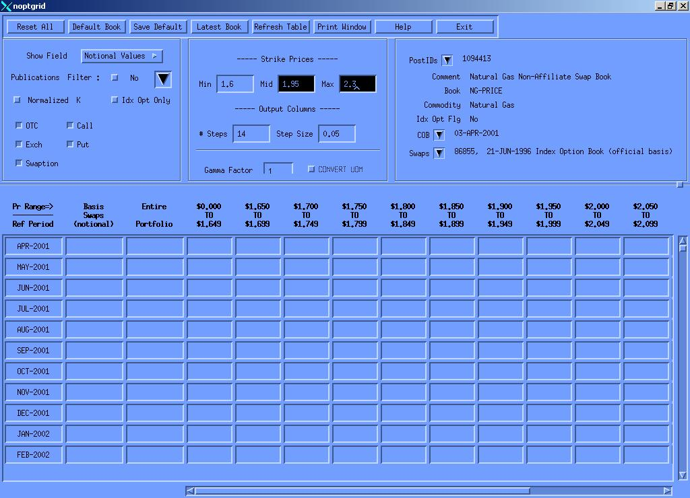

The modifications required by the Gas Trading group are to integrate the Option Grid into Excel. The Gas Trading group also requires multiple step sizes in their output columns, and that no empty columns should be made visible.

The IT development timeline for this task is provided towards the end of this document.
Task 3: Gas Daily Options:

The Gas Trading group had requested some modifications and reports for the Gas Daily Options. The OSTRIP model has been adjusted to allow two inputs, NYMEX vol and GD vol.

The report that is currently being worked upon for the Gas Daily Options is as follows:

Option Delta Change Forward Month report: This report also requires changes to the ERMS PortCalc application.

The IT development timeline for this task is provided towards the end of this document.

Task 4: Basis Options:

The systems need to be enhanced to capture and value different kinds of spread options including Basis Options (off NYMEX). Since the current system does not capture Basis Options, a new TAGG deal entry type will need to be created. Currently, ERMS does not handle spread options; therefore, spread options will need to be added to PortCalc. A correlation spreadsheet will also be developed to upload the correlation curves. Additionally, the “Top Page” report in ERMS will also need to be modified to include additional sensitivities.

The IT development timeline for this task is provided towards the end of this document.

Task 5: Options reports:

The Gas Trading group has also requested the development of Options reports that fall in the following two categories:

Sample PL reports:

Total PL:

Curve Shift:

Gamma PL:

Vega PL:

ETA PL:
Sample Sensitivity reports:

Total Sensitivity:

Delta Positions:

Gamma Sensitivity:

Vega Sensitivity:

ETA Sensitivity:

The IT development timeline for these reports is provided towards the end of this document.

Task 6: Transport Deal Capture & Valuation:

Based upon the requirements provided by the Gas Trading group, the Transport deals will be valued in the similar fashion as Basis Options in the PortCalc application of ERMS. A new deal entry type will also be developed to capture the transport deals in TAGG.

The additional fields that will be required to capture the new transport deal type in TAGG are as follows:

- Fuel percentage
- Commodity (strike)
- 2 Pub Codes (receipt/delivery pub codes)
- Demand charges

In addition to the creation of new deal entry type, and changes to the PortCalc application in ERMS, the curve structure will also need to be modified to handle correlation, and a correlation spreadsheet will also be developed for the correlation curves.

The IT development timeline for this task is provided towards the end of this document.

Task 7: Single point of deal entry for term deals:

The issue of single point of deal entry has been addressed in two phases. The Phase 1 of single deal entry allowed the users to enter simple types of physical deals at the time of deal creation.

In this phase of the project, the users will be able to enter and edit all types of physical deals. In order to handle the remaining types of physical deals, various tasks will need to be implemented. The Graphical User Interface (GUI) needs to be defined, along with the detail mapping of the data elements. Data delivery and monitoring mechanisms will also need to be designed.

Sitara deal entry will be modified to incorporate the single deal entry functionality. All physical deals will be entered through the new Sitara deal entry system. The users will be able to view TAGG deals through the TAGG deal entry system; however, the “save” and “edit” capabilities will be disabled, once Sitara’s single deal entry functionality is ready.

The detailed IT development timeline for this task is provided towards the end of this document.

Dependencies And Risk Factors

Dependencies

The timely deployment of the deliverables for this project is also dependent upon the Gas Trading and Risk groups. In addition to assisting in the refining of requirements, the designated representatives from these two groups will also be required for the user acceptance testing, which is a also a very critical part of this project.

The appropriate signers from the above-mentioned groups have also been included in the project sign-off sheet of this document.

Risk Factors

There is a risk that the requirements gathering process is not sufficient to uncover all the user requirements prior to initial product delivery. This risk, however, will be mitigated by the presence of domain experts (both IT and business) on the project team.

A risk factor may also arise during the detail design phase. Once the detail design process is commenced, the IT development team may uncover additional areas of development, which may require necessary adjustments to the project timeline.

Another risk factor arises in the area of personnel. The possibility arises that the project team may lose members to other projects or other companies. This risk is difficult to mitigate and requires attention to personnel management.

The list of risk factors listed above is complete as of date. As other risk factors arise, the GTV project team will bring them to the attention of the project stakeholders.

Project Timeline

Estimated Schedule for Phase II

