Gas Trading Vision II
Inception – Phase II

Inception Document



On behalf of
Enron Net Works, LLC

Document Classification: | Released for Review
Version: | 1
Point of contact: | Zhiyong Wei
Date: | April 6, 2001

Sign off

The signatories agree with the definitions, processes and recommendations stated in this document and agree for the first
phase to begin based on this document.

Business Sponsors Name Louise Kitchen

_______________________ Date ______________

Name Geof Storey

_______________________ Date ______________

Name Jeff Gossett

_______________________ Date ______________

IT Sponsors Name Philippe Bibi

_______________________ Date ______________

Name Beth Perlman

_______________________ Date ______________

Name Steve Stock

_______________________ Date ______________

Name Zhiyong Wei

_______________________ Date ______________

Name Dave Nommensen

___________________ Date ___________

Name Jim Ogg

_______________________ Date ______________

Name Bob McAuliffe

___________________ Date ___________

Contents

1 Management summary 4
2 phase ii issues 5
3 DEPENDENCIES AND RISK FACTORS…………………………………………………………………8
3.1 dependencies 8
3.2 risk factors 8
4 Project timeline 9
4.1 Estimated Schedule for Phase II 9

Management summary
The purpose of this document is to present a revised set of requirements and timelines for the Phase II of the Gas Trading Vision-II project. The purpose of the Gas Trading Vision-II project is to develop additional systems functionality and to modify the existing business processes to provide the natural gas businesses of Enron North America (US & Canada) with a consolidated position screen/report and enhanced position reporting tools for each of the various gas business units.

Phase I of the Gas Trading Vision-II project was commenced on March 21, 2001, with an estimated go-live date for May 21, 2001.

The issues and requirements for Phase II are being addressed in this document, alongwith the proposed IT development timeline.

Phase II Issues

Issue 1: Capability for desk roll-ups on an ad-hoc basis:

In phase 1 of GTV II, the roll-up capability has been provided with predefined desks. In this phase, traders need to have the ability of defining roll-up desks on an ad-hoc basis. Also, the various portfolios need not to be shared, and the portfolio calculation should be performed only on the actively viewed portfolios.

The IT development timeline for this issue is provided towards the end of this document.

Issue 2: Option Grid:

The Gas Trading group would like to have modifications made to the Option Grid that is currently in existence. A screen shot of the existing Option Grid is as follows:

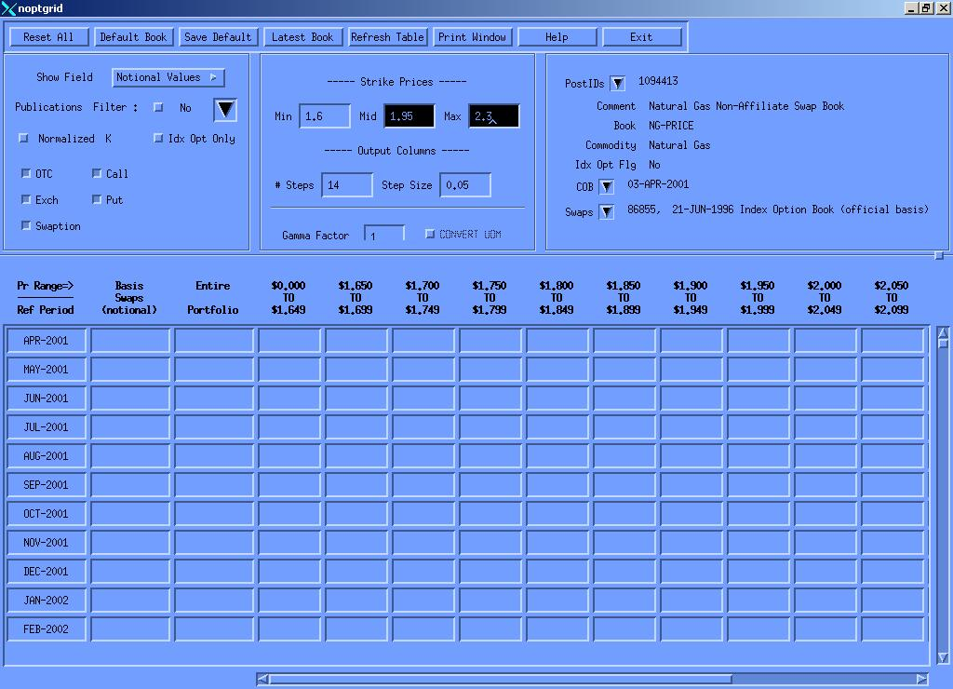

The modifications required by the Gas Trading group are to convert this existing Option Grid into Excel. The Gas Trading group also requires multiple step sizes in their output columns, and that no empty columns should be made visible.

The IT development timeline for this issue is provided towards the end of this document.

Issue 3: Spreadsheet for option buckets:

The Gas Trading group also requires the development of a spreadsheet that will either listen to or download real-time information about new or changed deals for the NYMEX options.

The data elements required by the Gas Trading group are as follows:

- Deal number
- Counterparty ID
- Buy/Sell code
- Notional volume
- Call/Put code
- Strike price
- Book code
- Deal type

The IT development timeline for this issue is provided towards the end of this document.

Issue 4: Gas Daily Options:

The Gas Trading group had requested some modifications and reports for the Gas Daily Options. The OSTRIP model has been adjusted to allow two inputs, NYMEX vol and GD vol.

The reports that are currently being worked upon for the Gas Daily Options are as follows:

Option Delta Change Forward Month report: This report also requires changes to the ERMS PortCalc application.

Fixed Price Matrix report:

Index Price Matrix report:

The IT development timeline for this issue is provided towards the end of this document.

Issue 5: Basis Options:

The systems need to be enhanced to capture and value different kinds of spread options including Basis Options (off NYMEX). Since the current system does not capture Basis Options, a new deal entry type will need to be created. Currently, ERMS does not handle spread options; therefore, spread options will need to be added to PortCalc. Additionally, the “Top Page” report in ERMS will also need to be modified to include additional sensitivities.

The IT development timeline for this issue is provided towards the end of this document.

Dependencies And Risk Factors

Dependencies

The timely deployment of the deliverables for this project is also dependent upon the Gas Trading and Risk groups. In addition to assisting in the refining of requirements, the designated representatives from these two groups will also be required for the user acceptance testing, which is a also a very critical part of this project.

The appropriate signers from the above-mentioned groups have also been included in the project sign-off sheet of this document.

Risk Factors

There is a risk that the requirements gathering process is not sufficient to uncover all the user requirements prior to initial product delivery. This risk, however, will be mitigated by the presence of domain experts (both IT and business) on the project team.

A risk factor also arises in the area of personnel. The possibility arises that the project team may lose members to other projects or other companies. This risk is difficult to mitigate and requires attention to personnel management.

The list of risk factors listed above is complete as of date. As other risk factors arise, the GTV project team will bring them to the attention of the project stakeholders.

Project Timeline

Estimated Schedule for Phase II

