The stupidity of some people in this world never fails to amaze.

This picture is real - not doctored in anyway - and was taken last week in
Waldorf by a Transportation Supervisor for a company that delivers building
materials for 84 Lumber. When he saw it in the parking lot of IHOP, he went
and bought a camera to take pictures.

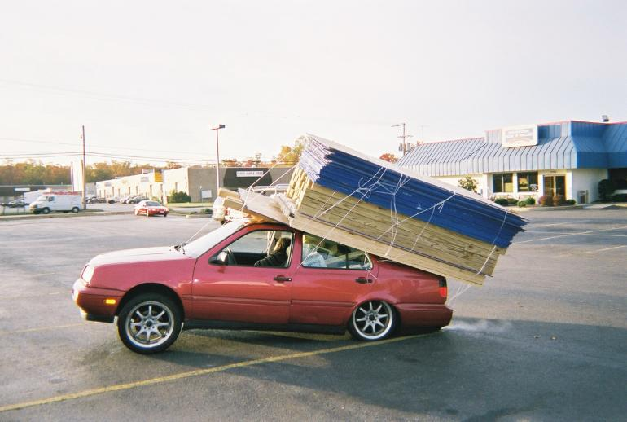

The car is still running as can be witnessed by the exhaust. A woman is
either asleep or otherwise out in the front seat passenger side. The guy
driving it was over jogging up and down on Rt. 925 in the background. The
witnesses said their physical state was OTHER than normal and the police
just shook their heads in amazement. The driver finally came back after the
police were there and was getting down at the back to cut the 'twine around
the load. They told him to get back until it was taken off.
The materials were loaded at Home Depot. Their store manager said they
had the customer sign a waiver!
Both back tires are trashed. The back shocks were driven up through the
floorboard. In the back seat were 10 bags, 80 lbs. each of concrete. On
the roof are many 2X4s, 4X4s and sheets of OSB. They estimated the load
weight at 3000 lbs. The car is a VW Jetta with FL plates and the guy said
he was headed for Annapolis.

JUST UNBELIEVABLE!!!!

